UNITED STATES

SECURITIES AND EXCHANGE COMMISSION
Washington, D.C. 20549

FORM 10-Q

QUARTERLY REPORT PURSUANT TO SECTION 13 OR 15(d) OF THE

SECURITIES EXCHANGE ACT OF 1934

For the Quarter Ended

Commission File Number

September 30, 2000

1-3229

NORTHROP GRUMMAN CORPORATION

(Exact name of registrant as specified in its charter)

DELAWARE | No. 95-1055798
(State or other jurisdiction of | (I.R.S. Employer
incorporation or organization) | Identification
 | Number)

1840 Century Park East, Los Angeles, California 90067

www.northgrum.com
(Address of principal executive offices and internet site)

(310) 553-6262

(Registrant's telephone number, including area code)

Indicate by check mark whether the registrant (1) has filed all reports required to be filed by Section 13 or 15(d) of the Securities Exchange Act of 1934 during the preceding 12 months (or such shorter period that the registrant was required to file such reports), and (2) has been subject to such filing requirements for the past 90 days.

Yes x No

APPLICABLE ONLY TO CORPORATE ISSUERS

Indicate the number of shares outstanding of each of the issuer's classes of common stock, as of the latest practicable date.

Common Stock outstanding as of October 24, 2000 71,813,318 shares

Northrop Grumman Corporation and Subsidiaries

INDEX

Part I. Financial Information

Item 1. Financial Statements

Consolidated Condensed Statements of Financial Position

Consolidated Condensed Statements of Financial Operations

Consolidated Condensed Statements of Changes in Shareholders' Equity

Consolidated Condensed Statements Of Cash Flows

Selected Industry Segment Information

Notes to Consolidated Condensed Financial Statements

Item 2. Management's Discussion and Analysis of the Company's Financial

Condition and the Results Of Operations

Item 3. Quantitative and Qualitative Disclosures About Market Risks

Part II Other Information

Item 1. Legal Proceedings

Item 6. Exhibits and Reports on Form 8-K

Northrop Grumman Corporation and Subsidiaries

Part I. Financial Information

Item 1. Financial Statements
CONSOLIDATED CONDENSED STATEMENTS

OF FINANCIAL POSITION

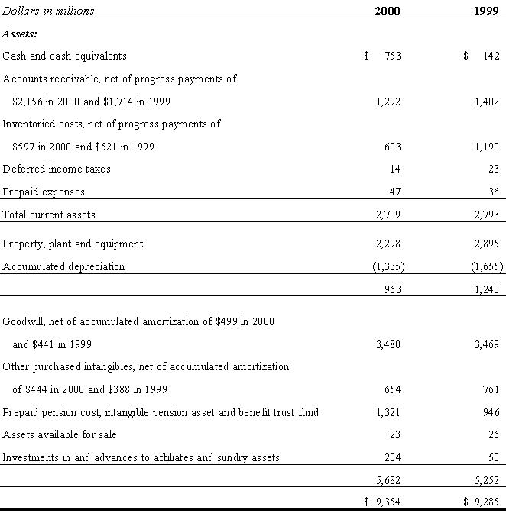

I-1

Northrop Grumman Corporation and Subsidiaries

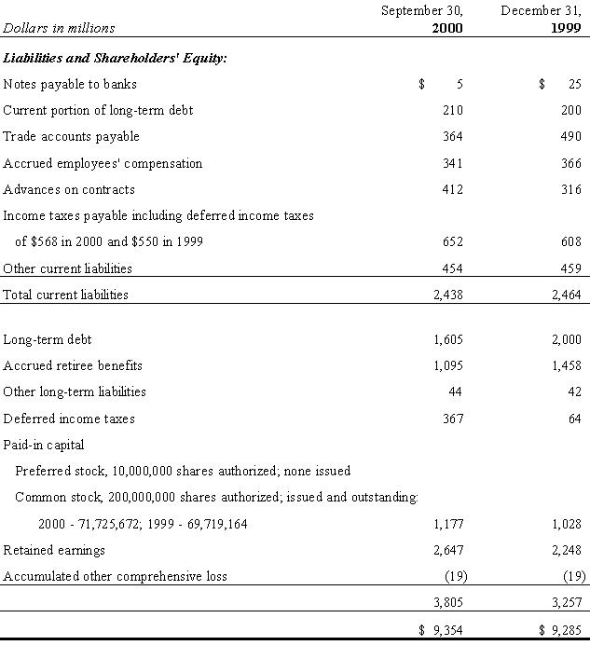

The accompanying notes are an integral part of these consolidated financial statements.

I-2

Northrop Grumman Corporation and Subsidiaries

CONSOLIDATED CONDENSED STATEMENTS

OF OPERATIONS

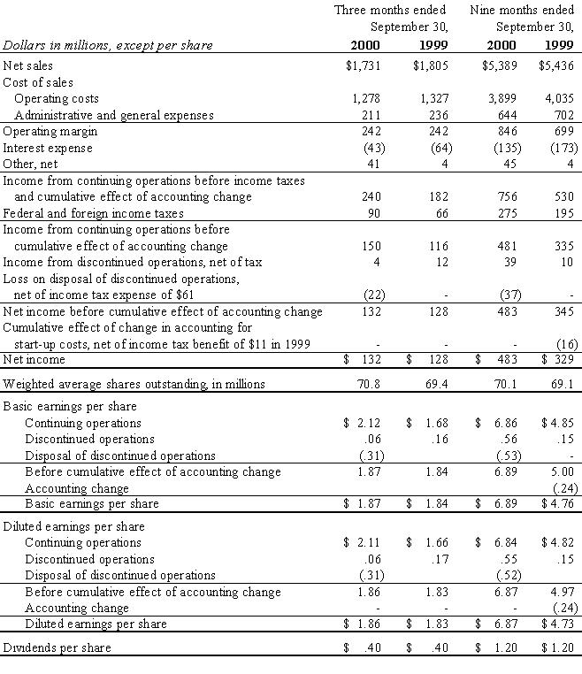

The accompanying notes are an integral part of these consolidated financial statements.

I-3

Northrop Grumman Corporation and Subsidiaries

CONSOLIDATED CONDENSED STATEMENTS

OF CHANGES IN SHAREHOLDERS' EQUITY

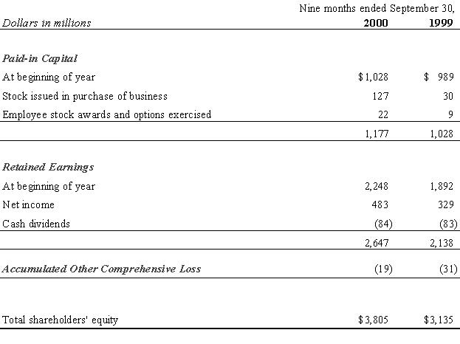

The accompanying notes are an integral part of these consolidated financial statements.

I-4

Northrop Grumman Corporation and Subsidiaries

CONSOLIDATED CONDENSED STATEMENTS

OF CASH FLOWS

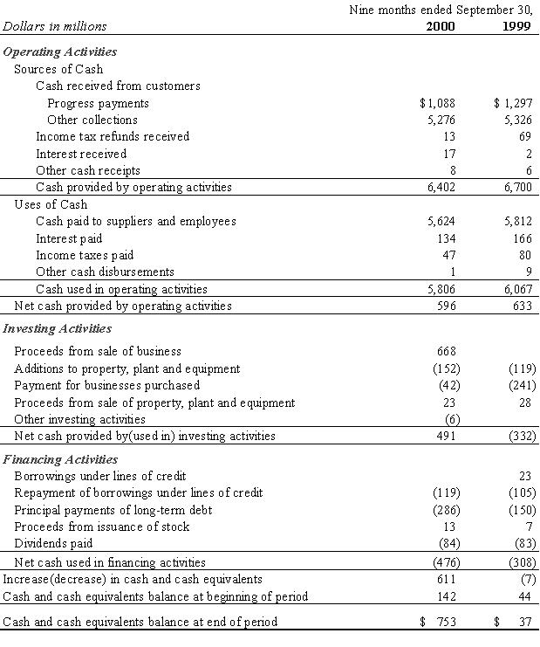

I-5

Northrop Grumman Corporation and Subsidiaries

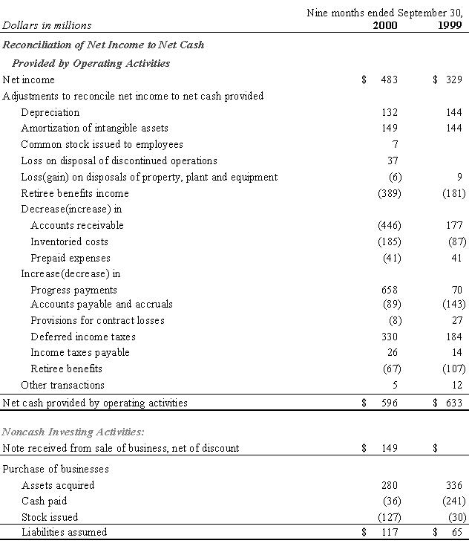

The accompanying notes are an integral part of these consolidated financial statements

I-6

Northrop Grumman Corporation and Subsidiaries

SELECTED INDUSTRY SEGMENT INFORMATION

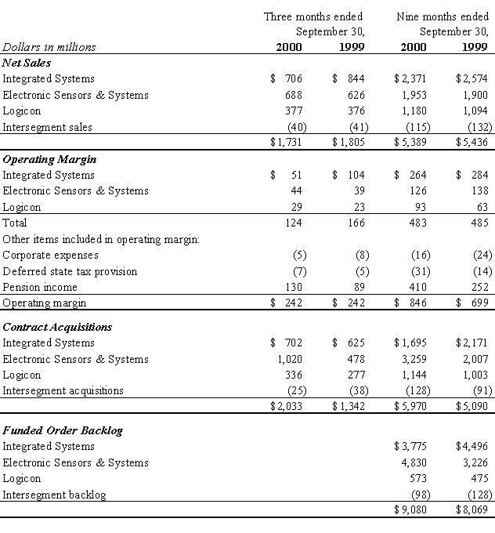

I-7

Northrop Grumman Corporation and Subsidiaries

NOTES TO CONSOLIDATED CONDENSED

FINANCIAL STATEMENTS

Basis of Presentation

The accompanying unaudited consolidated condensed financial statements have been prepared by management in accordance with the instructions to Form 10-Q of the Securities and Exchange Commission. They do not include all information and notes necessary for a complete presentation of financial position, results of operations, changes in shareholders' equity, and cash flows in conformity with generally accepted accounting principles. They do, however, in the opinion of management, include all adjustments necessary for a fair statement of the results for the periods presented. The financial statements should be read in conjunction with the Notes and Independent Auditors' Report contained in the company's 1999 annual report as restated for discontinued operations and filed on Form 8-K.

Discontinued Operations

Effective July 24, 2000, the company completed the sale of its commercial aerostructures (Aerostructures) business to The Carlyle Group, pursuant to an Asset Purchase Agreement dated as of June 9, 2000 between Northrop Grumman and Vought Aircraft Industries, Inc., an entity owned by The Carlyle Group. Aerostructures is a major producer of commercial and military aircraft subassemblies, the majority of which are sold to The Boeing Company and, for military contracts, ultimately to the U.

S. Government. The purchase price was composed of $668 million in cash and a promissory note for $175 million, maturing in nine years, with interest payable in kind for four years and interest payable in kind or cash thereafter. The proceeds were received and recorded in the third quarter of 2000. An estimated loss on the sale of $37 million was recorded in the second and third quarters of 2000. The loss includes the settlement and curtailment of various pension and other post-retirement benefit plans, the write-off

of goodwill, and preliminary assessments of both various costs and the value of the promissory note. The amount of the loss may be adjusted in the fourth quarter of 2000, pending the final determination of these amounts.

The company's Consolidated Statements of Income and related footnote disclosures have been restated to reflect Aerostructures as discontinued operations for all periods presented. The balance sheet as of December 31, 1999, and Cash Flows Statements for all periods presented have not been restated. Operating results of the discontinued Aerostructures business are as follows:
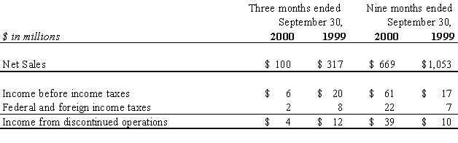

I-8

Northrop Grumman Corporation and Subsidiaries

Earnings per Share

Basic earnings per share are calculated using the weighted average number of shares of common stock outstanding during each period, after giving recognition to stock splits and stock dividends. Diluted earnings per share reflect the dilutive effect of stock options and other stock awards granted to employees under stock-based compensation plans.

Basic and diluted earnings per share are calculated as follows:
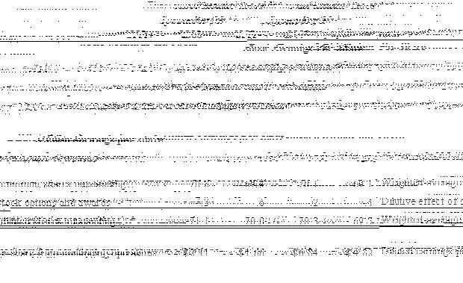

Acquisitions

On August 31, 2000, the company completed its acquisition of Comptek Research, Inc., in a stock-for-stock transaction. Comptek Research is a leading supplier of electronic warfare and information dominance technologies for U.S. and international defense customers. Approximately 1.6 million shares of common stock were issued for Comptek's stock. The purchase method of accounting was used to record the acquisition. The major business units of Comptek have been integrated into Northrop Grumman's three operating sectors from the acquisition date.

On October 23, 2000, the company completed its acquisition of Federal Data Corporation, a leading systems integrator and supplier of information technology to the federal government, for $302 million, including approximately $130 million in cash, $154 million in debt that was retired

I-9

Northrop Grumman Corporation and Subsidiaries

in conjunction with the closing and $18 million in other transaction costs. The transaction will be recorded in the fourth quarter of 2000 using the purchase method of accounting. Federal Data will be integrated into the operations of Logicon from the acquisition date.

On October 31, 2000, the company completed its acquisition of Sterling Software, Inc., (known as Sterling's Federal Systems Group), a provider of information technology services to the federal government, for $150 million in cash. The transaction will be recorded in the fourth quarter of 2000 using the purchase method of accounting. Sterling Software, Inc., will be integrated into the operations of Logicon from the acquisition date.

I-10

Northrop Grumman Corporation and Subsidiaries

Item 2. MANAGEMENT'S DISCUSSION AND

ANALYSIS OF THE COMPANY'S FINANCIAL
CONDITION AND THE RESULTS OF OPERATIONS

Sales were 4 percent lower for the third quarter and 1 percent lower for the first nine months of 2000 versus the same periods of 1999. Increased Electronic Sensors and Systems (ESS) segment and Information Technology (Logicon) segment sales for both the third quarter and nine-month periods were more than offset by lower Integrated Systems (ISS) segment sales.

ISS sales are 16 percent lower for the third quarter and 8 percent lower for the first nine months of 2000 as compared with the same periods of 1999, primarily due to decreased Air Combat Systems (ACS) sales. For the third quarter, lower B-2 sales are the major cause of the ACS decrease. For the nine-month period, lower B-2 and F/A-18C/D sales are somewhat offset by increased F/A-18E/F sales, as this program transitions from the development phase in early 1999 to the current production phase.

ESS sales for the third quarter and first nine months of 2000 increased by 10 percent and 3 percent, respectively, as compared to the same periods last year. The third quarter increase is largely due to higher marine sales, included in the Command, Control, Communications, Intelligence and Naval Systems (C3I&N) business area, and higher automation and information sales, included in the "Other" business area. The nine-month period increase reflects higher automation and information sales, higher land combat systems sales, included in the Aerospace Electronic Systems business area, and lower air defense and air traffic control radar systems sales for international customers, included in C3I&N.

Logicon sales for the third quarter of 2000 were virtually unchanged from the third quarter of 1999, due to delays in I-CASE orders now expected in the fourth quarter. For the first nine months of 2000, Logicon sales were 8 percent higher than the same period of 1999, largely attributable to growth in the Government Information Technology business area.

I-11

Northrop Grumman Corporation and Subsidiaries

Sales by business area and units delivered were:

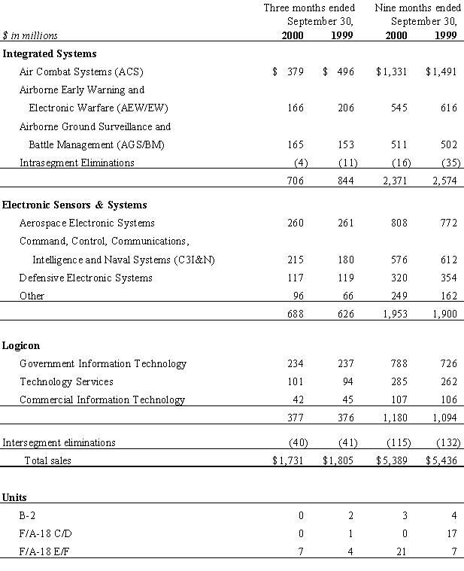

I-12

Northrop Grumman Corporation and Subsidiaries

ISS segment operating margin in the third quarter of 2000 was $51 million compared with $104 million reported in the third quarter of 1999. ISS results reflect improved Joint STARS operating margin offset by lower B-2 volume and the effect of nonrecurring relocation and realignment costs associated with the sale of the commercial aerostructures business and the relocation of the sector's headquarters. Last year's third quarter results included the delivery of two B-2s and an upward cumulative margin rate adjustment of $11 million on the B-2 program. For the first nine months of 2000, ISS segment operating margin was $264 million compared with $284 million reported for the same period of 1999. This year's nine-month period reflects three B-2 deliveries compared with four in the same period of 1999 and improved Joint STARS operating margin. Last year's nine-month period included upward cumulative margin rate adjustments on the B-2 program totaling $47 million.

ESS operating margin was $44 million and $126 million for the third quarter and first nine months of the year as compared with

$39 million and $138 million for the same periods of 1999. The third quarter increase and the nine-month period decrease are both primarily attributable to changes in pension-related margin. In July 1999 the company merged three of its pension plans into one, resulting in reduced pension-related margin beginning in the third quarter of 1999.

Logicon's operating margin in the third quarter and first nine-month period of 2000 was $29 million and $93 million, respectively, up from the $23 million and $63 million reported in the same periods a year ago. Logicon benefited from replacing several defined-contribution employee benefit plans with a defined-benefit type pension plan in the first quarter of 2000. While the total cash

contributions remain the same, the cost is now included in net pension income, in accordance with company policy. As a result, the company's pension income is lower than it otherwise would have been and Logicon's reported operating margin is higher by $5 million for the third quarter and $15 million for the first nine months of the year, with an additional $5 million of cash contributions expected to be made in the remaining quarter of this year. The increase in the nine-month period operating margin also reflects increased sales volume and improved performance.

Operating margin includes pension income of $130 million for the third quarter and $410 million for the first nine months of 2000 as compared with $89 million and $252 million for the same periods of 1999. Pension income was reassessed as a result of the sale of the company's commercial aerostructures business in July and is now expected to be approximately $540 million for the year 2000.

I-13

Northrop Grumman Corporation and Subsidiaries

Interest expense was $43 million for the third quarter of 2000 and $135 million for the first nine months of 2000, as compared with $64 million and $173 million, respectively, for the same periods last year. Interest on debt was down $11 million for the third quarter and $27 million for the first nine months as compared to the same periods for 1999, principally as a result of a lower average level of borrowings in these periods. Last year's third quarter and first nine-month periods included $11 million of interest expense related to settlements of various legal and tax issues.

Other income for the third quarter of 2000 increased to $41 million compared with $4 million for the comparable period a year ago. The increase includes $18 million of interest income and a pretax gain totaling $16 million, $12 million realized and $4 million unrealized, on stock owned in Satcon Technology Corporation, which purchased Northrop Grumman's power electronics business unit in late 1999.

The company's effective federal income tax rate was 36 percent for the first nine months of 2000 compared with 37 percent for the same period in 1999.

The company completed the sale of its commercial aerostructures (Aerostructures) business to The Carlyle Group on July 24, 2000. The company's Consolidated Condensed Statements of Operations and Selected Industry Segment Information have been restated to reflect Aerostructures as discontinued operations for all periods presented.

Aerostructures income from discontinued operations, net of tax, was $4 million for the third quarter and $39 million for the first nine months of 2000 as compared with $12 million and $10 million for the same periods of 1999. Included in these amounts are related pretax pension income of $2 million for the third quarter and $22 million for the first nine months of 2000 as compared with $3 million and $7 million for the same periods of 1999.

The $37 million total after tax loss on the sale of Aerostructures, recorded in the second and third quarters of 2000, includes the settlement and curtailment of various pension and other post-retirement benefit plans, the write-off of goodwill, and preliminary assessments of both various costs and the value of the promissory note received in partial payment. Final determination of these amounts in the fourth quarter of 2000 may result in a further adjustment. The proceeds from the sale, $668 million in cash and a promissory note for $175 million, were received and recorded in the third quarter of 2000. The cash proceeds were used, in part, to pay down debt. The remainder will be used for further repayment of debt and general corporate purposes, including potential strategic acquisitions.

I-14

Northrop Grumman Corporation and Subsidiaries

Due to the sale of Aerostructures, ISS will move its headquarters to a new location in the Dallas metropolitan area. The current estimate for nonrecurring ISS relocation and realignment costs is approximately $20 million, most of which will occur in the second half of 2000.

On August 31, 2000, the company completed its acquisition of Comptek Research, Inc., in a stock-for-stock transaction. Comptek Research is a leading supplier of electronic warfare and information dominance technologies for U.S. and international defense customers. Approximately 1.6 million shares of common stock were issued for Comptek's stock. The purchase method of accounting was used to record the acquisition. The major business units of Comptek have been integrated into Northrop Grumman's three operating sectors from the acquisition date.

On October 23, 2000, the company completed its acquisition of Federal Data Corporation, a leading systems integrator and supplier of information technology to the federal government, for $302 million, including approximately $130 million in cash, $154 million

in debt that was retired in conjunction with the closing and $18 million in other transaction costs. The transaction will be recorded in the fourth quarter of 2000 using the purchase method of accounting. Federal Data will be integrated into the operations of Logicon from the acquisition date.

On October 31, 2000, the company completed its acquisition of Sterling Software, Inc., (known as Sterling's Federal Systems Group), a provider of information technology services to the federal government, for $150 million in cash. The transaction will be recorded in the fourth quarter of 2000 using the purchase method of accounting. Sterling software, Inc., will be integrated into the operations of Logicon from the acquisition date.

The Securities and Exchange Commission recently issued Staff Accounting Bulletin (SAB) No. 101 Revenue Recognition in Financial Statements. Since substantially all of the company's revenue is recognized in compliance with Statement of Position (SOP) No. 81-1 Accounting for Performance of Construction-Type and Certain Production-Type Contracts and SOP No. 97-2 Software Revenue Recognition, implementation of SAB No. 101 has no material effect on the company's results of operations or financial position.

In June 1998 the Financial Accounting Standards Board issued SFAS No. 133 - Accounting for Derivative Instruments and Hedging Activities, which becomes effective for fiscal years beginning after June 15, 2000. This standard provides authoritative guidance on accounting and financial reporting for derivative instruments. The company will adopt this standard effective January 1, 2001. Adoption of this standard is not expected to have a material effect on the company's results of operations, financial position, or cash flows.

I-15

Northrop Grumman Corporation and Subsidiaries

During the first nine months of 2000, $596 million of cash was generated by operations versus the $633 million generated in the same period last year. For the remainder of 2000, cash generated from operating activities, supplemented by borrowings under the credit agreement, are expected to be more than sufficient to service debt, finance capital expenditures, and continue paying dividends to the shareholders. The company's liquidity and financial flexibility will continue to be provided by cash flow generated by operating activities, supplemented by the unused borrowing capacity available under the company's credit agreement and other short-term credit facilities.

Forward-Looking Information

Certain statements and assumptions in Management's Discussion and Analysis and elsewhere in this quarterly report on Form 10-Q contain or are based on "forward-looking" information (that the company believes to be within the definition in the Private Securities Litigation and Reform Act of 1995) and involve risk and uncertainties. Such "forward-looking" information includes statements and assumptions with respect to future revenues, expected program performance and cash flows, the outcome of contingencies including litigation, environmental remediation, the effect of completed and planned acquisitions and divestitures of businesses, and anticipated costs of capital investments. The company's operations are subject to various risks and uncertainties resulting from its position as a supplier, either directly or as subcontractor or team member, to the U.S. Government and its agencies as well as to foreign governments and agencies. Actual outcomes are dependent upon factors, including, without limitation, the company's successful performance of internal plans; government customers' budgetary restraints; customer changes in short-range and long-range plans; domestic and international competition in both the defense and commercial areas; product performance and the timing of deliveries under existing contracts; continued development and acceptance of new products; performance issues with key suppliers and subcontractors; government import and export policies; acquisition or termination of government contracts; the outcome of political and legal processes; the results of acquisition and divestitures and environmental remediating; legal, financial, and governmental risks related to international transactions and global needs for military aircraft, military and civilian electronic systems and support and information technology; as well as other economic, political risks and uncertainties. Additional information regarding these factors is contained in the company's other SEC filings, including without limitation, the Company's Annual Report on Form 10-K for the year ended December 31, 1999.

I-16

Northrop Grumman Corporation and Subsidiaries

Item 3. Quantitative and Qualitative Disclosures About Market Risks

The company has fixed-rate long-term debt obligations, most of which are not callable until maturity. The company also has financial instruments that are subject to interest rate risk, principally variable-rate short-term debt outstanding under the Credit

Agreement. The company may enter into interest rate swap agreements to offset the variable-rate characteristics of these loans. At September 30, 2000, no interest rate swap agreements were in effect.

Only a small portion of the company's transactions are contracted in foreign currencies. The company does not consider the market risk exposure relating to foreign currency exchange to be material.

I-17

Northrop Grumman Corporation and Subsidiaries

INDEPENDENT ACCOUNTANTS' REPORT

Board of Directors and Shareholders
Northrop Grumman Corporation
Los Angeles, California

We have reviewed the accompanying consolidated condensed statements of financial position of Northrop Grumman Corporation and Subsidiaries as of September 30, 2000, and the related consolidated condensed statements of operations for the three- and nine-month periods ending September 30, 2000 and 1999, and the related consolidated condensed statements of changes in shareholders' equity and cash flows. These financial statements are the responsibility of the Corporation's management.

We conducted our review in accordance with standards established by the American Institute of Certified Public Accountants. A review of interim financial information consists principally of applying analytical procedures to financial data and of making inquiries of persons responsible for financial and accounting matters. It is substantially less in scope than an audit conducted in accordance with auditing standards generally accepted in the United States of America, the objective of which is the expression of an opinion regarding the financial statements taken as a whole. Accordingly, we do not express such an opinion.

Based on our review, we are not aware of any material modifications that should be made to such consolidated condensed financial statements for them to be in conformity with accounting principles generally accepted in the United States of America.

We have previously audited, in accordance with auditing standards generally accepted in the United States of America, the consolidated balance sheet of Northrop Grumman Corporation and Subsidiaries as of December 31, 1999, and the related consolidated statements of income, comprehensive income, changes in shareholders' equity, and cash flows for the year then ended (not presented herein); and in our report dated January 26, 2000, except for the discontinued operations footnote, as to which the date is July 24, 2000, we expressed an unqualified opinion on those consolidated financial statements. In our opinion, the information set forth in the accompanying condensed consolidated balance sheet as of December 31, 1999 is fairly stated, in all material respects, in relation to the consolidated balance sheet from which it has been derived.

DELOITTE & TOUCHE LLP

Los Angeles, California

October 18, 2000

I-18

Northrop Grumman Corporation and Subsidiaries

Part II. OTHER INFORMATION

Item 1. Legal Proceedings

Fanni and related cases

Five shareholder class action lawsuits, making similar allegations, were filed between July and September, 1998 in the United States District Court for the Central District of California against the company, its directors, and certain of its officers. Three of these lawsuits, respectively encaptioned Fanni v. Northrop Grumman Corp., et al., Schnee v. Northrop Grumman Corp., et al., and Florida State Board of Admin. v. Northrop Grumman Corp., et al. allege that defendants issued misleading proxy materials in connection with the proposed acquisition of the company by Lockheed Martin Corporation, in violation of the federal securities laws. These actions were later consolidated and seek unspecified damages on behalf of a class of shareholders related to the accelerated vesting of stock incentive plans upon the shareholder vote to approve the merger. Plaintiffs filed an appeal from the Court's April, 2000, order that dismissed these actions with prejudice. The other lawsuits, respectively encaptioned Burroughs v. Northrop Grumman Corp., et al., and Miller, et al. v. Northrop Grumman Corp., et al., were also consolidated and allege that defendants disseminated misleading information in connection with the proposed acquisition, in violation of the federal securities laws, thereby artificially inflating the market price of the company's common stock. These actions seek unspecified damages for a class of shareholders who purchased Northrop Grumman stock between July 3, 1997 and March 9, 1998. On April 11, 2000, the

Court entered an order dismissing these actions without prejudice. Plaintiffs filed an amended complaint on June 30, 2000 and on October 16, 2000, the Court dismissed these actions with prejudice.

U.S. ex rel. McMorrough v. Northrop Grumman Corporation

In October 1998, the United States, acting through the Department of Justice, intervened in a portion of this civil action initially filed under seal in the U.S. District Court for the Western District of Louisiana in March 1995. The government intervened in the portion of the complaint that alleges the company knowingly supplied improperly heat-treated parts for Joint STARS aircraft in 1994 and 1995, in violation of the False Claims Act. As previously reported, the government's allegations regarding the heat treatment of parts were settled for $750,000. The company denied any liability as part of the settlement. The company recently settled the allegations that were being pursued separately by the relators, and the entire case was concluded on October 16, 2000.

II-1

Northrop Grumman Corporation and Subsidiaries

General

The company, as a government contractor, is from time to time subject to U.S. Government investigations relating to its operations. Government contractors that are found to have violated the False Claims Act, or are indicted or convicted for violations of other Federal laws, or are considered not to be responsible contractors may be suspended or debarred from government contracting for some period of time. Such convictions could also result in fines. Given the company's dependence on government contracting, suspension or debarment could have a material adverse effect on the company.

The company is involved in certain other legal proceedings arising in the ordinary course of business, none of which the company's management believes will have a material adverse effect on the company's financial condition.

II-2

Northrop Grumman Corporation and Subsidiaries

Item 6. Exhibits and Reports on Form 8-K

- Exhibits

  - Letter from independent accountants regarding unaudited interim financial information.

  - Financial Data Schedule

- Reports on Form 8-K

A report on Form 8-K was filed August 8, 2000 restating the financial statements previously presented in the December 31, 1999 report on Form 10-K and March 31, 2000 report on Form 10-Q to give effect to the sale of Aerostructures. The filing of this report on Form 8-K was noted in Item 6 in the Second Quarter report on Form 10-Q filed on August 11, 2000.

SIGNATURES

Pursuant to the requirements of the Securities Exchange Act of 1934, the registrant has duly caused this report to be signed on its behalf by the undersigned thereunto duly authorized.

Northrop Grumman Corporation (Registrant)

Date: November 3, 2000 by/s/ R. B. Waugh, Jr.

R. B. Waugh, Jr
Corporate Vice President and Chief Financial
Officer

Date: November 3, 2000 by/s/J. H. Mullan

John H. Mullan

Corporate Vice President and Secretary

II-3

Northrop Grumman Corporation and Subsidiaries

EXHIBIT (15)

Letter from Independent Accountants Regarding

Unaudited Interim Financial Information

November 3, 2000

Northrop Grumman Corporation

Los Angeles, California

We have made a review, in accordance with standards established by the American Institute of Certified Public Accountants, of the unaudited interim financial information of Northrop Grumman Corporation and subsidiaries for the periods ended September 30, 2000 and 1999, as indicated in our report dated October 18, 2000; because we did not perform an audit, we expressed no opinion on the information.

We are aware that our report referred to above, which is included in your Quarterly Report on Form 10-Q for the quarter ended September 30, 2000, is incorporated by reference in Registration Statement Nos. 33-59815, 33-59853, 333-68003 and 333-40862-01 on Form S-8, Registration Statement Nos. 333-78251 and 333-85633 on Form S-3 and Registration Statement No. 333-40862 on Form S-4.

We also are aware that the aforementioned report, pursuant to Rule 436 (c) under the Securities Act of 1933, is not considered a part of the Registration Statement prepared or certified by an accountant or a report prepared or certified by an accountant within the meaning of Sections 7 and 11 of that Act.

DELOITTE & TOUCHE LLP

Los Angeles, California

II-4

