FILING PURSUANT TO RULE 425 OF THE

SECURITIES ACT OF 1933, AS AMENDED

FILER: NORTHROP GRUMMAN CORPORATION

SUBJECT COMPANY: TRW INC. (NO. 1-2384)

FILING: REGISTRATION STATEMENT ON FORM S-4

(REGISTRATION NO. 333-83672)

Certain statements and assumptions in these materials contain or are based on “forward-looking” information (that Northrop Grumman believes to be within the definition in the Private Securities Litigation Reform Act of 1995) and involve risks and uncertainties. Such “forward-looking” information includes, among other things, statements as to the impact of the proposed acquisition on revenues and earnings. Such statements are subject to numerous assumptions and uncertainties, many of which are outside Northrop Grumman’s control. These include completion of the merger, governmental regulatory processes, Northrop Grumman’s ability to successfully integrate the operations of TRW, achieve a successful transaction or other resolution with respect to the TRW automotive sector, assumptions with respect to future revenues, expected program performance and cash flows, the outcome of contingencies including litigation, environmental remediation, divestitures of businesses, and anticipated costs of capital investments. Northrop Grumman’s operations are subject to various additional risks and uncertainties resulting from its position as a supplier, either directly or as subcontractor or team member, to the United States Government and its agencies as well as to foreign governments and agencies; actual outcomes are dependent upon factors, including, without limitation, Northrop Grumman’s successful performance of internal plans; government customers’ budgetary restraints; customer changes in short-range and long-range plans; domestic and international competition in both the defense and commercial areas; product performance; continued development and acceptance of new products; performance issues with key suppliers and subcontractors; government import and export policies; acquisition or termination of government contracts; the outcome of political and legal processes; legal, financial, and governmental risks related to international transactions and global needs for military aircraft, military and civilian electronic systems and support, information technology; naval vessels, space systems and related technologies, as well as other economic, political and technological risks and uncertainties and other risk factors set out in Northrop Grumman’s filings from time to time with the Securities and Exchange Commission, including, without limitation, Northrop Grumman’s reports on Form 10-K and Form 10-Q. In addition, there can be no assurance regarding the completion of the merger or other transactions described, the receipt of necessary government approvals, or the satisfaction of any other conditions to the merger.

Northrop Grumman Corporation filed a registration statement on Form S-4 (File No. 333-83672) with the Securities and Exchange Commission on March 4, 2002 with respect to its offer to exchange all outstanding shares of TRW capital stock for Northrop Grumman stock. The Registration Statement has been amended to include a joint proxy statement/prospectus relating to the proposed merger of Northrop Grumman and TRW Inc. pursuant to the Agreement and Plan of Merger, dated as of June 30, 2002, by and among Northrop Grumman, Richmond Acquisition Corp. and TRW. The directors, certain executive officers and other employees and representatives of Northrop Grumman may be deemed to be participants in the solicitation of proxies for the shareholder meetings relating to the proposed merger. Information concerning such potential Northrop Grumman participants is contained in the joint proxy statement/prospectus which constitutes a part of the registration statement, as amended from time to time THE JOINT PROXY STATEMENT/PROSPECTUS RELATING TO THE PROPOSED MERGER CONTAINS IMPORTANT INFORMATION WHICH SHAREHOLDERS OF NORTHROP GRUMMAN AND TRW ARE URGED TO READ BEFORE MAKING ANY DECISIONS REGARDING THE MERGER OR THE OTHER TRANSACTIONS DESCRIBED THEREIN. Copies of the joint proxy statement/prospectus, and any amendments or supplements thereto, may be obtained without charge at the SEC’s internet website at www.sec.gov as they become available.

These materials are neither an offer to purchase nor a solicitation of an offer to sell shares of TRW or Northrop Grumman stock.

Kent Kresa

TRW Headquarters Employee Meeting

September 13, 2002

[Phil Odeen introduces Kent Kresa and Ron Sugar]

Thanks, Phil. It’s good to be with all of you. I’m well aware that these are tough times for TRW headquarters employees, and I appreciate your coming to hear what we have to say.

I realize that your biggest concern right now is personal – how long your jobs will continue. We’ll talk a fair amount about that later in this meeting.

But I also imagine you’re interested in why TRW is so attractive to Northrop Grumman; why we believe the combination of the two companies makes so much sense, and what the next steps will be in completing the transaction. Let me get into this by telling you something about Northrop Grumman’s strategy since the early 90s.

Over the last decade we’ve repositioned ourselves as the nation’s third largest defense enterprise — an industry leader in systems integration, defense electronics, information technology and shipbuilding. We have 100,000 extremely talented employees who work in 44 states and 25 countries. Our projected 2002 revenues are nearly $18 billion, with almost 11 percent coming from international sales.

It was in the early 1990s that we began our transformation of Northrop Corporation, then a producer of military aircraft. We anticipated that the end of the Cold War would mean not only fewer new aircraft programs, but also a paradigm shift in defense procurement priorities. We set out to be a leading provider of capabilities that we thought would be key for militaries in the 21st century.

2

Since 1993 we’ve completed 15 acquisitions, while, at the same time, we’ve concentrated on achieving superior performance in our existing businesses. We’ve built strength in defense electronics, information technology and the other capabilities mentioned earlier and have achieved a great many of our strategic objectives.

The TRW acquisition will help us with the one node of the battle management network where we lack expertise, space. It will bring us tremendous new capabilities in critical areas of satellite systems and missile defense. It also adds great strength to our already substantial business in information technology and our overall systems integration capabilities. In fact, thanks to TRW, Northrop Grumman will become the largest provider of information technology to the Federal government and one of three major contributors to the nation’s satellite and missile defense requirements.

The combined entity of Northrop Grumman and TRW will create the nation’s second largest defense company. Our projected sales in 2003 will be more than $26 billion.

3

We’ll be a powerful and highly competitive company with tremendous growth prospects.

I often say that Northrop Grumman is a company of immigrants because so many employees have come to us from other places. We value the influx of diverse skills and company heritages as a chief source of our competitive strength. TRW people, for instance, are some of the best in the world, and we’re absolutely delighted that they will be joining the Northrop Grumman team.

Further, the strength resulting from our diversity provides all of us with greater opportunities for professional development and career growth. I believe the TRW employees who become part of Northrop Grumman will find that their futures are bright.

4

Although we have acquired many companies, we also have successfully integrated them into Northrop Grumman. In fact, integrating new businesses into the Northrop Grumman portfolio has become one of our core competences. Our strong track record here is one reason the investment community has reacted positively to the TRW transaction, in addition to the strategic benefits of the combination.

I think new members of our team from other companies have been impressed by how quickly and effectively the integration process was carried out. I expect you will have a similar view when we stand the TRW businesses up as Northrop Grumman operations. As we previously announced, we plan for your Space & Electronics and Systems businesses to operate as freestanding sectors of the company reporting to the Office of the Chairman.

5

I mentioned earlier the great respect that Northrop Grumman has for TRW people. That includes the people in this room. We expect and hope that a number of headquarters employees will have opportunities with Northrop Grumman and TRW Automotive.

Getting a fix on this, of course, will involve addressing some important transition issues. In just a moment, I’m going to ask Ron to brief you on our transition-planning process. Ron will have overall responsibility for the integration. Day-to-day responsibility for transition planning will be in the hands of Mike Hateley, who is Howard Knicely’s counterpart at Northrop Grumman.

Another thing we have respect for is TRW’s outstanding record of supporting your local community. We know that generations of TRW employees have contributed their personal time to enhance community life in this area. The TRW Foundation has been an important contributor to the health of the non-profit sector in Cleveland.

6

We admire TRW’s model of community good citizenship. In fact, we ourselves have always been strong supporters of the local communities in which we have facilities – and we certainly intend to continue this practice in all the areas where our people from TRW are located.

The Northrop Grumman-TRW transaction is moving along at the expected pace. We still believe we’ll be though the anti-trust, European Union and other reviews – and be able to conduct our shareholder meetings and reach a closing by the end of the fourth quarter.

As for automotive, you know we have announced our intention to separate that business, through either a spin or a sale. At this point there is nothing further to announce; but we and your colleagues here in Cleveland and Detroit are working very hard on this, and will keep you informed whenever we have news.

7

With such key happenings still developing, we certainly have fixed no date for the closing of the Cleveland headquarters itself. However, we do know that we will need a number of you to stay on for a period of time after that closing to help with the transition.

I’d like to turn now to Ron Sugar, who will update you on the transition planning process. At the end, we’ll be glad to take your questions. Ron …

#####

8

Ron Sugar

TRW Headquarters Employee Meeting

September 13, 2002

Returning to the TRW headquarters facility certainly brings back memories for me: I spent 20 years overall with TRW – working with some of the finest people in the industry. If circumstances permitted all of you to join the new Northrop Grumman, we would be very fortunate indeed.

For those of you who do join our team, you’ll find that there are many similarities between the cultures of our two companies.

As government contractors we have many of the same customers. We know each other not only as competitors, but as teammates — which is one of the unique aspects of being in our industry.

9

Both our companies are driven by technology and innovation, and we each expect to be the best at whatever we do.

We also share a belief in respecting and valuing our people as the essential ingredient in our success.

Let me project ahead a bit and offer some very preliminary observations of the ways in which TRW corporate employees will be affected by the transaction. And let me consider first the non-automotive part of the transaction.

The first hurdle for the transaction to close is the regulatory approvals and then the approval by shareholders.

We expect that the transaction will close by the end of the fourth quarter – mid November, early December.

10

The transition-planning process is what will generate the information we need to plan the integration of the two corporate offices and to clarify the employment opportunities going forward. Mike Hateley and Howard Knicely will work together to form the transition teams comprised of employees of both companies.

These teams will define the new Northrop Grumman corporate office structure and establish the resource plans to support the corporate organization. Our functional team leaders will be meeting with yours, getting to know your staffs and encouraging a dialogue about how to achieve the best results for the new company.

There will be a detailed and communicated selection process to support full time offers and transitional assignments.

11

Conversely, if layoffs are required, following the appropriate notice period, there will be a redeployment process to assist employees in their job search.

It is our objective to be in a position to advise every employee here in writing of their options within 60 days following the formal close of the transaction.

We have already frozen hiring at our corporate office, to make sure TRW employees are given an opportunity to be considered for currently open positions and positions that emerge from this transaction, or from other circumstances. We also have a website, called Horizons, that Northrop Grumman employees use to apply for any opening across the company – and we will make that site available to you on Day One.

12

At this early date, of course, we don’t know how many or what kind of opportunities we will be in a position to offer — though, clearly, any that do materialize would involve re-locating from Cleveland. All I can say at this point is that we hope the analysis of our needs allows us to draw significantly on your talent. We found that in the Litton transition, we were able to offer a significant number of openings to Litton corporate employees.

I should add that everything I have just said also applies to TRW corporate employees located outside Cleveland. For example, the transition teams will be exploring the same questions about functions and staffing levels with your government relations organization in the Washington office, as well as other headquarters employees working in your operating companies around the country.

13

For those of you who do not join our team, TRW has, as you know, committed to providing you with an enhanced severance benefit, as well as outplacement support in obtaining new employment.

As a result of the transaction some of headquarters employees will be needed on a temporary basis here in Cleveland to support various aspects of the TRW transition. Obviously, the TRW Systems and Space businesses will still require their same corporate services from the time of the transaction closing until they are formally established as Northrop Grumman sectors.

TRW is offering an enhanced severance package not only to those who are laid off, but also to those working in transitionary assignments, once these are completed. How long the assignments will last is unknown at this time. Clearly, that depends on how soon the TRW corporate functions supported in

14

Cleveland can be transitioned to the new company’s corporate office.

I can tell you this, however. Kent has already announced that he expects the integration of TRW into Northrop Grumman to be substantially complete 4 months after we close the transaction. We are also going to place a high priority on communicating regularly and directly about our progress and decision-making throughout the transition process.

Let me turn now to the subject of the automotive business – very briefly, because, as Kent noted, things here have not proceeded beyond our statement of intent to separate the business.

It is clear that the automotive business, whether it is spun or sold, will require a continuation of the corporate support it has been receiving from Cleveland. Therefore, both of the scenarios I described earlier – continued employment or

15

temporary employment during transition – seem highly likely for some of the folks supporting automotive. But discussion even of the process for determining opportunities will have to wait until there is an announcement of an agreement to sell or a decision to spin.

I hope the comments we have shared are helpful. Believe me, I know that your #1 question is, “What does this mean for me, personally? — and, as I promised earlier, as events go forward, we will tell you what we know as soon as we know it. As Kent and I both said, we think TRW is a great company, and we want the very best for everyone involved.

Now, Kent and I would be happy to try to answer any further questions you may have.

16

Kent Kresa’s introductory remarks leading into his Powerpoint presentation (A Strategic Overview of NOC) to the Systems business of TRW, Reston, VA, September 13, 2002

Thank you, Phil. I hope you enjoyed our corporate video. It certainly makes clear the exciting breadth of our expertise that enables us to contribute so much to our customer.

Ron and I are delighted to have this chance to meet with you. We look forward to soon being able to officially welcome the Systems business of TRW to the New Northrop Grumman Corporation.

We’re excited about having you join us – you bring outstanding capabilities that will make our company more competitive.

17

A perfect example is the key contract you just won that extends your role as prime contractor at the Joint National Integration Center. Congratulations on a great job! We look forward to working with you to keep the momentum going.

One thing I believe you’ll like about Northrop Grumman is that you’ll be joining what I call a company of immigrants.

Most of us have come from other companies – and we’re convinced that this diversity of backgrounds accounts for much of our competitive strength. So we value the heritages of all the great companies we came from.

At the same time, like immigrants to America, we have come to Northrop Grumman to create a new enterprise. What matters to us now is the upward climb we are making together – realizing our strategy, leading markets, winning programs.

18

If you talk to many of our other new arrivals, I think they’ll tell you you’re joining a great company that offers you many opportunities for achieving business success and realizing your professional dreams.

They’ll also tell you we’re a socially responsible company, setting high standards for business conduct and values.

What I’d like to do now is give you a strategic overview of the company – focusing on how we’re positioned in the defense marketplace; what strategic steps we took to achieve this positioning; and how we see TRW as helping us build a new Northrop Grumman.

[START SLIDE SHOW]

19

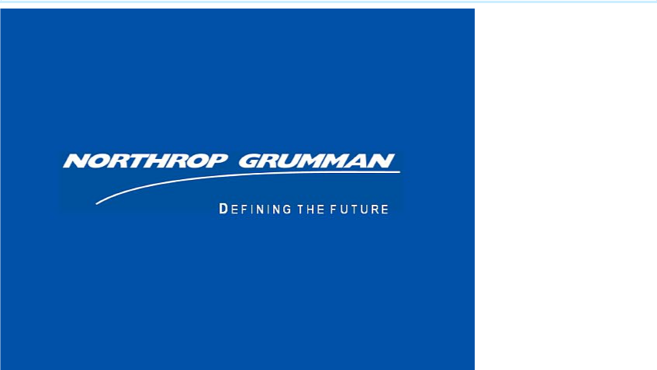

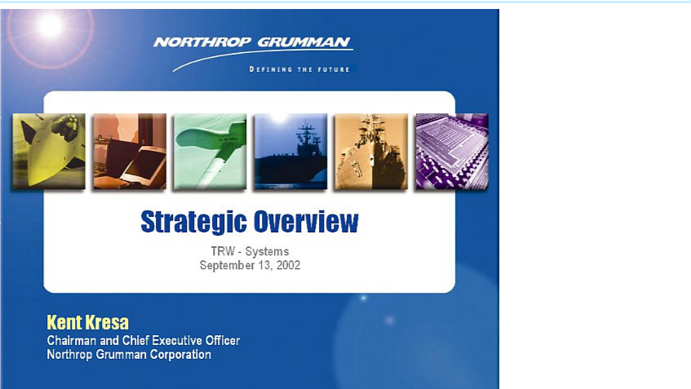

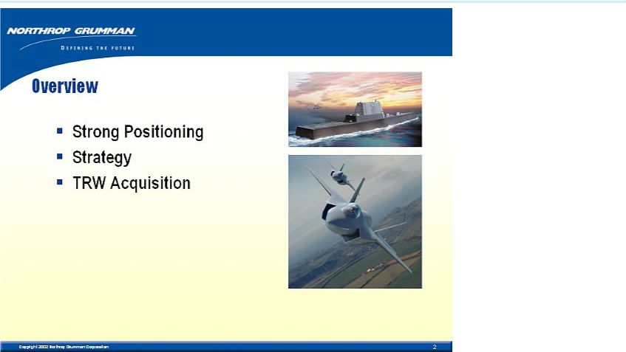

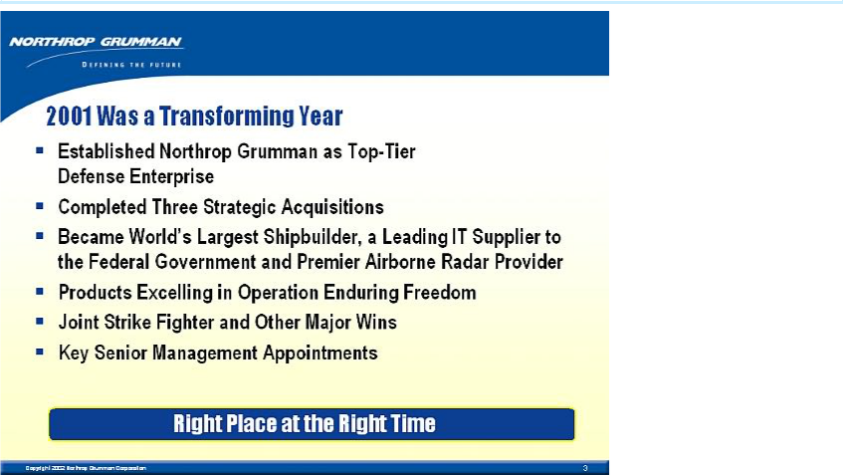

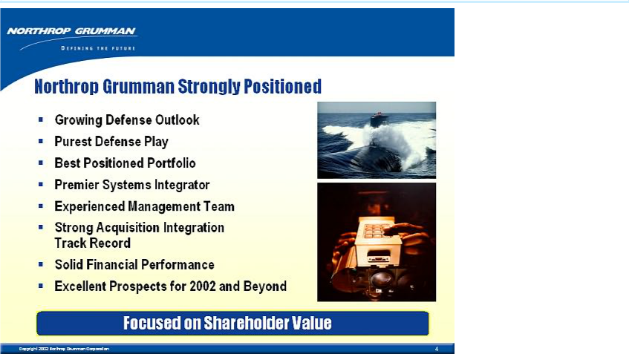

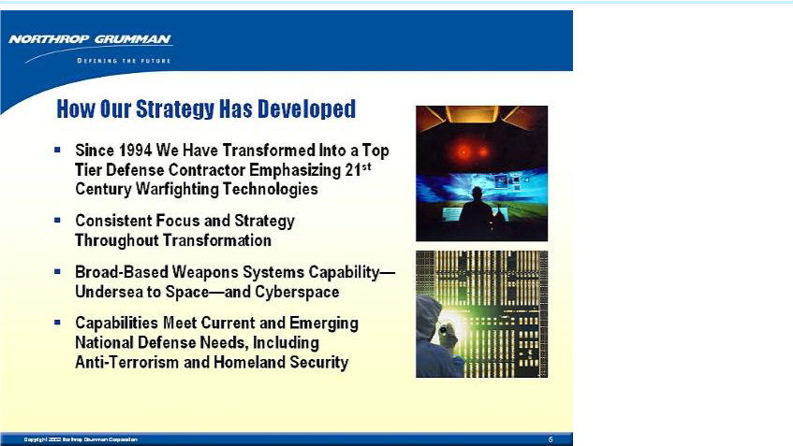

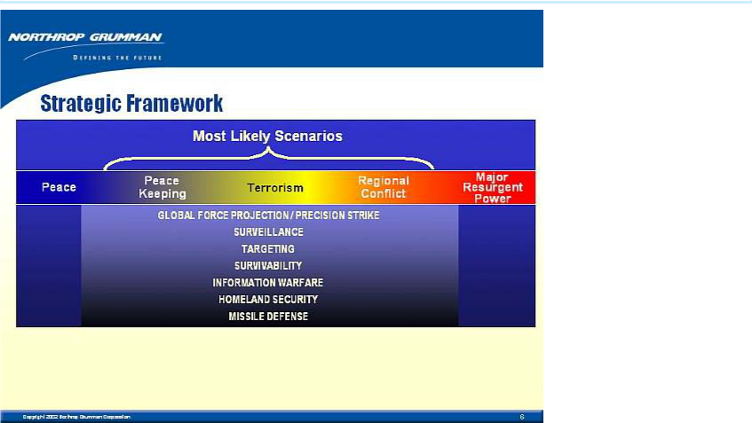

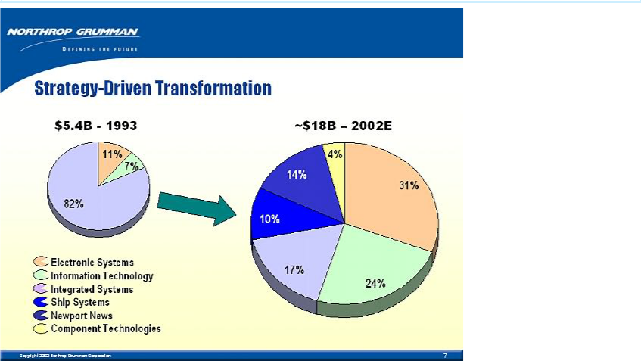

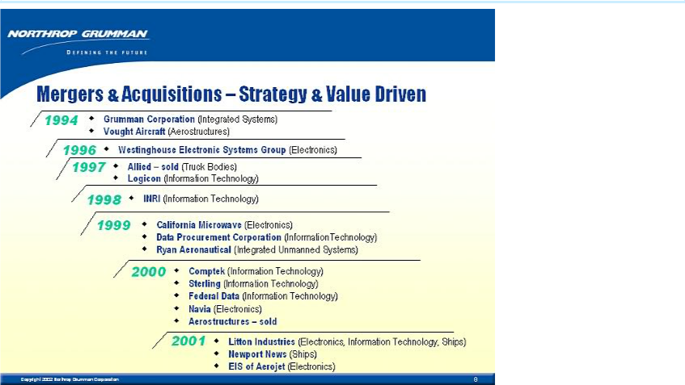

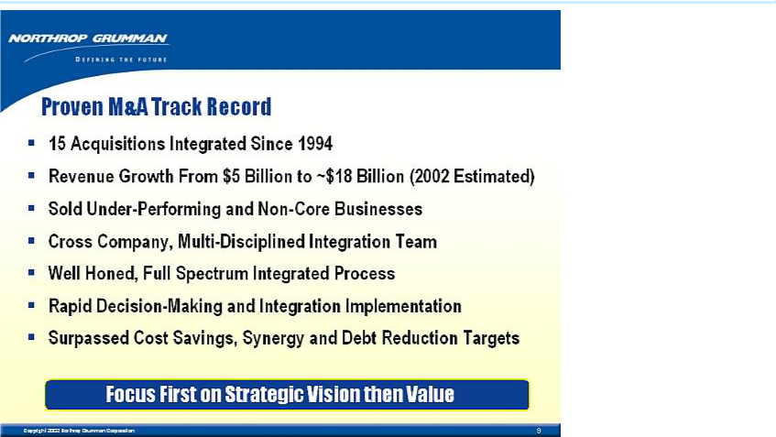

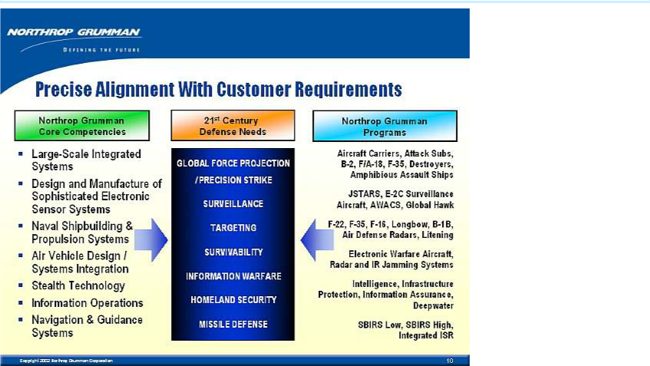

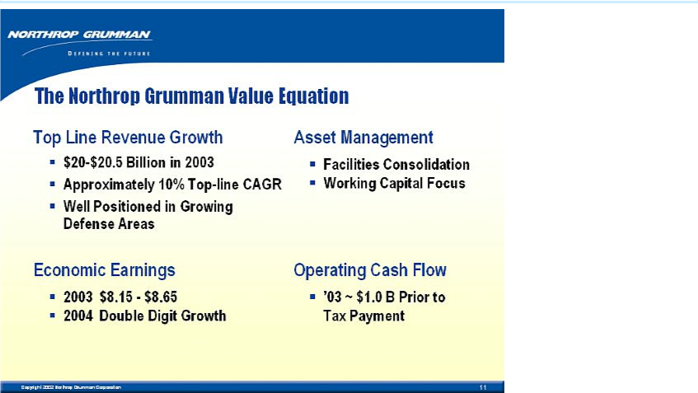

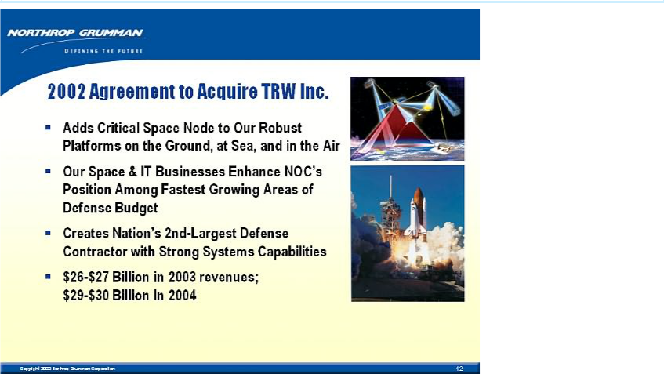

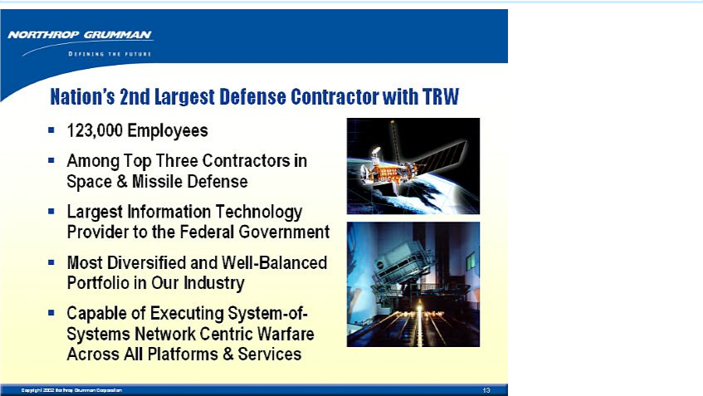

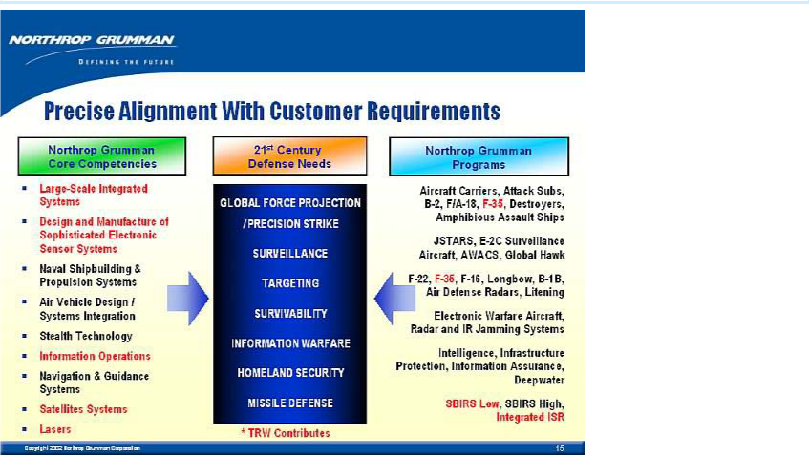

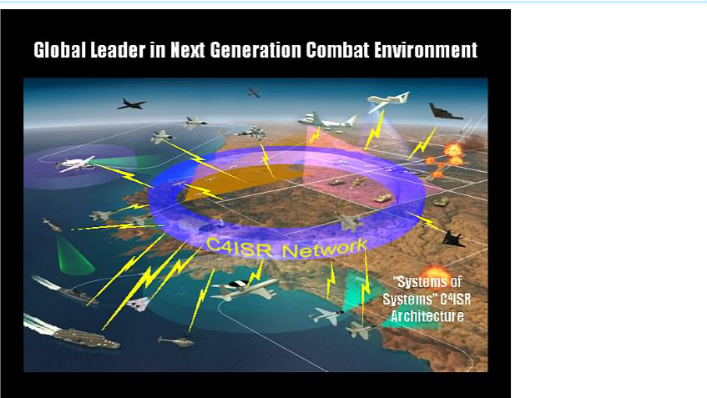

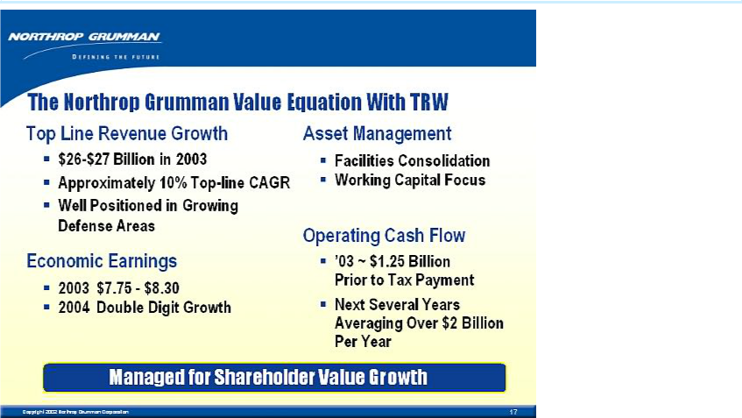

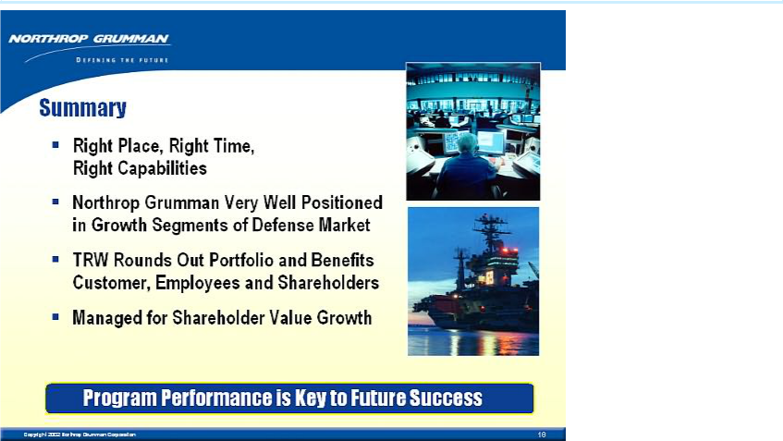

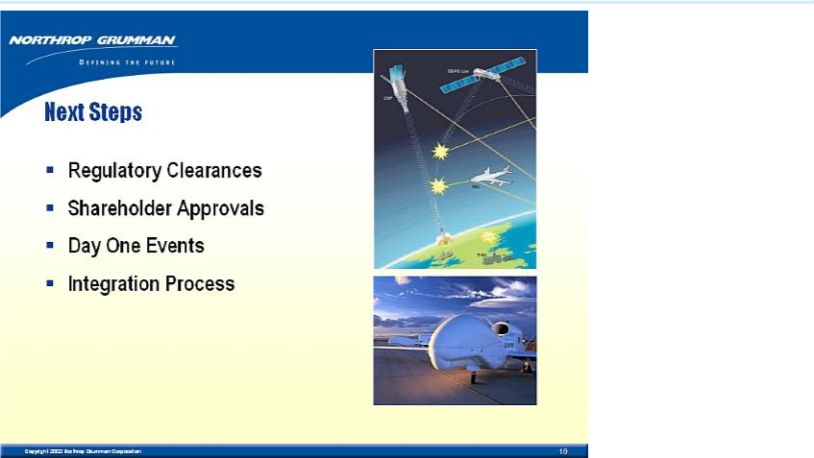

Ron Sugar’s introductory remarks leading into his Powerpoint presentation (an Operations Overview of NOC) to the Systems business of TRW, Reston, VA, September 13, 2002

- Thank you, Kent. Great to be here with leaders of TRW Systems.

- We look forward to your joining the NOC team.

- As I saw while at TRW, you have tremendous expertise. We’ll have many successes together.

- I add my congratulations on your $600 million JNIC contract. Excellent work!

- I’m one of the immigrants Ken spoke about – since I came to NOC with the Litton acquisition.

41

- At first, I had questions about the acquisition. But became persuaded that NOC has the industry’s best strategic plan – and offers unparalleled opportunities.

- I think you’ll share my enthusiasm for NOC’s strategies — and find the company a great place to work.

- Most of us from Litton impressed by effectiveness of NOC integration process. Expect you’ll agree, as the TRW businesses become NOC operations. More on integration later.

- Many similarities between cultures of our companies.

- We’re government contractors with many of the same customers. We’re not only competitors, but teammates – a unique aspect of our industry.

42

- Both companies driven by technology and innovation. Expect to be best at what we do.

- Finally, we respect and value people as main ingredient in our success.

- You’ve come to an exciting company with very strong operations. I’ll give you a brief introduction to these operations. Let me start with some outstanding recent successes.

[START SLIDE SHOW]

43

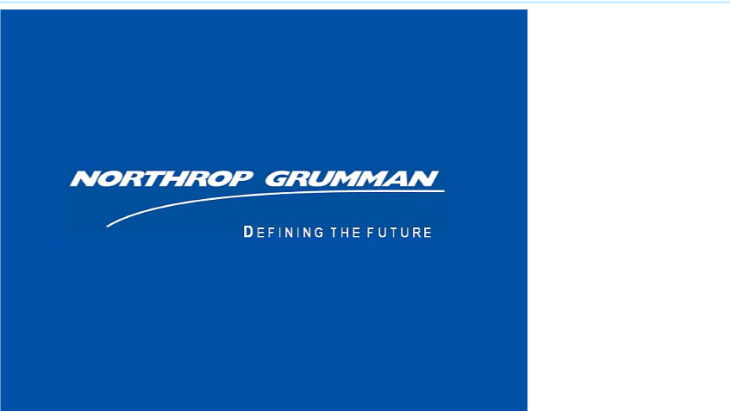

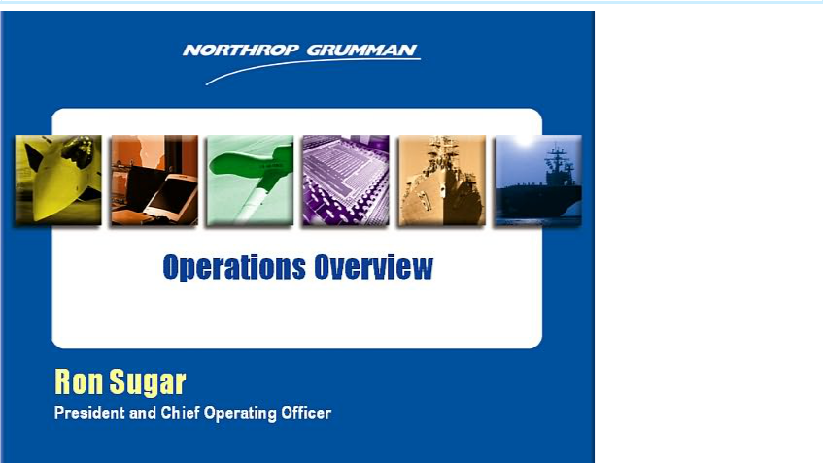

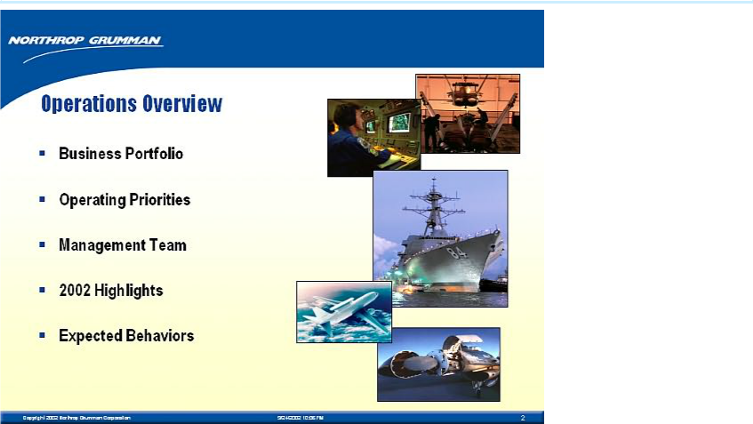

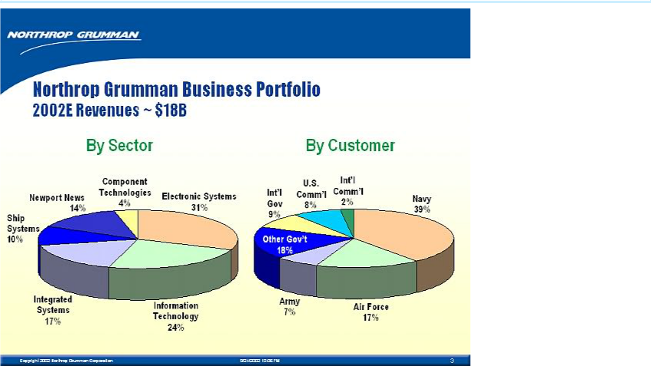

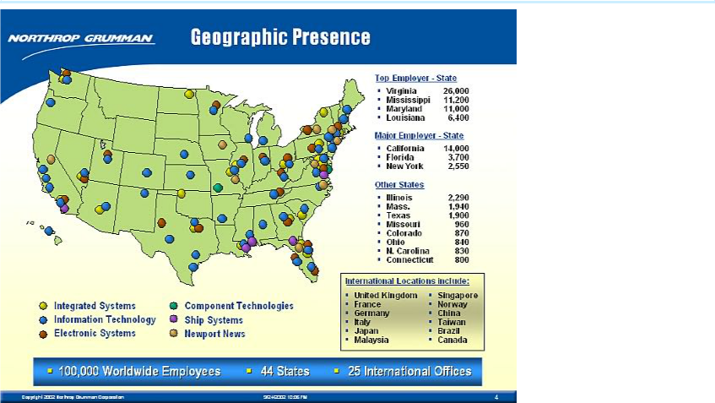

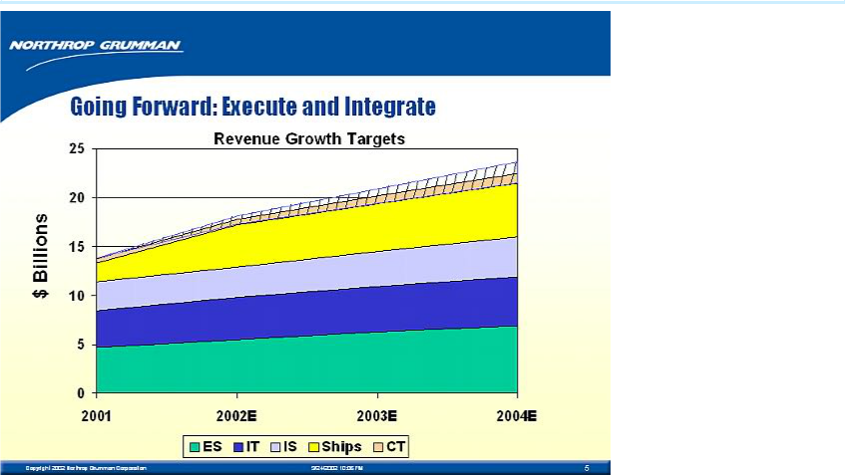

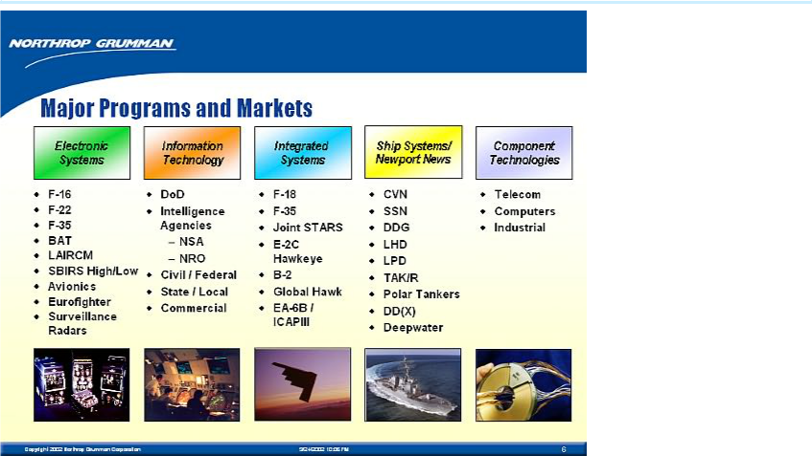

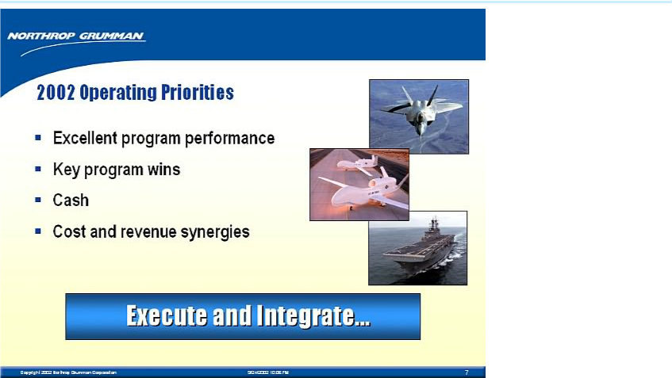

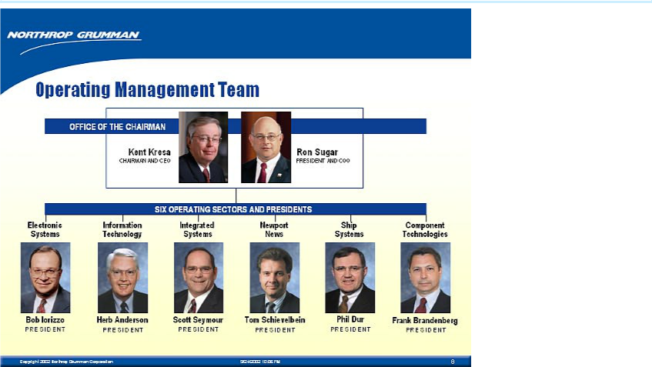

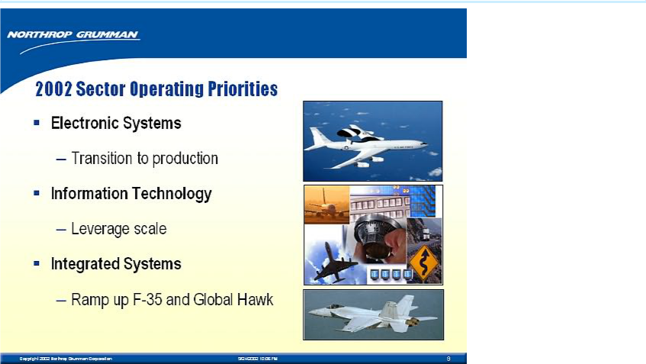

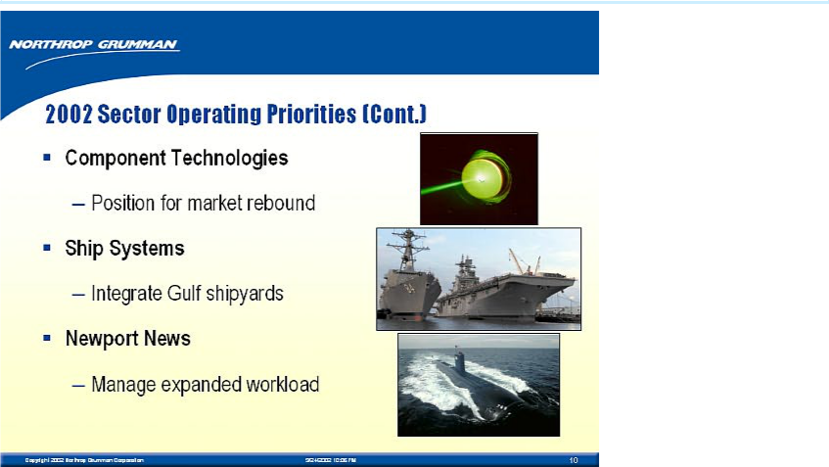

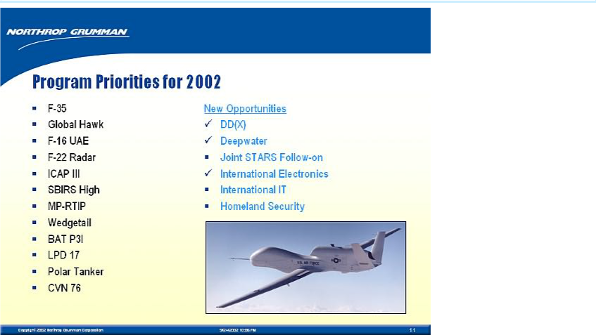

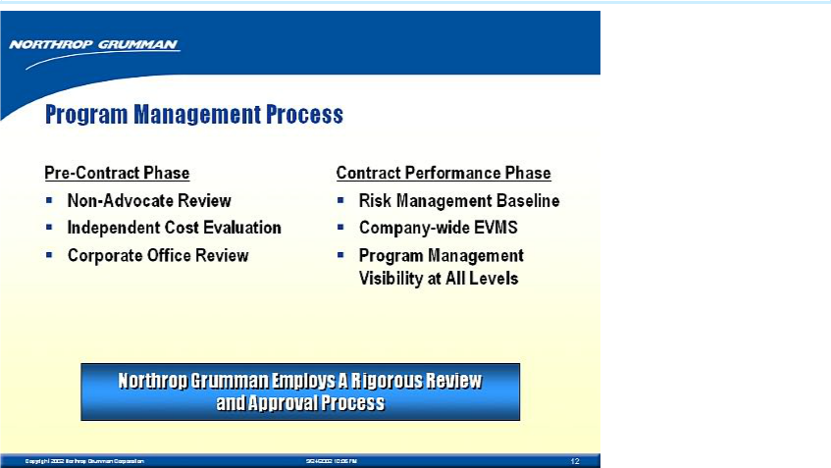

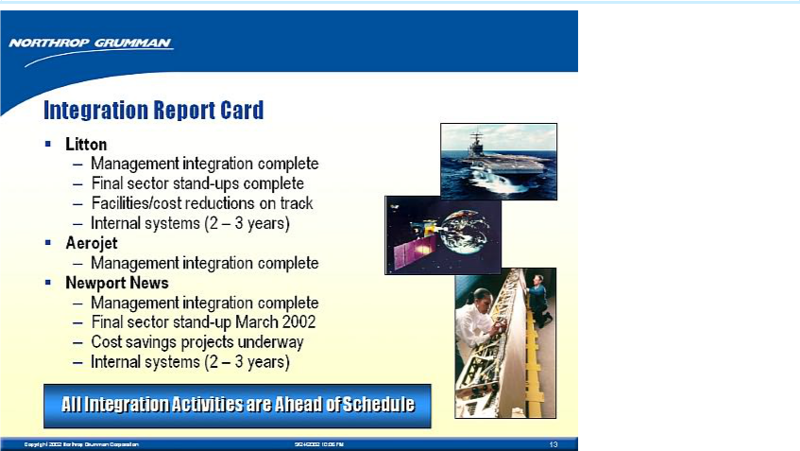

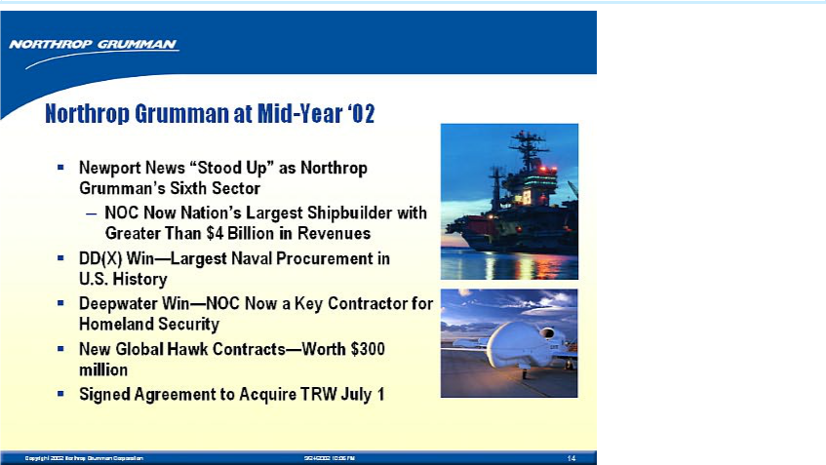

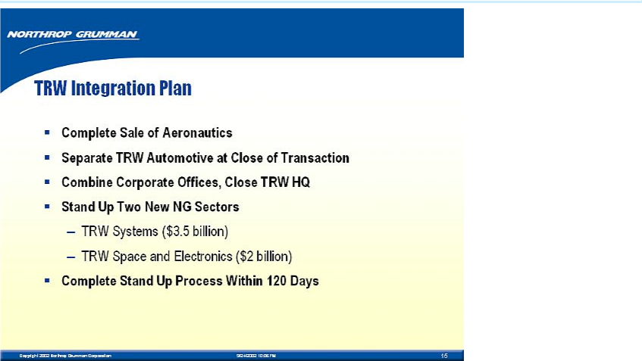

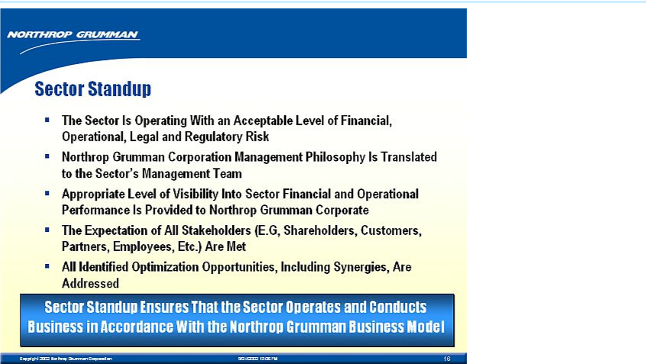

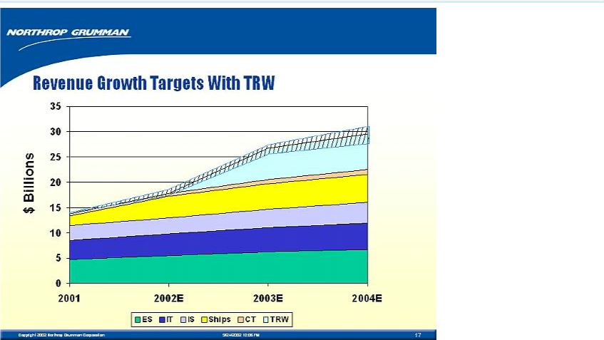

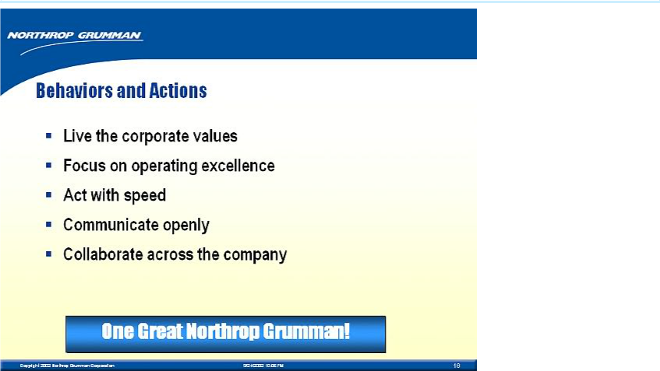

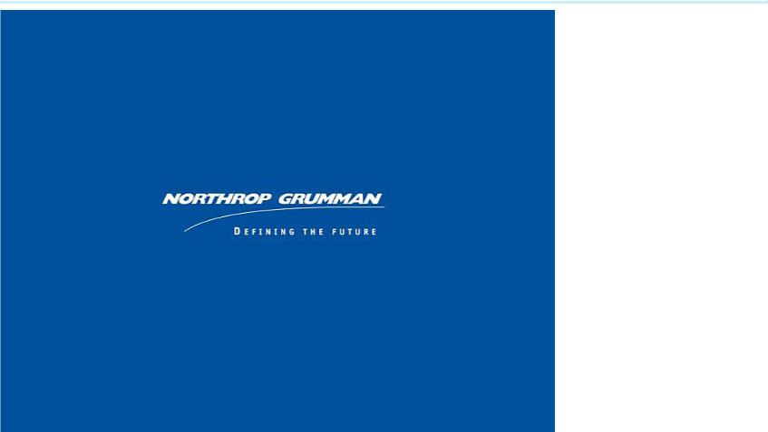

Kent Kresa’s introductory remarks leading into his Powerpoint presentation (A Strategic Overview of NOC) to the Space and Electronics business of TRW, Redondo Beach, CA, September 16, 2002

Thank you, Phil. I hope you enjoyed our corporate video. It certainly makes clear the exciting breadth of our expertise that enables us to contribute so much to our customer.

Ron and I are delighted to have this chance to meet with you. We look forward to soon being able to officially welcome the Space and Electronics business of TRW to the New Northrop Grumman Corporation.

We’re excited about having you join us – you bring outstanding capabilities that will make our company more competitive.

65

There are two perfect examples of this. The $4.5 billion contract for the polar-orbiting weather satellite system, and the $800 million award for NASA’s next generation telescope. Congratulations on great work! We look forward to working with you to keep the momentum going.

One thing I believe you’ll like about Northrop Grumman is that you’ll be joining what I call a company of immigrants.

Most of us have come from other companies – and we’re convinced that this diversity of backgrounds accounts for much of our competitive strength. So we value the heritages of all the great companies we came from.

At the same time, like immigrants to America, we have come to Northrop Grumman to create a new enterprise.

66

What matters to us now is the upward climb we are making together – realizing our strategy, leading markets, winning programs.

If you talk to many of our other new arrivals, I think they’ll tell you you’re joining a great company that offers you many opportunities for achieving business success and realizing your professional dreams.

They’ll also tell you we’re a socially responsible company, setting high standards for business conduct and values.

What I’d like to do now is give you a strategic overview of the company – focusing on how we’re positioned in the defense marketplace; what strategic steps we took to achieve this positioning; and how we see TRW as helping us build a new Northrop Grumman.

[Start Slide Show]

67

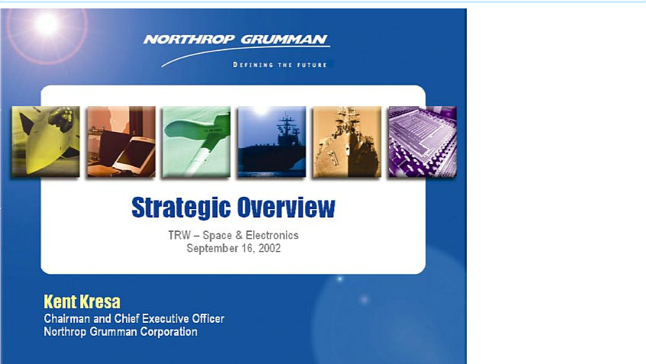

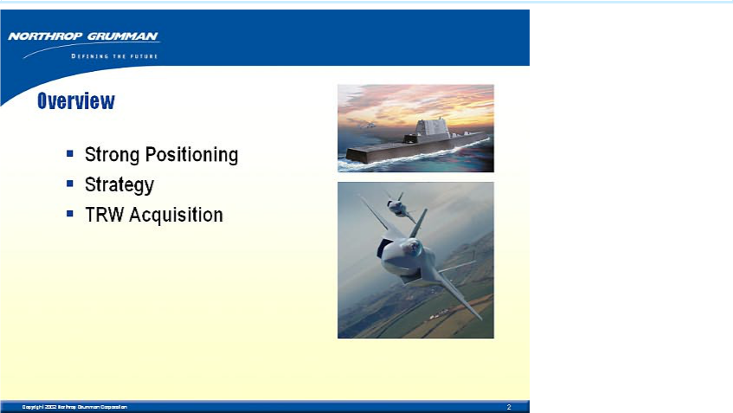

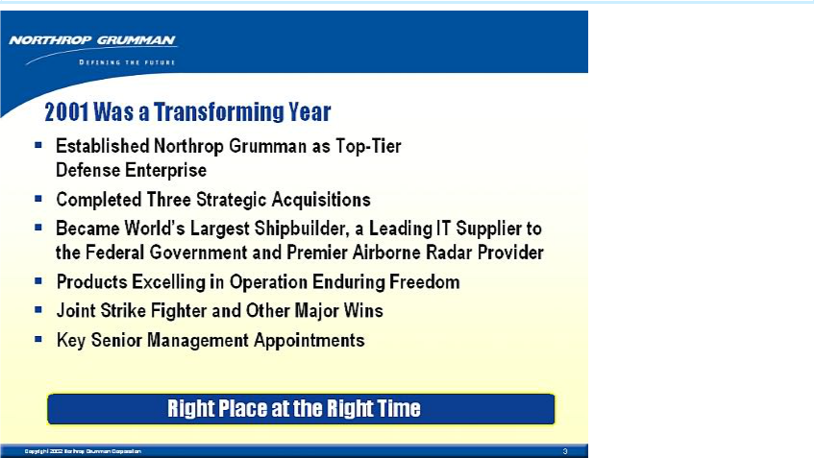

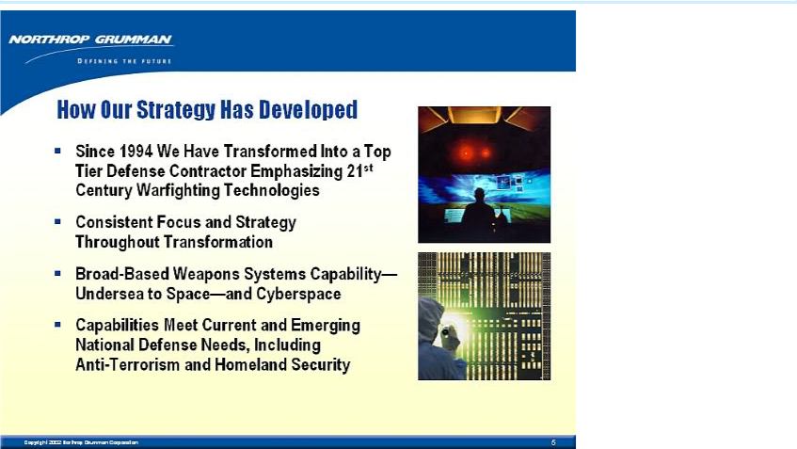

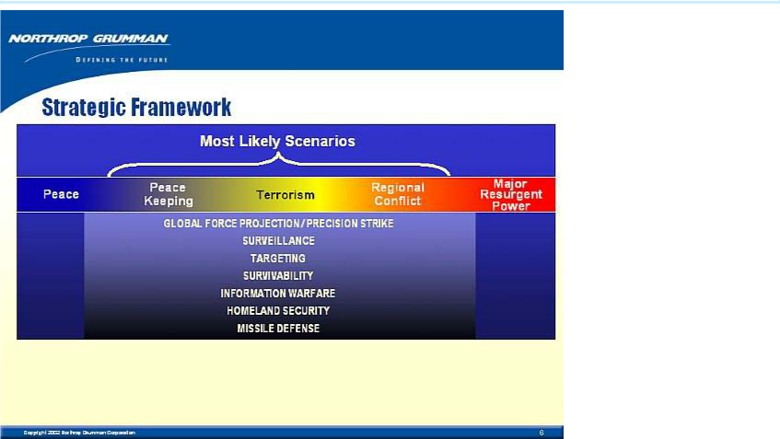

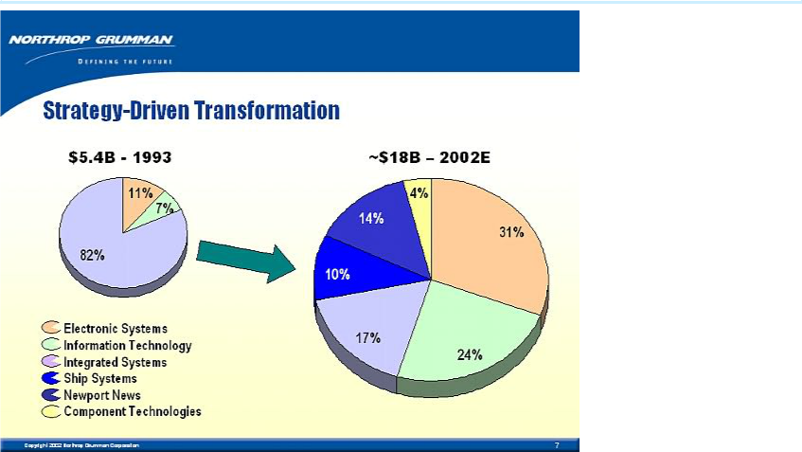

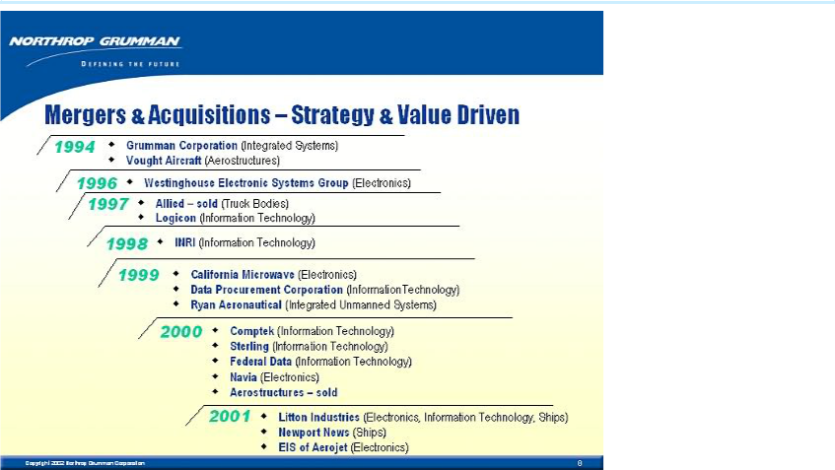

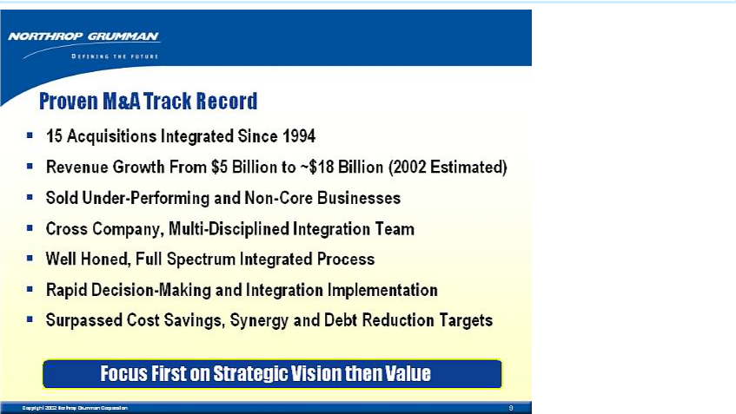

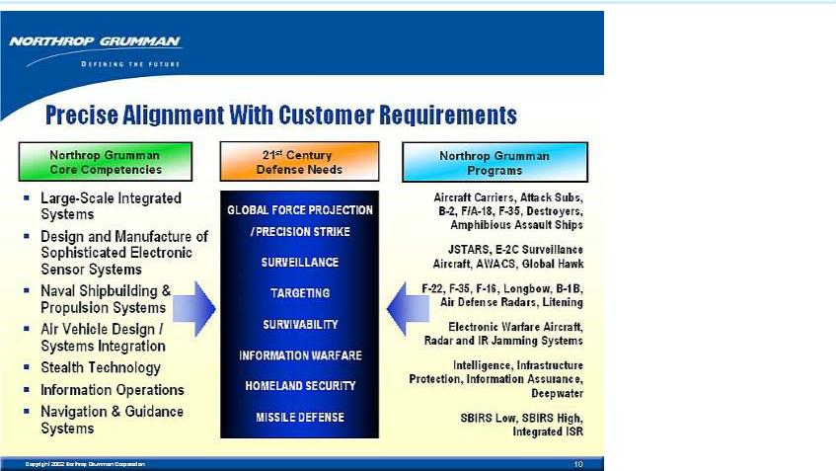

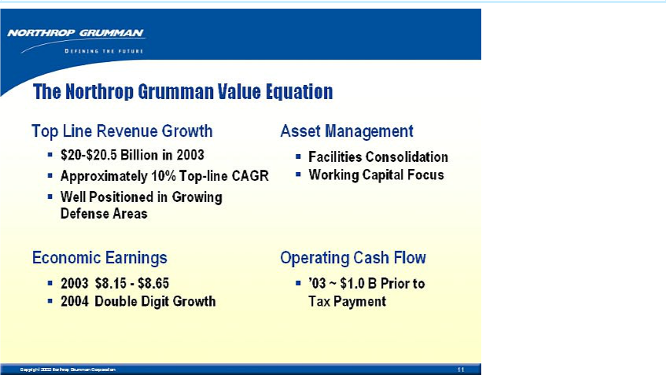

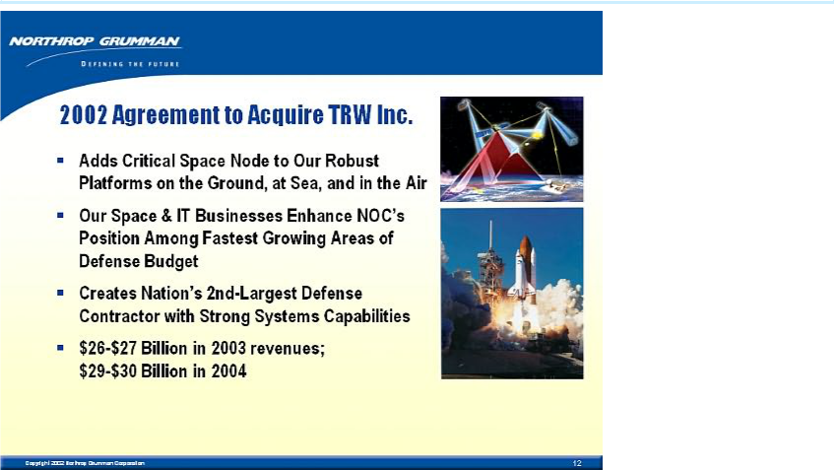

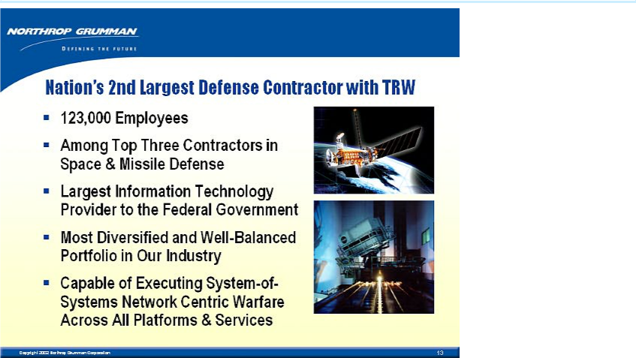

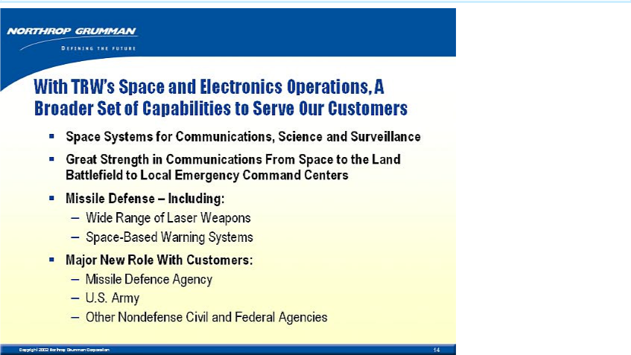

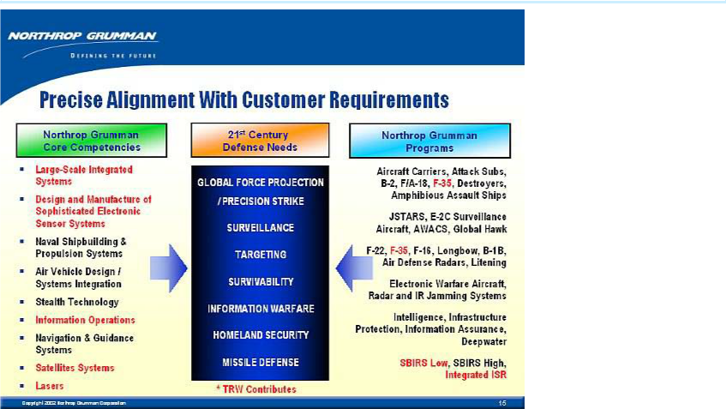

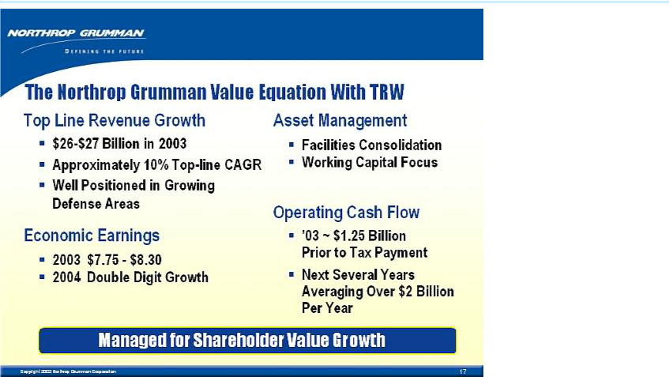

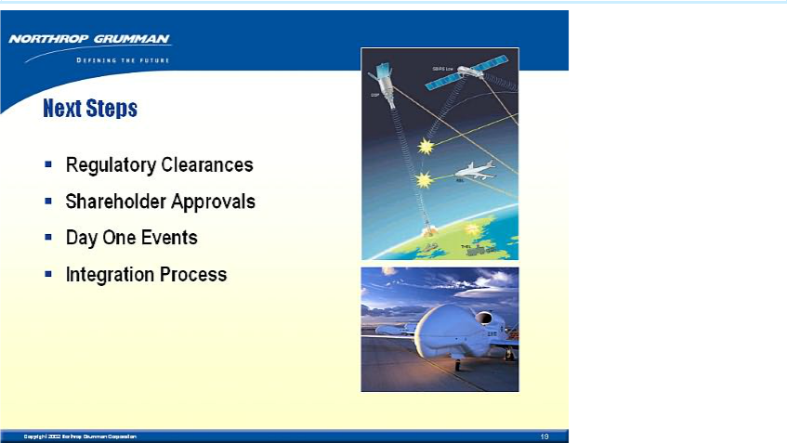

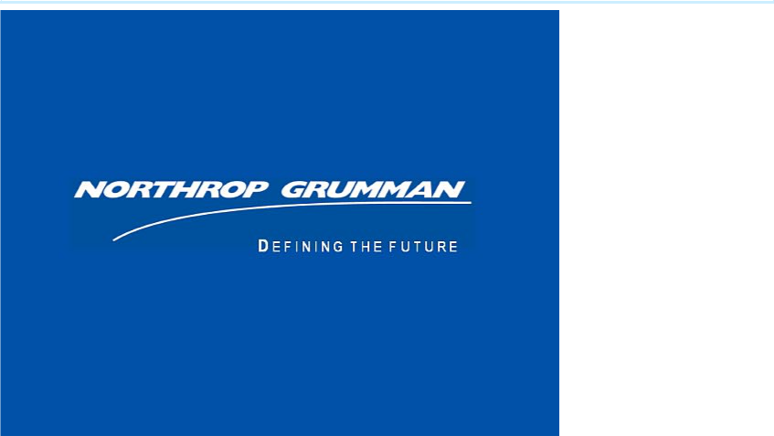

Ron Sugar’s introductory remarks leading into his Powerpoint presentation (an Operations Overview of NOC) to the Space and Electronics business of TRW, Redondo Beach, CA, September 16, 2002

- Thank you, Kent. Great to be here with leaders of TRW Space and Electronics.

- We look forward to your joining the NOC team.

- As I saw while at TRW, you have tremendous expertise. We’ll have many successes together.

- I add my congratulations on your terrific weather satellite and NASA telescope contracts. Excellent work!

89

- I’m one of the immigrants Ken spoke about – since I came to NOC with the Litton acquisition.

- At first, I had questions about the acquisition. But became persuaded that NOC has the industry’s best strategic plan – and offers unparalleled opportunities.

- I think you’ll share my enthusiasm for NOC’s strategies — and find the company a great place to work.

- Most of us from Litton impressed by effectiveness of NOC integration process. Expect you’ll agree, as your business becomes a NOC operation. More on integration later.

- Many similarities between cultures of our companies.

90

- We’re government contractors with many of the same customers. We’re not only competitors, but teammates – a unique aspect of our industry.

- Both companies driven by technology and innovation. Expect to be best at whatever we do.

- Finally, we respect and value people as main ingredient in our success.

- You’ve come to an exciting company with very strong operations. I’ll give you a brief introduction to these operations. Let me start with some outstanding recent successes.

[START SLIDE SHOW]

91



