UNITED STATES

SECURITIES AND EXCHANGE COMMISSION

Washington, D.C. 20549

SCHEDULE 14A

Proxy Statement Pursuant to Section 14(a) of the
Securities Exchange Act of 1934
Filed by the Registrant Filed by a Party other than the Registrant

Check the appropriate box:

Preliminary Proxy Statement

Confidential, for Use of the Commission Only (as permitted by Rule 14a-6(e)(2))

Definitive Proxy Statement

Definitive Additional Materials

Soliciting Material Pursuant to §240.14a-12

Northrop Grumman Corporation

(Name of Registrant as Specified In Its Charter)

(Name of Person(s) Filing Proxy Statement, if other than the Registrant)

Payment of Filing Fee (Check the appropriate box):

No fee required.

Fee computed on table below per Exchange Act Rules 14a-6(i)(1) and 0-11.

- Title of each class of securities to which the transaction applies:

- Aggregate number of securities to which the transaction applies:

- Per unit price or other underlying value of the transaction computed pursuant to Exchange Act Rule 0-11 (set forth the amount on which the filing fee is calculated and state how it was determined):

- Proposed maximum aggregate value of the transaction:

- Total fee paid:

Fee paid previously with preliminary materials.

Check box if any part of the fee is offset as provided by Exchange Act Rule 0-11(a)(2) and identify the filing for which the offsetting fee was paid previously. Identify the previous filing by registration statement number, or the Form or Schedule and the date of its filing.

- Amount Previously Paid:

- Form, Schedule or Registration Statement No.:

- Filing Party:

- Date Filed:


Northrop Grumman Corporation

2980 Fairview Park Drive

Falls Church, Virginia 22042

May 5, 2020

Dear Shareholder:

On April 3, 2020, Northrop Grumman Corporation filed our definitive Proxy Statement for the 2020 Annual Meeting of Shareholders. In connection with the 2020 Annual Meeting, shareholders are being asked to approve, on an advisory basis, the compensation of our named executive officers, as described in the Proxy Statement (“say on pay proposal”). On April 26, 2020, Glass Lewis, a proxy advisory firm, issued voting recommendations relating to the 2020 Annual Meeting. Glass Lewis recommends in favor of the Company’s say on pay proposal, but raised several issues related to the Company’s executive compensation programs. The statement below constitutes a Report Feedback Statement in response to Glass Lewis’ analysis of the Company’s executive compensation and is intended to provide additional information that we believe shareholders will value as they review the Glass Lewis report and bring more clarity on Glass Lewis’ Pay-for-Performance analysis of the Company.

The Report Feedback Statement contains certain non-GAAP financial measures, which are noted herein. For more information, including definitions, reconciliations to the most directly comparable GAAP measure and why we believe these measures may be useful to investors, see Appendix A - Use of Non-GAAP Financial Measures.

*****

To: Glass Lewis

Re: Report Feedback Statement

We appreciate the opportunity to provide a response to the 2020 Glass Lewis Report on Northrop Grumman Corporation’s 2020 Proxy Statement filed on April 3, 2020. We are providing additional clarification that we believe our shareholders will value as they review the Glass Lewis report. We are concerned that the Glass Lewis’ Pay-for-Performance analysis leaves an inaccurate perception of Northrop Grumman’s executive compensation program, although we acknowledge and appreciate that Glass Lewis recommended a vote “FOR” our 2020 Say-on-Pay proposal.

With regard to Glass Lewis’ Pay-For-Performance analysis disclosed on page 7 of the report, we agree Glass Lewis has disclosed the GAAP measures correctly as reported by Northrop Grumman. However, we contend Glass Lewis should also have considered pension-adjusted metrics in their analysis of our performance. As noted in our proxy statement, management uses pension-adjusted metrics, such as pension-adjusted net income, as internal measures of financial performance and for performance-based compensation decisions. This has been our consistent practice for many years as it adjusts our earnings for the non-operational impact of pension income and expense. Also, during 2018, the company changed its accounting for pensions to the mark-to-market method, which is the preferable method under U.S. GAAP, but can result in significant volatility in GAAP earnings.

When evaluating our bottom line performance, we adjust GAAP earnings for the after-tax impact of pension income recognized during the year and mark-to-market pension income or expense recognized at the end of the year. As such, during 2018 and 2019, we removed from earnings $ 1.3B and $1.0B, respectively, of net pension income recorded during those years and added back to earnings $0.6B and $1.4B, respectively, of mark-to-market pension expense recorded at the end of those years. During 2018 and 2019, we also adjusted our earnings for items associated with the Company’s June 2018 acquisition of Orbital ATK, including intangible asset amortization, step-up depreciation and transaction-related expenses.

We believe the noted adjustments to our 2018 and 2019 GAAP earnings allowed us to more effectively compare the Company’s operating results against our peers during those years. We also note that pension-related adjustments are a common practice across our industrial and broader market peers.

The charts below highlight the after-tax impact of the adjustments described above on our 2018 and 2019 GAAP earnings. On a pension-adjusted basis, net income and EPS increased significantly from 2018 to 2019.
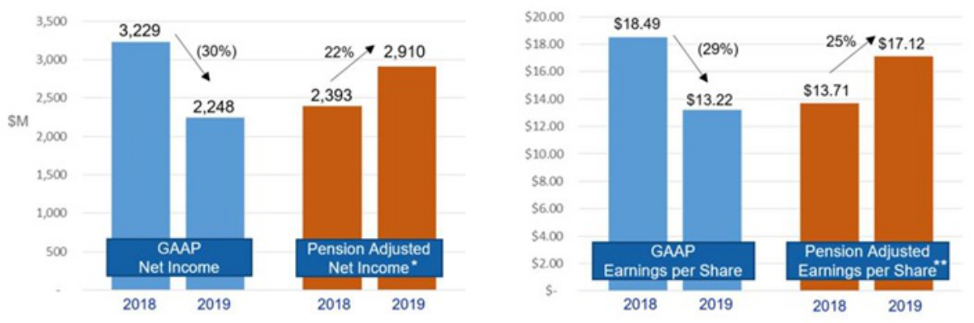

We welcome our shareholders to review our 2020 Proxy Statement and to contact the company with any questions they may have.

Sincerely,
David F. Keffer

- Pension-Adjusted Net Income is a non-GAAP measure. For more information, including the definition, a reconciliation to the most directly comparable GAAP measure and why we believe the measure may be useful to investors, see "Appendix A - Use of Non-GAAP Financial Measures” in the company’s 2020 Proxy Statement and Appendix A attached.

** Based on 174.6M and 170.0M weighted average diluted shares outstanding in 2018 and 2019, respectively.

Appendix A - Use of Non-GAAP Financial Measures

This filing contains non -GAAP (accounting principles generally accepted in the United States of America) financial measures, as defined by SEC Regulation G and noted herein. While we believe investors and other users of our financial statements may find these non-GAAP financial measures useful in evaluating our financial performance and operational trends, they should be considered as supplemental in nature, and therefore, should not be considered in isolation or as a substitute for financial information prepared in accordance with GAAP. Definitions and reconciliations for the non-GAAP financial measures contained herein are provided below. Other companies may define these measures differently or may utilize different non-GAAP financial measures.

Pension-adjusted metrics: For financial statement purposes, we account for our employee pension plans in accordance with GAAP (FAS). However, the cost of these plans is charged to our contracts in accordance with the Federal Acquisition Regulation (FAR) and the related U.S. Government Cost Accounting Standards (CAS) that govern such plans. We use pension-adjusted metrics as internal measures of financial performance and for performance-based compensation decisions. The net FAS (service)/CAS pension adjustment referred to below reflects the difference between CAS pension expense included as cost in segment operating income and the service cost component of FAS expense included in total operating income. The following pension-adjusted measures may be useful to investors and other users of our financial statements in evaluating our performance based upon the pension costs charged to our contracts. All pension-adjusted metrics are reconciled below.

After-tax net pension adjustment: The net income impact, after-tax at the statutory rate of 21 percent, of the net FAS (service)/CAS pension adjustment and net FAS (non-service) pension benefit.

Pension-adjusted net income: Net earnings before the after-tax net pension adjustment as defined above and excluding MTM (expense) benefit and related tax impacts. As approved by the Compensation Committee, this metric has been adjusted to exclude Innovation Systems intangible asset amortization and PP&E step-up depreciation and Orbital ATK transaction-related expenses. Orbital ATK transaction-related expenses are primarily comprised of advisory, legal and other costs related to the completion of the transaction.

 |  | Total Year
($M) |  | 2019
Net earnings | $ | 2,248
Net FAS (service)/CAS pension adjustment |  | (465)
Net FAS (non-service) pension benefit |  | (800)
Tax effect of net pension adjustment |  | 266
After-tax net pension adjustment |  | (999)
Innovation Systems intangible asset amortization and PP&E step-up depreciation |  | 375
Orbital ATK transaction-related expenses |  | 9
Tax effect of items above |  | (81)
After-tax MTM adjustment |  | 1,358
Pension-adjusted net income | $ | 2,910

 | Total Year
($M) | 2018
Net earnings | $ | 3,229
Net FAS (service)/CAS pension adjustment |  | (613)
Net FAS (non-service) pension benefit |  | (1,049)
Tax effect of net pension adjustment |  | 349
After-tax net pension adjustment |  | (1,313)
MTM pension expense (1) |  | 699
Innovation Systems operating income |  | (342)
Innovation Systems intangible asset amortization and PP&E step-up depreciation |  | 208
Orbital ATK transaction-related expenses |  | 45
Other |  | (6)
Tax effect of items above |  | (127)
Pension-adjusted net income | $ | 2,393
⁽¹⁾ Represents the MTM expense related to the Company's pension plans only. During 2018, the Company recorded a total MTM expense of $ |  | 655 million,
of which $699 million related to pension and ($44) million related to OPB.

