UNITED STATES
SECURITIES AND EXCHANGE COMMISSION
Washington, D.C. 20549
SCHEDULE 14A
Proxy Statement Pursuant to Section 14(a)
of the Securities Exchange Act of 1934
Filed by the Registrant
Filed by a Party other than the Registrant
Check the appropriate box:
Preliminary Proxy Statement
Confidential, for Use of the Commission Only (as permitted by Rule 14a-6(e)(2))
Definitive Proxy Statement
Definitive Additional Materials
Soliciting Material Pursuant to §240.14a-12
Northrop Grumman Corporation
(Name of Registrant as Specified In Its Charter)
(Name of Person(s) Filing Proxy Statement, if other than the Registrant)
Payment of Filing Fee:
No fee required.
Fee paid previously with preliminary materials.
Fee computed on table in exhibit required by Item 25(b) per Exchange Act Rules 14a-6(i)(1) and 0-11

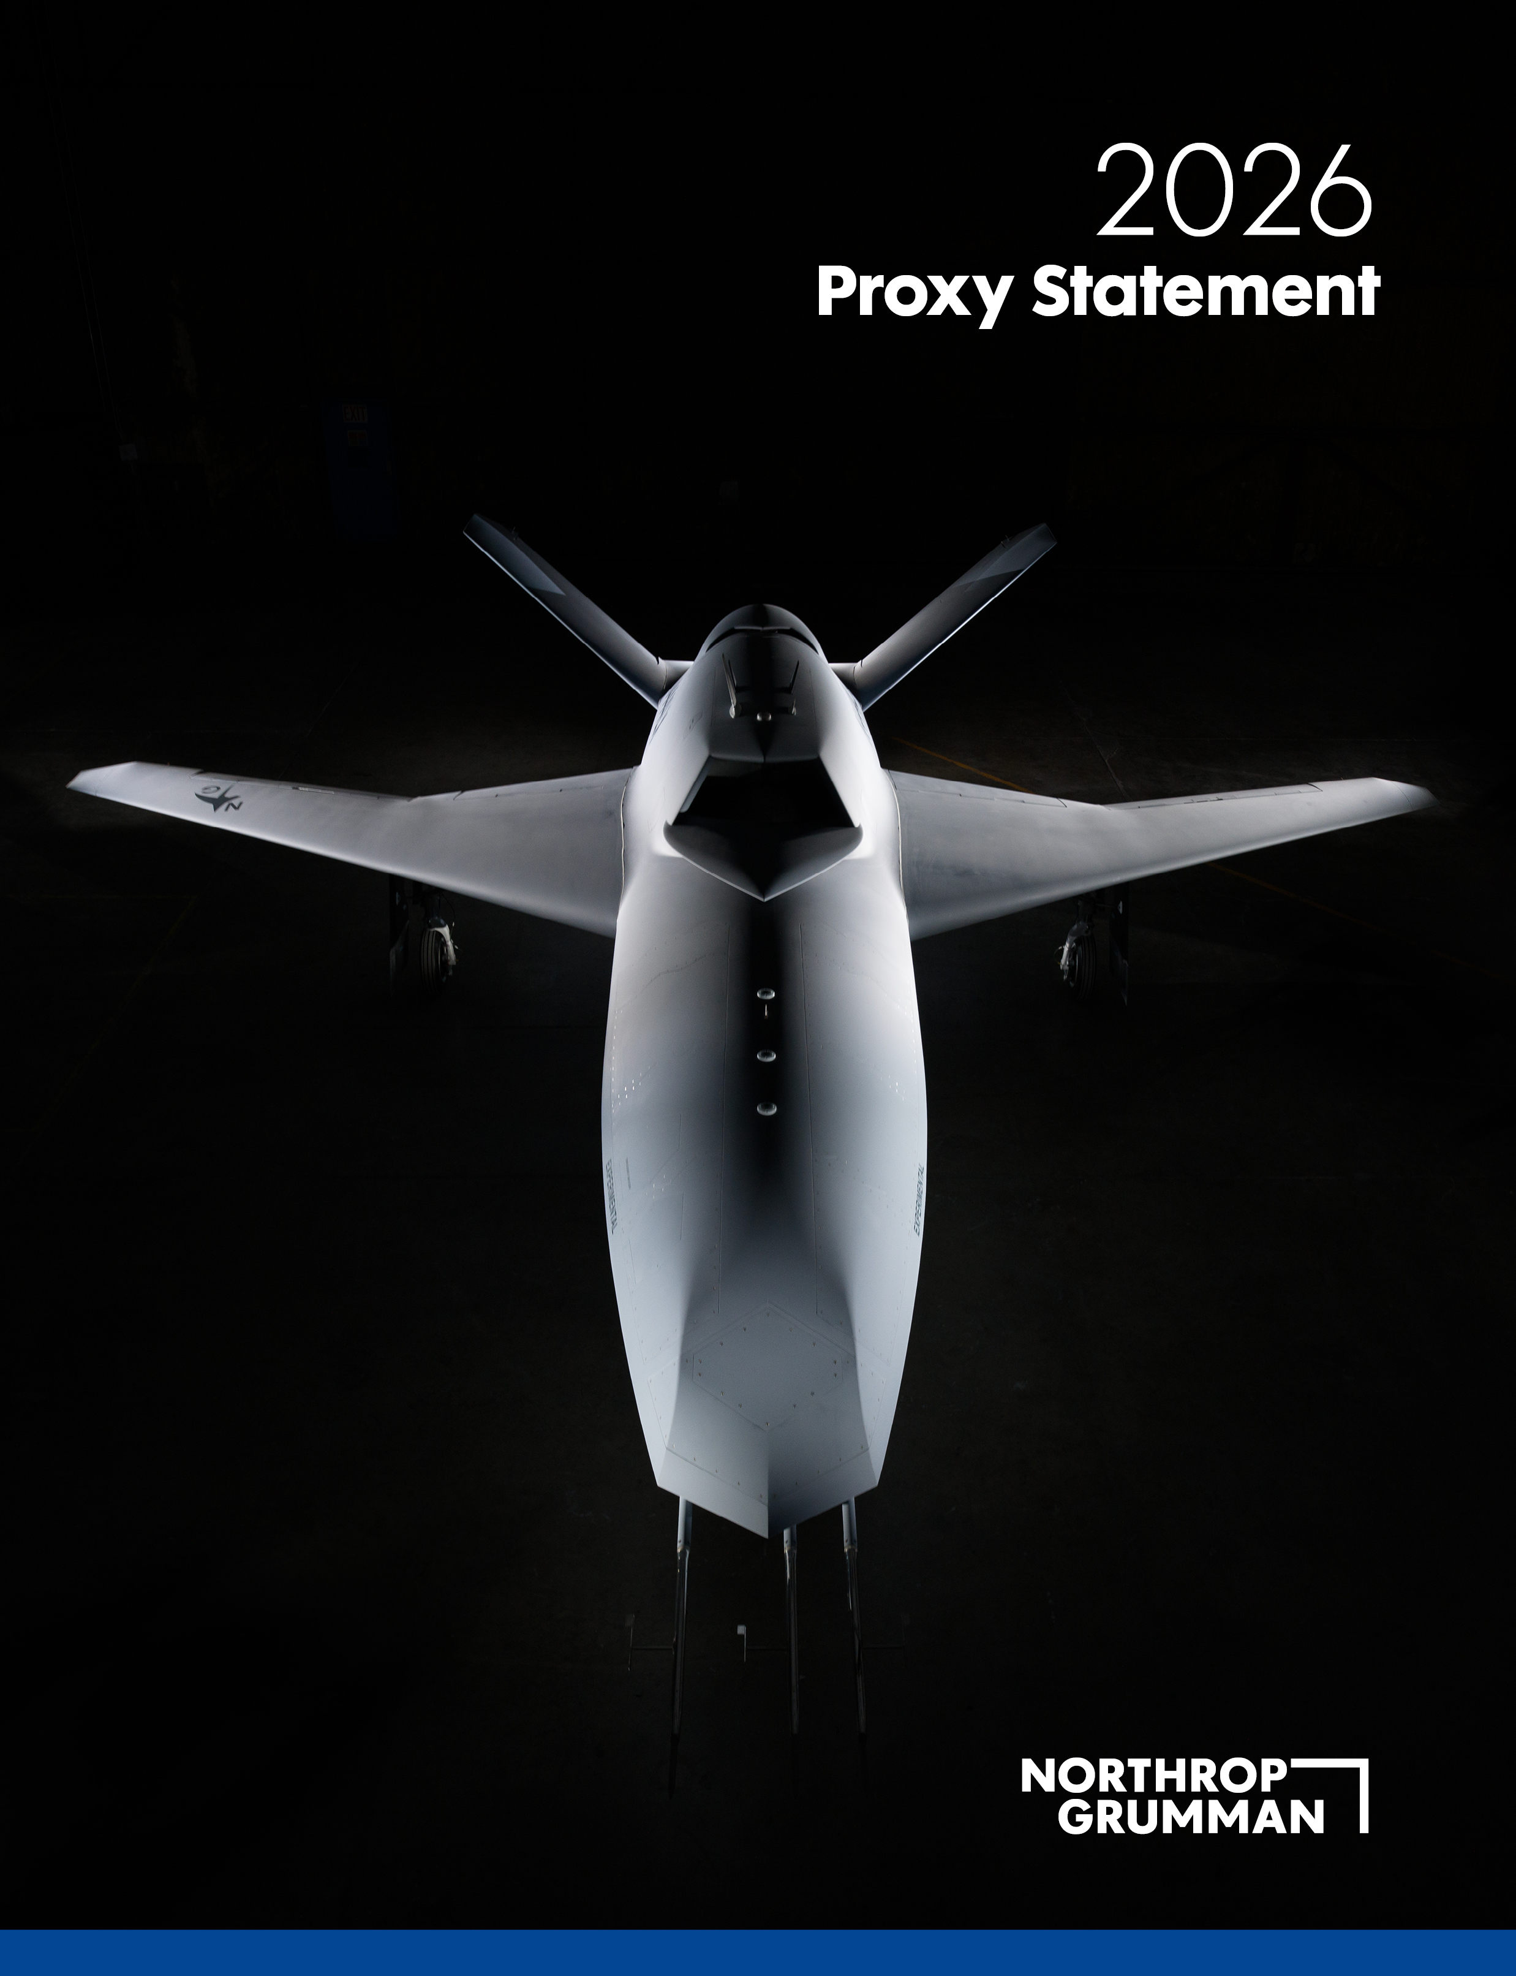

Our Values
Our Values form the foundation of our pioneering culture and enable us to deliver for our shareholders. Our Values define our operating principles as we face an increasingly complex world. They reflect who we are and how we behave, and they articulate what is important to us.
We Do the  Right Thing |  |  | We earn trust, act with ethics, integrity and transparency, treat everyone with respect and value diverse perspectives.
We Do What We  Promise |  |  | We own the delivery of results, focused on quality outcomes.
We Commit to  Shared Success |  |  | We work together to focus on the mission and take accountability for the sustainable success of our people, customers, shareholders, suppliers and communities.
We  Pioneer |  |  | With fierce curiosity, dedication and innovation, we seek to solve the world’s most challenging problems.

 |  |  | For more information about our Values, please visit our website at www.northropgrumman.com/who-we-are/our-values.

Letter from the Board of Directors
April 3, 2026
Dear Fellow Shareholders,
We invite you to participate in Northrop Grumman Corporation’s 2026 Annual Meeting of Shareholders on Wednesday, May 20, 2026, beginning at 8:00 a.m. ET. The accompanying Proxy Statement explains more about the matters to be voted on at the Annual Meeting, proxy voting instructions, and other information regarding participation.

Northrop Grumman remains steadfast in our mission to deliver the advanced, cutting-edge solutions the United States and its allies need today as we face increasingly complex national security challenges. By combining deep technical expertise, sustained investment, and the capacity to design, produce, and field capabilities at speed, we are committed to enabling our customers’ most urgent and important global security missions.

Centered on technology leadership, a laser focus on performance and deploying capital in value-creating ways, our business strategy is designed to generate sustained growth and long-term shareholder value by aligning our robust and diverse portfolio of capabilities with our customers’ national security priorities. In 2025, sales increased 2 percent to $42 billion, as compared with $41 billion in 2024, and organic sales* grew by 3 percent, reflecting strong execution across our portfolio.

Ending the year with a record backlog of $95.7 billion, we generated approximately $4.8 billion in operating cash flow and $3.3 billion in free cash flow*, reflecting an increase of 8 percent and 26 percent, respectively. These results further support the investments we have made in capacity and capability over the last several years, enabling us to deliver with urgency against our customers’ highest priorities– all while strengthening our nation and company for the future.

Our success is powered by a highly skilled and dedicated workforce, whose expertise, commitment to our values, and integrity enable Northrop Grumman to achieve excellence for our customers. With a strong foundation, clear strategic priorities, robust global demand and sustained momentum, we remain confident that we will continue to deliver for our customers and shareholders in 2026 and beyond.

*This metric is a non-GAAP financial measure. For more information, see ”Appendix A - Use of Non-GAAP Financial Measures.”

2026 Proxy Statement |  |  | 1

Letter from the Board of Directors

Your vote is important, and we value receiving feedback from our shareholders.

On behalf of the entire leadership team, thank you for your continued support of Northrop Grumman.

Sincerely,
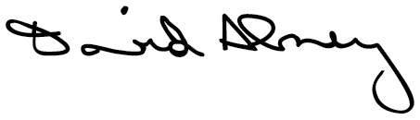 |  |  |  |  |  | 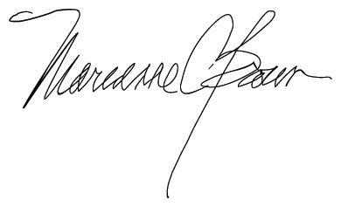 |  |  |  |  |  | 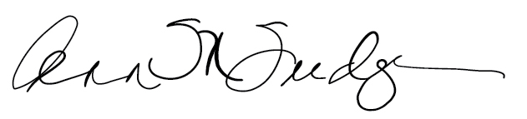
David P. Abney |  |  |  |  |  | Marianne C. Brown |  |  |  |  |  | Ann M. Fudge
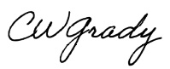 |  |  |  |  |  | 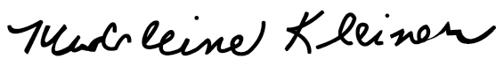 |  |  |  |  |  | 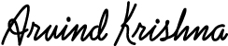
Christopher W. Grady |  |  |  |  |  | Madeleine A. Kleiner |  |  |  |  |  | Arvind Krishna
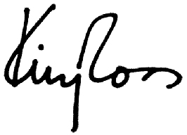 |  |  |  |  |  | 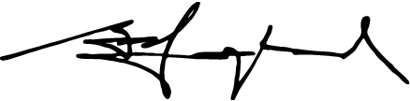 |  |  |  |  |  | 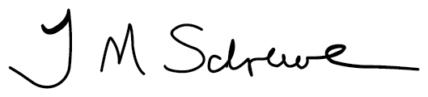
Kimberly A. Ross |  |  |  |  |  | Gary Roughead |  |  |  |  |  | Thomas M. Schoewe
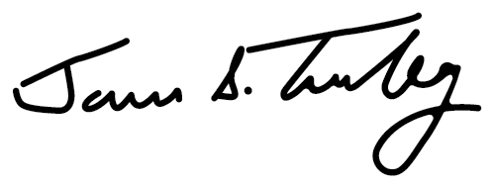 |  |  |  |  |  | 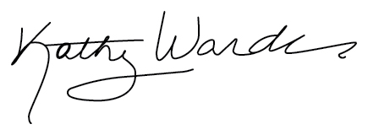 |  |  |  |  |  | 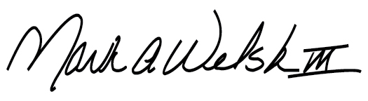
James S. Turley |  |  |  |  |  | Kathy J. Warden |  |  |  |  |  | Mark A. Welsh III
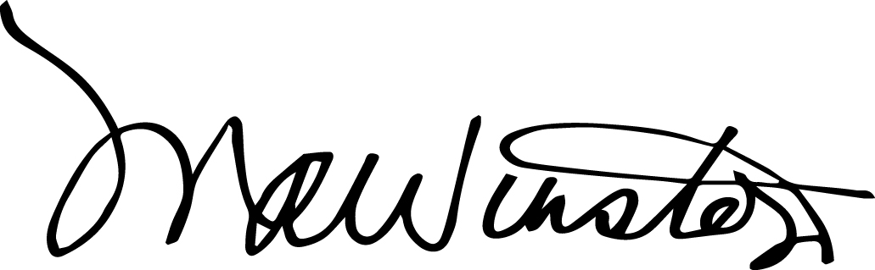
Mary A. Winston

2 |  |  | Northrop Grumman

Notice of 2026 Annual Meeting of Shareholders
 |  |  | DATE AND TIME  May 20, 2026  (Wednesday)  8:00 AM Eastern Daylight Time |  |  |  |  |  | LOCATION  Online via live webcast at:  www.virtualshareholdermeeting.com/NOC2026 |  |  |  |  |  | WHO CAN VOTE  Shareholders of record at the close of business on March 24, 2026 are entitled to vote at the Annual Meeting
Voting Items
Proposals |  |  |  |  |  | Board Vote  Recommendations |  |  | For Further  Details
1. |  |  | Election of the 11 Director Nominees Named in this Proxy Statement |  |  | “FOR” each Director Nominee |  |  | Page 15
2. |  |  | Advisory Vote to Approve Compensation of Named Executive Officers |  |  | “FOR” |  |  | Page 46
3. |  |  | Ratification of Appointment of Independent Auditor |  |  | “FOR” |  |  | Page 88
4. |  |  | Shareholder Proposal to Provide for an Independent Board Chair |  |  | “AGAINST” |  |  | Page 91
Shareholders will also act on any other business as may properly come before the Annual Meeting or any adjournment or postponement thereof by or at the direction of the Board of Directors. The Annual Meeting will be conducted exclusively online through a live webcast in order to facilitate shareholder attendance and participation. You can find detailed instructions on how to attend on page 97 of this Proxy Statement.
Your vote is important. Please promptly submit your vote by internet or telephone, or by signing, dating and returning a proxy card or voting instruction form in the postage-prepaid envelope provided so that your shares will be represented and voted at the meeting. A paper copy of the proxy materials may be obtained by logging on to www.proxyvote.com and following the instructions given.
By order of the Board of Directors,
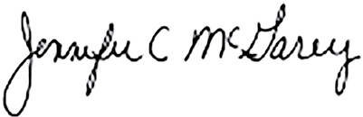
Jennifer C. McGarey
Corporate Vice President and Secretary

How to Vote |  |  |  |  |  |  |  |  |  |  |  | Important Notice Regarding the Availability of Proxy Materials for the Shareholders Meeting to be held on May 20, 2026:  The Proxy Statement for the 2026 Annual Meeting of Shareholders and the Annual Report for the year ended December 31, 2025 are available at: www.proxyvote.com.
 |  |  | INTERNET  www.proxyvote.com |  |  |  |  |  | TELEPHONE  800-690-6903
 |  |  | MAIL  Mark, sign, date and promptly mail a proxy card in the postage-paid envelope. A paper copy of the proxy materials may be obtained at www.proxyvote.com |  |  |  |  |  | QR CODE  Registered shareholders may vote by scanning the QR code on their proxy card or notice with their mobile device.
 |  |  | DURING THE ANNUAL MEETING  Registered shareholders may vote during the Annual Meeting online at www.virtualshareholdermeeting.com/NOC2026. If you have already voted online, by telephone, by QR code or by mail, your vote during the Annual Meeting will supersede your earlier vote.

2026 Proxy Statement |  |  | 3

Table of Contents
Our Values |  |  |  |  |  | IFC*
Letter from the Board of Directors |  |  |  |  |  | 1
Notice of 2026 Annual Meeting of Shareholders |  |  |  |  |  | 3
About Northrop Grumman |  |  |  |  |  | 6
Proxy Statement Summary |  |  |  |  |  | 7
Management and Shareholder Proposals |  |  |  |  |  | 13
Shareholder Engagement |  |  |  |  |  | 14
 |  |  | Proposal 1: Election of Directors |  |  | 15
Director Qualifications and Experience |  |  |  |  |  | 15
2026 Nominees for Director |  |  |  |  |  | 17
Director Nomination Process |  |  |  |  |  | 23
Corporate Governance |  |  |  |  |  | 26
Overview |  |  |  |  |  | 26
Role of the Board and Key Areas of Board Oversight |  |  |  |  |  | 27
Risk Oversight |  |  |  |  |  | 28
Board Leadership Structure |  |  |  |  |  | 31
Committees of the Board |  |  |  |  |  | 33
Board Meetings and Executive Sessions |  |  |  |  |  | 36
Director Orientation and Continuing Education |  |  |  |  |  | 36
Director Independence |  |  |  |  |  | 37
Our Culture |  |  |  |  |  | 38
Board Memberships and External Relationships |  |  |  |  |  | 39
Annual Self-Assessment Process |  |  |  |  |  | 40
Succession Planning |  |  |  |  |  | 41
Communications with the Board of Directors |  |  |  |  |  | 41
Compensation of Directors |  |  |  |  |  | 42
2025 Director Compensation |  |  |  |  |  | 44
Deferred Stock Units |  |  |  |  |  | 45
 |  |  | Proposal 2: Advisory Vote to Approve Compensation of Named Executive Officers |  |  | 46
Executive Compensation |  |  |  |  |  | 47
Compensation Discussion & Analysis |  |  |  |  |  | 47
Compensation Philosophy and Objectives |  |  |  |  |  | 48
2025 Compensation Elements |  |  |  |  |  | 50
2025 Performance Highlights |  |  |  |  |  | 51
Shareholder Engagement |  |  |  |  |  | 51
Our Compensation Best Practices |  |  |  |  |  | 52
How We Make Executive Compensation Decisions |  |  |  |  |  | 52
Key Components of Our Executive Compensation Programs |  |  |  |  |  | 56
Other NEO Benefits |  |  |  |  |  | 65
Policies and Procedures |  |  |  |  |  | 67
Compensation and Human Capital Committee Report |  |  |  |  |  | 69
4 |  |  | Northrop Grumman

Table of Contents
Compensation Tables |  |  |  |  |  | 70
Summary Compensation Table |  |  |  |  |  | 70
2025 Grants of Plan-Based Awards |  |  |  |  |  | 72
Outstanding Equity Awards at 2025 Fiscal Year End |  |  |  |  |  | 73
2025 Stock Vested |  |  |  |  |  | 74
2025 Pension Benefits |  |  |  |  |  | 75
2025 Nonqualified Deferred Compensation |  |  |  |  |  | 78
Termination Payments and Benefits |  |  |  |  |  | 79
2025 CEO Pay Ratio |  |  |  |  |  | 82
Pay Versus Performance |  |  |  |  |  | 83
Equity Compensation Plan Information |  |  |  |  |  | 87
 |  |  | Proposal 3: Ratification of Appointment of Independent Auditor |  |  | 88
Audit Fees and All Other Fees |  |  |  |  |  | 89
Policy on Audit and Risk Committee Pre-Approval of Audit and Permissible Non-Audit Services |  |  |  |  |  | 89
Audit and Risk Committee Report |  |  |  |  |  | 89
 |  |  | Proposal 4: Shareholder Proposal |  |  | 91
Transactions with Related Persons and Control Persons |  |  |  |  |  | 94
Related Person Transactions |  |  |  |  |  | 94
Indemnification Agreements |  |  |  |  |  | 94
Voting Securities and Principal Holders |  |  |  |  |  | 95
Stock Ownership of Certain Beneficial Holders |  |  |  |  |  | 95
Stock Ownership of Officers and Directors |  |  |  |  |  | 96
Questions and Answers About the Annual Meeting |  |  |  |  |  | 97
Miscellaneous |  |  |  |  |  | 100
Voting on Other Matters |  |  |  |  |  | 100
Shareholder Proposals for the 2027 Annual Meeting |  |  |  |  |  | 100
Shareholder Nominations for Director Elections at the 2027 Annual Meeting |  |  |  |  |  | 100
Householding Information |  |  |  |  |  | 100
Cost of Soliciting Proxies |  |  |  |  |  | 101
Available Information |  |  |  |  |  | 101
Incorporation by Reference |  |  |  |  |  | 101
Annual Report |  |  |  |  |  | 102
Appendix A – Use of Non-GAAP Financial Measures |  |  |  |  |  | 103
* Inside Front Cover

2026 Proxy Statement |  |  | 5

Northrop Grumman: Defining Possible
We solve the toughest problems
Northrop Grumman Corporation (NYSE: NOC) is a leading global aerospace and defense technology company. We deliver a broad range of products, services and solutions to United States (U.S.) and international customers, and principally to the U.S. Department of War and intelligence community. Our broad portfolio is aligned to support national security priorities and our solutions equip our customers with capabilities they need to connect, protect and advance humanity.
A pioneering vision for the future
Northrop Grumman is a leading provider of space systems, military aircraft, missile defense, advanced weapons and long-range fires capabilities, mission systems, networking and communications, strategic deterrence systems, and breakthrough technologies, such as advanced computing, microelectronics and cyber. We are focused on competing and winning programs that enable continued growth, performing on our commitments and affordably delivering capabilities our customers need.
At Northrop Grumman, our exceptional team combines its extraordinary depth of knowledge with a pioneering mentality to define — and redefine — what's possible. With the investments we've made in advanced technologies, combined with our talented workforce and digital transformation capabilities, Northrop Grumman is well positioned to meet our customers' needs today and in the future.

Our Strategy Remains Focused on:
Technology Leadership |  |  |  |  |  | Sustainably and Profitably Grow |  |  |  |  |  | Laser Focus on Performance |  |  |  |  |  | Balanced Capital Deployment
 |  |  |  |  |  |  |  |  |  |  |  |  |  |  |  |  |  | 
Maintaining technology leadership and delivering innovative and affordable solutions with speed |  |  |  |  |  | Sustainably and profitably growing our business in our customers’ highest priority missions while maintaining contracting discipline |  |  |  |  |  | Keeping a laser focus on performance and driving cost efficiencies |  |  |  |  |  | Deploying our capital in value creating ways for our customers and investors

6 |  |  | Northrop Grumman

Proxy Statement Summary
This summary highlights information contained elsewhere in this Proxy Statement. For additional information about these topics, please refer to the discussions contained in this Proxy Statement and in our Annual Report on Form 10-K for the year ended December 31, 2025 (2025 Form 10-K) filed with the U.S. Securities and Exchange Commission (SEC) on January 27, 2026.
We intend to mail a Notice of Internet Availability of Proxy Materials to Shareholders of record as of the Record Date and to make this Proxy Statement and accompanying materials available on the internet on or about April 3, 2026.

2025 Performance Highlights
We achieved another year of exceptional financial performance in 2025 while staying focused on executing our strategy and deploying capital to drive value creation. Another year of record-breaking backlog reflects the enduring demand for our capabilities and the alignment of our portfolio with key defense priorities. Sales reached $42 billion for the year, operating margin rate expanded by 20 basis points, and diluted earnings per share (EPS) rose to $29.08, with mark-to-market (MTM) adjusted EPS* coming in at $26.34 – exceeding the high end of our guidance. Operating cash flow increased by 8% and free cash flow* increased by 26% year over year, fueled by the growth of our business and disciplined working capital management. Our capital deployment strategy continues to prioritize high-impact investments in our business that generate lasting value for both our customers and shareholders.
Financial Highlights
Record backlog of  $95.7 billion or more than 2x our annual sales |  |  | Sales of $42 billion, up 2% year over year and up  3% organically* |  |  | Operating Margin (OM) rate of 10.8%, an increase of  20 basis points compared to 2024
Net cash provided by operating activities of  $4.8 billion and free cash flow* of $3.3 billion |  |  | Invested $1.5 billion in capital expenditures, equating to 3.5% of company sales |  |  | Increased our quarterly dividend by 12%, our 22nd consecutive annual increase
* This metric is a non-GAAP financial measure. For more information, see ”Appendix A - Use of Non-GAAP Financial Measures.”

2026 Proxy Statement |  |  | 7

Proxy Statement Summary
Executive Compensation Highlights
We are committed to performance-based executive compensation programs that align with our shareholders’ interests, reflecting our Company’s objectives and our strategy of investing for and delivering long-term profitable growth.
Compensation Snapshot
CEO |  |  | Other Named Executive Officers (NEOs)
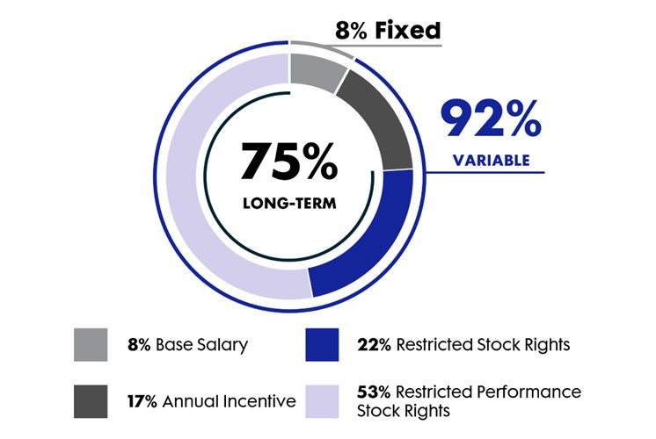 |  |  | 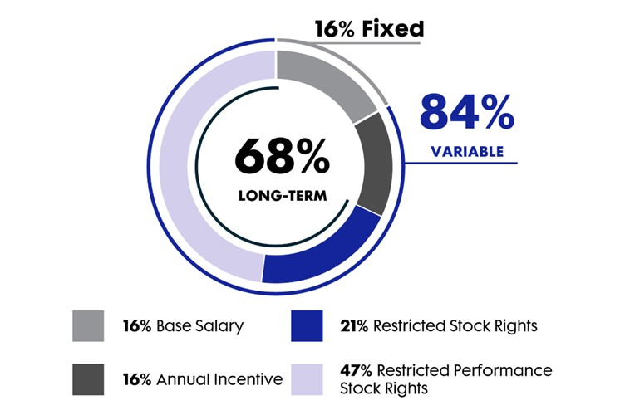
Paying For Performance
In 2025, we continued to maintain robust pay-for-performance practices. All incentive plan performance payouts reflect our performance against our 2025 goals.
We delivered strong financial performance  in 2025 |  |  | 114%  2025 ANNUAL INCENTIVE PLAN  (AIP) PAY FOR OUR NEOs |  |  | 148%  2025 LONG-TERM INCENTIVE PLAN  (LTIP) PAYOUT FOR OUR NEOs

We are committed to an unrelenting focus on our customers, an inclusive workplace for our employees and environmental sustainability. To reinforce these commitments we included related strategic performance metrics in our executive compensation program. |  |  | 2025 Non-financial Metrics in Annual Incentives
 |  |  |  |  |  | Customer  Quality | Customer Satisfaction
 |  |  |  |  |  | People  Inclusion and Belonging
 |  |  |  |  |  | Environment  Environmental Sustainability

8 |  |  | Northrop Grumman

Proxy Statement Summary
High Say-on-Pay Support
Consistent  Shareholder Approval  95%  3-YEAR AVERAGE OF SHAREHOLDER VOTES IN FAVOR OF SAY-ON-PAY |  |  |  |  |  | Highlights of our executive compensation programs:
 |  |  |  |  |  | Over 80% of Executive Compensation is Variable |  |  |  |  |  | Stock Ownership Guidelines for All Officers:  CEO 7x  Other NEOs 3x |  |  |  |  |  | 3-Year Mandatory Holding Period for 50% of Vested Shares
 |  |  |  |  |  | Recoupment Policy on Cash and Equity Incentive Payouts |  |  |  |  |  | No Individual Change in Control Agreements |  |  |  |  |  | No Hedging or Pledging of Company Stock

2026 Proxy Statement |  |  | 9

Proxy Statement Summary
Board Nominee Highlights
 |  |  |  |  |  | Age* |  |  | Director  Since |  |  | Committee Memberships
Name and Professional Background |  |  |  |  |  |  |  |  |  |  |  | AR |  |  | CH |  |  | NG |  |  | P
 |  |  | David P. Abney  Former Executive Chairman of the Board of Directors and  Chief Executive Officer of United Parcel Service, Inc. (UPS) |  |  | 70 |  |  | 06/2020
 |  |  | Marianne C. Brown  Former Chief Operating Officer, Global Financial Solutions,  Fidelity National Information Services, Inc. |  |  | 67 |  |  | 03/2015
 |  |  | Christopher W. Grady  Retired Admiral, U.S. Navy and Former Vice Chairman of the Joint Chiefs of Staff |  |  | 63 |  |  | 02/2026
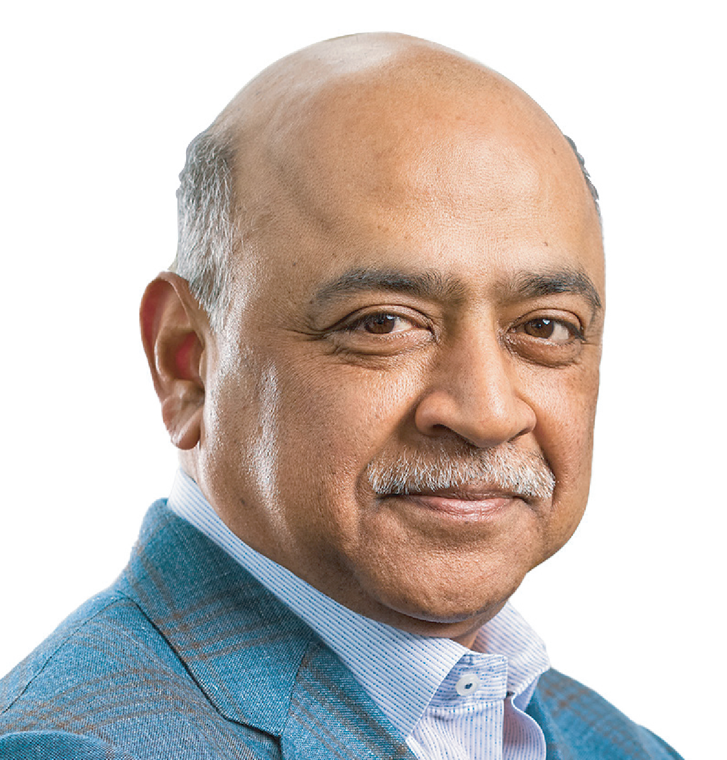 |  |  | Arvind Krishna  Chairman and Chief Executive Officer, International Business Machines  Corporation (IBM) |  |  | 63 |  |  | 11/2022
 |  |  | Kimberly A. Ross  Former Chief Financial Officer, WeWork and Baker Hughes Company |  |  | 60 |  |  | 03/2023
 |  |  | Gary Roughead  Retired Admiral, U.S. Navy and Former Chief of Naval Operations |  |  | 74 |  |  | 02/2012
 |  |  | Thomas M. Schoewe  Former Executive Vice President and CFO, Wal-Mart Stores, Inc. |  |  | 73 |  |  | 08/2011
 |  |  | James S. Turley  Former Chairman and Chief Executive Officer, Ernst & Young |  |  | 70 |  |  | 02/2015
 |  |  | Kathy J. Warden  Chair, Chief Executive Officer and President, Northrop Grumman Corporation |  |  | 54 |  |  | 07/2018
 |  |  | Mark A. Welsh III  Former President, Texas A&M University; Retired General, U.S. Air Force and Former Chief of Staff, U.S. Air Force |  |  | 72 |  |  | 12/2016
 |  |  | Mary A. Winston  President and Founder of WinsCo Enterprises, Inc. |  |  | 64 |  |  | 03/2023
AR |  |  | Audit and Risk Committee |  |  | NG |  |  | Nominating and Corporate Governance Committee |  |  |  |  |  | Chair |  |  |  |  |  | Member
CH |  |  | Compensation and Human Capital Committee |  |  | P |  |  | Policy Committee
* Age as of April 3, 2026.

10 |  |  | Northrop Grumman

Proxy Statement Summary
We have a highly qualified slate of Board nominees
AVERAGE AGE  66.4  YEARS |  |  | 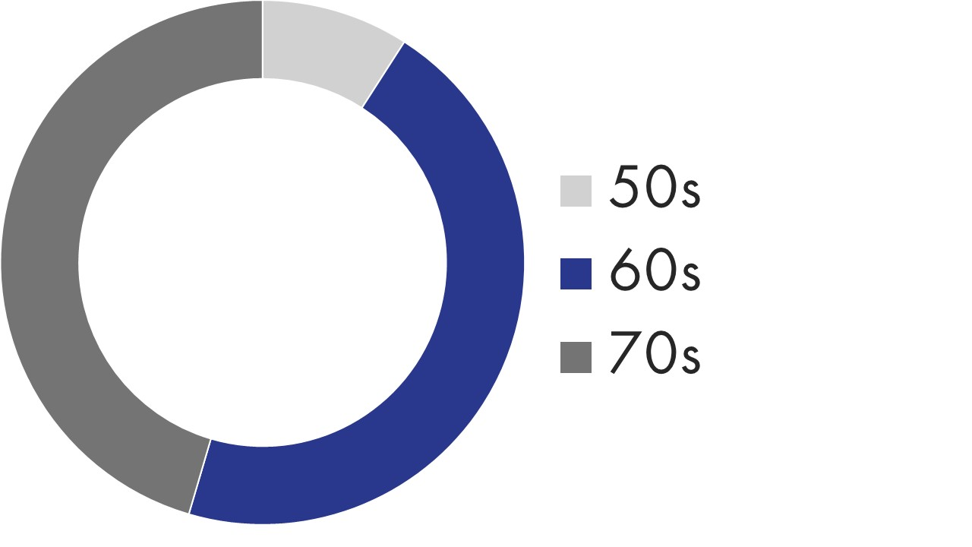 |  |  | AVERAGE TENURE  7.6  YEARS |  |  | 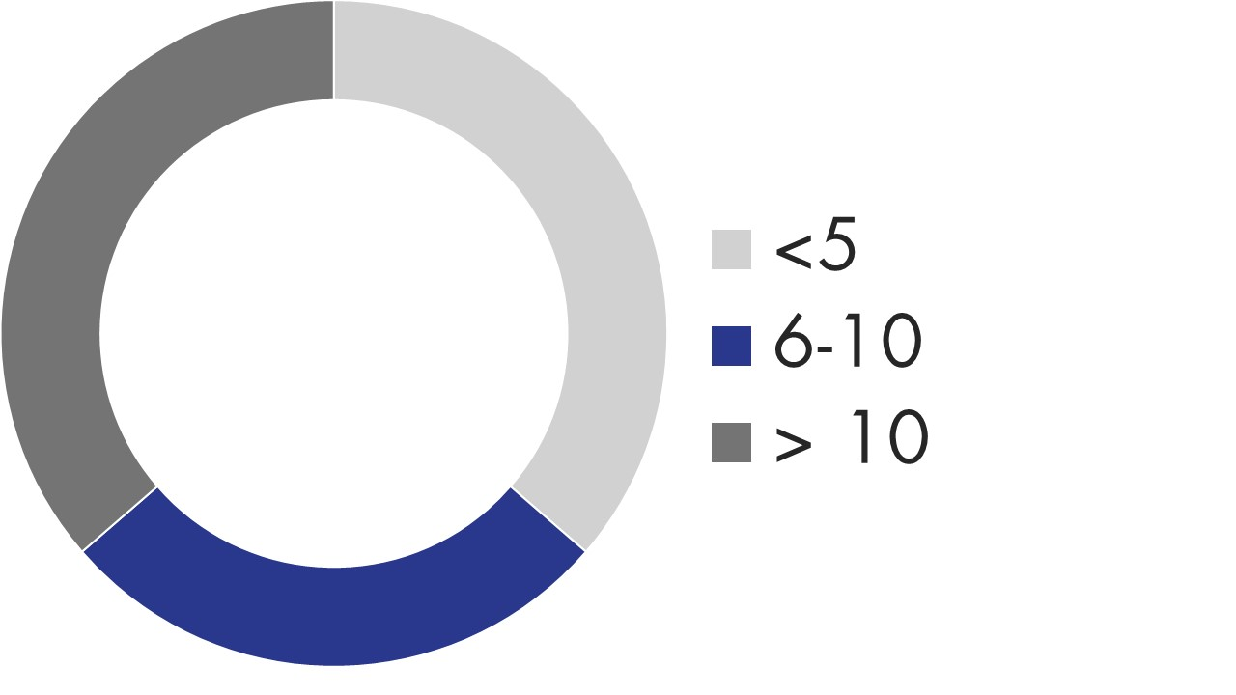
Our Board brings a vast array of experience and talents that help foster the long-term success of the Company, and benefit all of its stakeholders:
 |  |  | Senior Leadership Experience |  |  |  |  |  | Senior Government/Military Experience
 |  |  | Corporate Governance Expertise |  |  |  |  |  | International Experience
 |  |  | Financial Expertise/Literacy |  |  |  |  |  | Human Capital Strategy/  Talent Management
 |  |  | Risk Oversight/Management |  |  |  |  |  | Cybersecurity/Technology Expertise
 |  |  | Defense and Industrial Experience |  |  |  |  |  | Environmental Sustainability/  Corporate Responsibility
2026 Proxy Statement |  |  | 11

Proxy Statement Summary
Governance Highlights
STRONG INDEPENDENT  OVERSIGHT |  |  |  |  |  | COMMITMENT TO BOARD  EFFECTIVENESS |  |  |  |  |  | ROBUST SHAREHOLDER  RIGHTS
92% independent Board  Fully independent Board committees  Lead Independent Director with robust responsibilities and oversight  Regular executive sessions |  |  |  |  |  | Thorough annual self-assessment of Board, committee and individual director performance  Overboarding policy (no more than three other public company boards without the consent of the Chair, Nominating and Corporate Governance Committee)  Focus on ability to devote appropriate time and resources |  |  |  |  |  | Annual director elections with majority voting standard in uncontested elections  Proxy access  Right to call special meeting at 15% threshold  Right to act by written consent  No supermajority voting requirements
 |  |  | BOARD REFRESHMENT, COMPOSITION AND RECOGNITION |  |  |  |  |  | ALIGNMENT AND ENGAGEMENT WITH SHAREHOLDER INTERESTS
 |  |  | Sustained history of highly qualified directors with wide-ranging skills and perspectives, including current slate of director nominees  Mandatory retirement at age 75  Consistent Board refreshment (6 directors have been added and 5 directors have left our Board since 2020)  Our directors are consistently recognized for being influential corporate directors  Our Chair, CEO and President, Kathy Warden, was awarded the Voice of Industry Award from the Aerospace Industries Association |  |  |  |  |  | Extensive shareholder engagement program providing for regular shareholder access to management and directors  Executive compensation metrics that reflect commitment to investing for and achieving long-term profitable growth, maintaining alignment with shareholders’ interests  Stock ownership requirements for directors and executive officers  Robust recoupment policy for incentive compensation
SUSTAINABILITY AND CORPORATE RESPONSIBILITY
Strong ethics program and corporate culture  Engaged and talented workforce  Human Rights Policy with robust oversight  Long-standing commitment to effective corporate governance and shareholder rights |  |  |  |  |  | Chief Environment, Quality and Safety Officer focused on fostering a strong safety culture throughout the organization, in addition to implementing strategies for product quality, enhanced risk assessment and mitigation, and environmental regulatory compliance |  |  |  |  |  | Transparent political contributions policy and trade association activity aligned with Company business objectives and values  Far-reaching engagement with local communities  Global Corporate Responsibility team focused on strengthening corporate culture and communities

12 |  |  | Northrop Grumman

Management and Shareholder Proposals
PROPOSAL 1
Election of Directors |  |  | > See page 15 for more details
The Board of Directors unanimously recommends that you vote “FOR” the 11 nominees for director listed in Proposal 1.
PROPOSAL 2
Advisory Vote to Approve Compensation of  Named Executive Officers |  |  | > See page 46 for more details
The Board of Directors unanimously recommends that you vote “FOR” this proposal.
PROPOSAL 3
Ratification of Appointment of Independent Auditor |  |  | > See page 88 for more details
The Board of Directors unanimously recommends that you vote “FOR” this proposal.
Based on its recent evaluation, the Audit and Risk Committee of the Board of Directors believes that the appointment of Deloitte & Touche LLP (Deloitte) is in the best interests of the Company and its shareholders. The Audit and Risk Committee believes that Deloitte is independent and well-qualified to serve as the Company's independent auditor in 2026.
PROPOSAL 4
Shareholder Proposal to Provide for an Independent Board Chair |  |  | > See page 91 for more details
The Board of Directors unanimously recommends that you vote “AGAINST” this proposal.

2026 Proxy Statement |  |  | 13

Shareholder Engagement
At Northrop Grumman, regular engagement with our shareholders plays a vital role in our corporate governance framework. Through our comprehensive outreach program, we gather valuable feedback to better understand shareholder priorities. These conversations involve key members of our leadership team and, at times, our Board, ensuring we remain attuned to shareholder perspectives while offering them direct access to our organization's leadership.

Our shareholder outreach program is structured to help ensure ongoing engagement with shareholders throughout the year. This includes participating in investor conferences, non-deal roadshows, one-on-one meetings, and site visits. In addition, we seek engagement with our largest shareholders twice a year with an emphasis on corporate governance topics.

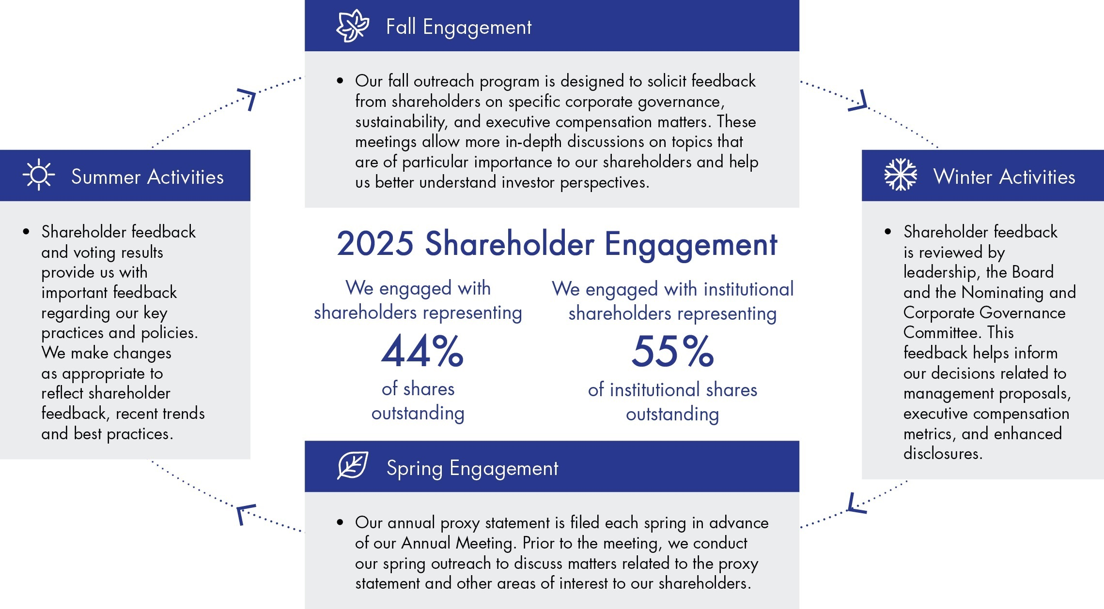

KEY ITEMS DISCUSSED WITH SHAREHOLDERS IN 2025
Governance Topics  •Shareholder Proposals  •Executive Compensation  •Board Composition and Structure  •Artificial Intelligence |  |  |  |  |  | Company Strategy  •Technology Leadership  •Customer Priorities  •Digital Transformation  •Human Capital Management |  |  |  |  |  | Financial Topics  •Financial Performance and Outlook  •Portfolio Composition  •Capital Deployment  •Acquisition Reform |  |  |  |  |  | Sustainability Topics  •Environmental Goals  •Supply Chain  •Inclusion  •Human Rights

14 |  |  | Northrop Grumman

Proposal 1: Election of Directors
Our Board has nominated 11 directors for election at the Annual Meeting. In accordance with our retirement policy, Ms. Kleiner, a director who has served on our Board since 2008, and Ms. Fudge, a director who has served on our Board since 2016, are not standing for re-election at the Annual Meeting as they will have attained their 75th birthday prior to the Annual Meeting. They will conclude their service on the Board immediately following the Annual Meeting. The number of members of the Board will be reduced from 13 to 11 directors effective upon the retirements of Ms. Kleiner and Ms. Fudge. All of the director nominees listed below except for Adm. Grady were last elected by shareholders at the 2025 Annual Meeting. Each of the director nominees has consented to serve, and we do not know of any reason why any of them would be unable to serve, if elected. If a nominee becomes unavailable or unable to serve before the Annual Meeting (for example, due to serious illness), the Board may determine to leave the position vacant, reduce the number of authorized directors or designate a substitute nominee. In the unanticipated event that a nominee becomes unavailable for election to the Board, the proxyholders will have full discretion and authority to vote, or refrain from voting, for any other nominee in accordance with their judgment.
Vote Required
To be elected, a nominee must receive more votes cast “for” than votes cast “against” his or her election. Abstentions and broker non-votes will have no effect on this proposal. If a nominee is not re-elected, he or she will remain in office until a successor is elected or until his or her earlier resignation or removal. See page 25 for additional information on our Director Election Process.
 |  |  | THE BOARD OF DIRECTORS UNANIMOUSLY RECOMMENDS THAT YOU VOTE “FOR” THE 11 NOMINEES FOR DIRECTOR LISTED BELOW.

Director Qualifications and Experience
The Nominating and Corporate Governance Committee evaluates Board nominees by considering a range of criteria, including certain general attributes and each individual’s personal and professional background. The assessment focuses on achieving a diverse mix of skills and experiences necessary for effective governance and oversight by the Board as a whole, ultimately advancing the long-term interests of our shareholders. The Committee is dedicated to ensuring a talented and well-rounded board, comprised of members with the requisite skills, experience, and commitment to serve the Company and its shareholders. The Committee provides regular updates to the Board regarding the mix of skills and expertise needed in the future, taking into account the evolving needs of the Company and its businesses and upcoming retirements from the Board.
THE COMMITTEE CONSIDERS A RANGE OF CRITERIA WHEN EVALUATING POTENTIAL CANDIDATES
High personal and professional integrity  Relevant educational and professional background and experience  Diverse and complementary skills and experiences relevant to the Company |  |  | Ability to contribute towards the Company’s strategic goals and objectives  Willingness to apply for and ability to obtain and retain a top secret security clearance |  |  | Ability to represent the best interests of all shareholders  Ability and willingness to devote appropriate time and attention to Board service
We believe that the wide-ranging qualifications of our directors, including, but not limited to, those outlined below, enable our Board to effectively provide strategic oversight and guidance that promotes the best interests of our Company and shareholders.
2026 Proxy Statement |  |  | 15

Proposal 1: Election of Directors
Skills and Significant Experience: |  |  |  |  |  |  |  |  |  |  |  |  |  |  |  |  |  |  |  |  |  |  |  |  |  |  |  |  |  |  |  |  |  |  |  |  |  |  | 
 |  |  | SENIOR LEADERSHIP |  |  | n |  |  | n |  |  | n |  |  | n |  |  | n |  |  | n |  |  | n |  |  | n |  |  | n |  |  | n |  |  | n |  |  | 11
Provides valuable insights and enhances oversight in core management areas, facilitating long-term growth
 |  |  | CORPORATE GOVERNANCE |  |  | n |  |  | n |  |  | n |  |  | n |  |  | n |  |  | n |  |  | n |  |  | n |  |  | n |  |  | n |  |  | n |  |  | 11
Provides the experience necessary to develop and maintain an effective governance framework to help ensure strong Board and management accountability and transparency and effective protection of shareholder interests
 |  |  | FINANCIAL |  |  | n |  |  | n |  |  | n |  |  | n |  |  | n |  |  | n |  |  | n |  |  | n |  |  | n |  |  | n |  |  | n |  |  | 11
Assists directors in understanding and overseeing the Company's financial reporting and internal controls, as well as other aspects of financial decision-making
 |  |  | RISK OVERSIGHT/MANAGEMENT |  |  | n |  |  | n |  |  | n |  |  | n |  |  | n |  |  | n |  |  | n |  |  | n |  |  | n |  |  | n |  |  | n |  |  | 11
Equips the Board with essential expertise needed to create and manage a robust risk oversight system
 |  |  | DEFENSE AND INDUSTRIAL |  |  | n |  |  |  |  |  |  |  |  | n |  |  | n |  |  | n |  |  | n |  |  |  |  |  |  |  |  | n |  |  |  |  |  | 6
Supports oversight of the Company’s strategy, performance and product development, with an understanding of strategic developments in our industry
 |  |  | INTERNATIONAL |  |  | n |  |  | n |  |  | n |  |  | n |  |  | n |  |  | n |  |  | n |  |  | n |  |  | n |  |  | n |  |  | n |  |  | 11
Supports an understanding of geographically diverse business and regulatory environments and cultural perspectives that informs global business strategy and assists in overseeing and driving international growth
 |  |  | CYBERSECURITY/TECHNOLOGY |  |  | n |  |  |  |  |  | n |  |  | n |  |  | n |  |  |  |  |  | n |  |  |  |  |  |  |  |  | n |  |  |  |  |  | 6
Supports our business in providing oversight of cybersecurity risk management, digital transformation and artificial intelligence and encourages the Company's development of technological differentiation
 |  |  | HUMAN CAPITAL STRATEGY/TALENT MANAGEMENT |  |  | n |  |  | n |  |  | n |  |  | n |  |  | n |  |  | n |  |  | n |  |  | n |  |  | n |  |  | n |  |  | n |  |  | 11
Provides valuable experience to oversee the Company's strategy to recruit, retain and develop highly qualified talent with wide ranging skills and backgrounds
 |  |  | ENVIRONMENTAL SUSTAINABILITY/ CORPORATE RESPONSIBILITY |  |  | n |  |  | n |  |  |  |  |  |  |  |  | n |  |  |  |  |  | n |  |  |  |  |  |  |  |  | n |  |  | n |  |  | 6
Supports the Board’s oversight and management of the Company's sustainability initiatives and corporate responsibility

16 |  |  | Northrop Grumman

Proposal 1: Election of Directors
2026 Nominees for Director
The following pages contain biographical and other information about each of the nominees. In addition, we have provided information regarding some of the particular experiences and skills that led the Board to conclude that each nominee should serve as a director.
Unless instructed otherwise, the proxyholders will vote the proxies received by them “FOR” the election of the director nominees listed below.
Ms. Kathy J. Warden has served as Chair since August 2019 and as Chief Executive Officer and President of the Company since January 2019. She has served on the Board of Directors since July 2018. Prior to becoming CEO and President, Ms. Warden served as President and Chief Operating Officer of the Company from January 2018 through December 2018, as Corporate Vice President and President of the Company’s Mission Systems Sector from 2016 through 2017, as Corporate Vice President and President of the Company’s former Information Systems Sector from 2013 to 2015, and as Vice President of the Company’s Cyber Intelligence Division from 2011 to 2012. Prior to joining the Company in 2008, Ms. Warden held leadership roles at General Dynamics and Veridian Corporation. Earlier, she was a principal in a venture internet firm and also spent nearly a decade with General Electric Company working in commercial industries.
EXPERIENCE AND SKILLS
•Extensive experience in operational leadership, strategy, performance and business development in government and commercial markets, including cybersecurity and technology expertise
•Prior leadership positions within Northrop Grumman (including as President, Chief Operating Officer and President of two business sectors)
•Significant aerospace and defense industry experience
OTHER CURRENT PUBLIC COMPANY DIRECTORSHIPS
•Member of the Board of Directors of Merck & Co., Inc.
SELECTED OTHER DIRECTORSHIPS AND MEMBERSHIPS
•Member and former Chair of the Aerospace Industries Association
•Chair of the Board of Directors of Catalyst
•Chair of the Board of the Greater Washington Partnership
•Former Chair of the Board of Directors of the Federal Reserve Bank of Richmond
Kathy J. Warden
Chair, Chief Executive Officer and President, Northrop Grumman Corporation
Age: 54
Director since:
July 2018
2026 Proxy Statement |  |  | 17

Proposal 1: Election of Directors
 |  |  |  |  |  | Mr. David P. Abney served as the Executive Chairman of the UPS Board of Directors from March 2016 through September 2020. From September 2014 to June 2020, he was the Chief Executive Officer of UPS. Prior to that, Mr. Abney was UPS’s Chief Operating Officer from 2007 to 2014. From 2003 to 2007, he was Senior Vice President and President of UPS International. Mr. Abney began his UPS career in 1974.  EXPERIENCE AND SKILLS  •Extensive leadership and business experience as a former Executive Chairman, Chief Executive Officer and Chief Operating Officer of a large multinational enterprise  •Significant expertise in international operations and global logistics  •Broad experience with talent management and leading global teams  •Significant board experience, including as non-executive chair  OTHER CURRENT PUBLIC COMPANY DIRECTORSHIPS  •Member of the Board of Directors of Freeport-McMoRan Inc.  •Member of the Board of Directors of Target Corporation  FORMER PUBLIC COMPANY DIRECTORSHIPS WITHIN THE LAST FIVE YEARS  •Member of the Board of Directors of Macy’s, Inc.
David P. Abney
Former Executive Chairman of the Board of Directors and Chief Executive Officer of United Parcel Service, Inc. (UPS)
Age: 70
Director since:
June 2020
Committee membership:
Compensation and Human Capital Committee (Chair), Nominating and Corporate Governance Committee
 |  |  |  |  |  | Ms. Marianne C. Brown served as the Chief Operating Officer of Fidelity National Information Services, Inc.’s (FIS) Global Financial Solutions organization from January 2018 until June 2019. Prior to that, Ms. Brown served as Chief Operating Officer, Institutional and Wholesale Business of FIS since December 2015, when it acquired SunGard Financial Systems. Ms. Brown was the Chief Operating Officer of SunGard Financial Systems, a software and IT services provider, from February 2014 to November 2015. Prior to that, Ms. Brown was the CEO and president of Omgeo, a global financial services technology company, from March 2006 to February 2014.  EXPERIENCE AND SKILLS  •Substantial business experience as a former Chief Operating Officer and Chief Executive Officer  •Significant experience in IT goods and services, cyber protection and business management  •Community and philanthropic leader  OTHER CURRENT PUBLIC COMPANY DIRECTORSHIPS  •Member of the Board of Directors of Akamai Technologies, Inc.  •Member of the Board of Directors of The Charles Schwab Corporation  •Member of the Board of Directors of IBM  FORMER PUBLIC COMPANY DIRECTORSHIPS WITHIN THE LAST FIVE YEARS  •Member of the Board of Directors of VMWare, Inc.
Marianne C. Brown
Former Chief Operating Officer, Global Financial Solutions, Fidelity National Information Services, Inc.
Age: 67
Director since:
March 2015
Committee membership:
Audit and Risk Committee, Nominating and Corporate Governance Committee (Chair)
18 |  |  | Northrop Grumman

Proposal 1: Election of Directors
 |  |  |  |  |  | Admiral Christopher W. Grady served as the twelfth Vice Chairman of the Joint Chiefs of Staff, the United States’ second highest-ranking military officer, from December 2021 until October 2025. During this time, Admiral Grady served on the Deputies Committee of the National Security Council and chaired the Joint Requirement Oversight Council, which is responsible for reviewing and establishing acquisition priorities for major weapon systems among the military branches. He also served as the senior member of the Nuclear Weapons Council, responsible for managing the atomic stockpile and coordinating nuclear weapon-related programs and budgets. During his extensive career, he also served as the Commander of the U.S. Fleet Forces Command and Commander of the U.S. 6th Fleet and Naval Striking and Support Forces, NATO, in addition to several other senior leadership roles within the U.S. Navy.  EXPERIENCE AND SKILLS  •Broad leadership and enterprise oversight experience from an extensive career as a senior military officer with the U.S. Navy  •Significant expertise in geopolitics, the national and global security environment, cybersecurity, critical infrastructure protection and multinational stakeholder engagement  •Experience with human capital strategy and talent development  •Significant expertise in technology modernization and innovation strategy  SELECTED OTHER DIRECTORSHIPS AND MEMBERSHIPS  •Member of the Board of Governors of the United Service Organizations, Inc. (USO)  •Member of the Board of Trustees of Fisher House Foundation, Inc.  •Member of the Board of Directors of Domino Data Lab, Inc. (an enterprise artificial intelligence platform provider)
Christopher W. Grady
Admiral, U.S. Navy (Ret.) and Former Vice Chairman of the Joint Chiefs of Staff
Age: 63
Director since:
February 2026
Committee membership:
Audit and Risk Committee, Policy Committee
Mr. Arvind Krishna has served as Chief Executive Officer of IBM and a member of IBM’s Board of Directors since April 2020. He was elected Chairman of IBM’s Board of Directors in December 2020. He joined IBM in 1990. Mr. Krishna led the IBM Cloud and Cognitive Software business unit from 2017 to April 2020 and was a principal architect of the acquisition of Red Hat, the largest acquisition in IBM’s history. Mr. Krishna also served as the director of IBM’s Research division from 2015 to 2020. Previously, he was general manager of IBM’s Systems and Technology Group, IBM’s development and manufacturing organization. Prior to that, he built and led many of IBM’s data-related businesses.
EXPERIENCE AND SKILLS
•Extensive global business and organizational leadership experience as the Chairman and Chief Executive Officer of a large multinational corporation
•Deep knowledge of manufacturing and research, including in artificial intelligence and computing
•Significant experience in cyber and digital transformation
•Significant technology experience
OTHER CURRENT PUBLIC COMPANY DIRECTORSHIPS
•Chairman of the Board of Directors of IBM
SELECTED OTHER DIRECTORSHIPS AND MEMBERSHIPS
•Member of the Board of Directors of the Federal Reserve Bank of New York
•Member of the Board of Directors of the US-India Strategic Partnership Forum
Arvind Krishna
Chairman and Chief Executive Officer, International Business Machines Corporation (IBM)
Age: 63
Director since:
November 2022
Committee membership:
Compensation and Human Capital Committee, Policy Committee
2026 Proxy Statement |  |  | 19

Proposal 1: Election of Directors
 |  |  |  |  |  | Ms. Kimberly A. Ross served as Chief Financial Officer of WeWork from March through October 2020. She served as Senior Vice President and Chief Financial Officer of Baker Hughes Company from 2014 to 2017. Ms. Ross was Executive Vice President and Chief Financial Officer of Avon Products, Inc. from 2011 to 2014. Prior to that, she served as the Executive Vice President and Chief Financial Officer of Royal Ahold N.V. from 2007 to 2011 and previously held a variety of senior management positions at Royal Ahold.  EXPERIENCE AND SKILLS  •Extensive experience through service as the Chief Financial Officer of large public companies, including expertise in financial reporting, internal auditing processes and managing corporate finance for global companies  •Significant international business experience through her service as an executive of large public companies with extensive international operations  •Substantial senior leadership skills  •Audit committee financial expert  OTHER CURRENT PUBLIC COMPANY DIRECTORSHIPS  •Member of the Board of Directors of The Cigna Group  •Member of the Board of Directors of KKR & Co. Inc.  FORMER PUBLIC COMPANY DIRECTORSHIPS WITHIN THE LAST FIVE YEARS  •Member of the Board of Directors of Nestlé S.A.  •Member of the Board of Directors of KKR Acquisition Holdings I Corp.
Kimberly A. Ross
Former Chief Financial Officer, WeWork and Baker Hughes Company
Age: 60
Director since:
March 2023
Committee membership:
Audit and Risk Committee, Policy Committee
 |  |  |  |  |  | Admiral Gary Roughead retired from his position as the 29th Chief of Naval Operations in September 2011, after serving in that position for four years. The Chief of Naval Operations is the senior military position in the United States Navy. As Chief of Naval Operations, Admiral Roughead stabilized and accelerated ship and aircraft procurement plans and the Navy’s capability and capacity in ballistic missile defense and unmanned air and underwater systems. He restructured the Navy to address the challenges and opportunities in cyber operations. Prior to becoming the Chief of Naval Operations, he held six operational commands (including commanding both the Atlantic and Pacific Fleets). Admiral Roughead is a Robert and Marion Oster Distinguished Military Fellow at the Hoover Institution.  EXPERIENCE AND SKILLS  •Extensive career as a senior military officer with the U.S. Navy, including numerous operational commands, as well as leadership positions, most recently as the 29th Chief of Naval Operations  •Significant expertise in national security, information warfare, cyber operations and global security issues  •Broad experience in leadership and matters of global relations, particularly in the Pacific region, Europe and the Middle East  •Experience with talent development and management  SELECTED DIRECTORSHIPS AND MEMBERSHIPS  •Member of the Board of Directors of Maersk Line, Limited  •Trustee of the Dodge and Cox Funds  •Trustee of Johns Hopkins University  •Member of the Board of Managers of the Johns Hopkins University Applied Physics Laboratory  •Former Chairman of the Board of Directors of Fincantieri Marinette Marine Corporation
Gary Roughead
Admiral, U.S. Navy (Ret.) and Former Chief of Naval Operations
Age: 74
Director since:
February 2012
Committee membership:
Compensation and Human Capital Committee, Policy Committee (Chair)
20 |  |  | Northrop Grumman

Proposal 1: Election of Directors
 |  |  |  |  |  | Mr. Thomas M. Schoewe was Executive Vice President and Chief Financial Officer of Wal-Mart Stores, Inc. from 2000 to 2011. Prior to his employment with Wal-Mart, he held several leadership roles at the Black & Decker Corporation.  EXPERIENCE AND SKILLS  •Extensive financial experience acquired through positions held as the Chief Financial Officer of large public companies, as well as expertise in Sarbanes-Oxley controls, risk management and mergers and acquisitions  •Significant international experience through his service as an executive of large public companies with substantial international operations  •Experience at Wal-Mart and Black & Decker on large-scale transformational enterprise information technology implementations  •Extensive experience as a member of the audit, risk, compensation and policy committees of other public companies  •Audit committee financial expert  SELECTED DIRECTORSHIPS AND MEMBERSHIPS  •Member of the Board of Trustees of Loyola University Chicago  •Former Member of the Board of the Ladies Professional Golf Association  FORMER PUBLIC COMPANY DIRECTORSHIPS WITHIN THE LAST FIVE YEARS  •Member of the Board of Directors of KKR & Co. Inc.  •Member of the Board of Directors of General Motors Corporation
Thomas M. Schoewe
Former Executive Vice President and Chief Financial Officer, Wal-Mart Stores, Inc.
Age: 73
Director since:
August 2011
Committee membership:
Audit and Risk Committee (Chair), Nominating and Corporate Governance Committee
 |  |  |  |  |  | Mr. James S. Turley served as Chairman and Chief Executive Officer of Ernst & Young from 2001 until his retirement in 2013. Mr. Turley joined Ernst & Young in 1977 and held various positions there. He was named Deputy Chairman in 2000.  EXPERIENCE AND SKILLS  •Extensive experience and expertise in areas of finance, accounting and business management acquired over 36-year career at Ernst & Young, including serving as Chairman and Chief Executive Officer of Ernst & Young  •Significant experience in areas of risk management  •Extensive international experience through his service as an executive of a leading global professional services organization  •Significant public company board leadership experience, including as non-executive chair  •Extensive experience as a member of the audit committee of other public companies  •Audit committee financial expert  OTHER CURRENT PUBLIC COMPANY DIRECTORSHIPS  •Member of the Board of Directors of Citigroup  •Independent Chair of the Board of Directors of Emerson Electric Company  •Member of the Board of Directors of Precigen, Inc.  SELECTED OTHER DIRECTORSHIPS AND MEMBERSHIPS  •Member of the Board of Directors of Kohler Co.  •Member of the Board of Directors of ArchBridge Family Office
James S. Turley
Former Chairman and Chief Executive Officer, Ernst & Young
Age: 70
Director since:
February 2015
Committee membership:
Audit and Risk Committee, Nominating and Corporate Governance Committee
2026 Proxy Statement |  |  | 21

Proposal 1: Election of Directors
 |  |  |  |  |  | General Mark A. Welsh III served as the 27th President of Texas A&M University from December 2023 to September 2025, after being named interim President in July 2023. Prior to being named interim President, he had served as Dean of the Bush School of Government and Public Service at Texas A&M University since August 2016. Prior to that, General Welsh served as Chief of Staff of the United States Air Force (USAF), the senior uniformed Air Force officer responsible for the organization, training and equipping of active duty, Guard, Reserve and civilian forces serving in the United States and overseas. During his long career, General Welsh also served as a member of the Joint Chiefs of Staff, Commander of the United States Air Forces in Europe and Commander of NATO’s Air Command, Associate Director for Military Affairs at the Central Intelligence Agency and Commandant of the United States Air Force Academy.  EXPERIENCE AND SKILLS  •Extensive career as a senior military officer and member of the Joint Chiefs of Staff, having held leadership positions at the highest levels of the United States Air Force  •Experience with administration of large, complex educational institution, including serving as president  •Extensive experience and in-depth knowledge of issues related to global security and the intelligence community  •Broad leadership experience and international experience, particularly in Europe  •Experience with talent development and management
Mark A. Welsh III
Former President, Texas A&M University; General, USAF (Ret.); Former Chief of Staff, USAF
Age: 72
Director since:
December 2016
Committee membership:
Audit and Risk Committee, Policy Committee
 |  |  |  |  |  | Ms. Mary A. Winston is the President and Founder of WinsCo Enterprises, a consulting firm providing financial and board governance advisory services since 2016. She served as interim Chief Executive Officer of Bed Bath & Beyond from May 2019 to November 2019, and as Executive Vice President and Chief Financial Officer of Family Dollar Stores from 2012 to 2015. Prior to that, Ms. Winston served as Senior Vice President and Chief Financial Officer of Giant Eagle, Inc. from 2008 to 2012, and as Executive Vice President and Chief Financial Officer of Scholastic Corporation from 2004 to 2007.  EXPERIENCE AND SKILLS  •Substantial financial expertise acquired through positions held as the Chief Financial Officer of large public and private companies, as well as expertise in risk management and mergers and acquisitions  •Significant senior leadership and international experience as an executive officer or director of large companies with global operations  •Extensive expertise in corporate governance  •Broad operations, manufacturing and supply chain experience  OTHER CURRENT PUBLIC COMPANY DIRECTORSHIPS  •Member of the Board of Directors of Chipotle Mexican Grill  •Member of the Board of Directors of The Toronto-Dominion Bank  FORMER PUBLIC COMPANY DIRECTORSHIPS WITHIN THE LAST FIVE YEARS  •Member of the Board of Directors of Acuity Brands, Inc.  •Member of the Board of Directors of Bed Bath & Beyond, Inc.  •Member of the Board of Directors of Domtar Corporation  •Member of the Board of Directors of Dover Corporation
Mary A. Winston
President and Founder of WinsCo Enterprises, Inc.
Age: 64
Director since:
March 2023
Committee membership:
Compensation and Human Capital Committee, Policy Committee

22 |  |  | Northrop Grumman

Proposal 1: Election of Directors
Director Nomination Process
Board Composition, Refreshment and Succession Planning
The Nominating and Corporate Governance Committee actively considers the composition, capabilities and range of skills and perspectives of the Board to ensure it is well positioned to serve the best interests of the Company and its shareholders. The Nominating and Corporate Governance Committee regularly assesses what skills, experiences and other attributes can best contribute to the effective operation of the Board, particularly in light of the changing environment and evolving needs of the Company, including the criteria described on page 15. The Committee strives to achieve an effective balance, with strong and varied capabilities, including new perspectives. The Committee also considers other commitments of our directors, including service on other public company boards and leadership positions. The Nominating and Corporate Governance Committee identifies director candidates from a wide range of sources and may employ a third-party search firm to assist in the process. Information regarding Board changes and the skills and tenure of our Board nominees is provided below.

Board changes since 2020 |  |  |  |  |  | Skills of recently added Directors
6 new directors have been added to the Board |  |  |  |  |  |  |  |  | Defense and Industrial Experience |  |  |  |  |  | Financial Expertise/Literacy
5 directors have left the Board
 |  |  |  |  |  |  |  |  | Operations and Logistics |  |  |  |  |  | Cybersecurity/Technology
Board nominees:
AVERAGE AGE  66.4  YEARS |  |  |  |  |  | AVERAGE TENURE  7.6  YEARS

Retirement Policy
We have a retirement policy that provides for a director to retire at the annual meeting following his or her 75th birthday, unless the Board determines, based on special circumstances, that it is in the Company’s best interest to request that the director serve beyond such date.
2026 Proxy Statement |  |  | 23

Proposal 1: Election of Directors
Identification and Consideration of New Nominees
1 |  |  | ESTABLISH NOMINEE CRITERIA |  |  |  |  |  | The Nominating and Corporate Governance Committee is responsible for establishing the criteria for Board membership, recognizing that it is the responsibility of a director to represent the long-term interests of our shareholders as a whole.

2 |  |  | REVIEW OF CANDIDATE’S HISTORY |  |  |  |  |  | The employment and other activities and associations of candidates are reviewed for any legal impediment, conflict of interest or other consideration or concerns that might prevent or interfere with service on our Board.
3 |  |  | CANDIDATE EVALUATION |  |  |  |  |  | In evaluating candidates, the Nominating and Corporate Governance Committee considers:  •the personal integrity and the professional reputation of the individual;  •the education, professional background and particular skills and experience most beneficial to service on our Board;  •how the nominee brings diverse and complementary skills, experiences and perspectives valuable to the Company and Board at the time;  •a director candidate's ability and willingness to devote appropriate time and resources to Board service, taking into account the director candidate's outside time commitments, including service on other public company boards of directors and leadership positions held on such boards; and  •a director candidate's willingness to obtain and retain a top secret security clearance.  The Nominating and Corporate Governance Committee evaluates potential director candidates on the basis of the candidate’s background, qualifications and experience. The Committee carefully considers whether a potential candidate would be able to fulfill his or her duties to the Company consistent with Delaware law and the Company’s governing documents, including the Company's Principles of Corporate Governance, and security requirements. The Committee seeks to ensure each candidate will enhance the effectiveness of the Board overall.
4 |  |  | RECOMMENDATION FOR ELECTION |  |  |  |  |  | The Nominating and Corporate Governance Committee recommends to the full Board nominees for election.

24 |  |  | Northrop Grumman

Proposal 1: Election of Directors
Shareholder Nominations
Shareholders may recommend director candidates for consideration by the Nominating and Corporate Governance Committee pursuant to our Principles of Corporate Governance. The Nominating and Corporate Governance Committee considers such director candidates recommended by shareholders similarly to other potential director candidates brought to the attention of the Nominating and Corporate Governance Committee. Shareholder recommendations for director candidates under our Principles of Corporate Governance must be addressed to the Nominating and Corporate Governance Committee in care of the Corporate Secretary. In addition, and as discussed immediately below, shareholders may also directly nominate director candidates in accordance with our Bylaws.
Proxy Access
Under the Company’s proxy access bylaws, a shareholder, or a group of up to 20 shareholders, that has maintained continuous ownership of 3% or more of the Company’s outstanding common stock for at least three years may include in the Company’s proxy materials director nominees constituting up to the greater of two nominees or nominees constituting 20% of the number of directors in office. Director nominees may receive compensation from third parties for their candidacy, up to the total annual compensation paid to directors of the Company, as well as reimbursement for reasonable expenses, provided there is full disclosure of such compensation. Under the Company’s bylaw provisions, directors are treated similarly, whether nominated through proxy access or otherwise, and held to the same high fiduciary standards to serve all shareholders.
The Company’s Bylaws provide our shareholders with broad and meaningful access to the Company’s proxy materials while enhancing transparency, protecting the interests of all shareholders and ensuring good governance. The terms of the Company's proxy access bylaw provisions are also broadly consistent with other Fortune 500 companies' terms, reflecting best practices.
Director Election Process
Our Bylaws and Certificate of Incorporation provide for the annual election of directors. Each director will hold office until the next annual meeting of shareholders and until his or her successor is elected or until his or her earlier resignation or removal. Generally, in order to be elected, a director must receive more votes cast “for” than “against” his or her election, unless one or more shareholders provide notice of an intention to nominate one or more candidates to compete with the Board’s nominees for election in accordance with the procedures set forth in the Company’s corporate governance documents.
Effect of Failure to Obtain and Retain Security Clearance or Receive the Required Vote
Each director is required to tender a resignation in the event of and effective upon the failure to obtain top secret security clearance within 12 months of election or appointment to the Board, or the failure to retain a top secret security clearance once obtained. If an incumbent director fails to obtain and retain a top secret security clearance, the Nominating and Corporate Governance Committee will consider whether the Board should accept the director’s resignation and will submit a recommendation for prompt consideration by the Board. In addition, each director is required to tender a resignation in the event of and effective upon the failure to receive the required vote at any future meeting at which such director faces re-election. The Nominating and Corporate Governance Committee and the Board will consider relevant facts in deciding whether to accept a resignation, including, without limitation, any harm to the Company that may result from accepting the resignation.

2026 Proxy Statement |  |  | 25

Corporate Governance

Overview
We are dedicated to maintaining high standards of corporate governance with robust practices that promote accountability, transparency, and ethics, ultimately enhancing long-term shareholder value. By continually assessing our governance framework and incorporating stakeholder feedback and best practices, we ensure that our policies align with our values and drive sustainable growth that benefits our shareholders, employees, customers, partners and communities.
We outline some key aspects of our strong corporate governance and responsible business practices below.
 |  |  | Values |  |  |  |  |  | Principles of Corporate Governance
Our values provide the foundation for our culture and success:  •We Do The Right Thing - we earn trust, act with ethics, integrity and transparency, treat everyone with respect and value diverse perspectives;  •We Do What We Promise - we own the delivery of results, focused on quality outcomes;  •We Commit To Shared Success - we work together to focus on the mission and take accountability for the sustainable success of our people, customers, shareholders, suppliers and communities; and  •We Pioneer - with fierce curiosity, dedication and innovation, we seek to solve the world’s most challenging problems. |  |  |  |  |  | Our Principles of Corporate Governance outline the role and responsibilities of our Board and the high standards our directors maintain. They set forth additional independence requirements for our directors and provide guidelines for Board leadership and Board and committee membership, among other items. The Board reviews these principles at least annually and considers opportunities for improvement and modification. Our Principles of Corporate Governance are available at investor.northropgrumman.com.
 |  |  | Standards of Business Conduct
Our Standards of Business Conduct outline our commitment to ethics and integrity, consistent with our values and how we do business. They reflect and reinforce our commitment to our core values. They apply to our directors, officers and employees. We also require our suppliers to meet similar standards through our Standards of Business Conduct for Suppliers and Other Trading Partners. Our Standards of Business Conduct and our Standards of Business Conduct for Suppliers and Other Trading Partners are available at www.northropgrumman.com/corporate-responsibility/ethics-and-business-conduct/standards-of-business-conduct.
Among other things, our Standards of Business Conduct:
•require our employees to live our values in all aspects of our business;
•require strict adherence to all applicable laws and regulations;
•reflect our commitment to maintaining a speak-up culture that values inclusion, and provides our employees a sense of belonging to enable success;
•reinforce our commitment to good corporate citizenship and the global communities where we live, work and serve;
•reflect our commitment to providing a work environment where every person is treated with respect and dignity;
•require a focus on performance and the consistent production of quality results;
•reflect our commitment to the safety of our people and products; and
•call upon all employees and other stakeholders to raise any questions or issues of concern (including on an anonymous basis).
We report amendments to provisions of our Standards of Business Conduct on our website.

26 |  |  | Northrop Grumman

Corporate Governance
Role of the Board and Key Areas of
Board Oversight
The primary responsibility of our Board is to foster the long-term success of the Company, promoting the interests of our shareholders. Our directors are well-informed and exercise their business judgment in a manner they reasonably believe to be in the best interests of the Company and our shareholders and in a manner consistent with their fiduciary responsibilities. The role of the Board includes, but is not limited to, the following:

 |  |  |  |  |  | Strategy  •Oversee our long-term business strategies, operations and performance (including restricted programs)  •Review and approve significant corporate actions  •Provide advice and guidance to management
 |  |  |  |  |  | Risk  •Oversee the enterprise risk management process  •Ensure that each of our significant risks is effectively considered and mitigated
 |  |  |  |  |  | Culture and Human Capital  •Ensure a strong culture  •Oversee human capital strategy, including certain human-capital related policies and programs  •Execute robust succession planning, including selecting the Chief Executive Officer, and electing officers of the Company  •Review and approve executive compensation overall, including the compensation of the Chief Executive Officer
 |  |  |  |  |  | Governance  •Ensure effective corporate governance practices  •Oversee our ethics and compliance programs  •Review and enhance Board performance  •Elect directors to fill vacant positions between Annual Meetings

2026 Proxy Statement |  |  | 27

Corporate Governance
Risk Oversight

As noted above, the Board is responsible for overseeing risk management, with a focus on both near and long term significant risks to the Company, our business and our strategy. For each significant risk, the Company identifies a senior executive responsible for its management, alongside a designated Board committee (or the full Board) tasked with providing oversight. The Board's governance framework for risk management allows for clear allocation of responsibilities of risk oversight among the full Board and its committees, leveraging the Board's skills and leadership structure. Our risk oversight framework facilitates regular assessments of the Company’s risk management processes and controls and whether they are functioning at maximum effectiveness.

Risk Oversight Framework
The following chart summarizes the Company's allocation of risk management oversight for certain significant risks.
BOARD OF DIRECTORS
•Ultimate responsibility for the oversight of risk, ensuring allocation of responsibility for the management of each significant risk
•Provides oversight of the Company’s risk management processes, including the Enterprise Risk Management Council
•Committees and management provide updates to the full Board on significant and emerging risks, including financial risks and risks related to cybersecurity, significant customers and programs, long term strategy, culture, human capital, technology development and artificial intelligence

AUDIT AND RISK COMMITTEE  •Responsible for assisting the Board in its overall oversight of enterprise risk management  •Oversight of financial risks, including related to environmental matters and insurance  •Oversight of cybersecurity risk and legal, ethics and compliance risk |  |  |  |  |  |  |  |  | COMPENSATION AND HUMAN CAPITAL COMMITTEE  •Oversight of human capital risk, including related to talent acquisition and retention  •Oversight of risk related to compensation programs and employee experience and engagement policies and practices |  |  |  |  |  |  |  |  |  |  |  | POLICY COMMITTEE  •Oversight of risks related to global security, political, budgetary, and technological issues  •Oversight of risks related to human rights, health and safety, corporate social responsibility and political contributions  •Oversight of environmental and sustainability policies, programs and reports |  |  |  |  |  |  |  |  | NOMINATING AND CORPORATE GOVERNANCE COMMITTEE  •Oversight of governance-related risks (including the Company's corporate governance policies and practices) and risks related to corporate culture  •Assist the Board in its oversight of succession planning risk
ENTERPRISE RISK MANAGEMENT COUNCIL (ERMC)
•Designed to help ensure that the Company has identified significant risks (including emerging risks) and is effectively managing such risks, including by developing comprehensive mitigation plans
•Comprised of all members of the Executive Leadership Team (ELT), as well as the Chief Accounting Officer, Corporate Secretary, Treasurer, Chief Ethics and Compliance Officer, Chief Environment, Quality and Safety Officer and VP, Internal Audit and also attended by the Chief Information Security Officer, Chief Technology Officer (CTO) and VP, Supply Chain
•The Steering Committee, comprised of certain ELT members, and the Working Committee, comprised of certain VP-level ERMC members, meet multiple times a year to align on risk calibration and management strategies
•The full ERMC meets at least twice a year to oversee, review and help ensure effective management of enterprise risks
•Members of the ERMC brief the Audit and Risk Committee at least annually on its deliberations and significant areas of concern

28 |  |  | Northrop Grumman

Corporate Governance
Management's Role in Enterprise Risk Management
Our governance framework has been carefully developed to help ensure a comprehensive system of oversight and accountability. The Company's management, under the oversight of the Board, executes the Company's risk management strategies and is the first line of defense in identifying emerging risks.

Enterprise Risk Management Council

The Enterprise Risk Management Council, comprised of key members of the Company's management team, plays a vital role in reviewing the significant risks to the enterprise and ensuring effective consideration, mitigation, and management. For each significant risk, the Company identifies a senior executive responsible for its management. During meetings of the ERMC, the Council receives updates from each management lead, with particular focus on any significant changes in the risk profile or necessary mitigations for such risk. During its meetings, the Council also discusses risk mitigation strategies, process enhancements and evolving and emerging risks. The ERMC helps ensure each identified risk is reviewed by a cross-functional team and provides a robust system of accountability.

Management Accountability: Briefings to the Board and its Committees

Although not exhaustive, the following is a summary of briefings and reports the Board and its committees receive from management in connection with the Board's risk oversight function.

BOARD OF DIRECTORS
•Reports from the CEO, CFO, VP, Corporate Strategy and Technology and other senior executives regarding corporate strategy, including specific strategic deep-dives and matters involving our key customers and pursuits
•Updates from senior management regarding evolving risk focus areas, including cybersecurity
•Updates from the General Counsel regarding legal and compliance matters
•Reports from the Chief Human Resource Officer (CHRO) regarding matters related to human capital strategy
•Updates from senior executive management regarding government relations and geopolitical matters
•Reports from the Chief Information and Digital Officer regarding digital transformation matters and artificial intelligence

AUDIT AND RISK COMMITTEE
•Updates from the CFO and General Counsel on overall risk management
•Updates from the Chief Ethics and Compliance Officer on ethics and compliance matters
•Reports from the CFO and VP, Tax regarding financial risk and significant tax matters
•Reports from the Controller and Chief Accounting Officer on internal controls and SEC filings
•Reports from the VP, Internal Audit addressing the internal audits, with a focus on high risk areas
•Updates from Sector CFOs, Sector Counsels and Deloitte Sector representative regarding Sector risk management and key risk areas
•Reports from the Chief Information Security Officer on information security and cybersecurity
•Reports from the Chief Environment, Quality and Safety Officer regarding assurance processes for sustainability reporting
•Updates from the Treasurer regarding risk related to financial derivatives and insurance matters

POLICY COMMITTEE
•Reports from VP, Legislative Affairs regarding political contributions, trade association memberships and related governance policies
•Updates from the Chief Environment, Quality and Safety Officer regarding sustainability and health and safety matters
•Updates from the Chair of the Human Rights Working Group (or her or his designee) regarding human rights matters
•Updates from CTO and VP, Corp. Strategy and Technology regarding technology policy and trends, including artificial intelligence
•Updates from VP, Global Corporate Responsibility regarding community relations and charitable giving
•Reports from CVP, Global Business Development regarding recent geopolitical events and developments
COMPENSATION AND HUMAN CAPITAL COMMITTEE
•Reports from the CFO and CHRO regarding incentive plans and incentive compensation performance
•Reports from the VP, Global Corporate Responsibility regarding matters related to employee experience
•Updates from VP, Total Rewards regarding the Company's benefit plans
NOMINATING AND CORPORATE GOVERNANCE COMMITTEE
•Reports from the General Counsel regarding corporate governance risks, including risks related to corporate culture
•Reports from the General Counsel on the Company's corporate governance policies and practices, including Board composition and succession and the roles and responsibilities of Committees

2026 Proxy Statement |  |  | 29

Corporate Governance
Evolving Risk Focus Areas
Our corporate governance framework is designed not only to understand and mitigate our current significant risks, but also to evaluate and prepare for evolving and future risks. Below are some of the evolving risk areas that our Board, committees, and management continue to assess and plan for.
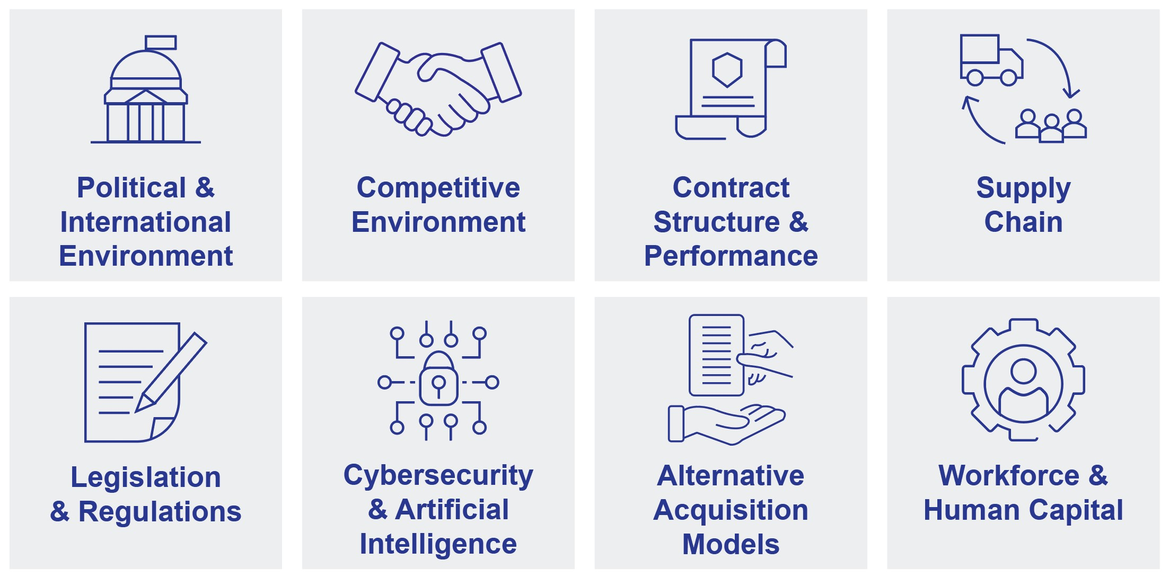

 |  |  | Evolving Risk Spotlight: Artificial Intelligence (AI)
For over 40 years, Northrop Grumman has been using AI in its operations and products and its groundbreaking impact continues to emerge. At Northrop Grumman, AI has the potential to transform every system, product and service that we produce for our customers, worldwide. The stakes are high—and our standards for ethics and security are even higher.
VALUES |  |  |  |  |  | GOVERNANCE
Our corporate values guide our innovation and set the stage for our five responsible AI principles to develop and design our AI systems and solutions: |  |  |  |  |  | A sophisticated AI governance framework is critical to help ensure robust oversight and accountability as we continue to use and evaluate new AI use cases within our organization.
HUMAN-CENTERED: We maintain meaningful human oversight and control over AI systems to confirm they perform to our standards.  SECURE: We protect and safeguard company, employee and customer data when using AI.  ACCOUNTABLE: We seek to ensure our AI is thoroughly documented to meet applicable standards and requirements.  ROBUST: We design and test our AI solutions for accuracy and identify and manage risks to maintain transparency.  ETHICAL: We partner across functions and with various stakeholders to identify and address potential ethical issues prior to deployment. |  |  |  |  |  | BOARD OVERSIGHT: Our Board provides oversight with respect to AI governance and receives periodic updates on the topic.
 |  |  |  |  |  | FOCUSED OVERSIGHT: Focused oversight of technology and AI-related risks are also reviewed with the Enterprise Risk Management Council.
 |  |  |  |  |  | AI GOVERNANCE FRAMEWORK: We have established cross-functional AI governance processes to review AI use cases for compliance with our internal AI policies, applicable laws and regulations, and industry best practices. Our governance processes include an enterprise-level AI governance board that reviews high risk use cases, as well as sector-level processes for reviewing use cases for mission applications.
 |  |  |  |  |  | POLICIES AND PROCEDURES: We have company policies and procedures regarding the requirements and processes for the responsible development, procurement, use, and governance of AI.
 |  |  |  |  |  | TRAINING: All employees are required to complete annual AI training, along with additional training to use certain applications.

30 |  |  | Northrop Grumman

Corporate Governance
Board Leadership Structure
Chair of the Board
Our Bylaws provide that our directors will designate a Chair of the Board from among its members. The Chair presides at all Board and shareholder meetings. The Chair interacts directly with all members of the Board and assists the Board to fulfill its responsibilities, including those related to risk oversight. As our Principles of Corporate Governance provide, the Board believes it is in the best interests of the Company and its shareholders for the Board to have flexibility to determine the best director to serve as Chair of the Board at the time, based on consideration of all relevant factors.
At least once every year, the Nominating and Corporate Governance Committee and the Board consider who is best suited to serve as Chair and whether that person should be an independent director given the circumstances at the time, including the external environment and needs of the Company. At its meeting in December 2025, the Board concluded that having Ms. Warden, our Chief Executive Officer, continue to serve as Chair is the most appropriate leadership structure for the Company at this time, and best positions the Company to be innovative, compete successfully, present one face to our customers and advance shareholder interests in today’s environment. The Board believes that Ms. Warden’s years of experience and her deep understanding of the Company’s business, day-to-day operations, growth opportunities, challenges and risk management practices gained through various leadership positions enable her to provide strong and effective leadership to the Board and to ensure that the Board is informed of important issues facing the Company. The Board consists entirely of independent directors, other than Ms. Warden, and continues to exercise a comprehensive, independent oversight function, with fully independent Board committees and a strong Lead Independent Director with clearly articulated responsibilities.
Lead Independent Director
If the Chair is not independent, our governance structure requires the independent directors to designate annually from among them a Lead Independent Director. Following our 2025 Annual Meeting, the independent directors designated Ms. Kleiner as Lead Independent Director. Upon Ms. Kleiner's retirement from the Board in May 2026, the independent directors have designated Mr. Turley as Lead Independent Director, subject to his re-election at the Annual Meeting. Mr. Turley brings extensive experience as both a CEO and in board leadership for a number of public companies to the role of Lead Independent Director. Mr. Turley served as Chairman and CEO of Ernst & Young, a global professional services organization, for twelve years. Following his retirement, Mr. Turley has served on the boards of a number of public, multi-national companies, including as the independent Board Chair of Emerson, a global software, engineering and technology company, the Lead Independent Director of Precigen, a biopharmaceutical company and as a member of the Board of Directors of Citigroup Inc., a global financial services company.
Our Principles of Corporate Governance explicitly prescribe a strong role for our Lead Independent Director, describing in detail significant responsibilities with respect to the operation and functioning of the Board and reflecting our commitment to robust corporate governance. The specific duties and responsibilities of the Lead Independent Director include the following:
•serve as the principal advisor to the Chair;
•authority to call, establish the agenda and review all the materials for, and chair all meetings of the Independent Directors, including executive sessions regularly scheduled at each full Board meeting, and special sessions of Independent Directors called in case of an emergency or matter requiring their separate consideration or decision;
•chair all other meetings of the Board at which the Chair is not present;
•regularly meet and consult with the Chair to provide independent oversight, as well as guidance and requests from Independent Directors; discuss the topics to be addressed during Board and Committee meetings; review agendas for upcoming Board and committee meetings, and discuss materials to be provided to Directors; review the results of recent Board meetings and agree to next steps; advise the Chair on decisions made by the Independent Directors in executive session and ensure implementation; and consult with the Chair more broadly to help ensure the Board’s effective exercise of governance, risk and oversight responsibilities;
•approve the schedule of Board and committee meetings to ensure there is significant opportunity for the Board to consider properly all necessary agenda items;
•serve as a liaison between the Chair and the Independent Directors;
•meet with shareholders and other stakeholders as appropriate;
•meet with senior management outside of Board meetings periodically and as requested;
•interview, along with the Chair and the Chair of the Nominating and Corporate Governance Committee, Board candidates and make recommendations to the Nominating and Corporate Governance Committee and the Board,
2026 Proxy Statement |  |  | 31

Corporate Governance
helping to prioritize the specific skill sets, diverse perspectives, experience and values that candidates for consideration should possess;
•coordinate with the Chair on the structure of committee membership and leadership;
•support the Chair to help facilitate succession planning and management development;
•lead the annual evaluation of the Chair and CEO;
•evaluate, along with the Chair, Nominating and Corporate Governance Committee (or Chair of the Board, as appropriate) whether a Board member's service on another company's board would interfere with such Board member's duties and responsibilities as a member of the Board;
•oversee, along with the Chair, Nominating and Corporate Governance Committee, the evaluation of the performance of the Board and meet with independent directors to discuss results of director peer evaluations; and
•perform such other duties as may be assigned by the Board.
Our Lead Independent Director plays a critical role in reviewing director feedback received through the annual director evaluation process and providing feedback to each director on their individual performance. Our Lead Independent Director is empowered to, and does, actively engage with our Chair and Chief Executive Officer to help enable a strong and effective Board of Directors.

32 |  |  | Northrop Grumman

Corporate Governance
Committees of the Board
The Board has four standing committees: the Audit and Risk Committee, the Compensation and Human Capital Committee, the Nominating and Corporate Governance Committee and the Policy Committee. The membership of these committees is typically determined at the organizational meeting of the Board held in conjunction with the annual meeting. All the committees are composed entirely of independent directors. The primary responsibilities of each of the committees, as of the date of this Proxy Statement, are summarized below, together with a table listing the membership and Chair of each committee. The charters for each standing committee can be found on the Investor Relations section of our website (www.northropgrumman.com).
ROLES AND RESPONSIBILITIES
Assist the Board in overseeing, among other things, the integrity of the Company’s financial statements and enterprise risk management, including by:
•reviewing and discussing the Company’s Annual Report on Form 10-K and Quarterly Reports on Form 10-Q
•reviewing and discussing management’s assessment of, and report on, the effectiveness of the Company’s internal control over financial reporting at least annually and the independent auditor's related report
•assisting the Board in its oversight of enterprise risk management (including through the different Board committees), including reviewing at least annually the Company's enterprise risk management processes
•appointing, retaining, overseeing, evaluating and terminating, if necessary, the independent auditor; reviewing the performance of the lead audit partner and overseeing the selection and approval of the lead audit partner
•reviewing and pre-approving audit and permitted non-audit services and related fees for the independent auditor
•reviewing and discussing with the independent auditor any critical audit matters identified by the independent auditor, the Company’s critical accounting policies and estimates, and material written communications with management
•reviewing and approving the annual risk-based internal audit plan and reviewing any significant issues raised by the internal audit function and, as appropriate, management’s actions for remediation
•reviewing with the General Counsel, at least annually, the status of significant pending litigation and other significant legal, compliance or regulatory matters
•reviewing with the Chief Ethics and Compliance Officer (CECO), at least annually, the state of the Company’s global compliance program and policies
•receiving reports periodically from the CECO on the Company’s ethics programs and policies, including contacts received through the Company’s OpenLine reporting system
•providing oversight and reviewing periodically the Company’s assessment and management of its financial risks, including those related to, among other things, insurance, nuclear, and environmental matters
•providing oversight and reviewing periodically the Company’s assessment and management of cybersecurity risks
•providing oversight of audit and assurance processes for sustainability reporting and related internal controls over publicly reported data

Audit and Risk Committee
COMMITTEE MEMBERS:
Thomas M. Schoewe† (chair)
Marianne C. Brown
Ann M. Fudge
Christopher W. Grady*
Kimberly A. Ross†
James S. Turley†
Mark A. Welsh III
Number of meetings in 2025: 8
† Qualifies as Audit Committee Financial Expert; all members are financially literate.
* Adm. Grady joined the Committee in February 2026.
2026 Proxy Statement |  |  | 33

Corporate Governance
ROLES AND RESPONSIBILITIES
Assist the Board in overseeing the Company’s compensation and human capital-related policies and practices, including by:
•overseeing and reviewing at least annually a risk assessment of the Company’s compensation programs, helping to ensure, among other factors, that compensation appropriately reflects Company priorities
•reviewing and approving the compensation for elected officers (other than the Chief Executive Officer, whose compensation is recommended by the Committee and approved or ratified by the independent directors)
•reviewing incentive and equity compensation plans, approving annual and long-term performance goals under such plans (including financial and non-financial metrics) and approving payments or grants under these plans for elected officers (other than the Chief Executive Officer, whose payments or grants are recommended by the Committee and approved or ratified by the independent directors)
•recommending for approval compensation for the non-employee directors, after consultation with the independent compensation consultant
•overseeing and reviewing the Company’s management of its human capital risk, including risks related to talent acquisition and retention
•overseeing and reviewing the Company’s policies and practices with respect to employee experience and engagement
•conducting an annual evaluation of the compensation consultant and reporting results of the evaluation to the Board
•preparing a Compensation and Human Capital Committee Report for inclusion in the Company's proxy statement
•establishing stock ownership guidelines and reviewing ownership levels on an annual basis
Compensation and Human Capital Committee
COMMITTEE MEMBERS:
David P. Abney (chair)
Madeleine A. Kleiner
Arvind Krishna
Gary Roughead
Mary A. Winston

Number of meetings in 2025: 6

Compensation and Human Capital Committee:
Interlocks and Insider Participation
During 2025, Ms. Kleiner, Ms. Winston and Messrs. Abney, Krishna and Roughead served as members of the Compensation and Human Capital Committee. Graham N. Robinson, who did not stand for re-election at our 2025 Annual Meeting, also served as a member of the Compensation and Human Capital Committee until his term ended in May 2025. During 2025, no member of the Compensation and Human Capital Committee had a relationship with the Company or any of our subsidiaries, other than as directors and shareholders, and no member was an officer or employee of the Company or any of our subsidiaries, a participant in a related person transaction or an executive officer of another entity, where one of our executive officers serves on the board of directors that would constitute a related person transaction or raise concerns of a compensation committee interlock.
34 |  |  | Northrop Grumman

Corporate Governance
ROLES AND RESPONSIBILITIES
Assist the Board in overseeing the Company’s corporate governance policies and practices, including by:
•overseeing and reviewing the Company’s management of governance-related risks, including the risks related to corporate culture
•assisting the Board in developing and maintaining a comprehensive and effective framework for Board oversight
•regularly reviewing the Company’s corporate governance policies and practices, including the Company’s bylaws, charter and certain other corporate governance documents
•regularly reviewing and considering corporate governance developments, emerging trends and best practices and recommending changes to the Board
•reviewing and making recommendations to the Board with respect to the corporate governance section of the proxy statement, including proposed responses to any shareholder proposals
•meeting with shareholders, proxy advisory groups and other stakeholders, as needed, to discuss issues of corporate governance
•reviewing and making recommendations to the Board regarding the composition and size of the Board and the criteria for Board membership
•discussing Board succession planning, identifying and recommending to the Board qualified potential candidates to serve on the Board and its committees, including reviewing candidates who are recommended by shareholders
•reviewing and determining (through the Chair of the committee) whether a director’s service on another board or elsewhere would interfere with the director’s duties and responsibilities as a member of the Board
•developing, recommending to the Board, and overseeing implementation of a robust annual performance evaluation process that includes an evaluation of each individual director, each committee and of the full Board's performance
Nominating and Corporate Governance Committee
COMMITTEE MEMBERS:
Marianne C. Brown (chair)
David P. Abney
Madeleine A. Kleiner
Thomas M. Schoewe
James S. Turley
Number of meetings in 2025: 6

ROLES AND RESPONSIBILITIES
Assist the Board in reviewing, among other things, policy, government relations and corporate responsibility matters, including by:
•reviewing and providing input on select global security, political, budgetary, technological and other similar issues and trends that could significantly impact the Company’s business activities and performance
•reviewing and providing oversight of the Company’s environmental and sustainability policies and programs and reviewing with the Company’s Chief Environment, Quality and Safety Officer at least annually the status of such programs
•reviewing and providing oversight of the Company’s policies supporting health and safety and human rights, and receiving updates from the Chair of the Human Rights Working Group (or his or her designee) on the Company’s human rights program
•reviewing and providing oversight over the Company’s policies and programs for corporate social responsibility, including community relations programs and support of charitable organizations
•reviewing the Company’s communications and advertising strategy
•reviewing the Company’s government relations strategy and providing oversight of the governance and compliance of the political action committee and policies and practices with respect to political contributions
Policy Committee
COMMITTEE MEMBERS:
Gary Roughead (chair)
Ann M. Fudge
Christopher W. Grady*
Arvind Krishna
Kimberly A. Ross
Mark A. Welsh III
Mary A. Winston

Number of meetings in 2025: 4

* Adm. Grady joined the Committee in February 2026.

2026 Proxy Statement |  |  | 35

Corporate Governance
Board Meetings and Executive Sessions
The Board meets no fewer than seven times each year (including via telephonic meetings). Special meetings of the Board may be called from time to time as appropriate. On an annual basis, the Board holds an extended meeting to review our long-term strategy.
The Board often holds its meetings at Company locations other than our corporate headquarters to provide the directors with a first-hand view of different elements of our business and an opportunity to interact with local management and employees at various levels.
The Board meets in executive session (with the directors only and then with the independent directors only) following each in-person Board meeting and on other occasions as needed. The Lead Independent Director presides over the executive sessions of the independent directors. The Audit and Risk Committee meets in executive session at least four times each year, and regularly requests separate executive sessions with representatives of our independent auditor and our senior management, including our Chief Financial Officer, General Counsel and our Vice President, Internal Audit. The Compensation and Human Capital Committee also meets in executive session from time to time and regularly receives a report from the Compensation and Human Capital Committee’s independent compensation consultant. The Nominating and Corporate Governance and Policy Committees also meet in executive session as they deem necessary.
Meeting Attendance
In 2025, the Board held ten meetings. Each director serving in 2025 attended 75% or more of the meetings of the Board and the committees on which he or she served during 2025, with the average attendance for all Board and committee meetings being approximately 97%. Board members are expected to attend each annual meeting, except where the failure to attend is due to unavoidable circumstances. All of our directors, other than Mr. Robinson, who did not seek re-election to the Board, attended our 2025 Annual Meeting.

Director Orientation and Continuing Education
Our comprehensive director orientation, continuing education initiatives and site visits help strengthen our Board's oversight function by ensuring that each of our directors have a deep understanding of our Company (including our mission, our customers and the trends that impact our business) and our shareholders and their priorities.
NEW DIRECTOR  ORIENTATION |  |  | •All new directors to the Board receive in-person orientation and training that is individually tailored, taking into account the director’s experience, background, education and committee assignments. The orientation program is led by members of senior management and covers a review of our strategy and operating plans, financial statements, corporate governance and key policies and practices, as well as the roles and responsibilities of our directors.  •All directors receive regular in-person training regarding our Company policies and procedures, including the Standards of Business Conduct, and broad exposure to our operations and teams. Members of senior management review with the Board the operating plan for each of our business sectors and the Company as a whole.
CONTINUING  DIRECTOR EDUCATION |  |  | •Directors attend continuing education programs to assist them in staying current on developments in corporate governance, our industry, the global environment and issues critical to the operation of our company.  •In addition to the programs our directors identify independently, the Company also provides our directors with suggestions for continuing educational opportunities, including in emerging and dynamic areas.  •In 2025, our directors had educational opportunities in a number of diverse topics, including risk management, artificial intelligence, governance accountability, cybersecurity, strategy, complex decision-making, and a number of other relevant topics.
SITE VISITS |  |  | •The Board also conducts periodic site visits to our facilities as part of its regularly scheduled Board meetings, and during “Sector Days,” when our directors visit our business operations to meet with local employees and management. These visits allow directors to interact with a broader group of our executives and employees and gain firsthand insights into our operations.

36 |  |  | Northrop Grumman

Corporate Governance
Director Independence
The Board and the Nominating and Corporate Governance Committee annually review the relevant relationships and arrangements between the Company and our directors and parties related to our directors in determining whether such directors are independent. No director is considered independent unless the Board has determined that the director meets the independence requirements under applicable New York Stock Exchange (NYSE) and SEC rules and under our categorical independence standards, which are described in our Principles of Corporate Governance. For a director to be considered independent, the Board must determine that a director has no material relationship with the Company other than as a director.
Our Principles of Corporate Governance provide that a director may be found not to qualify as an independent director if the director:
•has within the prior three years been a director, executive officer or trustee of a charitable organization that received annual contributions from the Company exceeding the greater of $1 million or 2% of the charitable organization’s annual gross revenues, where the gifts were not normal matching charitable gifts, did not go through normal corporate charitable donation approval processes or were made “on behalf of” a director;
•has, or has an immediate family member who has, within the prior three years been employed by, a partner in or otherwise affiliated with any law firm or investment bank in which the director’s or the immediate family member’s compensation was contingent on the services performed for the Company or in which the director or the immediate family member personally performed services for the Company and the annual fees paid by the Company during the preceding fiscal year exceeded the greater of $1 million or 2% of the gross annual revenues of such firm; or
•has, or has an immediate family member who has, within the prior three years owned, either directly or indirectly as a partner, shareholder or officer of another company, more than 5% of the equity of an organization that has a material business relationship with (including as a significant purchaser or supplier of goods or services), or more than 5% ownership in, the Company.
Independence Determination
In connection with their annual independence review, the Board and Nominating and Corporate Governance Committee considered certain relationships with organizations to which we have made payments or from which we have received payments in the usual course of our business in 2025. The Board of Directors considered that Mr. Abney, Ms. Brown, Ms. Fudge, Mr. Krishna, Mr. Robinson, Ms. Ross, Adm. Roughead, Mr. Schoewe, Mr. Turley, Gen. Welsh and Ms. Winston served as members of the board of directors or trustees and/or employees or executive officers of companies with which we do business or have made payments in the ordinary course.
The Board of Directors considered that Adm. Grady, Ms. Ross and Adm. Roughead served as members of the boards of organizations to which the Company made contributions during 2025 in the usual course of our charitable contributions program, or in connection with our matching gifts program (which limits the contributions to $10,000 per year per director). The amounts paid were below the applicable thresholds under NYSE rules and our Principles of Corporate Governance.
Following its review and the recommendation of the Nominating and Corporate Governance Committee, the Board affirmatively determined that, except Ms. Warden, all of the directors (Mr. Abney, Ms. Brown, Ms. Fudge, Adm. Grady, Ms. Kleiner, Mr. Krishna, Ms. Ross, Adm. Roughead, Mr. Schoewe, Mr. Turley, Gen. Welsh, and Ms. Winston) are independent. In addition, the Board of Directors determined that Mr. Robinson, who did not stand for re-election at our 2025 Annual Meeting, was independent while he served on the Board during fiscal year 2025. The independent directors, including Ms. Kleiner and Ms. Fudge, who are not standing for re-election at the 2026 Annual Meeting, constitute over 92% of the members of our Board. In addition, the Board determined that each member of the Audit and Risk Committee and the Compensation and Human Capital Committee meets the additional, heightened independence criteria applicable to such committee members under the NYSE rules.

2026 Proxy Statement |  |  | 37

Corporate Governance
Our Culture
Our strong culture — founded on our values; reflecting our commitment to ethics and integrity; enabling our employees to feel respected, included, and that they belong so they can perform at their best; and focused on enduring performance, innovation, agility and accountability — enables our success and long-term sustainable growth. Culture is critical to who we are and how we do business. Our values guide our Company and provide the foundation for our culture. Our culture and values serve as an enabling force that helps us pioneer, perform and deliver on quality, which results in value for our shareholders, customers, and employees. Our entire Company shares the responsibility to maintain and enhance it.
Management establishes and reinforces the Company’s culture, and our Board is actively engaged in providing oversight. The Board is committed to sustaining and enhancing the Company’s strong and enduring culture. For example:
•The Company conducts an annual employee experience survey, which gives our employees the opportunity to provide feedback on our Company culture and the environment that enables their success. This confidential survey assesses many aspects of the employee experience, including ethical climate, career development, enablement, team culture, manager effectiveness, belonging and well-being. The results of this survey are compared to external benchmarks and shared with the full Board annually.
•The Board meets with employees during site visits that are a critical part of Board meetings, and also during “Sector Days,” when our Board of Directors visits the operations across our four business sectors.
•Members of our Board often share their time by generously participating as speakers in Company leadership programs.
The Board’s committees oversee elements of the Company’s culture associated with their respective area of responsibility. For example:
•The Audit and Risk Committee reviews and discusses the Company’s global compliance programs and policies with our General Counsel and Chief Ethics and Compliance Officer, including the Company’s Standards of Business Conduct and related business conduct policies, and the tone set by leaders throughout the organization, and they meet periodically with our Chief Ethics and Compliance Officer to receive a report on matters that are communicated through the Company's OpenLine reporting system.
•The Compensation and Human Capital Committee reviews with the CHRO the Company’s human capital management, oversees policies and practices with respect to employee experience and engagement and reviews a risk assessment of the Company’s compensation programs.
•The Nominating and Corporate Governance Committee provides the Board oversight of the Company’s corporate culture and governance-related risks.
•The Policy Committee reviews and provides oversight of the Company's policies and programs with respect to environmental and sustainability matters, human rights, health and safety, and corporate social responsibility, including support of charitable organizations.

38 |  |  | Northrop Grumman

Corporate Governance
Board Memberships and External Relationships
While the Company recognizes the importance of having directors with significant experience in other businesses and activities, directors are required to ensure that other commitments, including, for example, other board memberships, employment, partnerships and consulting arrangements, do not interfere with their duties and responsibilities as members of the Board. Under our Principles of Corporate Governance, directors are required to provide notice to the General Counsel prior to accepting an invitation to serve on the board of any other organization or agreeing to other new commitments that could interfere with their duties and responsibilities as a member of our Board. The General Counsel then advises the Chair of the Nominating and Corporate Governance Committee (or the Chair of the Board, if notice is from the Chair of the Nominating and Corporate Governance Committee) and the Lead Independent Director. Our policies provide that a director should not accept the new commitment until advised by the Chair of the Nominating and Corporate Governance Committee (or Chair of the Board, as appropriate) that such engagement will not create unacceptable conflicts of interest or regulatory issues, conflict with Company policies or otherwise interfere with the director’s duties and responsibilities as a member of our Board. Directors are also required to promptly inform the General Counsel if an actual or potential conflict of interest arises, or they are concerned that a conflict may arise or circumstances exist that could otherwise interfere with their duties and responsibilities as a director. Directors are required to seek to avoid even an appearance of a conflict of interest.
Additionally, when a director’s principal occupation or business association changes substantially during his or her tenure as a director, our policies provide that the Board expects the director to tender his or her resignation for consideration by the Nominating and Corporate Governance Committee, which subsequently will recommend to the Board what action to take.
Director Overboarding
The Board regularly reviews the ability of our directors to devote the necessary time and resources to their service on the Board. At least annually, the Board considers the outside time commitments of all directors, including their service on other public company boards, as well as committee assignments and any leadership roles on those boards. Additionally, as part of the Board's annual self-assessment process, each non-employee director completes an individual director evaluation for each of the other non-employee directors. This evaluation includes an assessment as to whether each director commits sufficient time to the Board.
Our Board seeks to ensure that each director has the time and ability to engage fully and meaningfully to fulfill their responsibilities to our Company, provide effective oversight and advance the long-term interests of our shareholders.
In furtherance of this goal, our policies provide that independent directors may not serve on more than three other boards of publicly traded companies in addition to our Board, and a director who is a full-time employee of our Company may not serve on the board of more than one other public company, absent special approval.
Further, as discussed above, the Board and the Nominating and Corporate Governance Committee also have a robust process for assessing whether a director’s service on another board could create conflicts or otherwise potentially interfere with their responsibilities as a director, before the director accepts service on such other board.
In 2025, the Board conducted its regular review of directors’ other commitments and determined each director was in compliance with applicable policies.

2026 Proxy Statement |  |  | 39

Corporate Governance
Annual Self-Assessment Process
Each year, the Board conducts thorough self-assessment processes at each of the full Board level, within each committee, and at the individual director level. These processes are designed to ensure and enhance the effective operation of the Board. These evaluations also assist the Nominating and Corporate Governance Committee with its recommendation for directors to be renominated for election to the Board of Directors.
BOARD  EVALUATION |  |  | The self-assessment of the full Board is overseen by the Nominating and Corporate Governance Committee. As part of this assessment, the Lead Independent Director and Chair of the Nominating and Corporate Governance Committee facilitate a broad discussion of Board performance, held in executive session. Among other topics, the Board considers:  •the Board’s effectiveness in evaluating and monitoring the Company’s business plan, long-term strategy and risks;  •whether strategic and critical issues are being addressed by the Board in a timely manner;  •whether the Board’s expectations and concerns are openly communicated to and discussed with the Chief Executive Officer;  •whether there is adequate contact between the Board and members of senior management;  •whether the directors collectively operate effectively as a Board;  •whether the individual directors have the appropriate mix of attributes and skills to fulfill their duties as directors of the Company;  •whether there are adequate opportunities to raise questions and comments on issues, both inside and outside of Board meetings;  •whether the Board has focused adequately on succession planning; and  •whether the Board is adequately responsive to shareholder communication.  Following this review, the Board discusses the results and identifies opportunities for improvement, including any necessary steps to implement such improvements.
COMMITTEE  EVALUATION |  |  | Each of the Committees also conducts an annual self-assessment. During an executive session led by the Committee chair, each Committee considers, among other topics: whether the quality of participation and discussion at the Committee meetings is effective in facilitating the Committee’s fulfillment of its obligations under its charter; whether the Committee has sufficient opportunity to engage in strategic discussion; and whether the Committee is covering the right topics in the right amount of detail. Following this discussion, the Committee develops and implements a list of action items, as appropriate.
INDIVIDUAL  DIRECTOR  EVALUATION |  |  | Also as part of the annual self-assessment process, in 2025 each non-employee director completed an individual director evaluation for each of the other non-employee directors. These evaluations addressed various aspects of how each director contributed to the Board and served our shareholders. The evaluation results were compiled and provided directly to the Chair, the Lead Independent Director and the Chair of the Nominating and Corporate Governance Committee. These assessments included, among other topics, each non-employee director’s:  •understanding of the Company’s overall business and risk profile and its significant financial opportunities and plans;  •engagement during meetings and ability to commit sufficient time to the Board;  •analysis of benefits and risks of courses of action considered by the Board; and  •appropriate respect for the views of other Board members.  The Lead Independent Director or the Chair of the Nominating and Corporate Governance Committee met with each non-employee director individually to discuss the results of his or her assessment, including comments provided by other non-employee directors, and opportunities for growth.
SELF-ASSESSMENT  FEEDBACK |  |  | The Lead Independent Director or the Chair of the Nominating and Corporate Governance Committee reports generally on the overall results of these discussions to the Board in executive session. These evaluations also assist the Nominating and Corporate Governance Committee with its recommendation for directors to be renominated for election to the Board of Directors.

40 |  |  | Northrop Grumman

Corporate Governance
Succession Planning
The Board believes that providing for strong and effective continuity of leadership is critical to the success of our Company. The Board commits significant resources to ongoing, proactive succession planning, with processes in place for the Board to:
•evaluate the Chief Executive Officer annually based on a specific set of performance objectives;
•work with the Chief Executive Officer to support and ensure the development of potential succession candidates for the Chief Executive Officer and other leadership positions;
•discuss with the Chief Executive Officer annually an assessment of persons considered potential successors to various senior management positions; and
•thoroughly consider, plan for and ensure successful transitions of leadership.
Additionally, the Nominating and Corporate Governance Committee continuously assesses the composition of the Board and its future needs. The Committee regularly reviews the background, experience, engagement, skills, values and other attributes of current and potential future directors, considering the Company’s requirements for an effective Board and identifying potential current and future gaps.

Communications with the Board of Directors
Any interested person may communicate with any of our directors, our Board as a group, our non-employee directors as a group or our Lead Independent Director through the Corporate Secretary by writing to the following address: Office of the Corporate Secretary, Northrop Grumman Corporation, 2980 Fairview Park Drive, Falls Church, Virginia 22042. The Corporate Secretary will forward correspondence to the director or directors to whom it is addressed, except for job inquiries, surveys, business solicitations or advertisements and other inappropriate material. The Corporate Secretary may forward certain correspondence elsewhere within our Company for review and possible response.
The Board has met with, and looks forward to the opportunity to meet with, interested shareholders to address concerns and to receive input.
Interested persons may also report any concerns relating to accounting matters, internal accounting controls or auditing matters to non-management directors (including anonymously) by writing to the Chair of the Audit and Risk Committee, Northrop Grumman Board of Directors c/o Corporate Ethics and Compliance Office, 2980 Fairview Park Drive, Falls Church, Virginia 22042.

2026 Proxy Statement |  |  | 41

Compensation of Directors
In May 2025, the Compensation and Human Capital Committee recommended to the Board, and the Board approved, the current non-employee director fee structure, effective May 21, 2025. The current fee structure is the same as was approved in May 2024. The table below lists the annual fees payable to our non-employee directors from January 1, 2025 to December 31, 2025.
Name |  |  | Amount ($)  (1/1/25 - 12/31/25)
Annual Cash Retainer |  |  | 145,000
Lead Independent Director Retainer |  |  | 50,000
Committee Chair Retainer |  |  | 25,000
Audit and Risk Committee Retainer |  |  | 15,000
Annual Equity Grant |  |  | 182,500(1)
(1)The annual equity grant is deferred into a stock unit account pursuant to the 2024 Long-Term Incentive Stock Plan (2024 Plan) as described below. The Northrop Grumman Corporation Equity Grant Program for Non-Employee Directors (amended and restated effective May 15, 2024) sets forth the terms and conditions of the equity awards granted to non-employee directors under the 2024 Plan.

Current Non-Employee Director Fees |  |  | Current Additional Annual Fees
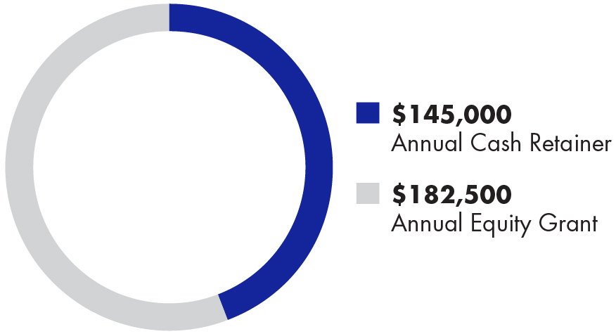 |  |  | 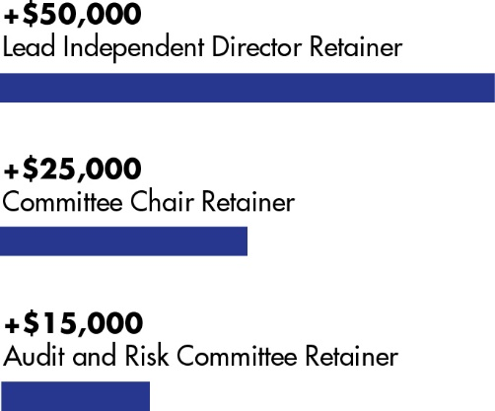
Retainer fees are paid on a quarterly basis at the end of each quarter.
To encourage directors to have a direct and material investment in shares of our common stock, non-employee directors are awarded an annual equity grant of $182,500 in the form of deferred stock units (Automatic Stock Units).
The Compensation and Human Capital Committee, with the assistance of its independent compensation consultant, is responsible for reviewing and recommending for Board approval the compensation of the non-employee directors. At the request of the Compensation and Human Capital Committee, the independent compensation consultant prepares annually a comprehensive benchmarking of our non-employee director compensation program against the compensation programs offered by our Target Industry Peer Group (the same peer group against which executive compensation is compared). Consistent with this benchmarking, the overarching approach for non-employee director compensation is to target approximately the 50th percentile of the Target Industry Peer Group and to align our director compensation with our shareholders’ interests.
42 |  |  | Northrop Grumman

Compensation of Directors
Awards to non-employee directors are made pursuant to the Northrop Grumman Corporation Equity Grant Program for Non-Employee Directors (the Director Program). The Director Program was amended and restated effective May 15, 2024, consistent with the shareholder-approved 2024 Plan (the Restated Director Program). Non-employee directors received an annual equity grant of Automatic Stock Units on July 31, 2024 which vested on May 15, 2025. Non-employee directors received an annual equity grant of Automatic Stock Units on May 21, 2025 which will vest on May 21, 2026. Under the Restated Director Program, directors may elect to have all or any portion of their Automatic Stock Units paid on (A) the earlier of (i) the beginning of a specified calendar year after the vesting date or (ii) their separation from service as a member of the Board, or (B) the vesting date. Directors may elect to defer to a later year all or a portion of their remaining cash retainer or committee retainer fees into a stock unit account as Elective Stock Units or in alternative investment options. Elective Stock Units are awarded on a quarterly basis. Directors may elect to have all or a portion of their Elective Stock Units paid on the earlier of (i) the beginning of a specified calendar year or (ii) their separation from service as a member of the Board. Stock units awarded under the Restated Director Program will be paid out in an equivalent number of shares of our common stock. Deferral elections are made prior to the beginning of the year for which the retainer fees will be paid. Directors are credited with dividend equivalents in connection with the accumulated stock units until the shares of common stock related to such stock units are issued.
Non-employee directors are also eligible to participate in our Matching Gifts Program for Education. Under this program, the Northrop Grumman Foundation matches director contributions, up to $10,000 per year per director, to eligible educational programs in accordance with the program.
Stock Ownership Requirements
Non-employee directors are required to own common stock of the Company in an amount equal to five times the annual cash retainer, with such ownership to be achieved within five years of the director’s election to the Board. Deferred stock units and Company stock owned outright by the director count towards this requirement.
Anti-Hedging and Pledging Policy
Company policy prohibits our directors, NEOs, other elected and appointed officers, designated employees who are subject to specific preclearance procedures under the Company’s insider trading policy and certain other employees who receive performance-based compensation, from engaging in hedging, pledging or other specified transactions. Specifically, this policy prohibits such persons from: engaging in hedging or derivative transactions, such as “cashless” collars, forward contracts, equity swaps or other similar or related transactions; entering into margin transactions involving Company stock; pledging Company securities as collateral for loans or other transactions; trading in puts, calls, options, warrants or other similar derivative instruments involving Company securities; or engaging in short sales of Company securities.
None of the shares of Company common stock held by our directors are pledged or subject to any hedging transaction.

2026 Proxy Statement |  |  | 43

Compensation of Directors
2025 Director Compensation
The table below provides information on the compensation of our non-employee directors for the year ended December 31, 2025.

Name |  |  | Fees Earned or  Paid in Cash(1)  ($) |  |  | Stock  Awards(2)  ($) |  |  | All Other  Compensation(3)  ($) |  |  | Total  ($)
David P. Abney |  |  | 170,000 |  |  | 182,500 |  |  | 18 |  |  | 352,518
Marianne C. Brown |  |  | 185,000 |  |  | 182,500 |  |  | 18,285 |  |  | 385,785
Ann M. Fudge |  |  | 160,000 |  |  | 182,500 |  |  | 13,550 |  |  | 356,050
Christopher W. Grady(4) |  |  | — |  |  | — |  |  | — |  |  | —
Madeleine A. Kleiner |  |  | 195,000 |  |  | 182,500 |  |  | 37,099 |  |  | 414,599
Arvind Krishna |  |  | 145,000 |  |  | 182,500 |  |  | 382 |  |  | 327,882
Graham N. Robinson(5) |  |  | 56,550 |  |  | — |  |  | 119 |  |  | 56,669
Kimberly A. Ross |  |  | 160,000 |  |  | 182,500 |  |  | 10,215 |  |  | 352,715
Gary Roughead |  |  | 170,000 |  |  | 182,500 |  |  | 24,208 |  |  | 376,708
Thomas M. Schoewe |  |  | 185,000 |  |  | 182,500 |  |  | 16,892 |  |  | 384,392
James S. Turley |  |  | 160,000 |  |  | 182,500 |  |  | 4,542 |  |  | 347,042
Mark A. Welsh III |  |  | 160,000 |  |  | 182,500 |  |  | 3,053 |  |  | 345,553
Mary A. Winston |  |  | 145,000 |  |  | 182,500 |  |  | 193 |  |  | 327,693
(1)Amounts reflect the annual cash retainer paid to each director, including any applicable annual committee and committee chair retainers and any applicable Lead Independent Director or Chair retainer. As described above, a director may elect to defer all or a portion of his or her annual cash retainer into a deferred stock unit account or alternative investment options. Amounts earned for 2025 and deferred as Elective Stock Units or deferred into alternative investment options are reflected in this column.
(2)The amount reported for each director reflects the aggregate fair value of the Automatic Stock Units on the grant date, as determined under Financial Accounting Standards Board Accounting Standards Codification Topic 718, Stock Compensation, excluding any assumed forfeitures, and are calculated using the closing market price of the Company’s common stock on the date of grant. The grant date fair value assumes the value of dividend equivalents accrued directly on the awarded units, though it does not include the estimated dollar value of additional stock units credited as a result of dividend equivalents earned, directly or indirectly, on reinvested dividend equivalents. The aggregate number of Automatic Stock Units and Elective Stock Units held by each director as of December 31, 2025 is provided in the Deferred Stock Units table below.
(3)Amounts reflect (i) the estimated dollar value of additional stock units credited to each non-employee director as a result of dividend equivalents earned, directly or indirectly, on reinvested dividend equivalents and (ii) matching contributions made through our Matching Gifts Program for Education discussed above as follows: Ms. Brown, $10,000; Ms. Fudge, $10,000; Ms. Ross, $10,000 and Mr. Roughead, $10,000.
(4)Adm. Grady was elected to the Board of Directors effective February 12, 2026.
(5)Mr. Robinson did not seek re-election at the 2025 Annual Meeting of Shareholders.

44 |  |  | Northrop Grumman

Compensation of Directors
Deferred Stock Units
As of December 31, 2025, the non-employee directors had the following aggregate number of deferred stock units accumulated in their deferral accounts for all years of service as a director, including additional stock units credited as a result of dividend equivalents earned on the stock units.
Name |  |  | Automatic Stock  Units |  |  | Elective Stock  Units |  |  | Total
David P. Abney |  |  | 391 |  |  | — |  |  | 391
Marianne C. Brown |  |  | 6,359 |  |  | 4,604 |  |  | 10,963
Ann M. Fudge |  |  | 4,133 |  |  | 541 |  |  | 4,674
Christopher W. Grady(1) |  |  | — |  |  | — |  |  | —
Madeleine A. Kleiner |  |  | 21,275 |  |  | — |  |  | 21,275
Arvind Krishna |  |  | 1,369 |  |  | 888 |  |  | 2,257
Graham N. Robinson(2) |  |  | — |  |  | — |  |  | —
Kimberly A. Ross |  |  | 1,259 |  |  | — |  |  | 1,259
Gary Roughead |  |  | 11,823 |  |  | — |  |  | 11,823
Thomas M. Schoewe |  |  | 13,186 |  |  | — |  |  | 13,186
James S. Turley |  |  | 5,736 |  |  | — |  |  | 5,736
Mark A. Welsh III |  |  | 4,012 |  |  | — |  |  | 4,012
Mary A. Winston |  |  | 1,187 |  |  | — |  |  | 1,187

(1) Adm. Grady was elected to the Board of Directors effective February 12, 2026.
(2) Mr. Robinson did not seek re-election at the 2025 Annual Meeting of Shareholders. All stock units were paid out to him in the form of common stock after his departure from the Board in May 2025.

2026 Proxy Statement |  |  | 45

Proposal 2: Advisory Vote to Approve Compensation of Named Executive Officers
Consistent with Section 14A of the Exchange Act, we are providing our shareholders with the opportunity to cast a non-binding, advisory vote to approve the compensation of our NEOs. This advisory vote, commonly known as “say-on-pay,” gives our shareholders the opportunity to express their views on our 2025 executive compensation programs and policies for our NEOs. The vote does not address any specific item of compensation and is not binding on the Board; however, as an expression of our shareholders’ views, the Compensation and Human Capital Committee seriously considers the vote when making future executive compensation decisions. The Board has adopted a policy of providing for annual advisory votes on the compensation of our NEOs and, thus, the next vote following the Annual Meeting is expected to be held at the 2027 Annual Meeting of Shareholders.
We believe our compensation programs reflect responsible, measured practices that effectively incentivize our executives to dedicate themselves fully to value creation for our shareholders, customers and employees. Our pay practices are aligned with our shareholders’ interests and with leading industry practice and are governed by a set of strong policies. Examples include:
•Double-trigger provisions for change in control situations, and no excise tax gross-ups for payments upon termination after a change in control;
•A recoupment policy applicable to performance based or time-based long-term cash and equity incentive compensation payments;
•Stock ownership guidelines of 7x base salary for the CEO and 3x base salary for other NEOs, and stock holding requirements of three years from the date paid for 50% of all net after-tax shares received; and
•Prohibitions on hedging or pledging of Company stock.
For a more extensive list of our best practices, refer to page 52 of this Proxy Statement. In addition, our Compensation Discussion and Analysis (CD&A) provides a detailed discussion of our performance-based approach to executive compensation. We encourage you to read the CD&A, the rest of this Proxy Statement and our 2025 Form 10-K, which describes our business and 2025 results in more detail.
Recommendation
The compensation of our executives is aligned to performance, is sensitive to shareholder returns, appropriately motivates and retains our executives, and is a competitive advantage in attracting and retaining the high caliber talent necessary to drive our business forward and build sustainable value for our shareholders. Accordingly, the Board recommends that shareholders approve the following resolution:
“RESOLVED, that, as an advisory matter, the shareholders of Northrop Grumman Corporation approve the compensation paid to the Company’s named executive officers as disclosed in this Proxy Statement pursuant to Item 402 of Regulation S-K, including the CD&A, compensation tables and narrative discussion.”
Vote Required
Approval of this proposal requires that the votes cast “for” the proposal exceed the votes cast “against” the proposal. Abstentions and broker non-votes will have no effect on this proposal.
THE BOARD OF DIRECTORS UNANIMOUSLY RECOMMENDS THAT YOU VOTE “FOR” PROPOSAL 2.

46 |  |  | Northrop Grumman

Executive Compensation

Compensation Discussion & Analysis
2025 Named Executive Officers (NEOs)
 |  |  | Kathy J. Warden  Chair, Chief Executive Officer and President |  |  |  |  |  | Kenneth B. Crews  Former Corporate Vice President and Chief Financial Officer(1) |  |  |  |  |  | Robert J. Fleming  Corporate Vice President and President, Space Systems
 |  |  | Thomas H. Jones  Corporate Vice President and President, Aeronautics Systems |  |  |  |  |  | Roshan S. Roeder  Corporate Vice President and President, Mission Systems
(1) Mr. Crews was the Corporate Vice President and Chief Financial Officer in 2025. He stepped down from this position effective January 7, 2026 and left the Company February 20, 2026. Mr. John Greene was appointed Corporate Vice President and Chief Financial Officer effective January 7, 2026.

2026 Proxy Statement |  |  | 47

Executive Compensation
Compensation Philosophy and Objectives
We provide attractive, flexible and market-based total compensation programs tied to performance and aligned with the interests of our shareholders. Our objective is to recruit and retain the caliber of executives and other key employees capable of achieving top performance and generating value for our shareholders, customers and employees.
Our goal is to lead our industry in delivery of capability with increased speed and scale aligned with customer strategic objectives, sustainable performance and build on our strong, enduring values. For our performance-based plans, we select metrics that drive shareholder value and benchmark our performance against peers, the market and our long-range strategic plan (LRSP). Our executive compensation and benefit programs are guided by the following principles:
 |  |  | Pay for Performance  •Our incentive plans are based on peer performance and benchmarks, the market and our LRSP.  •Above-target incentive payouts are awarded when we outperform our peers, market and LRSP benchmarks.
 |  |  | Leadership Recruitment, Retention and Succession  •Compensation is designed to be competitive with our peers and retain top talent.  •Programs are structured to attract, motivate and reward NEOs for delivering strong operational and strategic performance over time.
 |  |  | Sustainable Performance  •Our Annual Incentive Plan includes both financial and non-financial metrics to ensure we are building a strong foundation for long-term sustainable performance and shareholder value creation, and we are consistent with our commitment to sustainability.
 |  |  | Alignment with Shareholder Interests  •Our compensation structure places an appropriate amount of compensation at risk based on annual and long-term results.  •At-risk compensation is based on financial and non-financial performance measures and relative Total Shareholder Return (rTSR). Payouts under the rTSR portion of the plan are capped at target if the Company’s TSR is negative over the three-year performance period.  •A significant portion of compensation is delivered in equity, the vesting and value of which provides alignment with shareholder returns.  •Stock ownership guidelines, holding requirements for vested equity awards and our recoupment policy further align executive and shareholder interests.
 |  |  | Benchmarking  •Our compensation programs’ provisions and financial objectives are evaluated on an annual basis and modified in accordance with industry and business conditions (e.g., divestitures, unforeseen impacts, etc.).  •Benchmarks are set using a hybrid approach of peer, market and LRSP data.  •We seek to outperform our peers (a group of top global defense companies identified as the Performance Peer Group on page 54).  •We use a Target Industry Peer Group (TIPG) (identified on page 54) for broader market executive compensation analyses that includes comparisons to companies that reflect the labor market for executive talent.
In the Compensation Discussion & Analysis (CD&A), we provide an overview of our executive compensation programs and the underlying philosophy used to develop the programs. We describe the material components of our executive compensation programs for our 2025 NEOs and explain how and why our Compensation and Human Capital Committee determined certain compensation policies and decisions.
48 |  |  | Northrop Grumman

Executive Compensation
We refer to certain non-GAAP financial measures, which are identified with asterisks. For more information, including definitions, reconciliations to the most directly comparable GAAP measure and why these measures may be useful to investors, see “Appendix A - Use of Non-GAAP Financial Measures.” The 2025 NEO compensation is in the Summary Compensation Table on page 70 and other compensation tables contained in this Proxy Statement.

2026 Proxy Statement |  |  | 49

Executive Compensation
2025 Compensation Elements
Our executive compensation philosophy provides our NEOs with attractive, flexible and market-based total compensation tied to annual and long-term performance and aligned with the interests of our shareholders and our business objectives. The key elements of our compensation programs for our NEOs are summarized below.
Compensation Element |  |  | CEO |  |  | Other NEOs  (Average) |  |  | Purpose |  |  | Key Characteristics
Fixed |  |  | 8% |  |  | 16%
Base Salary |  |  | 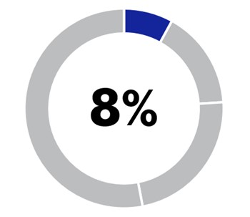 |  |  | 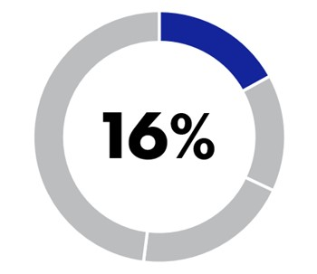 |  |  | Compensate equitably and competitively |  |  | •Determined by level of responsibility, competitive market pay assessment and individual performance
Variable |  |  | 92% |  |  | 84%
Annual Incentive Plan (AIP) |  |  | 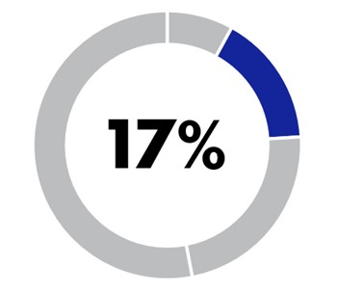 |  |  | 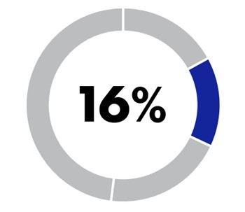 |  |  | Motivate and reward achievement of annual business objectives |  |  | •90% Financial Metrics  •35% Adjusted Cash Flow from Operations*  •35% Adjusted Segment Operating Income* Growth  •20% Adjusted Operating Margin Rate*  •10% Non-financial Metrics
Long-Term Incentive Plan (LTIP) Restricted Stock Rights (RSRs) |  |  | 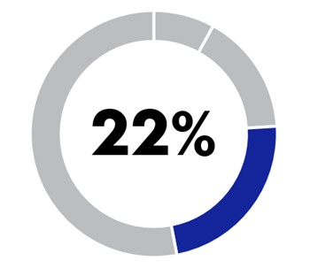 |  |  | 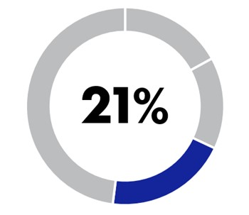 |  |  | Tie our executive officers’ priorities to shareholders’ and retain executive talent |  |  | •30% of annual LTIP grant  •Three-year cliff vesting
LTIP Restricted Performance Stock Rights (RPSRs) |  |  | 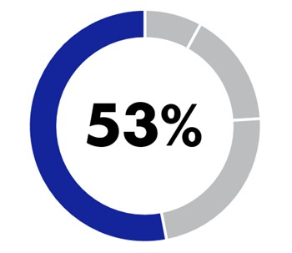 |  |  | 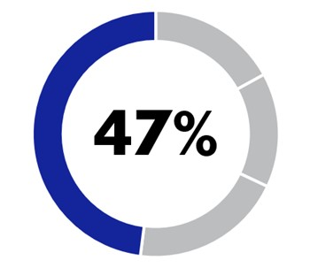 |  |  | Link the interests of our executive officers to those of our shareholders, motivate and reward achievement of long-term strategic goals and retain executive talent |  |  | •70% of annual LTIP grant  •Three-year performance period  •Equally weighted metrics of Adjusted Cumulative Free Cash Flow* (Adjusted Cumulative FCF*), Return on Invested Capital* (ROIC*) and relative TSR
* This metric is a non-GAAP financial measure. For more information, see “Appendix A - Use of Non-GAAP Financial Measures.”

50 |  |  | Northrop Grumman

Executive Compensation
2025 Performance Highlights
Strong demand drove backlog of $95.7B |  |  |  |  |  | Sales grew 2.2% to $42.0B
Operating Cash Flow of $4.8B  Free Cash Flow* of $3.3B |  |  |  |  |  | Operating Margin rate increased 20 basis points to 10.8%
Free Cash Flow*
($ in billions)
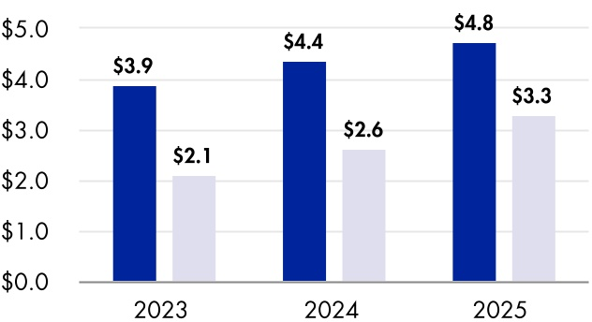
¢ |  |  | Operating Cash Flow |  |  | ¢ |  |  | Free Cash Flow*
3-Year Cumulative Total Shareholder Return
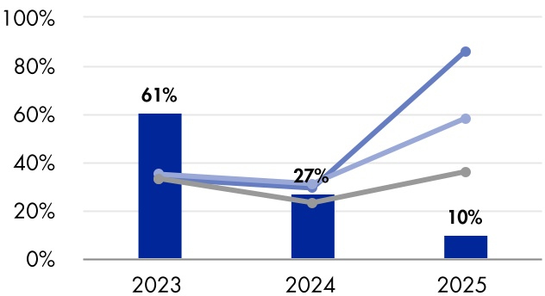
¢ |  |  | NOC |  |  | — |  |  | S&P 500
— |  |  | Industrials |  |  | — |  |  | Direct Peers Average
* This metric is a non-GAAP financial measure. For more information, see “Appendix A - Use of Non-GAAP Financial Measures.”

Shareholder Engagement
The Company is committed to fostering constructive engagement with shareholders to understand their viewpoints, address concerns, and enhance long-term value creation. We regularly engage with our shareholders to address questions regarding executive compensation and to reaffirm our philosophy and commitment to maintaining best-in-class pay practices. Through our most recent engagements and shareholder feedback, we have implemented enhancements to increase alignment, including:
•Improved disclosures around annual and long-term incentive metrics and goals to enhance transparency; and
•A refined clawback policy that strengthens alignment with shareholder interests and reflects current best practices.
For more detail, see the Shareholder Engagement section, on page 14.
As part of this engagement, the Company annually asks shareholders to approve, on an advisory basis, the compensation paid to our NEOs. The Compensation and Human Capital Committee reviews and discusses the results of the say-on-pay vote. In 2025, our executive compensation programs continued to receive strong support from shareholders with 95% approval at our 2025 Annual
Meeting of Shareholders. Furthermore, our programs have received an average approval rate of 96% over the past decade. Based on its review and feedback from shareholder engagement, the Compensation and Human Capital Committee determined that our programs are effective and aligned with shareholder interests.

Say-On-Pay Results
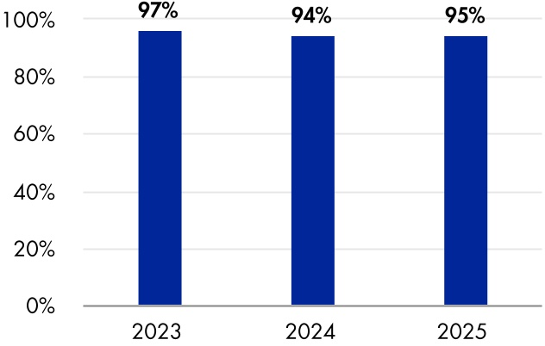

2026 Proxy Statement |  |  | 51

Executive Compensation
Our Compensation Best Practices
Our compensation programs incorporate best practices across all industries, including the following:
What We Do |  |  |  |  |  |  |  |  |  |  |  |  |  |  |  |  |  |  |  |  | What We Don’t Do
Pay for Performance |  |  |  |  |  | Annual Peer Group Review |  |  |  |  |  | Long-Term Incentives Focused on Performance |  |  |  |  |  |  |  |  | No Individual Change in Control Agreements
Compensation Elements Benchmarked at Market Median |  |  |  |  |  | Above-Target Annual Incentive Payouts When We Outperform Our Peer Benchmarks |  |  |  |  |  | Independent Consultant Reports Directly to Compensation and Human Capital Committee |  |  |  |  |  |  |  |  | No Employment Contracts for Chief Executive Officer (CEO) or Other NEOs
Recoupment Policy on Cash and Equity Incentive Compensation Payments |  |  |  |  |  | Dividends Paid Only Upon Vesting of Equity Awards |  |  |  |  |  | Stock Ownership Guidelines and Stock Holding Requirements |  |  |  |  |  |  |  |  | No Excise Tax Gross-ups for Payments Received Upon Termination After a Change in Control
LTIP Double Trigger Provisions for Change in Control |  |  |  |  |  | Regular Risk Assessments Performed |  |  |  |  |  | Cap on Annual Bonuses and RPSR Payouts |  |  |  |  |  |  |  |  | No Hedging or Pledging of Company Stock

How We Make Executive Compensation Decisions
Our Compensation and Human Capital Committee leads a rigorous and continuous process evaluating our thoughtfully designed programs throughout the year to ensure that we maintain executive compensation programs that align with the interests of our shareholders.
Assess |  |  |  |  |  |  |  |  | Establish
•Feedback from annual say-on-pay vote from shareholder outreach  •Market data with Independent Compensation Consultant  •Alignment of our financial and non-financial performance metrics with our overall strategy  •Annual independent risk review of compensation structure |  |  |  |  |  |  |  |  | •Performance metrics for AIP and RPSRs  •Relevant compensation and performance peer groups  •Annual salary, target AIP and target LTIP awards for NEOs
Rigorous Committee Oversight
Approve |  |  |  |  |  |  |  |  | Monitor
•AIP and RPSR performance target and metric results  •Final total compensation for NEOs (recommend CEO compensation to independent directors of the board for approval) |  |  |  |  |  |  |  |  | •Progress against AIP and RPSR performance metrics  •NEO performance  •Company policies and practices with respect to human capital risks
52 |  |  | Northrop Grumman

Executive Compensation
Roles and Responsibilities
COMPENSATION  AND HUMAN CAPITAL COMMITTEE |  |  | •Oversees our compensation policies, incentive and equity compensation plans and approves payments or grants under these plans and the compensation for the elected officers, other than the CEO.  •Recommends the base, bonus, and equity compensation for the CEO to the independent directors of the Board for approval.  •Reviews market data and other input from its Independent Compensation Consultant.  •Reviews and approves incentive goals and objectives (CEO goals and objectives are reviewed and approved by the independent directors).  •Evaluates and approves executive benefit and perquisite programs.  •Evaluates the competitiveness of each elected officer’s total compensation package.  •Oversees the Company's practices with respect to employee experience and engagement.  •Oversees the Company’s management of its human capital risk.  •Conducts an annual evaluation of the Independent Compensation Consultant.  •Reviews the performance of elected officers.  •Reviews and discusses with management the CD&A and provides a Compensation and Human Capital Committee Report for inclusion in the proxy statement.
INDEPENDENT  DIRECTORS |  |  | •Evaluate the performance and determine the compensation of the CEO (upon recommendation of the Compensation and Human Capital Committee).
INDEPENDENT COMPENSATION CONSULTANT  (Frederic W. Cook & Co.) |  |  | •Engaged by and reports directly to the Compensation and Human Capital Committee.  •Regularly participates in meetings of the Compensation and Human Capital Committee and communicates with the Compensation and Human Capital Committee Chair between meetings as needed.  •Participates in executive session with the Compensation and Human Capital Committee.  •Provides proactive advice to the Compensation and Human Capital Committee on best practices for Board governance of executive compensation, compensation-related risk management and areas for program design to most appropriately support the Company’s business strategy and organizational values.  •Provides a review of market data and advises the Compensation and Human Capital Committee on the levels and structure of our executive compensation policies and procedures, including compensation matters for NEOs.  •Reviews and advises the Compensation and Human Capital Committee on our total compensation philosophy, peer groups and target competitive positioning.  •Identifies market trends and practices and advises the Compensation and Human Capital Committee on program design implications.  •Serves as a resource to the Compensation and Human Capital Committee Chair on setting agenda items for Compensation and Human Capital Committee meetings and researches special projects.  •Receives compensation only for engagement with the Compensation and Human Capital Committee.
MANAGEMENT  (CEO with assistance from the Corporate Vice President and Chief Human Resources Officer and other Company employees) |  |  | •Makes compensation-related recommendations for elected officers, other than the CEO, to the Compensation and Human Capital Committee for its review and approval.  •Assesses each executive’s performance, skills and industry knowledge, market compensation benchmarks, and succession and retention considerations.  •Provides recommendations to the Compensation and Human Capital Committee regarding executive incentive and benefit plan designs and strategies, other than with respect to the CEO. These recommendations include financial and non-financial operational goals and criteria for our annual and long-term incentive plans.
2026 Proxy Statement |  |  | 53

Executive Compensation
Use of Competitive Data
Our Compensation and Human Capital Committee uses three separate peer groups to set our performance targets and evaluate performance, measure TSR and benchmark executive compensation practices, respectively. The three peer groups are outlined below.
PERFORMANCE PEER GROUP: SET PERFORMANCE TARGETS AND EVALUATE PERFORMANCE
The Compensation and Human Capital Committee uses the Performance Peer Group and LRSP (our five-year strategic operating and financial plan) data for the purpose of setting performance targets and evaluating performance of our AIP and LTIP. The Performance Peer Group encompasses similar global defense companies within the aerospace and defense market space. In 2025, the Compensation and Human Capital Committee used the peer group data from The Boeing Company, General Dynamics Corporation, L3Harris Technologies, Inc., Lockheed Martin Corporation and RTX Corporation for the purpose of setting performance targets.
TSR PEER GROUP: 2023-2025 LONG-TERM INCENTIVE AWARDS
Earned awards from the 2023-2025 performance cycle were contingent on our ranking compared to the S&P Industrials and the following TSR peer group:
2023 TSR PEER GROUP
BAE Systems |  |  | L3Harris Technologies, Inc. |  |  | RTX Corporation
The Boeing Company |  |  | Leidos Holdings, Inc. |  |  | Thales Group
General Dynamics Corporation |  |  | Leonardo
Huntington Ingalls Industries, Inc. |  |  | Lockheed Martin Corporation
TARGET INDUSTRY PEER GROUP (TIPG): BENCHMARK EXECUTIVE COMPENSATION PRACTICES
The Compensation and Human Capital Committee benchmarks our executive compensation levels and practices against the TIPG of 22 companies, including a subset containing six direct peers. Prior to the beginning of the year, the Compensation and Human Capital Committee sets the TIPG based on recommendations from the Independent Compensation Consultant. The TIPG is used to benchmark compensation for the following year. To identify peer companies for compensation benchmarking purposes, the Independent Compensation Consultant employs an objective criteria-based methodology where:
•the peer company was identified as part of a subset of direct peers with strong alignment to the aerospace and defense industry;
•the peer company was identified as a Global Industry Classification Standard company, with a prioritization of technology, manufacturing and engineering companies;
•revenues, total employees and market capitalization of the peer company were broadly similar to those of the Company; and
•the peer company participated in an annual third party compensation study.

54 |  |  | Northrop Grumman

Executive Compensation
The Compensation and Human Capital Committee reviews the TIPG annually with the Independent Compensation Consultant. The companies that comprise the TIPG used for 2025 compensation decisions are listed in the following table:
TARGET INDUSTRY PEER GROUP
3M Company |  |  | Honeywell International, Inc.(1)
Abbott Laboratories |  |  | Illinois Tool Works Inc.
Applied Materials, Inc. |  |  | Johnson Controls International plc
The Boeing Company(1) |  |  | L3Harris Technologies, Inc.(1)
Caterpillar, Inc. |  |  | Lam Research Corporation
Cisco Systems, Inc. |  |  | Lockheed Martin Corporation(1)
Cummins Inc. |  |  | Medtronic plc
Deere & Company |  |  | PACCAR Inc.
Eaton Corporation plc |  |  | Parker-Hannifin Corporation
Emerson Electric Company |  |  | QUALCOMM Inc.
General Dynamics Corporation(1) |  |  | RTX Corporation(1)
(1)Included in the subset of six direct peers also used for compensation benchmarking.
Peer Group Data (for the fiscal year ending 2025)
¢ |  |  | Northrop Grumman |  |  | ¢ |  |  | Direct Peer Group Median |  |  | ¢ |  |  | Target Industry Peer Group Median
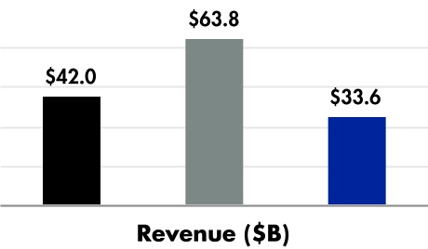
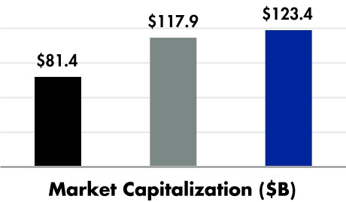

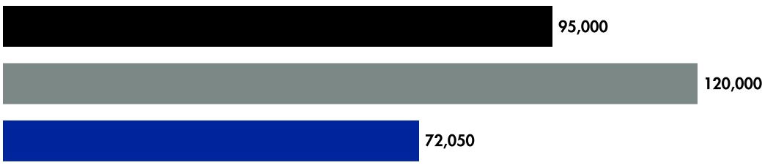
Number of Employees

It is the Company’s pay philosophy to provide the CEO a compensation package that includes competitive elements of base salary and target variable pay relative to the TIPG and the direct six peers noted in the table above.
Another element of the Company’s pay philosophy is to tie a significant portion of the CEO’s pay to performance. As a result, the CEO’s actual compensation may differ from the market median based on the Company’s actual performance.
In determining the base salary and target variable pay elements for the other NEOs, the Compensation and Human Capital Committee establishes the TIPG median as the benchmark. The Compensation and Human Capital Committee also considers several factors in determining their compensation, including executive compensation levels and practices of the TIPG, NEO individual experience, growth in job as demonstrated through sustained performance, leadership impact, retention and pay relative to the CEO. Actual annual incentive awards and long-term incentive award opportunities reflect these factors, as well as Company performance.

2026 Proxy Statement |  |  | 55

Executive Compensation
Key Components of Our Executive Compensation Programs
Base Salary
The Compensation and Human Capital Committee believes that competitive base salaries are necessary to attract and retain our NEOs. Base salaries are evaluated each year and determined by level of responsibility, competitive market pay assessment and individual performance. The table below reflects each NEO and their annual base salary as an elected officer, effective as of December 31 for the respective year, and year-over-year change if an NEO for two consecutive years.
Name |  |  | 2025  Base Salary |  |  | 2024  Base Salary |  |  | Change to  Base Salary
Kathy J. Warden |  |  | $ | 1,850,000 |  | $ | 1,800,000 |  | 3 |  | %
Kenneth B. Crews |  |  | $ | 850,000 |  | $ | 850,000 |  | 0 |  | %
Robert J. Fleming |  |  | $ | 815,000 |  | $ | 775,000 |  | 5 |  | %
Thomas H. Jones |  |  | $ | 840,000 |  | $ | 815,000 |  | 3 |  | %
Roshan S. Roeder |  |  | $ | 815,000 |  | $ | 775,000 |  | 5 |  | %
Annual Incentive Compensation
Our NEOs are eligible to receive annual cash bonuses under our 2006 Annual Incentive Plan and Incentive Compensation Plan, as amended and restated effective January 1, 2024 (AIP). We use a balance of financial and non-financial performance metrics aligned with our long-term strategy.
TARGET AWARD LEVELS FOR 2025 AIP
The Compensation and Human Capital Committee approves the annual incentive compensation target payout percentage for each NEO, other than the CEO. For the CEO, such percentage is approved by the independent directors of the Board.
The target incentive award (target bonus) represents a percentage of each NEO’s base salary. Following the completion of the fiscal year, the target bonus is used by the Compensation and Human Capital Committee, together with its assessment of Company and individual performance against established performance criteria, to determine the final bonus award amount. The table below reflects each NEO and their annual target bonus as an elected officer, effective as of December 31, 2025.
Name |  |  | Target Bonus (% of Base Salary)
Kathy J. Warden |  |  | 200 |  | %
Kenneth B. Crews |  |  | 100 |  | %
Robert J. Fleming |  |  | 100 |  | %
Thomas H. Jones |  |  | 100 |  | %
Roshan S. Roeder |  |  | 100 |  | %
Final bonus awards for each NEO were determined by multiplying the Northrop Grumman Company Performance Factor (CPF) by the target bonus. The CPF can range from 0% to 200%.
56 |  |  | Northrop Grumman

Executive Compensation
ANNUAL INCENTIVE FORMULA FOR 2025:
 |  |  | X |  |  |  |  |  | =
BASE SALARY |  |  |  |  |  | TARGET PAYOUT % |  |  |  |  |  | TARGET BONUS
 |  |  | X |  |  |  |  |  | =
TARGET BONUS |  |  |  |  |  | COMPANY PERFORMANCE FACTOR (1) |  |  |  |  |  | FINAL BONUS AWARD
(1) The CPF, which is capped at 200%, is comprised of two components, the Company Metrics Score (financial and non-financial), which can range from 0% to 200%, and a Strategic and Operational Assessment, which can range from 80% to 120%. The Strategic and Operational Assessment allows for broader application of business results not formally reflected in the core financial or non-financial metrics.
Annual performance evaluations are conducted by the Compensation and Human Capital Committee for the CEO, and by the CEO for each other NEO with review by the Compensation and Human Capital Committee. The Compensation and Human Capital Committee considers this performance information as well as the comparison to market data.
2025 AIP METRICS
For the 2025 AIP, and as in prior years, we used a mix of financial and non-financial metrics to measure our performance. Our AIP metrics reflect our commitment to investing for and achieving long-term profitable growth, maintaining alignment with shareholders’ interests, and incentivizing top performance against our industry peers.
Financial Metrics (90% Weight)
For 2025, the Compensation and Human Capital Committee determined the financial metrics would be Adjusted Cash Flow from Operations*and Adjusted Segment Operating Income* Growth, each weighted at 35% and Adjusted Operating Margin Rate* weighted at 20%. The financial metrics are defined as follows:
Financial Metrics |  |  | Weighting |  |  | Rationale |  |  | Calculation
ADJUSTED CASH FLOW FROM OPERATIONS* |  |  | 35% |  |  | Emphasizes the importance of generating cash for strategy execution. The metric incentivizes management to make capital investment decisions that support long-term profitable growth. |  |  | Net cash provided by operating activities, including adjustments as approved by the Compensation and Human Capital Committee.
ADJUSTED SEGMENT OPERATING  INCOME* GROWTH |  |  | 35% |  |  | Incentivizes management to focus on profitable growth and enables management to evaluate the financial performance and operational trends of our sectors. |  |  | The combined operating income of our four segments, less the operating income associated with intersegment sales and other approved adjustments.
ADJUSTED OPERATING MARGIN RATE* |  |  | 20% |  |  | Establishes high program performance expectations for the Company and incentivizes sound core operational business strategies. |  |  | Operating income before FAS/CAS pension operating adjustment and other approved adjustments, divided by sales.
* This metric is a non-GAAP financial measure. For more information, see “Appendix A - Use of Non-GAAP Financial Measures.”

2026 Proxy Statement |  |  | 57

Executive Compensation
Non-Financial Metrics (10% Weight)
In addition to the financial goals, various non-financial goals are used to align our objectives with our stakeholders.
For 2025, we selected the following non-financial metrics, each equally weighted at 2.5%:
Non-Financial Metric |  |  |  |  |  |  |  |  | How Measured
Customer |  |  |  |  |  |  |  |  | Program-specific objectives, including defect rates, process quality, supplier quality and other relevant program criteria, are evaluated cumulatively, with each individual program score equally weighted.
 |  |  |  |  |  | QUALITY
 |  |  |  |  |  |  |  |  | Customer feedback is evaluated cumulatively, using equally weighted scores from each individual program. This includes customer-generated performance scores, percentage of award fees gained, and both verbal and written feedback.
 |  |  |  |  |  | CUSTOMER SATISFACTION
People |  |  |  |  |  |  |  |  | Perform at or above the Qualtrics Survey Global Norm, with a focus on inclusion and belonging. Results are derived from the annual employee survey with a "percent favorable response" measurement scale.
 |  |  |  |  |  | INCLUSION AND BELONGING
Environment |  |  |  |  |  |  |  |  | Annual targets supporting the Company's sustainability goals. Specifically, net zero greenhouse gas emissions in operations by 2035 and reductions in water withdrawals and disposed solid waste by 2030.
ENVIRONMENTAL
SUSTAINABILITY
Payout Levels
Our AIP provides for payout levels from 0% to 200% of target. The minimum, target and maximum performance levels are derived based on an analysis of the historical and forecasted performance of our Performance Peer Group, and LRSP data for the financial metrics. The non-financial metrics’ performance levels are determined by specific goals approved by the Compensation and Human Capital Committee. Specific values are identified for each metric at selected points in the range between minimum and maximum and other values are determined by linear interpolation between these points. No payout is made if performance is below the minimum. Above-target payouts can be earned only if the Company’s performance exceeds the performance threshold noted in the table on the following page. The maximum payout of 200% is achieved if the Company’s performance is above the approximate top quartile performance target. This structure aligns above-target payouts with superior performance and provides reduced awards for below-target performance.
58 |  |  | Northrop Grumman

Executive Compensation
2025 AIP PERFORMANCE RESULTS
In determining the CPF, both financial and non-financial performance against goals are assessed. The 2025 Company Metrics Score based on the financial and non-financial metrics, was determined to be 114%. The Strategic and Operational Assessment was determined to be 100%, resulting in an overall CPF of 114%.
As approved by the Compensation and Human Capital Committee, 2025 Company performance calculations were adjusted, as applicable, to exclude the impact of net operating FAS/CAS, federal and foreign tax payments, CAS pension recoveries, and other adjustments to account for business conditions and certain costs unanticipated at the time the goals were established. All adjustments were made by the Compensation and Human Capital Committee using its discretion, as provided in our plan, to measure annual incentive performance while maintaining flexibility to provide equitable adjustments that address the impact of material non-operational and unforeseen events. Details are outlined in Appendix A - Use of Non-GAAP Financial Measures.
The individual financial and non-financial performance results are noted below.

FINAL 2025 COMPANY AIP RESULTS
 |  |  | Weighting |  |  | Weighted Payout
Financial Metrics |  |  | 90% |  |  | 103%
Non-Financial Metrics |  |  | 10% |  |  | 11%
Company Payout (1) |  |  |  |  |  | 114%
(1)The 2025 Company Payout includes a Strategic and Operational assessment, which was determined to be 100%.

FINANCIAL METRICS
 |  |  |  |  |  | Performance to Achieve Target Payout (1)
 |  |  |  |  |  | Threshold |  |  | Target |  |  |  |  |  | Maximum
Metric/Goal |  |  | Weighting |  |  | 0% |  |  | Low  100% |  |  | High  100% |  |  | 200% |  |  | 2025 Financial Score
Adjusted Cash Flow from Operations* |  |  | 35% |  |  | 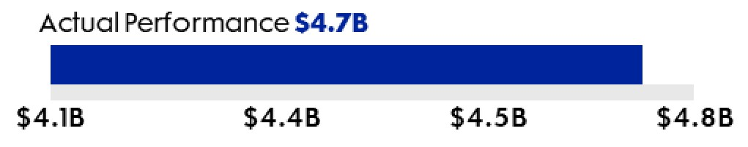 |  |  |  |  |  |  |  |  |  |  |  | 63%
Adjusted Segment Operating Income* Growth |  |  | 35% |  |  | 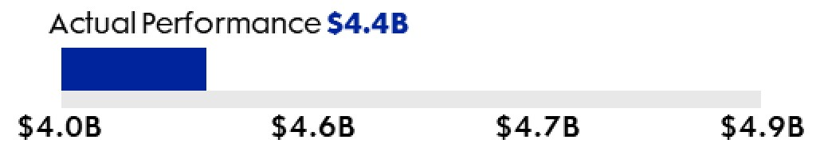 |  |  |  |  |  |  |  |  |  |  |  | 22%
Adjusted Operating Margin Rate* |  |  | 20% |  |  | 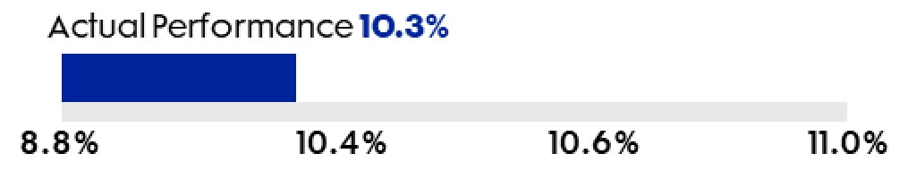 |  |  |  |  |  |  |  |  |  |  |  | 18%
Financial Metric Results |  |  |  |  |  |  |  |  |  |  |  |  |  |  |  |  |  | 103%
(1) Northrop Grumman’s AIP targets were set at or above the 2024 actuals across all metrics.
* This metric is a non-GAAP financial measure. For more information, see “Appendix A - Use of Non-GAAP Financial Measures.”

2026 Proxy Statement |  |  | 59

Executive Compensation
NON-FINANCIAL METRICS
The Company demonstrated strong performance in 2025 overall against the non-financial goals and the Compensation and Human Capital Committee approved a non-financial score of 111%, for a weighted payout of 11%.
Non-Financial Metric |  |  | Weighting |  |  | 2025 Performance |  |  | 2025 Financial Score
 |  |  | 2.5% |  |  | Exceeded, in aggregate, the quality target by 28%, including defect rates, process quality, supplier quality or other appropriate criteria for program type and phase. |  |  | 3%
QUALITY
 |  |  | 2.5% |  |  | Exceeded, in aggregate, the customer satisfaction target value by 2%, based on customer feedback, including customer-generated performance scores, award fees, and verbal and written feedback. |  |  | 3%
CUSTOMER SATISFACTION
 |  |  | 2.5% |  |  | Exceeded the 2025 target goals against the Qualtrics Survey Global Norm. We achieved highly favorable and above benchmark results. |  |  | 3%
INCLUSION AND BELONGING
 |  |  | 2.5% |  |  | Exceeded the annual targets, resulting in year-over-year reductions in water withdrawals and disposed solid waste, outweighing a slight increase in greenhouse gas emissions. |  |  | 2%
ENVIRONMENTAL
SUSTAINABILITY
Non-Financial Metric Results |  |  |  |  |  |  |  |  | 11%
60 |  |  | Northrop Grumman

Executive Compensation
Compensation and Human Capital Committee Discretion
The Compensation and Human Capital Committee approves bonus amounts for all NEOs except the CEO, whose annual bonus is recommended by the Compensation and Human Capital Committee to the independent directors of the Board for approval. The Compensation and Human Capital Committee has discretion to make adjustments to the annual bonus payouts for NEOs, other than the CEO, if it determines such adjustment is warranted due to unforeseen or unusual events. In 2025, the Compensation and Human Capital Committee made no additional adjustments to the recommended CPF or individual AIP participants’ awards.
2025 NEO AIP PAYOUTS
In consideration of both the financial and non-financial performance, the 2025 Company Performance Factor (CPF) was determined to be 114%.
In February 2026, the Compensation and Human Capital Committee recommended, and the independent directors of the Board approved, a 2025 annual incentive award of $4,218,000 for our CEO, Ms. Warden. Based on the CPF and individual performance, Ms. Warden recommended, and the Compensation and Human Capital Committee approved, the other NEOs’ annual incentive awards.
Name |  |  | AIP Target % of Salary |  |  | AIP Payout  Range % |  |  | Performance Payout |  |  | Actual Payout(1)
Kathy J. Warden |  |  | 200 |  | % | 0% - 200% |  |  | 114 |  | % | $ | 4,218,000
Kenneth B. Crews |  |  | 100 |  | % | 0% - 200% |  |  | 114 |  | % | $ | 969,000
Robert J. Fleming |  |  | 100 |  | % | 0% - 200% |  |  | 114 |  | % | $ | 929,100
Thomas H. Jones |  |  | 100 |  | % | 0% - 200% |  |  | 114 |  | % | $ | 957,600
Roshan S. Roeder |  |  | 100 |  | % | 0% - 200% |  |  | 114 |  | % | $ | 929,100
(1)Actual bonus payouts for 2025 performance are disclosed in this table and in the Summary Compensation Table.
Long-Term Incentive Compensation
In 2025, the Compensation and Human Capital Committee granted awards in the form of Restricted Performance Stock Rights (RPSRs) and Restricted Stock Rights (RSRs). The awards were comprised of 70% RPSRs and 30% RSRs. The Compensation and Human Capital Committee determined this long-term incentive mix would appropriately motivate and reward the NEOs to achieve our long-term objectives and further reinforce the link between their interests and the interests of our shareholders.
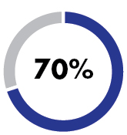 |  |  | Restricted Performance Stock Rights (RPSRs)  The RPSRs ensure sustainability and achievement of business goals over time. The RPSRs will vest and be distributed following the completion of the three-year performance period (commencing January 1, 2025, and ending December 31, 2027) if goals are met.
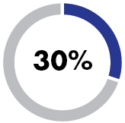 |  |  | Restricted Stock Rights (RSRs)  The RSRs provide retentive value and generally vest 100% after three years.
Earned RPSRs and RSRs may be paid in shares, cash or a combination of shares and cash at the Compensation and Human Capital Committee’s discretion. An executive generally must remain employed through the end of the vesting period to earn an award. Vesting for termination due to death, disability, retirement or a change in control is discussed in the “Termination Payments and Benefits” section on page 79. Dividend equivalents accrue on both RPSR and RSR awards earned and will be paid upon distribution of the RPSRs and RSRs. Following the distribution, 50% of all net after-tax shares received are subject to a three-year mandatory holding requirement.
2026 Proxy Statement |  |  | 61

Executive Compensation
RESTRICTED PERFORMANCE STOCK RIGHTS
The Compensation and Human Capital Committee evaluates RPSR performance requirements each year to ensure they are aligned with our business objectives. For the 2025 RPSR grant, the Compensation and Human Capital Committee determined that for the NEOs, performance metrics would be Adjusted Cumulative FCF*, Return on Invested Capital* (ROIC) and Relative Total Shareholder Return, each equally weighted at 1/3. The current metrics and weightings reflect the Company’s continued emphasis on operational performance directly impacted by management decisions and behaviors, while maintaining strong alignment with shareholder interests. Based on the performance against these metrics, shares earned for 2025 RPSR grants could vary from 0% to 200% of the rights awarded.
2025 RPSR Performance Measures
RPSR Metrics |  |  | Weighting |  |  | Rationale |  |  | Calculation
ADJUSTED CUMULATIVE FCF* |  |  | 1/3 |  |  | Focuses on cash generation to create shareholder value after investing in the business through capital expenditures. |  |  | Adjusted Cumulative FCF* is calculated as the total Free Cash Flow* over the three-year period excluding after-tax total pension funding, CAS pension recovery, and other approved adjustments, including the federal tax benefit from the One Big Beautiful Bill Act (OBBBA).
RETURN ON INVESTED CAPITAL* |  |  | 1/3 |  |  | Focuses on effective and profitable deployment of Invested Capital* resources |  |  | Return on Invested Capital* is calculated as the three-year average of Adjusted Net Operating Profit After-Tax* (Adjusted NOPAT*) divided by the three-year average of Invested Capital*. Both metrics include an adjustment for the impact of the Q4 2023 charge on the low-rate initial production phase of the B-21 program and other approved adjustments.
RELATIVE TOTAL SHAREHOLDER RETURN |  |  | 1/3 |  |  | Aligns the interests of executives with shareholders. |  |  | Relative TSR (rTSR) is measured by comparing cumulative stock price appreciation with reinvestment of dividends over the three-year period to the TSR Peer Group (50% of rTSR portion of award) and to the S&P Industrials (50% of rTSR portion of award), which comprises companies within the S&P 500 excluding Financials, Real Estate, Utilities and Transportation, reflecting the range of similar investment alternatives available to our shareholders. To smooth volatility in the market, the TSR calculation is based on the average of the three-year returns for each of the 30 calendar days, starting from the grant date, to the last 30 days of the performance period. The maximum rTSR payout is capped at 100% of target shares if the absolute TSR is negative, even if the rTSR would have resulted in a higher score.
* This metric is a non-GAAP financial measure. For more information, see “Appendix A - Use of Non-GAAP Financial Measures.”

62 |  |  | Northrop Grumman

Executive Compensation
Recently Completed RPSR Performance Period (2023-2025)
In February 2023, when granting RPSRs to NEOs who were elected officers at the time of the grant, the Compensation and Human Capital Committee selected Adjusted Cumulative FCF*, Return on Invested Capital* and rTSR, equally weighted at 1/3, as the performance metrics for the awards and established the performance criteria for the awards as set forth in the table below. Based on the performance against these metrics, shares earned for the 2023 RPSR grants could vary from 0% to 200% of the rights awarded.
 |  |  |  |  |  | Performance Required to Score (1)
 |  |  |  |  |  | Threshold |  |  | Target |  |  |  |  |  | Maximum
RPSR Metrics |  |  | Weighting |  |  | 0% |  |  | Low  100% |  |  | High  100% |  |  | 200% |  |  | 2025 Score
Adjusted Cumulative FCF* |  |  | 1/3 |  |  | 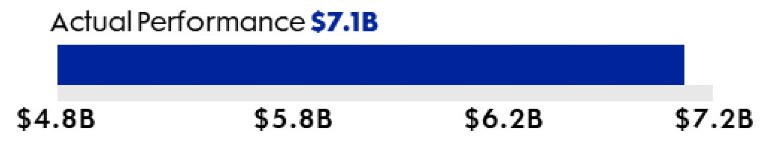 |  |  |  |  |  |  |  |  |  |  |  | 64%
Return on Invested Capital* |  |  | 1/3 |  |  | 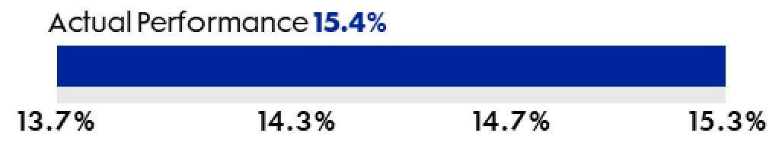 |  |  |  |  |  |  |  |  |  |  |  | 67%
Relative TSR - 2023 TSR Peer Group |  |  | 1/3 |  |  | 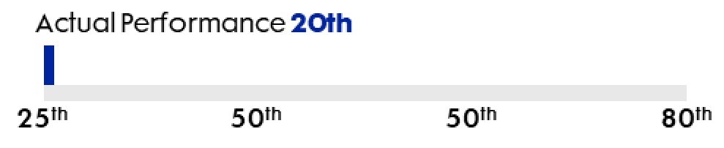 |  |  |  |  |  |  |  |  |  |  |  | 0%
Relative TSR - S&P Industrials |  |  |  |  |  | 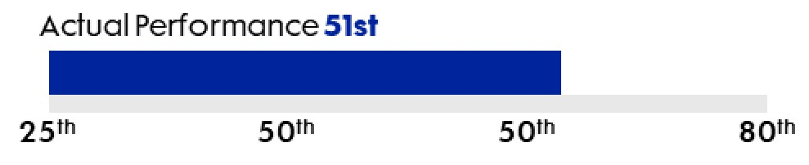 |  |  |  |  |  |  |  |  |  |  |  | 17%
RPSR Performance Factor (2) |  |  |  |  |  |  |  |  |  |  |  |  |  |  |  |  |  | 148%
(1) Northrop Grumman’s LTIP targets are, in some cases, lower than actuals in 2024. This is driven by changes to the calculation methodology given changes in tax law across the periods, specifically related to Section 174 R&D expenses.
(2) As approved by the Compensation and Human Capital Committee, Adjusted Cumulative FCF* and Return on Invested Capital* metrics for the 2023 RPSRs were adjusted, as applicable, to neutralize the impact of business conditions and certain costs unforeseen at the time of grant setting. Adjustments include the removal of CAS pension recovery, the IT services divestiture, cash received from certain federal and state tax settlements, impacts related to tax reform including the OBBBA, the impact of the Q4 2023 charge on the low-rate initial production phase of the B-21 program, the Training Services divestiture, the gain on sale of a minority investment in an international business and the loss on divestiture of a small international subsidiary. All adjustments were made by the Committee using its discretion, as provided in our plan, to measure 2023-2025 performance while maintaining flexibility to provide equitable adjustments that address the impact of material non-operational and unforeseen events. Details are outlined in Appendix A - Use of Non-GAAP Financial Measures.
* This metric is a non-GAAP financial measure. For more information, see “Appendix A - Use of Non-GAAP Financial Measures.”
In February 2026, the Compensation and Human Capital Committee reviewed performance for the January 1, 2023 to December 31, 2025 RPSR performance period. The combined weighted score for the metrics generated an overall performance score of 148%.
In February 2026, the NEOs received payouts in stock with respect to the outstanding RPSR awards that were granted in February 2023 for the three-year performance period ending December 31, 2025 (as described further in footnote three of the Outstanding Equity Awards Table on page 73).

2026 Proxy Statement |  |  | 63

Executive Compensation
2026 Updates to Our Executive Compensation Program
Our Annual Incentive Plan (AIP) is designed to reinforce management's unrelenting focus on delivering value for customers, while driving sustainable shareholder-aligned financial performance. The program balances strategic and operational priorities with disciplined financial outcomes to ensure that management remains focused on both near-term execution and long-term value creation.
For 2026, the Compensation and Human Capital Committee set the AIP metrics as follows: Financial Metrics (70%) - Cash Flow from Operations before Discretionary Pension Funding* (20%), Segment Operating Income* (25%) and Sales (25%); and Strategic Performance Metrics (30%) - Quality, Customer Satisfaction, On-Time Delivery, Scaling/Production Capacity, Belonging and Sustainability.
* This metric is a non-GAAP financial measure. For more information, see “Appendix A - Use of Non-GAAP Financial Measures.”

64 |  |  | Northrop Grumman

Executive Compensation
Other NEO Benefits
This section describes other benefits the NEOs receive. These benefits are not performance related and are designed to provide a competitive package for purposes of attracting and retaining the executive talent needed to achieve our business objectives. These benefits include retirement benefits, certain perquisites and severance arrangements.
Retirement Benefits
We maintain tax-qualified retirement plans (both defined benefit pension plans and defined contribution savings plans) that cover most of our workforce, including the NEOs. We also maintain nonqualified retirement plans that are available to our NEOs, which are designed to restore benefits that were limited under the tax-qualified plans or to provide supplemental benefits. Compensation, age and years of service factor into the amount of benefits provided under the plans. Thus, the plans are structured to reward and retain employees of long service and recognize higher performance levels as evidenced by increases in annual pay. The nonqualified supplemental defined benefit plans in which certain of our NEOs participate were frozen as to pay and service as of December 31, 2014.
The Compensation and Human Capital Committee assesses aggregate benefits available to the NEOs and has previously imposed an overall cap, generally limited to no more than 60% of final average pay on pension benefits for the NEOs. Additional information about these retirement plans and the NEO benefits under these plans can be found in the Pension Benefits Table and Nonqualified Deferred Compensation Table, on pages 75 and 78, respectively.
Perquisites
Our NEOs are eligible for certain limited executive perquisites that include financial planning and income tax preparation, physical exams and personal liability insurance. The Compensation and Human Capital Committee believes these perquisites are common within the competitive market for total compensation packages for executives and are useful in attracting, retaining and motivating talented executives. Perquisites provided to the NEOs in 2025 are detailed in the Summary Compensation Table on page 70.
Security Arrangements
Given the nature of our business, we maintain a study-based security program. Executive protection, including residential and/or travel, is based on a risk assessment and may change based on the individual’s profile. These security requirements are continuously assessed for each member and provided to the Board for informational purposes generally every three years. In selecting the level and form of protection, we and the Board consider security risks faced by those in our industry in general and security risks specific to our Company and its individuals. Based on security threat information obtained and an ongoing dialogue with law enforcement and security specialists, the Board has required that Ms. Warden and other NEOs receive varying levels of residential and travel protection.
Since we require this protection under a study-based security program and it is not designed to provide a personal benefit (other than the intended security), we do not view these security arrangements as compensation to the individuals. We report these security arrangements as perquisites as required under applicable SEC rules. In addition, we report them as taxable compensation to the individuals if they are not excludable from income as working condition fringe benefits under Section 132 of the Internal Revenue Code.
The Board has determined that the CEO should avoid traveling by commercial aircraft for purposes of security, rapid availability and communications connectivity during travel, and should use Company-provided aircraft for all air travel. If, as a result, the CEO uses Company-provided aircraft for personal travel, the costs of such travel are imputed as income and are subject to the appropriate tax reporting according to Internal Revenue Code regulations.
We regularly review the nature of the security threat and associated vulnerabilities with law enforcement and security specialists and will continue to adapt our security program as appropriate.
Severance Benefits
We maintain the Severance Plan for Elected and Appointed Officers of Northrop Grumman Corporation (Severance Plan), as amended and restated effective February 18, 2025. The Severance Plan is available to the CEO and other NEOs who qualify and are approved to receive such benefits. The purpose of the Severance Plan is to help bridge the gap in an executive’s income and health coverage during a period of unemployment following a qualified termination, and to ensure certain benefits for the Company.
We do not maintain any change in control (CIC) severance plans. In addition, we do not provide excise tax gross-ups for any payments received upon termination after a change in control.
2026 Proxy Statement |  |  | 65

Executive Compensation
Upon a “qualifying termination” (defined below) the Company may provide severance benefits to eligible NEOs under the Severance Plan. Provided the NEO signs a release and agrees to certain restrictions, he or she may receive: (i) a lump sum severance benefit equal to 1.5x annual base salary and target bonus of the CEO or 1.0x the annual base salary and target bonus of the other NEOs, (ii) a prorated performance bonus for the year of termination, (iii) continued medical and dental coverage for an 18-month severance period for the CEO, or a 12-month severance period for the other NEOs, (iv) income tax preparation/financial planning fees for the year of termination and the following year and (v) outplacement services paid in accordance with the Company’s contract terms, all subject to management approval. The cost of providing continued medical and dental coverage is based upon current premium costs. The cost of providing income tax preparation and financial planning is capped for the year of termination and for the year following termination. The annual cap for the CEO is $30,000 and for the other NEOs is $18,500.
A “qualifying termination” includes one of the following:
•involuntary termination, other than for cause or mandatory retirement; or
•election to terminate in lieu of accepting a downgrade to a non-officer position (i.e., good reason).
Change in Control Benefits
We do not maintain separate CIC programs or agreements. The only CIC benefits available to the NEOs are those described in the terms and conditions of the grants under the 2011 Long-Term Incentive Stock Plan (2011 Plan) and the 2024 Long-Term Incentive Stock Plan (2024 Plan).

66 |  |  | Northrop Grumman

Executive Compensation
Policies and Procedures
Stock Ownership Guidelines
We maintain stock ownership guidelines for our NEOs to further promote alignment of management and shareholder interests. These guidelines require that NEOs own Company stock with a value denominated as a multiple of their annual salaries, which can be accumulated over a five-year period from the date of hire or promotion into an elected officer position.
The guidelines are as follows:
Position |  |  | Stock Value as a Multiple of Base Salary
Chair and Chief Executive Officer
Other NEOs |  |  | 
Shares that satisfy the stock ownership guidelines include:
•Company stock owned outright;
•unvested RSRs; and
•the value of shares held in the Northrop Grumman Savings Plan or Northrop Grumman Financial Security and Savings Program.
Unvested RPSRs are not included in calculating ownership until they are converted to actual shares owned. Unexercised stock options are also excluded.
The Compensation and Human Capital Committee reviews compliance with our stock ownership guidelines on an annual basis. As of December 31, 2025, all NEOs were in compliance with the ownership guidelines or on track to meet the requirement by the end of the five-year period referenced above. The Compensation and Human Capital Committee continues to monitor compliance and will conduct a full review again in 2026.
Stock Holding Requirements
We have holding period requirements for payouts from long-term incentive grants, further emphasizing the importance of sustainable performance and appropriate risk-management behaviors. Under this policy, NEOs who received grants as an elected officer are required to hold, for a period of three years, 50% of their net after-tax shares received from RPSR and RSR distributions. These restrictions generally continue following termination and retirement; however, shares acquired from RPSR distributions more than one year after separation from the Company are not subject to the holding requirement.

SHAREHOLDER ALIGNMENT
AND FOCUS ON LONG-TERM,
SUSTAINABLE GROWTH
 |  |  | STOCK OWNERSHIP |  |  |  |  |  | + |  |  |  |  |  | STOCK HOLDING |  |  |  |  |  | =
2026 Proxy Statement |  |  | 67

Executive Compensation
Insider Trading and Anti-Hedging and Anti-Pledging Policy
The Company's insider trading policy governs the purchase and sale of the Company's securities by directors, officers and other employees subject to the policy and is reasonably designed to promote compliance with insider trading laws, rules and regulations and the listing standards of the NYSE. Company policy prohibits our NEOs and other elected officers from hedging or entering into margin transactions involving Company stock, and pledging Company securities as collateral for loans or other transactions. Additional information about our policy can be found in “Compensation of Directors - Stock Ownership Requirements and Anti-Hedging and Pledging Policy” on page 43. Additionally, the Company's insider trading policy is filed as Exhibit 19 to our 2025 Form 10-K.
Recoupment Policy
The Company’s recoupment policy generally provides that:
•if the Company is required to restate its financial results, the Company will recover, reasonably promptly as practicable from each executive officer, the amount of any erroneously awarded compensation that was received by such officer;
•the Board has discretion to recoup performance-based annual, or performance-based or time-based long-term cash, or performance-based or time-based long-term equity (collectively, "incentive compensation") paid to an elected officer in the event of a restatement or if an elected officer engages in illegal conduct that causes significant financial or reputational harm to the Company;
•the Board has discretion to recoup incentive compensation paid to the elected officer in the event the elected officer fails to report misconduct of another, or is grossly negligent in fulfilling his or her supervisory responsibilities to prevent such misconduct; and
•the CEO has discretion to recoup under similar circumstances incentive compensation provided to non-elected officers or other employees.
The Company’s recoupment policy includes a three-year look back for recovery of the erroneously awarded compensation or other incentive compensation. It also provides for certain disclosure in the event of recoupment, consistent with SEC and other legal requirements. The Company's Recoupment Policy is filed as Exhibit 97 to our 2025 Form 10-K.
Risk Management
The Compensation and Human Capital Committee annually reviews our compensation programs and together with the Independent Compensation Consultant assesses potential compensation-related risks to the Company. Based on this assessment for 2025, the Compensation and Human Capital Committee determined that the risk profile is appropriate and substantial risk management features are incorporated into our compensation programs. This determination reflects the following conclusions from the detailed risk assessment:
•there is appropriate balance to mitigate compensation-related risk in the executive compensation programs’ designs between fixed and variable pay, cash and stock components, annual and long-term measures, financial and non-financial measures and formulaic and discretionary decisions;
•there are appropriate policies in place to mitigate compensation-related risk, including the Compensation and Human Capital Committee’s and its advisor’s independence, transparent disclosure, officer stock ownership guidelines and holding period requirements, and hedging and recoupment policies; and
•there are no incentive or commission arrangements below the executive level that potentially encourage excessive risk-taking behavior.
Tax Deductibility of Pay
Section 162(m) of the Internal Revenue Code generally limits the annual tax deduction to $1 million per person for compensation paid to the Company’s ”covered employees,” defined to include the CEO, CFO, and the next three highest-paid NEOs excluding the CEO and CFO. The limitation also applies to individuals who were covered employees in any year after 2016.

68 |  |  | Northrop Grumman

Executive Compensation
Compensation and Human Capital Committee Report
The Compensation and Human Capital Committee reviewed and discussed the CD&A with management. Based on such review and discussion, the Compensation and Human Capital Committee recommended to the Board that the CD&A be included in this Proxy Statement. The Board has approved the recommendation.
Compensation and Human Capital Committee
David P. Abney, Chair
Madeleine A. Kleiner
Arvind Krishna
Gary Roughead
Mary A. Winston

2026 Proxy Statement |  |  | 69

Compensation Tables

Summary Compensation Table
Name & Principal Position |  |  | Year |  |  | Salary(1)  ($) |  |  | Bonus  ($) |  |  | Stock  Awards(2)  ($) |  |  | Non-Equity Incentive Plan Compensation(3)  ($) |  |  | Change in Pension Value and Non-Qualified Deferred Compensation Earnings(4)  ($) |  |  | All Other Compensation(5)  ($) |  |  | Total  ($)
Kathy J. Warden  Chair, Chief Executive Officer and President |  |  | 2025 |  |  | 1,840,385 |  |  | — |  |  | 16,750,230 |  |  | 4,218,000 |  |  | 1,270,017 |  |  | 1,278,811 |  |  | 25,357,443
 |  |  | 2024 |  |  | 1,790,385 |  |  | — |  |  | 16,099,810 |  |  | 5,194,800 |  |  | 266,692 |  |  | 1,007,512 |  |  | 24,359,199
 |  |  | 2023 |  |  | 1,730,769 |  |  | — |  |  | 16,000,440 |  |  | 5,082,875 |  |  | 1,205,310 |  |  | 718,099 |  |  | 24,737,493
Kenneth B. Crews (6)  Former Corporate Vice President and Chief Financial Officer |  |  | 2025 |  |  | 850,000 |  |  | — |  |  | 3,000,104 |  |  | 969,000 |  |  | 195,463 |  |  | 148,098 |  |  | 5,162,665
 |  |  | 2024 |  |  | 496,367 |  |  | — |  |  | 2,423,158 |  |  | 532,777 |  |  | — |  |  | 81,251 |  |  | 3,533,553
Robert J. Fleming  Corporate Vice President and President, Space Systems |  |  | 2025 |  |  | 807,308 |  |  | — |  |  | 3,500,158 |  |  | 929,100 |  |  | 308,345 |  |  | 628,340 |  |  | 6,173,251
 |  |  | 2024 |  |  | 770,193 |  |  | — |  |  | 3,399,814 |  |  | 1,147,000 |  |  | 43,990 |  |  | 311,758 |  |  | 5,672,755
Thomas H. Jones  Corporate Vice President and President, Aeronautics Systems |  |  | 2025 |  |  | 835,193 |  |  | — |  |  | 3,500,158 |  |  | 957,600 |  |  | — |  |  | 290,130 |  |  | 5,583,081
 |  |  | 2024 |  |  | 810,192 |  |  | — |  |  | 3,399,814 |  |  | 1,206,200 |  |  | — |  |  | 273,695 |  |  | 5,689,901
 |  |  | 2023 |  |  | 785,192 |  |  | — |  |  | 3,200,380 |  |  | 1,240,300 |  |  | — |  |  | 270,042 |  |  | 5,495,914
Roshan S. Roeder  Corporate Vice President and President, Mission Systems |  |  | 2025 |  |  | 807,308 |  |  | — |  |  | 3,500,158 |  |  | 929,100 |  |  | 330,501 |  |  | 158,987 |  |  | 5,726,054
 |  |  | 2024 |  |  | 770,193 |  |  | — |  |  | 3,399,814 |  |  | 1,147,000 |  |  | 70,844 |  |  | 166,407 |  |  | 5,554,258
 |  |  | 2023 |  |  | 750,000 |  |  | — |  |  | 3,149,450 |  |  | 1,177,500 |  |  | 238,461 |  |  | 116,021 |  |  | 5,431,432
(1)Includes amounts deferred under qualified savings and nonqualified deferred compensation plans.
(2)Represents the grant date aggregate fair value of RPSRs and RSRs granted during the periods presented. The fair value of awards was computed in accordance with Financial Accounting Standards Board (FASB) Accounting Standards Codification (ASC) Topic 718, including a discount for the Company's holding period requirements and excluding any assumed forfeitures. Assumptions used in the calculation of these amounts are disclosed in Notes 1 and 13 of the Company’s 2025 Form 10-K. The maximum grant date fair values of the 2025 RPSRs are as follows (grants assume a 200% maximum payout):
Name |  |  | Maximum Grant Date Fair Value ($)
Ms. Warden |  |  | 23,450,620
Mr. Crews |  |  | 4,200,096
Dr. Fleming |  |  | 4,900,044
Mr. Jones |  |  | 4,900,044
Ms. Roeder |  |  | 4,900,044
(3)These amounts were paid pursuant to the Company’s AIP and includes amounts deferred under the qualified savings and nonqualified deferred compensation plans.
70 |  |  | Northrop Grumman

Compensation Tables
(4)These amounts relate solely to the increased present value of the NEO’s pension plan benefits using mandatory SEC assumptions (see the descriptions of these plans under the Pension Benefits Table on page 75). The amount accrued in each year differs from the amount accrued in prior years due to an increase in age, service and pay (salary and bonus). The change in pension value is also highly sensitive to changes in the interest rate used to determine the present value of the payments to be made over the life of the executive.
Mr. Jones was hired after the Company’s defined benefit pension plans were closed to new entrants, and as a result, he does not participate in any defined benefit pension plans.
There were no above-market earnings in the nonqualified deferred compensation plans (see the descriptions of these plans under the Nonqualified Deferred Compensation Table on page 78).
(5) Amounts include, as applicable, (a) the value of perquisites and personal benefits, (b) basic life insurance premiums, (c) matching contributions through the Northrop Grumman Foundation made to eligible educational institutions and to non-profit organizations under a Company program, (d) Company contributions to defined contribution and deferred compensation plans, and (e) with respect to Dr. Fleming, a tax gross-up of $178,786 to cover costs incurred in connection with a Company-required relocation in accordance with our relocation policy. Where the value of the items reported in a particular category for an NEO exceeded $10,000 in 2025 (other than perquisites and personal benefits, which are subject to different thresholds as described below), those items are identified and quantified below.
Perquisites and Personal Benefits – Perquisites and other personal benefits provided to certain NEOs are as follows: security, travel-related perquisites (including use of Company aircraft and ground transportation services for personal travel and incidental expenses for family members if accompanying the NEO while on business travel), financial planning/income tax preparation services, insurance premiums paid by the Company on the NEO’s behalf, executive physicals and other nominal perquisites or personal benefits. We determine the incremental cost for perquisites and personal benefits based on costs or charges incurred by the Company for the benefits.
As discussed in “Other NEO Benefits - Security Arrangements,” the Company provides NEOs with certain residential and travel security protection due to the nature of our business and security threat information. The amounts reflected in the “All Other Compensation” column include expenses for certain residential and travel security that we treat as perquisites under relevant SEC guidance, even though the need for such expenses arises from the risks associated with their positions with the Company. The Company calculates the cost of travel security coverage based on the hourly rates and overhead fees charged directly to the Company by the firms providing security personnel. If Company security personnel are used, their hourly rates are used to calculate the cost of coverage. The Company calculates the value of personal use of Company aircraft based on the incremental cost of each element. Fixed costs that would be incurred in any event to operate Company aircraft (e.g., aircraft purchase costs, maintenance not related to personal trips and flight crew salaries) are not included.
The cost of any category of the listed perquisites and personal benefits did not exceed the greater of $25,000 or 10% of total perquisites and personal benefits for any NEO in 2025, except for the following:
i.Ms. Warden: costs attributable to security protection ($672,768), which includes personal travel on Company aircraft consistent with the Company’s security program ($250,757); and
ii.Dr. Fleming: costs attributable to relocation ($222,743), security protection ($32,653).
Contributions to Plans – In 2025, we made the following Company contributions to the defined contribution and deferred compensation plans:
Name |  |  | Company Contributions ($)
Ms. Warden |  |  | 562,815
Mr. Crews |  |  | 110,622
Dr. Fleming |  |  | 156,345
Mr. Jones |  |  | 252,696
Ms. Roeder |  |  | 136,802
(6) Mr. Crews was the Corporate Vice President and Chief Financial Officer in 2025. He stepped down from this position effective January 7, 2026 and left the Company February 20, 2026. Mr. John Greene was appointed Corporate Vice President and Chief Financial Officer effective January 7, 2026.

2026 Proxy Statement |  |  | 71

Compensation Tables
2025 Grants of Plan-Based Awards
 |  |  |  |  |  |  |  |  | Estimated Future Payouts Under  Non-Equity Incentive  Plan Awards(1) |  |  |  |  |  |  |  |  |  |  |  | Estimated Future Payouts  Under Equity Incentive  Plan Awards(2)(3) |  |  |  |  |  |  |  |  | All Other  Stock  Awards:  Number of  Shares of  Stock or  Units(4)  (#) |  |  | Grant  Date Fair  Value of  Stock  Awards(5)  ($)
Name |  |  | Grant Type |  |  | Grant Date |  |  | Threshold  ($) |  |  | Target  ($) |  |  | Maximum  ($) |  |  |  |  |  | Threshold  (#) |  |  | Target  (#) |  |  | Maximum  (#)
Kathy J. Warden |  |  | Incentive Plan |  |  |  |  |  | — |  |  | 3,700,000 |  |  | 7,400,000
 |  |  | RPSR |  |  | 2/18/2025 |  |  |  |  |  |  |  |  |  |  |  |  |  |  | — |  |  | 25,628 |  |  | 51,256 |  |  |  |  |  | 11,725,310
 |  |  | RSR |  |  | 2/18/2025 |  |  |  |  |  |  |  |  |  |  |  |  |  |  |  |  |  |  |  |  |  |  |  | 11,752 |  |  | 5,024,920
Kenneth B. Crews |  |  | Incentive Plan |  |  |  |  |  | — |  |  | 850,000 |  |  | 1,700,000
 |  |  | RPSR |  |  | 2/18/2025 |  |  |  |  |  |  |  |  |  |  |  |  |  |  | — |  |  | 4,590 |  |  | 9,180 |  |  |  |  |  | 2,100,048
 |  |  | RSR |  |  | 2/18/2025 |  |  |  |  |  |  |  |  |  |  |  |  |  |  |  |  |  |  |  |  |  |  |  | 2,105 |  |  | 900,056
Robert J. Fleming |  |  | Incentive Plan |  |  |  |  |  | — |  |  | 815,000 |  |  | 1,630,000
 |  |  | RPSR |  |  | 2/18/2025 |  |  |  |  |  |  |  |  |  |  |  |  |  |  | — |  |  | 5,355 |  |  | 10,710 |  |  |  |  |  | 2,450,022
 |  |  | RSR |  |  | 2/18/2025 |  |  |  |  |  |  |  |  |  |  |  |  |  |  |  |  |  |  |  |  |  |  |  | 2,456 |  |  | 1,050,136
Thomas H. Jones |  |  | Incentive Plan |  |  |  |  |  | — |  |  | 840,000 |  |  | 1,680,000
 |  |  | RPSR |  |  | 2/18/2025 |  |  |  |  |  |  |  |  |  |  |  |  |  |  | — |  |  | 5,355 |  |  | 10,710 |  |  |  |  |  | 2,450,022
 |  |  | RSR |  |  | 2/18/2025 |  |  |  |  |  |  |  |  |  |  |  |  |  |  |  |  |  |  |  |  |  |  |  | 2,456 |  |  | 1,050,136
Roshan S. Roeder |  |  | Incentive Plan |  |  |  |  |  | — |  |  | 815,000 |  |  | 1,630,000
 |  |  | RPSR |  |  | 2/18/2025 |  |  |  |  |  |  |  |  |  |  |  |  |  |  | — |  |  | 5,355 |  |  | 10,710 |  |  |  |  |  | 2,450,022
 |  |  | RSR |  |  | 2/18/2025 |  |  |  |  |  |  |  |  |  |  |  |  |  |  |  |  |  |  |  |  |  |  |  | 2,456 |  |  | 1,050,136
(1)Represents the potential range of payouts under the Company’s AIP. Actual payouts are shown in the Summary Compensation Table column entitled “Non-Equity Incentive Plan Compensation” on page 70.
(2)The Company did not grant stock options in 2025.
(3)These amounts relate to RPSRs granted in 2025 under the 2024 Plan. For additional details on our RPSRs, refer to “Key Components of Our Executive Compensation Programs - Long-Term Incentive Compensation” on page 61.
(4)These amounts relate to RSRs granted in 2025 under the 2024 Plan. For additional details on our RSRs, refer to “Key Components of Our Executive Compensation Programs - Long-Term Incentive Compensation” on page 61.
(5)For details on the computation of the grant date value of awards, refer to footnote (2) of the "Summary Compensation Table" on page 70.

72 |  |  | Northrop Grumman

Compensation Tables
Outstanding Equity Awards at 2025 Fiscal Year End
Name |  |  | Grant Date |  |  | Number of  Shares or Units of  Stock that Have  Not Vested(1)  (#) |  |  | Market Value of  Shares or Units of  Stock that Have  Not Vested(2)  ($) |  |  | Equity Incentive Plan  Awards: Number of  Unearned Shares, Units  or Other Rights that  Have Not Vested(3)  (#) |  |  | Equity Incentive Plan  Awards: Market  or Payout Value of  Unearned Shares, Units  or Other Rights that  Have Not Vested(2)  ($)
Kathy J. Warden |  |  | 2/18/2025 |  |  | 11,752 |  |  | 6,701,108 |  |  | 25,628 |  |  | 14,613,342
 |  |  | 2/14/2024 |  |  | 11,155 |  |  | 6,360,693 |  |  | 24,309 |  |  | 13,861,235
 |  |  | 2/16/2023 |  |  | 10,760 |  |  | 6,135,460 |  |  | 23,342 |  |  | 13,309,842
Kenneth B. Crews |  |  | 2/18/2025 |  |  | 2,105 |  |  | 1,200,292 |  |  | 4,590 |  |  | 2,617,264
 |  |  | 7/31/2024 |  |  | 1,277 |  |  | 728,158 |  |  | 2,799 |  |  | 1,596,018
 |  |  | 2/14/2024 |  |  | 269 |  |  | 153,386 |  |  | 627 |  |  | 357,522
 |  |  | 2/16/2023 |  |  | 232 |  |  | 132,289 |  |  | 542 |  |  | 309,054
Robert J. Fleming |  |  | 2/18/2025 |  |  | 2,456 |  |  | 1,400,436 |  |  | 5,355 |  |  | 3,053,475
 |  |  | 2/14/2024 |  |  | 2,356 |  |  | 1,343,415 |  |  | 5,133 |  |  | 2,926,888
 |  |  | 2/16/2023 |  |  | 264 |  |  | 150,535 |  |  | 617 |  |  | 351,820
Thomas H. Jones |  |  | 2/18/2025 |  |  | 2,456 |  |  | 1,400,436 |  |  | 5,355 |  |  | 3,053,475
 |  |  | 2/14/2024 |  |  | 2,356 |  |  | 1,343,415 |  |  | 5,133 |  |  | 2,926,888
 |  |  | 2/16/2023 |  |  | 2,152 |  |  | 1,227,092 |  |  | 4,669 |  |  | 2,662,310
Roshan S. Roeder |  |  | 2/18/2025 |  |  | 2,456 |  |  | 1,400,436 |  |  | 5,355 |  |  | 3,053,475
 |  |  | 2/14/2024 |  |  | 2,356 |  |  | 1,343,415 |  |  | 5,133 |  |  | 2,926,888
 |  |  | 2/16/2023 |  |  | 2,017 |  |  | 1,150,114 |  |  | 4,376 |  |  | 2,495,239
(1)Outstanding RSRs generally vest three years from date of grant.
(2)The value listed is based on the closing price of the Company’s stock of $570.21 on December 31, 2025, the last trading day of the year.
(3)Outstanding RPSRs granted in 2025, 2024 and 2023 vest based on performance for the three-year performance period ending on December 31, 2027, 2026 and 2025, respectively. All RPSR grants are subject to the Compensation and Human Capital Committee’s approval of the performance-based earn-out percentage applicable to the grant following the end of the performance period. Amounts presented assume target level performance. The 2023 RPSRs were distributed in February 2026 upon the Compensation and Human Capital Committee’s approval. The actual number of shares earned by the NEOs in February 2026 as a result of the vesting was as follows:
Name |  |  | Actual Shares Earned (#)
Ms. Warden |  |  | 34,546
Mr. Crews |  |  | 802
Dr. Fleming |  |  | 913
Mr. Jones |  |  | 6,910
Ms. Roeder |  |  | 6,476

2026 Proxy Statement |  |  | 73

Compensation Tables
2025 Stock Vested
 |  |  | Stock Awards(1)(2)(3)
Name |  |  | Number of Shares Acquired on Vesting  (#) |  |  | Value Realized on Vesting  ($)
Kathy J. Warden |  |  | 39,022 |  |  | 17,222,869
Kenneth B. Crews |  |  | 847 |  |  | 373,766
Robert J. Fleming |  |  | 886 |  |  | 390,868
Thomas H. Jones |  |  | 8,215 |  |  | 3,625,627
Roshan S. Roeder |  |  | 1,305 |  |  | 611,183
(1)The number of shares and the amounts reflected in the table are reported on an aggregate basis and do not reflect shares sold or withheld to pay withholding taxes.
(2)Consists of RPSRs and RSRs granted in 2022. The 2022 RPSRs vested based on the three-year performance period which ended on December 31, 2024 and were distributed in February 2025. The 2022 RSRs vested three years from the date of grant and were distributed in February 2025. Ms. Roeder's 2023 RSRs awarded on December 5, 2023, had a two-year vest and were distributed in December 2025.
(3)NEOs who were elected officers at the time of the grant are subject to a three-year mandatory holding requirement on 50% of all net-after tax shares distributed.

74 |  |  | Northrop Grumman

Compensation Tables
2025 Pension Benefits
The following table provides information about the pension plans in which the NEOs participate (described in more detail on the following pages), including the present value of each NEO’s accumulated benefits as of December 31, 2025, calculated pursuant to SEC specifications for this table. Our policy generally limits an executive’s total benefit under these plans to be no more than 60% of final average pay.
Name(1) |  |  | Plan Name |  |  | Number of Years  Credited Service(2)  (#) |  |  | Present Value of  Accumulated  Benefit(3)  ($) |  |  | Payments  During Last  Fiscal Year  ($)
Kathy J. Warden |  |  | OSERP II |  |  | 17.3 |  |  | 5,293,114 |  |  | —
Kenneth B. Crews |  |  | Pension Plan |  |  | 21.3 |  |  | 335,252 |  |  | —
 |  |  | ERISA 2 |  |  | 21.3 |  |  | 184,662 |  |  | —
Robert J. Fleming |  |  | Retirement Plan B |  |  | 20.1 |  |  | 582,924 |  |  | —
 |  |  | Litton Restoration Plan |  |  | 20.1 |  |  | 419,523 |  |  | —
Roshan S. Roeder |  |  | Pension Plan |  |  | 24.0 |  |  | 460,445 |  |  | —
 |  |  | ERISA 2 |  |  | 24.0 |  |  | 466,820 |  |  | —
(1)Mr. Jones was hired after the Company’s defined benefit pension plans were closed to new entrants and as a result, he does not participate in any defined benefit pension plans.
(2)Each NEO’s actual service is as follows: Ms. Warden: 17.3 years, Mr. Crews: 21.3 years, Dr. Fleming: 20.1 years and Ms. Roeder: 23.8 years.
(3)Amounts are calculated using the following assumptions:
•the NEO retires on the earliest date he/she could receive an unreduced benefit under each plan;
•the form of payment is a single life annuity; and
•the discount rate is 5.56% for the Pension Plan, 5.56% for Retirement Plan B and 5.58% for all other plans. The mortality table is the Pri-2012 White Collar mortality table projected generationally with an adjusted version of Scale MP-2021 for all plans.
Pension Plans and Descriptions
Most of the pension plans were closed to new hires in 2008. Prior to that time, the Company consolidated the pension plan provisions from diverse Heritage Formulas to a Cash Balance Formula. Over time, the Company also transitioned officers, including NEOs, from supplemental executive retirement plans to a deferred compensation plan, called the Officers Retirement Account Contribution Plan (ORAC). In addition, all final average pay formulas were frozen as of December 31, 2014.
The pension plans in which NEOs participate are listed below.
•ERISA 2 is the ERISA Supplemental Program 2. This plan makes participants whole for benefits they lose under the Pension Plan due to certain Internal Revenue Code limits.
•Litton Restoration Plan is the Litton Industries, Inc. Restoration Plan 2. This plan makes participants whole for benefits they lose under the Retirement Plan B due to certain Internal Revenue Code limits.
•OSERP II is the Officers Supplemental Executive Retirement Program II. This plan provides a pension benefit for certain Company officers.
•Pension Plan is the Northrop Grumman Pension Plan. This is a tax qualified pension plan covering a broad base of Company employees.
•Retirement Plan B is the Northrop Grumman Retirement Plan “B”. This is a tax qualified pension plan covering a broad base of Company employees.
2026 Proxy Statement |  |  | 75

Compensation Tables
Pension Plan and Retirement Plan B (Tax Qualified Plans)
The Pension Plan has a heritage (non-cash balance) pension formula that applies to Ms. Roeder (Heritage Formula). This is described in detail in the Heritage Formula table that follows. Prior to 2004, the Company transitioned all the heritage formulas in this plan to a Cash Balance Formula. The Cash Balance Formula is a percentage of pay credited to a hypothetical account, which grows with interest. At retirement, the Cash Balance Account is converted to a monthly pension benefit (further information is included in the Cash Balance Formulas section below). The final benefit from this plan is the sum of the two formulas: the Heritage Formula benefit plus the Cash Balance Formula benefit.
Mr. Crews and Dr. Fleming have pension benefits under a Cash Balance Formula in the Pension Plan and Retirement Plan B, respectively.
Ms. Roeder has pension benefits under two subplans of the Pension Plan due to her transfer between business units. She receives a benefit under the Heritage Formula and a Cash Balance Formula in the Northrop Grumman Electronic Systems Pension Plan, a subplan of the Pension Plan (ES Subplan) based on her employment in this subplan. She also receives a benefit under the Northrop Grumman Retirement Value Plan (RVP Subplan) Cash Balance Formula.
Heritage Formula
The following table summarizes the key features of the Heritage Formula applicable to the eligible NEO.
Feature |  |  | ES Subplan
Benefit Formula |  |  | Eligible Pay x 2%
Eligible Pay (limited by Internal Revenue Code section 401(a)(17)) |  |  | Salary plus bonus paid while participating in this subplan
Normal Retirement |  |  | Age 65
Early Retirement |  |  | Age 58 with 30 years of service or age 60 with 10 years of service
Early Retirement Reduction (for retirements occurring between Early Retirement and Normal Retirement) |  |  | Benefits are reduced for commencement prior to age 65
Cash Balance Formulas
The RVP Subplan Cash Balance Formula in the Pension Plan is a hypothetical account balance consisting of pay credits plus interest. It has the following features:
•pay credits are a percentage of pay that vary based on an employee’s points (age plus service) and are credited monthly. The percentage applicable to Ms. Roeder as of her transfer from the RVP Subplan was 4.5%.
•interest is credited at the 30-year U.S. Treasury bond rate subject to a four-month lookback. The December 31, 2025 interest credit rate was 4.87%.
•eligible pay is salary plus bonus, as limited by Internal Revenue Code section 401(a)(17).
•after termination of employment, a participant's vested RVP Subplan Cash Balance benefit may be distributed immediately, regardless of age, in a variety of actuarially equivalent monthly annuities or as a lump sum.

The Cash Balance formula in the Pension Plan and the Retirement Plan B is a hypothetical account balance consisting of pay credits plus interest. It has the following features:
•pay credits are a percentage of pay that vary based on an employee’s points (age plus service) and are credited monthly. The percentage applicable to the NEOs on December 31, 2025 was 6.5%.
•interest is credited at the 30-year U.S. Treasury bond rate subject to a four-month lookback and a minimum annual interest rate of 2.25%. The December 31, 2025 interest credit rate was 4.87%.
•eligible pay is salary plus bonus, as limited by Internal Revenue Code section 401(a)(17).
•eligibility for early retirement occurs at age 55 with 10 years of service. Benefits may be reduced if commenced prior to Normal Retirement Age (65).

76 |  |  | Northrop Grumman

Compensation Tables
ERISA 2 and Litton Restoration Plan (Nonqualified Restoration Plans)
The ERISA 2 and Litton Restoration Plan are nonqualified plans that restore benefits provided for under the Pension Plan and Retirement Plan B, respectively, but for the limits on eligible pay imposed by Internal Revenue Code section 401(a)(17) and the overall benefit limitation of Internal Revenue Code section 415. Benefits and features in these restoration plans otherwise are generally the same as described above for the underlying tax qualified plan.
OSERP II (Nonqualified Supplemental Executive Retirement Plan)
This plan provides pension benefits to certain new hires on or before 2009. It has a Final Average Pay formula and a Cash Balance formula. The Final Average Pay formula is described in detail in the table below. The Cash Balance benefit is described in the Cash Balance Formulas section above. The final benefit from this plan is the sum of the Final Average Pay benefit through December 31, 2014 and the Cash Balance benefit from January 1, 2015 without regard to the limits imposed by Internal Revenue Code sections 401(a)(17) and 415.
Feature |  |  | OSERP II
Benefit Formula |  |  | Final Average Pay times 2% for each year of service up to 10 years, 1.5% for each subsequent year up to 20 years, and 1% for each additional year over 20 and less than 45 (service is frozen as of December 31, 2014)
Final Average Pay |  |  | Average of highest three years of Eligible Pay (frozen as of December 31, 2014)
Eligible Pay |  |  | Salary and bonus (including amounts above the Internal Revenue Code section 401(a)(17) limit)
Normal Retirement |  |  | Age 65
Early Retirement |  |  | Age 55 with 10 years of service
Early Retirement Reduction |  |  | Benefits are reduced for commencement prior to the earlier of age 65 or 85 points (age + service)
Information on Executives Eligible for Early Retirement
No NEO is eligible for early retirement as of December 31, 2025 under the pension plans.

2026 Proxy Statement |  |  | 77

Compensation Tables
2025 Nonqualified Deferred Compensation
Name |  |  | Plan Name |  |  | Executive  Contributions in  Last FY(1)  ($) |  |  | Registrant  Contributions in  Last FY(2)  ($) |  |  | Aggregate  Earnings in Last  FY(3)  ($) |  |  | Aggregate  Withdrawals/  Distributions  ($) |  |  | Aggregate  Balance at Last  FYE(4)  ($)
Kathy J. Warden |  |  | Savings Excess |  |  | 534,815 |  |  | 267,408 |  |  | 1,854,131 |  |  | (6,294) |  |  | 10,706,365
 |  |  | ORAC |  |  | — |  |  | 281,407 |  |  | 488,836 |  |  | (6,461) |  |  | 3,025,756
Kenneth B. Crews |  |  | Savings Excess |  |  | 103,278 |  |  | 41,311 |  |  | 64,753 |  |  | (970) |  |  | 428,734
 |  |  | ORAC |  |  | — |  |  | 55,311 |  |  | 35,946 |  |  | (673) |  |  | 273,595
Robert J. Fleming |  |  | Savings Excess |  |  | 160,431 |  |  | 64,172 |  |  | 399,519 |  |  | (1,505) |  |  | 2,340,415
 |  |  | ORAC |  |  | — |  |  | 78,172 |  |  | 67,315 |  |  | (1,193) |  |  | 456,125
Thomas H. Jones |  |  | Savings Excess |  |  | 84,570 |  |  | 146,040 |  |  | 186,854 |  |  | (3,358) |  |  | 1,666,423
 |  |  | ORAC |  |  | — |  |  | 81,656 |  |  | 109,075 |  |  | (1,927) |  |  | 862,713
Roshan S. Roeder |  |  | Savings Excess |  |  | 320,862 |  |  | 48,129 |  |  | 194,266 |  |  | (1,129) |  |  | 1,370,519
 |  |  | ORAC |  |  | — |  |  | 78,172 |  |  | 58,564 |  |  | (1,831) |  |  | 436,108
(1)NEO contributions in this column are also included in the 2025 Summary Compensation Table on page 70, under the columns entitled “Salary” and “Non-Equity Incentive Plan Compensation.”
(2)Company contributions in this column are included in the 2025 Summary Compensation Table, under the column entitled “All Other Compensation.”
(3)Aggregate earnings in the last fiscal year are not included in the 2025 Summary Compensation Table because they are not above market or preferential.
(4)NEO and Company contributions in this column may include balances for merged plans.
Employee contributions by Ms. Warden, Mr. Jones and Ms. Roeder for the years ended December 31, 2025, 2024 and 2023, collectively, previously reported as compensation in the Summary Compensation tables are shown below. Because Mr. Crews and Dr. Fleming were not NEOs for the year ended December 31, 2023, employee contribution data for this year is not presented.
Name |  |  | Employee Contributions ($)
Ms. Warden |  |  | 1,541,327
Mr. Crews |  |  | 140,359
Dr. Fleming |  |  | 437,575
Mr. Jones |  |  | 269,959
Ms. Roeder |  |  | 769,932
Deferred Compensation Plans and Descriptions
The deferred compensation plans in which the NEOs participate are listed below:
•ORAC is the Northrop Grumman Officers Retirement Account Contribution Plan. This plan allows eligible executives, including NEOs, to receive a Company contribution of 4% of base salary and bonus.
•Savings Excess Plan is the Northrop Grumman Savings Excess Plan. This plan allows eligible employees, including the NEOs, to (i) defer up to 50% of their salary and bonus beyond the compensation limits of the tax qualified plans and receive a Company matching contribution of up to 7% of pay and (ii) receive Retirement Account Contributions and Non-elective Contributions beyond the compensation limits in the qualified plan, if eligible.

78 |  |  | Northrop Grumman

Compensation Tables
Termination Payments and Benefits
The following table summarizes certain payments and benefits the NEOs may receive upon termination, subject to the referenced plans and terms and conditions of the awards.
 |  |  | Voluntary Termination(3) |  |  | Involuntary Termination Not For Cause(3) |  |  | Post-CIC Involuntary or Good Reason Termination |  |  | Death or Disability(3)
RSRs(1) |  |  | Unvested RSRs are forfeited, except in the case of early retirement where the RSRs are prorated and mandatory retirement (age 65) where they will fully vest. Retention awards do not include retirement provisions. |  |  | Unvested RSRs are forfeited, except in the case of early retirement where the RSRs are prorated and mandatory retirement (age 65) where they will fully vest. Retention awards do not include retirement provisions. |  |  | For certain change in control events as set forth in both the 2011 Plan and 2024 Plan (CIC), unvested RSRs will vest and payment is accelerated, only in the event of a double trigger (CIC and termination other than for cause within the specified period), or if the acquiring company fails to assume the awards; subject to certain limitations to the extent such accelerated payments would otherwise trigger an excise tax. |  |  | Unvested RSRs will fully vest and payment is accelerated.
RPSRs(1)(2) |  |  | Unvested RPSRs are forfeited except in the case of early retirement where the RPSRs are prorated and mandatory retirement (age 65) where they fully vest. |  |  | Unvested RPSRs are forfeited except in the case of early retirement where the RPSRs are prorated and mandatory retirement (age 65) where they fully vest. |  |  | For a CIC, unvested RPSRs will fully vest and payment is accelerated based on a truncated performance period, only in the event of a double trigger (CIC and termination other than for cause within the specified period), or if the acquiring company fails to assume the awards; subject to certain limitations to the extent such accelerated payments would otherwise trigger an excise tax. |  |  | Unvested RPSRs are prorated and payment, at target, is accelerated.
Cash Severance |  |  | No payment. |  |  | Lump sum equal to 1.5x base salary and bonus target of the CEO, or 1.0x the sum of the base salary and bonus target of the other NEOs, and a prorated performance bonus for the year of termination. |  |  | No payment. |  |  | No payment.
Medical/Dental Continuation |  |  | No payment. |  |  | Continued medical and dental coverage for an 18-month severance period for the CEO, or a 12-month severance period for the other NEOs. |  |  | No payment. |  |  | No payment.
Financial Planning/Income Tax |  |  | No payment. |  |  | Reimbursement of fees for the year of termination and the following year. |  |  | No payment. |  |  | No payment.
Outplacement Services |  |  | No payment. |  |  | Expenses paid in accordance with the Company’s contract terms. |  |  | No payment. |  |  | No payment.
(1)Terms of equity awards granted to the NEOs under the 2011 Plan and the 2024 Plan.
(2)Subject to the Compensation and Human Capital Committee’s approval of the earn-out percentage based on the RPSR performance metrics.
(3)Any retirement treatment requires employment for at least six months following the grant date with respect to RSRs and at least six months of the performance period with respect to RPSRs.
2026 Proxy Statement |  |  | 79

Compensation Tables
The Potential Termination Payments Table provides estimated payments and benefits that the Company would have provided to each NEO if his or her employment had terminated on December 31, 2025 for the reasons set forth in the table below. The Company stock price is assumed to be $570.21, the closing market price on December 31, 2025, the last trading day of the year. These payments and benefits are payable based on:
•the Severance Plan; and
•the 2011 Plan and the 2024 Plan and the terms and conditions of equity awards made pursuant to the plan.
Due to the many factors that affect the nature and amount of any benefits provided upon termination events, actual amounts paid or distributed to NEOs may be different from the values shown in the table. Factors that may affect these amounts include timing during the year of the occurrence of the event, our stock price, the NEO’s age and the terms and circumstances of the event. The amounts described below are in addition to an NEO’s benefits described in the Pension Benefits and Nonqualified Deferred Compensation Tables on pages 75 and 78, respectively, as well as benefits generally available to our employees such as distributions under our savings plan, disability or life insurance benefits and accrued vacation.
80 |  |  | Northrop Grumman

Compensation Tables
Termination Payment Table
Potential Termination Payments
Name |  |  | Executive Benefits |  |  | Voluntary  Termination  ($) |  |  | Involuntary  Termination  Not For Cause(1)  ($) |  |  | Post-CIC  Involuntary  or Good Reason  Termination(2)  ($) |  |  | Death or  Disability  ($)
Kathy J. Warden |  |  | RSRs (3) |  |  | — |  |  | 11,793,084 |  |  | 19,197,261 |  |  | 19,197,261
 |  |  | RPSRs (3) |  |  | — |  |  | 14,115,549 |  |  | 28,474,577 |  |  | 14,115,549
 |  |  | Severance Benefits (4)
 |  |  | Cash Severance |  |  | — |  |  | 8,325,000 |  |  | — |  |  | —
 |  |  | Medical/Dental Continuation |  |  | — |  |  | 21,063 |  |  | — |  |  | —
 |  |  | Financial Planning/Income Tax |  |  | — |  |  | 30,000 |  |  | — |  |  | —
 |  |  | Outplacement Services |  |  | — |  |  | 20,000 |  |  | — |  |  | —
Kenneth B. Crews |  |  | RSRs (3) |  |  | — |  |  | — |  |  | 2,214,125 |  |  | 2,214,125
 |  |  | RPSRs (3) |  |  | — |  |  | — |  |  | 4,570,804 |  |  | 2,174,781
 |  |  | Severance Benefits (4)
 |  |  | Cash Severance |  |  | — |  |  | 1,700,000 |  |  | — |  |  | —
 |  |  | Medical/Dental Continuation |  |  | — |  |  | 2,290 |  |  | — |  |  | —
 |  |  | Financial Planning/Income Tax |  |  | — |  |  | 18,500 |  |  | — |  |  | —
 |  |  | Outplacement Services |  |  | — |  |  | 20,000 |  |  | — |  |  | —
Robert J. Fleming |  |  | RSRs (3) |  |  | — |  |  | 1,389,602 |  |  | 2,894,386 |  |  | 2,894,386
 |  |  | RPSRs (3) |  |  | — |  |  | 2,968,513 |  |  | 5,980,363 |  |  | 2,968,513
 |  |  | Severance Benefits (4)
 |  |  | Cash Severance |  |  | — |  |  | 1,630,000 |  |  | — |  |  | —
 |  |  | Medical/Dental Continuation |  |  | — |  |  | 665 |  |  | — |  |  | —
 |  |  | Financial Planning/Income Tax |  |  | — |  |  | 18,500 |  |  | — |  |  | —
 |  |  | Outplacement Services |  |  | — |  |  | 20,000 |  |  | — |  |  | —
Thomas H. Jones |  |  | RSRs (3) |  |  | 2,419,971 |  |  | 2,419,971 |  |  | 3,970,943 |  |  | 3,970,943
 |  |  | RPSRs (3) |  |  | 2,969,654 |  |  | 2,969,654 |  |  | 5,980,363 |  |  | 2,969,654
 |  |  | Severance Benefits (4)
 |  |  | Cash Severance |  |  | — |  |  | 1,680,000 |  |  | — |  |  | —
 |  |  | Medical/Dental Continuation |  |  | — |  |  | 5,803 |  |  | — |  |  | —
 |  |  | Financial Planning/Income Tax |  |  | — |  |  | 18,500 |  |  | — |  |  | —
 |  |  | Outplacement Services |  |  | — |  |  | 20,000 |  |  | — |  |  | —
Roshan S. Roeder |  |  | RSRs (3) |  |  | — |  |  | — |  |  | 3,893,965 |  |  | 3,893,965
 |  |  | RPSRs (3) |  |  | — |  |  | — |  |  | 5,980,363 |  |  | 2,969,654
 |  |  | Severance Benefits (4)
 |  |  | Cash Severance |  |  | — |  |  | 1,630,000 |  |  | — |  |  | —
 |  |  | Medical/Dental Continuation |  |  | — |  |  | 8,894 |  |  | — |  |  | —
 |  |  | Financial Planning/Income Tax |  |  | — |  |  | 18,500 |  |  | — |  |  | —
 |  |  | Outplacement Services |  |  | — |  |  | 20,000 |  |  | — |  |  | —
(1)Similar treatment provided for certain “good reason” terminations, as described in “Key Components of Our Executive Compensation Programs - Severance Benefits” found on page 65; however, there would be no termination payment in the event of an involuntary termination for cause.
(2)The amounts assume full acceleration, which, as discussed above, may not occur to the extent that it would result in an excise tax that decreases the after-tax value of the awards to an NEO.
(3)Long-term incentive awards result in a benefit under Voluntary Termination and Involuntary Termination Not for Cause only if eligible for retirement treatment under the terms and conditions of the grants.
(4)Represents the following benefits under the Severance Plan, assuming a termination date of December 31, 2025: (i) cash severance equivalent to 1.5x the sum of the annual base salary and target annual bonus of the CEO or 1.0x the sum of the annual base salary and target annual bonus of the other NEOs, (ii) continued medical/dental coverage for the severance period, (iii) financial planning/income tax preparation fees for the year following termination and (iv) outplacement services paid in accordance with the Company’s contract terms.

2026 Proxy Statement |  |  | 81

2025 CEO Pay Ratio
We are providing the following information about the relationship of the annual total compensation of our median employee and the annual total compensation of our CEO, Ms. Warden, as of our fiscal year ended December 31, 2025. The pay ratio included in this information is a reasonable estimate calculated in a manner consistent with Item 402(u) of Regulation S-K under the Securities Exchange Act of 1934, as amended (the "Exchange Act").
In accordance with SEC rules, we used the same median employee in 2025 who we identified in the prior year's proxy statement. There were no changes to our global employee population or our compensation plans that would result in a significant change to our pay ratio.
We calculated the median employee’s annual total compensation in the same manner as the CEO’s annual total compensation as calculated in the Summary Compensation Table on page 70. The median employee’s annual total compensation was $112,998, which includes other forms of compensation such as financial and wellness benefits. The CEO’s annual total compensation was $25,357,443. Based on this information, for 2025 the ratio of the annual total compensation of the CEO to the annual total compensation of the median employee was 224:1.

82 |  |  | Northrop Grumman

Pay Versus Performance
Pay Versus Performance Table
The following table provides five years of the Company’s compensation and performance history prepared in accordance with the Exchange Act and does not necessarily reflect value actually realized by the executives or how our Compensation and Human Capital Committee evaluates compensation decisions in light of Company or individual performance. For information on how our Compensation and Human Capital Committee aligns pay with performance when making compensation decisions, please review the CD&A beginning on page 47.
Based on the data shown in the table there is general alignment between the ”compensation actually paid” (CAP), as defined by the SEC, and the included metrics. While the CAP calculation includes important compensation elements, it does not reflect the executives’ ”earned” compensation.
Year(1) |  |  | Summary Compensation Table (SCT) Total for Principal Executive Officer (PEO) ($) |  |  | CAP to PEO(2)(3)  ($) |  |  | Avg SCT Total for non-PEO NEOs  ($) |  |  | Avg CAP to non-PEO NEOs(2)(3)  ($) |  |  | Value of Initial Fixed $100 Investment Based on: |  |  |  |  |  | Net Income  ($) |  |  | CSM: Adjusted Cash Flow from Operations*(6)  ($)
 |  |  |  |  |  |  |  |  |  |  |  |  |  |  | TSR(4)  ($) |  |  | Peer Group TSR(4)(5)  ($)
2025 |  |  | 25,357,443 |  |  | 46,134,000 |  |  | 5,661,263 |  |  | 8,862,915 |  |  | 203.19 |  |  | 212.68 |  |  | 4,182,000,000 |  |  | 4,712,000,000
2024 |  |  | 24,359,199 |  |  | 26,351,663 |  |  | 5,285,552 |  |  | 5,642,332 |  |  | 148.07 |  |  | 125.30 |  |  | 4,174,000,000 |  |  | 4,109,000,000
2023 |  |  | 24,737,493 |  |  | 13,440,872 |  |  | 5,751,083 |  |  | 3,930,874 |  |  | 145.27 |  |  | 111.48 |  |  | 2,056,000,000 |  |  | 3,637,000,000
2022 |  |  | 20,672,072 |  |  | 54,746,734 |  |  | 5,388,919 |  |  | 11,074,607 |  |  | 166.57 |  |  | 106.08 |  |  | 4,896,000,000 |  |  | 3,913,000,000
2021 |  |  | 19,876,767 |  |  | 38,893,119 |  |  | 5,274,973 |  |  | 9,100,357 |  |  | 116.47 |  |  | 91.84 |  |  | 7,005,000,000 |  |  | 4,475,000,000
* This metric is a non-GAAP financial measure. For more information, see “Appendix A - Use of Non-GAAP Financial Measures.”
(1) Ms. Warden is included as the Principal Executive Officer (PEO), CEO, for years. Messrs. Crews and Jones, Dr. Fleming and Ms. Roeder are included in the non-PEO NEO averages for 2025. Messrs. Crews, Jones and Keffer, Dr. Fleming and Ms. Roeder are included in the non-PEO NEO averages for 2024. Messrs. Keffer, Caylor and Jones and Ms. Roeder are included in the non-PEO NEO averages for 2023. Messrs. Keffer, Bromberg, Caylor and Jones are included in the non-PEO NEO averages for 2022. Messrs. Keffer, Caylor, Larson and Ms. Petryszyn are included in the non-PEO NEO averages for 2021.
(2) The CAP calculations for the PEO and non-PEO NEOs are included in the table below, as defined by the SEC. The non-PEO NEOs reflect an average for each year.
CAP Calculation =
Summary Compensation Table
- Annual stock award
- Change in pension value (a)
+ Pension service cost
+ Prior pension service cost
± Fair value of current year equity awards, annual change in fair value as of year-end for unvested awards, fair value as of vesting of awards granted and vested in year, annual change in value as of vesting of prior year's awards, annual change in value of prior year's awards forfeited and value of dividends or other earnings paid on stock
Year ($M) |  |  | CAP Calculation (per SEC)
 |  |  | PEO
 |  |  | SCT Total |  |  | Annual Stock Award |  |  | Change in Pension Value |  |  | Pension Service Cost |  |  | Prior Pension Service Cost |  |  | Equity Value |  |  | Total
2025 |  |  | 25.4 |  |  | (16.8) |  |  | (1.3) |  |  | 0.41 |  |  | — |  |  | 38.4 |  |  | 46.1
2024 |  |  | 24.4 |  |  | (16.1) |  |  | (0.3) |  |  | 0.41 |  |  | — |  |  | 18.0 |  |  | 26.4
2023 |  |  | 24.7 |  |  | (16.0) |  |  | (1.2) |  |  | 0.35 |  |  | — |  |  | 5.5 |  |  | 13.4
2022 |  |  | 20.7 |  |  | (14.3) |  |  | — |  |  | 0.52 |  |  | — |  |  | 47.8 |  |  | 54.7
2021 |  |  | 19.9 |  |  | (13.5) |  |  | (0.4) |  |  | 0.51 |  |  | — |  |  | 32.4 |  |  | 38.9
2026 Proxy Statement |  |  | 83

Pay Versus Performance
Year ($M) |  |  | CAP Calculation (per SEC)
 |  |  | Non-PEO NEOs (Avg)
 |  |  | SCT Total |  |  | Annual Stock Award |  |  | Change in Pension Value |  |  | Pension Service Cost |  |  | Prior Pension Service Cost |  |  | Equity Value |  |  | Total
2025 |  |  | 5.7 |  |  | (3.4) |  |  | (0.2) |  |  | 0.03 |  |  | — |  |  | 6.8 |  |  | 8.9
2024 |  |  | 5.3 |  |  | (3.3) |  |  | — |  |  | 0.02 |  |  | — |  |  | 3.6 |  |  | 5.6
2023 |  |  | 5.8 |  |  | (3.2) |  |  | (0.2) |  |  | 0.04 |  |  | — |  |  | 1.5 |  |  | 3.9
2022 |  |  | 5.4 |  |  | (3.4) |  |  | — |  |  | 0.05 |  |  | — |  |  | 9.1 |  |  | 11.1
2021 |  |  | 5.3 |  |  | (3.1) |  |  | (0.1) |  |  | 0.06 |  |  | — |  |  | 7.0 |  |  | 9.1
a.The change in pension value amounts relate solely to the increased present value of the NEO’s pension plan benefits using mandatory SEC assumptions, see additional information in the Summary Compensation Table on page 70.
(3) Key components that factor into the amount reported as CAP (in accordance with the SEC definition) are the Company’s year-end stock value and equity awards. Executives receive the value of their equity grants only upon vesting. The value reflected for unvested grants, as calculated in CAP, does not reflect value actually received or realized by the executives during the covered year. The equity component of CAP for fiscal years 2025, 2024, 2023, 2022 and 2021 are further detailed in the table below. The equity values were calculated in accordance with the SEC methodology for determining CAP for each year shown.
The amounts deducted or added in calculating the equity award adjustments are as follows:
Year ($M) |  |  | Equity Valuation
 |  |  | PEO
 |  |  | Fair Value of Current Year Equity Awards as of Year-End |  |  | Annual Change in Fair Value as of Year-End for Unvested Awards |  |  | Fair Value as of Vesting of Awards Granted and Vested in Year |  |  | Annual Change in Value as of Vesting of Prior Year's Awards |  |  | Annual Change in Value of Prior Year's Awards Forfeited |  |  | Value of Dividends or Other Earnings Paid on Stock |  |  | Total Equity Value Included in CAP
2025 |  |  | 23.9 |  |  | 5.2 |  |  | — |  |  | 8.2 |  |  | — |  |  | 1.1 |  |  | 38.4
2024 |  |  | 18.4 |  |  | (0.8) |  |  | — |  |  | (0.5) |  |  | — |  |  | 0.9 |  |  | 18.0
2023 |  |  | 17.1 |  |  | (8.1) |  |  | — |  |  | (4.6) |  |  | — |  |  | 1.1 |  |  | 5.5
2022 |  |  | 25.5 |  |  | 13.2 |  |  | — |  |  | 8.2 |  |  | — |  |  | 0.9 |  |  | 47.8
2021 |  |  | 22.5 |  |  | 4.7 |  |  | — |  |  | 4.4 |  |  | — |  |  | 0.8 |  |  | 32.4
Year ($M) |  |  | Equity Valuation
 |  |  | Non-PEO NEOs (Avg)
 |  |  | Fair Value of Current Year Equity Awards as of Year-End |  |  | Annual Change in Fair Value as of Year-End for Unvested Awards |  |  | Fair Value as of Vesting of Awards Granted and Vested in Year |  |  | Annual Change in Value as of Vesting of Prior Year's Awards |  |  | Annual Change in Value of Prior Year's Awards Forfeited |  |  | Value of Dividends or Other Earnings Paid on Stock |  |  | Total Equity Value Included in CAP
2025 |  |  | 4.9 |  |  | 0.9 |  |  | — |  |  | 0.9 |  |  | — |  |  | 0.1 |  |  | 6.8
2024 |  |  | 3.7 |  |  | (0.1) |  |  | — |  |  | (0.1) |  |  | — |  |  | 0.1 |  |  | 3.6
2023 |  |  | 3.5 |  |  | (1.4) |  |  | — |  |  | (0.8) |  |  | — |  |  | 0.2 |  |  | 1.5
2022 |  |  | 5.6 |  |  | 2.2 |  |  | — |  |  | 1.2 |  |  | — |  |  | 0.1 |  |  | 9.1
2021 |  |  | 5.0 |  |  | 1.0 |  |  | 0.2 |  |  | 0.7 |  |  | — |  |  | 0.1 |  |  | 7.0
The fair value of the grants awarded in the respective years generally correlates with the movement in the Company’s stock price, which is a key driver in the amount of, and change in, CAP.
The Company’s relative TSR and operational metrics score determine the number of performance shares that vest for each three-year cycle, ranging from 0% to 200% for the 2025, 2024, 2023, 2022 and 2021 RPSR grants. The executive RPSR performance scores were 148%, 107%, 141%, 135% and 122%, in 2025, 2024, 2023, 2022, and 2021, respectively, which contributed to the incremental change in CAP year-over-year, along with the change in stock price.
(4) TSR has been calculated in the same manner as under Regulation S-K 402(v)(2)(iv).
(5) Standard & Poor’s (S&P) Aerospace and Defense (A&D) Index as disclosed in our 2025 Form 10-K.
(6) Adjusted Cash Flow from Operations*, as defined on page 103, is the Company Selected Measure (CSM), linking performance for the most recently completed fiscal year to CAP for the PEO and non-PEO NEOs. The selected measure focuses on cash generation for strategy execution and enables management to make capital investment decisions that support long-term profitable growth. For more information, including how the measure is calculated, see “Appendix A - Use of Non-GAAP Financial Measures” on page 103.
84 |  |  | Northrop Grumman

Pay Versus Performance
Tabular List of Performance Measures
In 2025, the greatest impact on the compensation of our PEO and non-PEO NEOs was from the Company’s LTI plan, particularly our performance against the metrics for our RPSRs, which comprise 70% of the LTI award and approximately half of the total direct compensation for our PEO and non-PEO NEOs. The RPSR metrics reflect the Company’s continued emphasis on operational performance directly impacted by management decisions and behaviors, and are set to motivate and reward the PEO and non-PEO NEOs to achieve our long-term objectives. The metrics reinforce the link between the Company’s interests and the interests of our shareholders. For more detail, see the “Key Components of Our Executive Compensation Programs” section. These performance measures align to the Company’s “Compensation Philosophy and Objectives” as described in the CD&A, on page 48.
In addition, absolute TSR, which reflects our Company's stock value, is another important measure because it has a significant impact on our executives’ required CAP calculation. It is important to note, if absolute TSR is negative, the relative TSR (rTSR) RPSR metric is capped at 100%. Lastly, Adjusted Cash Flow from Operations*, the CSM, focuses on generating cash for strategy execution and enables leaders to make capital investment decisions that support long-term growth. The metric is an important driver for assessing the Company's AIP performance.
These key financial performance measures are as follows:
Performance Measures |  |  | Type
Adjusted Cumulative FCF* |  |  | RPSR Metric
Relative TSR |  |  | RPSR Metric
Return on Invested Capital* (ROIC*) |  |  | RPSR Metric
Absolute TSR |  |  | Value of LTI
Adjusted Cash Flow from Operations* |  |  | CSM/AIP Metric
* This metric is a non-GAAP financial measure. For more information, see “Appendix A - Use of Non-GAAP Financial Measures.”

2026 Proxy Statement |  |  | 85

Pay Versus Performance
Relationship Between CAP and Financial Performance Measures
The PEO and other non-PEO NEOs’ CAP amounts are aligned with the Company’s TSR. This is due primarily to the Company’s use of equity incentives, which are tied directly to stock price in addition to the Company’s financial performance.
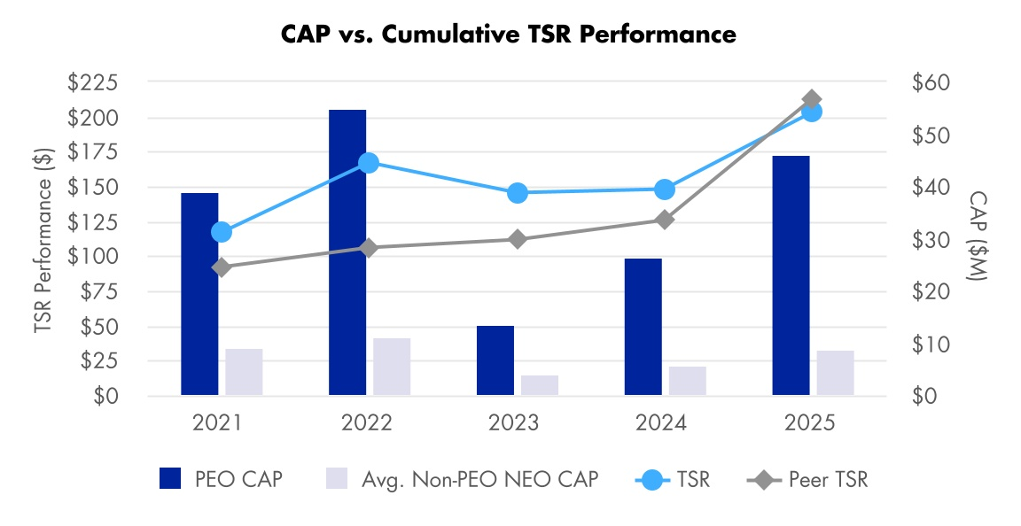
Adjusted Cash Flow from Operations* was selected as the CSM to focus on an annual metric, per SEC guidance. This metric emphasizes the importance of generating cash for strategy execution and enables management to make capital investment decisions. Since it has a stronger focus on our annual performance rather than long-term performance, the impact of Adjusted Cash Flow from Operations* on CAP is moderate compared to the LTI plan metrics.
While the Company is required to include net income as a metric in the Pay Versus Performance table, we do not believe the metric is an appropriate selection for analyzing CAP, as defined by the SEC. Net income is not used to measure compensation due to the non-operational impacts of the annual mark-to-market pension and other postretirement benefits “OPB“ adjustments, which include actuarial gains and losses that can vary significantly from year to year.
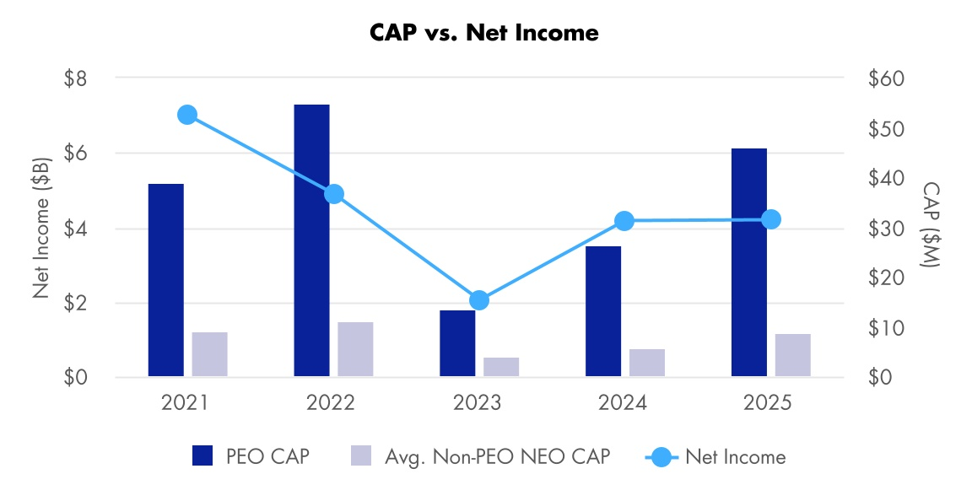
* This metric is a non-GAAP financial measure. For more information, see “Appendix A - Use of Non-GAAP Financial Measures.”

86 |  |  | Northrop Grumman

Equity Compensation Plan Information
We currently maintain three equity compensation plans: the 2024 Plan, the 2011 Plan and the 1993 Stock Plan for Non-Employee Directors, as amended (1993 Directors Plan). Each of these plans has been approved by our shareholders.
The following table sets forth the number of shares of our common stock to be issued upon payout of outstanding awards and the number of shares remaining available for future award grants under these equity compensation plans as of December 31, 2025.

Plan category |  |  | Number of shares of  common stock to be  issued upon exercise  of outstanding options and  payout of outstanding  awards(1)  (#) |  |  | Weighted-average  exercise price of  outstanding options(2)  ($) |  |  | Number of shares of  common stock remaining  available for future issuance  under equity compensation plans  (excluding shares reflected in the  first column)(3)  (#)
Equity compensation plans approved  by shareholders |  |  | 964,810 |  |  | N/A |  |  | 5,503,642
Equity compensation plans not  approved by shareholders |  |  | N/A |  |  | N/A |  |  | N/A
Total |  |  | 964,810 |  |  | N/A |  |  | 5,503,642 |  |  | (4)
(1)This number includes 446,181 shares that were subject to outstanding stock awards, 171,433 awards earned at year end but pending distribution subject to the final performance adjustments determined in February 2026, and additional performance shares of 270,433, which reflect the number of shares deliverable under payment of outstanding restricted performance stock rights, assuming maximum performance criteria have been achieved, under the 2024 Plan and 2011 Plan, and 76,763 shares subject to outstanding stock units credited under the 2024 Plan, 2011 Plan and 1993 Directors Plan.
(2)There were no options outstanding as of December 31, 2025.
(3)Of the aggregate number of shares that remained available for future issuance, 5,503,642 were available under the 2024 Plan as of December 31, 2025. No new awards may be granted under the 2011 Plan or the 1993 Directors Plan.
(4)After giving effect to our February 2026 awards, the number of shares of common stock remaining available for future issuance would be 5,205,732 (assuming maximum payout of such awards).

2026 Proxy Statement |  |  | 87

Proposal 3: Ratification of Appointment of Independent Auditor
The Audit and Risk Committee believes that the appointment of Deloitte & Touche LLP (Deloitte) is in the best interests of the Company and its shareholders, and proposes and recommends that the shareholders ratify the Audit and Risk Committee’s appointment of Deloitte as our independent auditor for 2026.
Deloitte served as our independent auditor for 2025, and Deloitte or its predecessors have served as the independent auditor for the Company (including certain of its predecessor companies) since 1975. The Audit and Risk Committee is responsible for the appointment, compensation, retention, oversight, evaluation and termination, if necessary, of our independent auditor. In determining whether to retain Deloitte or engage another independent registered public accounting firm as the Company’s independent auditor, at least annually the Audit and Risk Committee, with management and our internal auditors, reviews and evaluates Deloitte’s performance and independence. As part of its review, the Audit and Risk Committee considers, among other things, the following:
•the quality and efficiency of Deloitte’s current and historical services provided to the Company;
•Deloitte’s capability, expertise and efficiency in handling the breadth and complexity of the Company’s global businesses and operations;
•the quality and candor of Deloitte’s communications with the Audit and Risk Committee;
•Deloitte’s independence from the Company;
•the appropriateness of Deloitte’s fees;
•external data on audit quality and performance, including recent Public Company Accounting Oversight Board reports on Deloitte and its peer firms; and
•Deloitte’s tenure as our independent auditor (including its knowledge of the Company and its operations, accounting policies and practices and internal controls).
Based on its evaluation, the Audit and Risk Committee believes that Deloitte is independent and well-qualified to serve as the Company’s independent auditor in 2026.
The Audit and Risk Committee also reviews the performance of Deloitte’s lead audit partner, and the Audit and Risk Committee and its Chair oversee the rotation of Deloitte’s lead audit partner and are involved in the selection and approval of the lead audit partner. The lead audit partner rotates every five years in accordance with regulatory requirements. In addition, the Audit and Risk Committee is responsible for reviewing and pre-approving audit and non-audit services and related fees for the independent auditor.
Although ratification is not required by our Bylaws or otherwise, the Audit and Risk Committee is submitting the selection of Deloitte to shareholders as a matter of good corporate governance. If the shareholders fail to ratify the appointment of Deloitte, the Audit and Risk Committee will consider this in its selection of auditor for the following year. A representative from Deloitte will attend the Annual Meeting and will have the opportunity to make a statement and respond to appropriate questions.
Vote Required
Approval of this proposal requires that the votes cast “for” the proposal exceed the votes cast “against” the proposal. Abstentions and broker non-votes will have no effect on this proposal.
THE BOARD OF DIRECTORS UNANIMOUSLY RECOMMENDS THAT YOU VOTE “FOR” PROPOSAL 3.

88 |  |  | Northrop Grumman

Proposal 3: Ratification of Appointment of Independent Auditor
Audit Fees and All Other Fees
The following table summarizes aggregate fees incurred for professional audit services for the audit of the Company’s consolidated financial statement audits for the years ended December 31, 2025 and 2024, and fees billed for other services in fiscal years 2025 and 2024, in each case by Deloitte, the member firms of Deloitte Touche Tohmatsu Limited and their respective affiliates:
 |  |  |  |  |  | 2025 |  |  |  |  |  | 2024
Audit Fees(1) |  |  | $ |  |  | 21,922,000 |  |  | $ |  |  | 21,649,000
Audit-Related Fees(2) |  |  |  |  |  | — |  |  |  |  |  | —
Tax-Related Fees(3) |  |  |  |  |  | 427,000 |  |  |  |  |  | 418,000
All Other Fees(4) |  |  |  |  |  | 50,000 |  |  |  |  |  | 25,000
Total Fees |  |  | $ |  |  | 22,399,000 |  |  | $ |  |  | 22,092,000
(1)Audit fees for 2025 and 2024 reflect fees of $19,885,000 and $19,405,000, respectively, for the consolidated financial statement audits and include the audit of internal controls pursuant to Section 404 of the Sarbanes-Oxley Act of 2002. Audit fees for 2025 and 2024 also include $1,933,000 and $1,850,000, respectively, for foreign statutory audits. Fees for foreign statutory audits are reported in the year in which the audits are performed. For example, foreign statutory audit fees reported in 2025 relate to audits of the Company’s foreign entities for the fiscal year ended 2024. The remaining 2025 audit fees primarily relate to audit services associated with the Company’s Form 8-K filing in connection with its debt offering in May 2025. The remaining 2024 audit fees primarily relate to audit services associated with the Company’s Form 8-K filing in connection with its debt offering in January 2024, the Company’s Form S-8 filing in July 2024 and testing procedures associated with the Company's implementation of the S/4HANA enterprise resource planning system and international general IT controls.
(2)Audit-related fees reflect fees for services that are reasonably related to the performance of the audit or review of the Company’s financial statements. There were no additional audit-related fees in 2025 or 2024. Audit-related fees exclude fees related to benefit plan audits, which are paid for by the plans, that totaled $1,577,000 for 2025 and $1,538,000 for 2024.
(3)Tax-related fees during 2025 and 2024 reflect fees of $427,000 and $418,000, respectively, for services concerning foreign income tax compliance, foreign Value Added Tax compliance and other tax matters.
(4)All Other Fees during 2025 reflect fees of $50,000 for services concerning the Company's Maryland State Tax Credit and the Company's allocation of hydrofluorocarbon allowances. All Other Fees during 2024 reflect fees of $25,000 for services concerning the Company's allocation of hydrofluorocarbon allowances.

Policy on Audit and Risk Committee Pre-Approval of Audit and Permissible Non-Audit Services
It is the Audit and Risk Committee’s policy to pre-approve all audit and permitted non-audit services provided by our independent auditor in order to provide reasonable assurance that the provision of these services does not impair the auditor’s independence. Pre-approval may be given at any time. The Audit and Risk Committee has delegated pre-approval authority for any individual project up to $1 million to the Chair of the Audit and Risk Committee.
The decisions of the Chair to pre-approve a permitted service are reported to the Audit and Risk Committee at its next meeting. The independent auditor is required to periodically report to the full Audit and Risk Committee regarding the extent of services provided by the independent auditor in accordance with this pre-approval policy, as well as the fees for the services performed to date.
The Audit and Risk Committee approved the audit and non-audit services provided by Deloitte, the member firms of Deloitte Touche Tohmatsu Limited and their respective affiliates during 2025 and 2024, in each case before being engaged to provide those services.

Audit and Risk Committee Report
The Audit and Risk Committee of the Board of Directors is responsible for assisting the Board of Directors in fulfilling its oversight responsibilities over the Company’s accounting, auditing and financial reporting processes and financial risk assessment and management process, and for monitoring compliance with certain regulatory and compliance matters. The Audit and Risk Committee’s written charter describes the Audit and Risk Committee’s responsibilities and has been approved by the Board of Directors.
2026 Proxy Statement |  |  | 89

Proposal 3: Ratification of Appointment of Independent Auditor
Management is responsible for preparing the Company’s financial statements and for the financial reporting process, including evaluating the effectiveness of the Company’s disclosure controls and procedures and internal control over financial reporting.
Deloitte & Touche LLP (Deloitte), the Company’s independent auditor, is responsible for performing an independent audit of the Company’s consolidated financial statements and expressing an opinion on the conformity of the financial statements with accounting principles generally accepted in the United States of America, and on the effectiveness of the Company’s internal control over financial reporting.
In connection with the preparation of the Company’s financial statements as of and for the year ended December 31, 2025, the Audit and Risk Committee reviewed and discussed the audited financial statements with the Company’s Chief Executive Officer, Chief Financial Officer, Chief Accounting Officer and Deloitte. The Audit and Risk Committee also discussed with Deloitte the communications required under applicable requirements of the Public Company Accounting Oversight Board (PCAOB) and the SEC, including the matters required to be discussed by Auditing Standard No. 1301, Communications with Audit Committees, as adopted by the PCAOB, and, with and without management present, discussed and reviewed the results of Deloitte’s examination of the financial statements. Additionally, the Audit and Risk Committee discussed with the Company’s internal auditors the results of their audits completed during 2025.
The Audit and Risk Committee received the written disclosures and the letter from Deloitte required by the applicable requirements of the PCAOB regarding the independent auditor’s communications with the Audit and Risk Committee concerning independence. In addition, the Audit and Risk Committee discussed with Deloitte that firm’s independence from the Company.
Based on the Audit and Risk Committee’s review and discussions described in this report, the Audit and Risk Committee recommended to the Board of Directors and the Board of Directors approved that the audited financial statements for the year ended December 31, 2025 be included in the Company’s Annual Report on Form 10-K for the year ended December 31, 2025 for filing with the SEC. The Audit and Risk Committee also reappointed Deloitte to serve as the Company’s independent auditor for 2026, and requested that this appointment be submitted to shareholders for ratification at the Annual Meeting.

AUDIT AND RISK COMMITTEE
Thomas M. Schoewe, Chair
Marianne C. Brown
Ann M. Fudge
Kimberly A. Ross
James S. Turley
Mark A. Welsh III

90 |  |  | Northrop Grumman

Proposal 4: Shareholder Proposal
Mr. John Chevedden, 2215 Nelson Avenue, No. 205, Redondo Beach, California 90278, a beneficial owner of at least 10 shares of common stock of the Company, has stated that he intends to present the following proposal at the Annual Meeting. The proposal and supporting statement, for which the Board accepts no responsibility, has been reproduced below without modification. The Board opposes the shareholder proposal for the reasons stated below.

Proposal 4 - Shareholder Proposal to Provide for an Independent Board Chair
Proposal 4 — Independent Board Chairman

Shareholders request that the Board of Directors adopt an enduring policy, and amend the governing documents as necessary including the Corporate Governance Guidelines in order that 2 separate people hold the office of the Chairman and the office of the CEO as soon as possible.

The Chairman of the Board shall be an Independent Director. An independent Lead Director shall not be a substitute for an independent Board Chairman.

The Board shall have the discretion to select an interim Chairman of the Board, who is not an Independent Director, to serve while the Board is required to seek an Independent Chairman of the Board on an accelerated basis. This policy could be phased in when there is a contract renewal for our current CEO or for the next CEO transition although it is better to adopt it now to obtain the maximum benefit.

An independent Board Chairman at all times improves corporate governance by bringing impartiality, objective oversight, and external expertise to board decisions, mitigating conflicts of interest, enhancing transparency, and boosting shareholder confidence.

This detached perspective allows the chairman to focus on shareholder interests, strengthen management accountability, and provide critical checks and balances, ultimately contributing to long-term sustainability and credibility.

An independent Board Chairman could help Northrop Grumman deal with a relative plateau in the stock price. The Northrop Grumman sock price was at $556 in 2022 and only at $561 in late 2025 despite a robust stock market.

An independent Board Chairman could also help NOC deal with headwinds like those that emerged in 2025:

A significant source of negative press was the news that NOC took a $477 million pre-tax loss on the B-21 Raider stealth bomber program due to higher-than-anticipated manufacturing and material costs. This led to a 49% drop in Q1 2025 net earnings and a sharp decline in NOC's stock price in April 2025.

NOC lowered its full-year 2025 revenue guidance on more than one occasion due to delayed program awards, timing of material receipts, and challenges within the space systems segment which faced a wind-down of 2 large programs.

NOC lost the bid for the Next Generation Interceptor (NGI) anti-missile contract (an estimated $17 billion program) to Lockheed Martin, which was viewed as a competitive setback.

Revenue shortfalls and conservative forecasts led to a cautious, and at times negative, market reaction and investor concern over NOC's growth trajectory.

The Aeronautics Systems and Space Systems segments experienced sales and operating income declines, offsetting growth in other areas.

Please vote yes:
Independent Board Chairman — Proposal 4
2026 Proxy Statement |  |  | 91

Proposal 4: Shareholder Proposal
Board of Directors’ Statement in Opposition to Proposal 4
Our shareholders have considered and rejected seven similar independent Chair proposals since 2012, most recently in 2024. The Board remains consistent in its view that the Company and its shareholders are best served when the Board retains the flexibility to utilize its experience, knowledge and judgment, informed by ongoing input from our shareholders and other stakeholders, to determine which director is best suited to serve as Chair and as Lead Independent Director, considering the full breadth of facts and circumstances. While an independent Chair may be appropriate in some situations, a rigid requirement that the Board must always have an independent Chair ignores the dynamic and complex reality of our business and the capabilities of our leaders to manage it. Regardless of the legitimate question of whether Delaware law would even permit the Company to adopt an “enduring” policy of the type requested by this proposal, the Board believes the proposal is not in the best interests of our Company because such an inflexible requirement would deprive the Board of its authority to determine the most effective leadership structure that best serves the Company and its stakeholders in an evolving environment.
Under our Bylaws and Principles of Corporate Governance, the Board has the authority to determine whether the positions of Chair and CEO should be held by the same or different persons, and re-evaluates and makes this determination at least annually. The Board of Directors acknowledges that an independent Chair can add value for certain companies and in certain circumstances. For example, the Board has selected an independent Chair during periods of CEO transition when it determined that such a structure would best support continuity. However, after carefully weighing the many factors that inform our governance decisions, the Board has concluded that an independent Chair is not the optimal model for our Company at this time—especially given the strength of our existing Lead Independent Director role.
The Board remains confident that a single individual serving as both Chair and CEO, paired with the strong, independent oversight provided by our Lead Independent Director, provides the most advantageous combination of executive direction and oversight at this time. The Company’s governance structure not only safeguards the interests of the Company and its shareholders, but it also best positions us to innovate, compete effectively, and present a unified face to our customers and stakeholders.
The Board considers a wide range of factors when determining the most effective leadership structure for the Board. These factors include:
•the role of the Board and the responsibilities of the Lead Independent Director and the Chair;
•the experience and capabilities of the directors and the management team;
•the strategic and other challenges and opportunities facing the Company, both at the time and in the near future;
•the evolving security, geopolitical and macroeconomic environment in which we operate and the requirements on management and the Board;
•relationships with our largest customers, appropriators and regulators;
•the confidence shareholders have in the Company’s leadership;
•the importance of presenting one leadership voice to our customers in the U.S. and globally;
•the importance of promoting a clear, unified strategic vision for the Company, ensuring that strategies adopted by the Board are well-positioned for execution by management; and
•the Company's performance under the current leadership structure and the effectiveness of the Chair's leadership, including as reflected in the Company's results, strategic execution and long-term value creation.
At the Nominating and Corporate Governance Committee (“Governance Committee”) and the Board meeting in December 2025, the Governance Committee and the Board engaged in an extensive discussion regarding the most appropriate leadership structure, and again concluded that the Company would be best served by having Ms. Warden, our CEO, continue to serve as Chair, counterbalanced by continuing to have an independent director serve as Lead Independent Director. The Board believes this is the best leadership structure for the Company at this time. Ms. Warden’s deep understanding of our Company, including its risks, opportunities, and customers, combined with her extensive industry experience, strong relationships with key stakeholders, advanced technical expertise, and comprehensive knowledge of corporate governance best practices, uniquely positions her to provide strong and effective Board leadership for our Company.
The Company’s strong performance under Ms. Warden’s leadership supports the Board’s decision to retain a combined Chair-CEO structure. While the proponent points to selective stock price movements and discrete program challenges to bolster his argument for an independent Chair, such snapshots do not reflect the Company’s overall performance, long-term
92 |  |  | Northrop Grumman

Proposal 4: Shareholder Proposal
value creation, or the complexity of the environment in which it operates. For example, as of the last trading day of February 2026, over both five and ten-year periods, Northrop Grumman’s total shareholder return has outperformed the S&P 500 and a majority of the companies that the Company considers its peers within the defense sector. This track record underscores Ms. Warden’s ability to lead the Company’s delivery of sustained value and reward shareholders with significant returns over time. Additionally, as of the last trading day of February 2026, the Company’s market capitalization has grown 146% and its share price has increased 196% since 2019, the year Ms. Warden was elected Chief Executive Officer and Chair of the Company. Further, the Company ended 2025 with a record backlog of approximately $95.7 billion and generated approximately $4.8 billion in operating cash flow, with free cash flow* of $3.3 billion, reflecting an increase of approximately 8% and 26%, respectively, the third consecutive year of operating cash flow growth of at least 8% and the third consecutive year of free cash flow* growth of at least 25%, providing significant momentum for future growth. Most importantly, the Company has continued to execute on some of our nation’s most critical national security programs, demonstrating resilience and disciplined execution despite industry-wide and macroeconomic headwinds. In short, the proponent’s argument is belied by the Company’s strong performance record under Ms. Warden’s leadership.
In accordance with our Bylaws and Principles of Corporate Governance, the Board is required to designate a Lead Independent Director from among them when the Chair is not independent. Ms. Kleiner has served as Lead Independent Director since December 2022 and during her tenure, has engaged with investors and demonstrated strong leadership skills, independent thinking and deep understanding of our business and our shareholders’ interest. Upon Ms. Kleiner’s retirement from the Board in May 2026, the Board has designated Mr. Turley to succeed Ms. Kleiner. Mr. Turley brings extensive experience in both CEO and board leadership positions to the role of Lead Independent Director. Mr. Turley served as Chairman and CEO of Ernst & Young, a global professional services firm, for twelve years. Following his retirement, Mr. Turley has served on the boards of a number of public, multi-national companies, including as the Non-Executive Chair of Emerson, a global software, engineering and technology company, the Lead Independent Director of Precigen, a biopharmaceutical company and as a member of the Board of Directors of Citigroup Inc., a global financial services company. This experience makes him uniquely qualified to serve as our Lead Independent Director.
Our Principles of Corporate Governance explicitly prescribe a strong role for our Lead Independent Director, describing in detail significant duties and responsibilities with respect to the oversight, operation and functioning of the Board. As part of its regular corporate governance reviews, the Board annually evaluates the duties and responsibilities of the Lead Independent Director to ensure the role remains appropriately empowered to provide effective leadership and independent oversight. Over the last few years, the Board has expanded and refined these responsibilities to ensure the role continues to meet the evolving needs of the Company and the Board.
A summary of the fulsome and specific duties and responsibilities of the Lead Independent Director is set forth on page 31 of this Proxy Statement. Among other roles, the Lead Independent Director is charged with serving as the principal advisor to the Chair. The Lead Independent Director also meets with shareholders, and works closely with the Chair to provide independent oversight and help ensure the Board effectively meets its responsibilities. The Lead Independent Director also leads the annual evaluation of the Chair and CEO. Additionally, the Lead Independent Director works closely with the Chair to facilitate succession planning and management development.
The Board consists entirely of independent directors, other than Ms. Warden, and continues to exercise a strong, independent oversight function (including through Board committees which are comprised entirely of independent directors). At each Board meeting, there is a scheduled session of the independent directors, led by the Lead Independent Director (if the Chair is not independent). And, among other roles, the independent directors elect the CEO, approve her or his annual compensation, provide performance feedback and direction, and oversee a robust succession planning process.
The Company’s carefully considered leadership structure provides flexibility to the Board to anticipate and respond to the environment in which the Company operates while simultaneously ensuring meaningful, independent Board governance. Having a highly qualified Chair supported by a strong Lead Independent Director builds confidence among shareholders and customers alike while strategically positioning the Company for sustained profitable growth in a dynamic landscape defined by rapid technological advancements and a continuously evolving geopolitical environment. Our shareholders have agreed with the Board’s judgment on this issue seven times before. The Board continues to believe our current leadership structure operates effectively to serve the interests of the Company and its shareholders and that mandating an independent Chair is unnecessary. We urge shareholders to again vote against this proposal.
Vote Required
Approval of this proposal requires that the votes cast “for” the proposal exceed the votes cast “against” the proposal. Abstentions and broker non-votes will have no effect on this proposal.

 |  |  | THE BOARD OF DIRECTORS UNANIMOUSLY RECOMMENDS THAT YOU VOTE “AGAINST” PROPOSAL 4.

2026 Proxy Statement |  |  | 93

Transactions with Related Persons and Control Persons

Related Person Transactions
The Company has a written policy approved by the Board, for the review, approval and ratification of transactions between our Company and our directors, executive officers and other related persons. A copy of the policy is available on the Investor Relations section of our website (www.northropgrumman.com). The policy provides for related person transactions to be reviewed in advance and approved or ratified, as applicable, by the Board of Directors, the Nominating and Corporate Governance Committee or the Chair of the Nominating and Corporate Governance Committee. A related person transaction may be approved if, after reviewing the relevant facts and circumstances, the reviewing party concludes that approving the related person transaction is in the best interests of the Company and its shareholders.
The policy defines a related person transaction as any transaction in which the Company was, is or will be a participant, where the amount involved exceeds $120,000, and in which a related person had, has or will have a direct or indirect material interest. A “related person” includes:
•any of our directors, nominees for director or executive officers;
•any person who, at the time of the occurrence or existence of the transaction, is the beneficial owner of more than 5% of our common stock; or
•an immediate family member of any such persons.
Under exceptional circumstances, if a related person transaction has not been approved in advance, the Nominating and Corporate Governance Committee will recommend to the Board of Directors such action as the Nominating and Corporate Governance Committee deems appropriate, including ratification, amendment or termination of the transaction.
The policy requires each director and executive officer to complete an annual questionnaire to identify his or her related interests and to notify the Corporate Secretary of any changes in their information.
State Street Corporation (State Street), acting in various fiduciary capacities, filed a Schedule 13G/A with the SEC reporting that as of December 31, 2023, State Street and certain of its subsidiaries collectively were the beneficial owners of more than 5% of our outstanding common stock. A subsidiary of State Street is the trustee for various Northrop Grumman defined benefit and defined contribution plan trusts. Two other State Street subsidiaries provide investment management services. During 2025, those State Street subsidiaries received approximately $5.3 million for such services, all of which was paid by the plan trusts.
BlackRock, Inc. (BlackRock) filed a Schedule 13G/A with the SEC reporting that as of September 30, 2024, BlackRock and certain of its subsidiaries collectively were the beneficial owners of more than 5% of our outstanding common stock. A subsidiary of BlackRock provides investment management services for certain assets within various Northrop Grumman defined benefit plan trusts. During 2025, the trusts paid that BlackRock subsidiary approximately $255,000 for such services.

Indemnification Agreements
Our Bylaws require us generally to indemnify our directors and executive officers to the fullest extent permitted by Delaware law. Additionally, as permitted by Delaware law, we have entered into indemnification agreements with each of our directors and elected officers. Under the indemnification agreements and our Bylaws, we have agreed to hold harmless and indemnify each indemnitee, generally to the fullest extent permitted by Delaware law, against expenses, liabilities and loss incurred in connection with threatened, pending or completed action, suit or proceeding, whether civil, criminal, administrative or investigative to which the indemnitee is made a party by reason of the fact that the indemnitee is or was a director or officer of the Company or any other entity at our request, provided however, that the indemnitee acted in good faith and in a manner reasonably believed to be in the best interests of our Company.

94 |  |  | Northrop Grumman

Voting Securities and Principal Holders

Stock Ownership of Certain Beneficial Holders
The following entities beneficially owned, to the best of our knowledge as of March 20, 2026, more than five percent of the outstanding common stock as of the dates indicated in the footnotes below. As of March 20, 2026, there were 142,033,159 shares of our common stock outstanding.
Name and Address of Beneficial Owner |  |  | Amount and Nature of  Beneficial Ownership of  Common Stock |  |  |  |  |  | Percent  of Class
State Street Corporation  1 Congress Street, Suite 1, Boston, MA 02114 |  |  | 13,860,192 |  |  | (1) |  |  | 9.8%
The Vanguard Group  100 Vanguard Blvd., Malvern, PA 19355 |  |  | 13,265,738 |  |  | (2) |  |  | 9.3%
Capital International Investors  333 South Hope Street, 55th Floor  Los Angeles, CA 90071 |  |  | 12,385,281 |  |  | (3) |  |  | 8.7%
BlackRock, Inc.  50 Hudson Yards  New York, NY 10001 |  |  | 10,688,475 |  |  | (4) |  |  | 7.5%
(1)This information was provided in a Schedule 13G/A jointly filed with the SEC on January 30, 2024 by State Street Corporation (State Street) and State Street’s subsidiaries State Street Bank and Trust Company (State Street Bank) and State Street Global Advisors Trust Company (State Street Global). According to State Street, as of December 31, 2023, it beneficially owned 13,860,192 shares and had sole voting power over 0 shares, shared voting power over 11,565,443 shares, sole dispositive power over 0 shares and shared dispositive power over 13,854,855 shares. According to State Street Bank, as of December 31, 2023, it beneficially owned 8,355,658 shares and had sole voting power over 0 shares, shared voting power over 8,355,658 shares, sole dispositive power over 0 shares and shared dispositive power over 0 shares. According to State Street Global, as of December 31, 2023, it beneficially owned 11,969,908 shares and had sole voting power over 0 shares, shared voting power over 1,460,684 shares, sole dispositive power over 0 shares and shared dispositive power over 11,969,408 shares. These totals include 8,355,658 shares held as of December 31, 2023 in the Defined Contribution Plans Master Trust for the Northrop Grumman Savings Plan and the Northrop Grumman Financial Security and Savings Program, for which State Street Bank acts as trustee and State Street Global acts as investment manager.
(2)This information was provided by The Vanguard Group (Vanguard) in a Schedule 13G/A filed with the SEC on April 30, 2025. According to Vanguard, as of March 31, 2025, Vanguard had sole voting power over 0 shares, shared voting power over 150,993 shares, sole dispositive power over 12,668,069 shares and shared dispositive power over 597,669 shares. Vanguard subsequently reported that due to an internal realignment it no longer has, or is deemed to have, beneficial ownership over Company securities beneficially owned by various subsidiaries and/or business divisions. Vanguard also reported that certain subsidiaries or business divisions that formerly had, or were deemed to have, beneficial ownership with Vanguard, will report beneficial ownership separately (on a disaggregated basis).
(3)This information was provided by Capital International Investors (Capital International), a division of Capital Research and Management Company and certain of its investment management subsidiaries and affiliates, in a Schedule 13G/A filed with the SEC on August 13, 2025. According to Capital International, as of June 30, 2025, Capital International had sole voting power over 12,218,846 shares, shared voting power over 0 shares, sole dispositive power over 12,385,281 shares and shared dispositive power over 0 shares.
(4)This information was provided by BlackRock, Inc. (BlackRock) in a Schedule 13G/A filed with the SEC on November 12, 2024. According to BlackRock, as of September 30, 2024, BlackRock had sole voting power over 9,965,772 shares, shared voting power over 0 shares, sole dispositive power over 10,688,475 shares and shared dispositive power over 0 shares.

2026 Proxy Statement |  |  | 95

Voting Securities and Principal Holders
Stock Ownership of Officers and Directors
The following table shows beneficial ownership of our common stock as of March 20, 2026 by each of our current directors, our named executive officers and all directors and executive officers as a group. As of March 20, 2026, there were 142,033,159 shares of our common stock outstanding. None of the persons named below beneficially owns in excess of 1% of our outstanding common stock. Unless otherwise indicated, each individual has sole investment power and sole voting power with respect to the shares owned by such person.
 |  |  | Shares of  Common Stock  Beneficially Owned |  |  | Share  Equivalents(1) |  |  |  |  |  | Total
Non-Employee Directors
David P. Abney |  |  | 2,083 |  |  | 392 |  |  |  |  |  | 2,475
Marianne C. Brown |  |  | — |  |  | 10,998 |  |  |  |  |  | 10,998
Ann M. Fudge |  |  | 1,178 |  |  | 4,689 |  |  |  |  |  | 5,867
Christopher W. Grady |  |  | — |  |  | 72 |  |  |  |  |  | 72
Madeleine A. Kleiner |  |  | — |  |  | 21,343 |  |  |  |  |  | 21,343
Arvind Krishna |  |  | — |  |  | 2,264 |  |  |  |  |  | 2,264
Kimberly A. Ross |  |  | — |  |  | 1,263 |  |  |  |  |  | 1,263
Gary Roughead |  |  | — |  |  | 11,861 |  |  |  |  |  | 11,861
Thomas M. Schoewe |  |  | 3,160 |  |  | 13,228 |  |  |  |  |  | 16,388
James S. Turley |  |  | 635 |  |  | 5,754 |  |  |  |  |  | 6,389
Mark A. Welsh III |  |  | 191 |  |  | 4,025 |  |  |  |  |  | 4,216
Mary A. Winston |  |  | 78 |  |  | 1,191 |  |  |  |  |  | 1,269
Named Executive Officers
Kathy J. Warden(2) |  |  | 196,681 |  |  | — |  |  |  |  |  | 196,681
Kenneth B. Crews |  |  | 3,362 |  |  | 117 |  |  |  |  |  | 3,479
Robert J. Fleming |  |  | 2,619 |  |  | — |  |  |  |  |  | 2,619
Thomas H. Jones |  |  | 11,205 |  |  | — |  |  |  |  |  | 11,205
Roshan S. Roeder |  |  | 2,353 |  |  | 119 |  |  |  |  |  | 2,472
Other Executive Officers |  |  | 2,677 |  |  | — |  |  |  |  |  | 2,677
All Directors and Executive Officers as a Group (21 persons) |  |  | 226,222 |  |  | 77,316 |  |  |  |  |  | 303,538 |  |  | (3)
(1)Share equivalents for directors represent non-voting deferred stock units acquired under the 2024 Plan, the 2011 Plan or the 1993 Directors Plan, some of which are paid out in shares of common stock at the conclusion of a director-specified deferral period, and others are paid out upon termination of the director’s service on the Board. Certain of the NEOs hold share equivalents with pass-through voting rights in the Northrop Grumman Savings Plan or the Northrop Grumman Financial Security and Savings Program.
(2)Ms. Warden also serves on the Company’s Board of Directors.
(3)Total represents 0.21% of the outstanding common stock as of March 20, 2026.

96 |  |  | Northrop Grumman

Questions and Answers About
the Annual Meeting
How do I attend the Annual Meeting?
The Annual Meeting will be held exclusively online via live webcast at www.virtualshareholdermeeting.com/NOC2026 on May 20, 2026. To be admitted to the Annual Meeting via the website, shareholders must enter the 16-digit voting control number found on their proxy card, voting instruction form, notice of internet availability of proxy materials, or email notification. You may begin to log into the website beginning at 7:45 AM Eastern Daylight Time. The meeting will begin promptly at 8:00 AM Eastern Daylight Time. If you encounter any technical difficulties, please call the number posted to the online webcast (it will be available starting at 7:45 AM Eastern Daylight Time and remain available for the duration of the meeting). We will disclose additional details about the Annual Meeting or changes to the process on the Investor Relations section of our website (www.northropgrumman.com) and/or in a public filing with the SEC, as appropriate.
Why did I receive a “Notice of Internet Availability of Proxy Materials” but not a full set of proxy materials?
We distribute our proxy materials to shareholders via the internet under the “Notice and Access” approach permitted by the rules of the SEC. This approach reduces the environmental impact of the Annual Meeting and our distribution costs, while providing a timely and convenient method of accessing the proxy materials and voting. On April 3, 2026, we mailed a “Notice of Internet Availability of Proxy Materials” to participating shareholders, containing instructions on how to access the proxy materials.
Who is entitled to vote at the Annual Meeting?
You may vote your shares of our common stock if you owned your shares as of the close of business on March 24, 2026 (Record Date). As of the Record Date, there were 142,033,159 shares of our common stock outstanding. You may cast one vote for each share of common stock you hold as of the Record Date on all matters presented.
How many votes must be present to hold the Annual Meeting?
The presence virtually or by proxy of the holders of a majority of the shares entitled to vote at the Annual Meeting will constitute a quorum at the Annual Meeting. Persons returning executed proxy cards will be counted as present for purposes of establishing a quorum even if they abstain from voting on any or all proposals. Shares held by brokers who vote such shares on any proposal and broker non-votes will be counted as present for purposes of establishing a quorum.
How can I receive a paper copy of the proxy materials?
Instead of mailing a printed copy of this Proxy Statement and accompanying materials to each shareholder of record, we have elected to provide a Notice of Internet Availability of Proxy Materials (Notice) as permitted by the rules of the SEC. The Notice instructs you as to how you may access and review all of the proxy materials and how you may provide your proxy. If you would like to receive a printed or electronic copy of this Proxy Statement and accompanying materials, you must follow the instructions for requesting such materials included in the Notice.
Will I have an opportunity to ask questions before or during the Annual Meeting?
Shareholders entitled to vote will be able to submit questions relevant to the business of the meeting during the meeting via www.virtualshareholdermeeting.com/NOC2026 by typing the question into the "Ask a Question" box and clicking “Submit.” In order to ask a question, shareholders will need to have a valid voting control number. You may also submit a question in advance of the meeting at www.proxyvote.com by logging in with the 16-digit voting control number found on your proxy card, voting instruction form, Notice, or email notification. Once you are past the login screen, click on “Questions for Management,” type in your question and click “Submit.” All questions should relate to the official business of the meeting, and management and shareholder proposals in particular. Management will seek to answer questions at the relevant time.
2026 Proxy Statement |  |  | 97

Questions and Answers About the Annual Meeting
What am I being asked to vote on and what are the Board of Directors’ recommendations?
The following table lists the proposals scheduled to be voted on, the vote required for approval of each proposal and the effect of abstentions and broker non-votes:
Proposal |  |  | Board  Recommendation |  |  | Vote  Required |  |  | Abstentions |  |  | Broker  Non-Votes |  |  | Unmarked  Proxy Cards
Election of the 11 Director Nominees Named in this Proxy Statement  (Proposal 1) |  |  | FOR |  |  | Majority of votes cast |  |  | No effect |  |  | No effect |  |  | Voted “FOR“
Advisory Vote to Approve Compensation of Named Executive Officers  (Proposal 2) |  |  | FOR |  |  | Majority of votes cast |  |  | No effect |  |  | No effect |  |  | Voted “FOR“
Ratification of Appointment of Independent Auditor  (Proposal 3) |  |  | FOR |  |  | Majority of votes cast |  |  | No effect |  |  | None expected |  |  | Voted “FOR“
Shareholder Proposal to Provide for an Independent Board Chair  (Proposal 4) |  |  | AGAINST |  |  | Majority of votes cast |  |  | No effect |  |  | No effect |  |  | Voted “AGAINST“
What is a broker non-vote?
Brokers who hold shares of common stock for the accounts of their clients may vote these shares either as directed by their clients or in their own discretion if permitted by the stock exchanges or other organizations of which they are members. Members of the New York Stock Exchange (NYSE) are permitted to vote their clients’ proxies in their own discretion on certain matters if the clients have not furnished voting instructions within ten days of the meeting. However, NYSE Rule 452 defines various matters as “non-routine,” and brokers who have not received instructions from their clients do not have discretion to vote their client’s shares on such “non-routine” matters, resulting in a “broker non-vote.”
In order to ensure that your shares are voted on all matters presented at the Annual Meeting, we encourage you to provide voting instructions in advance of the meeting, regardless of whether you plan to attend the Annual Meeting. If you are a beneficial owner whose shares are held of record by a broker and you do not provide voting instructions, your broker may elect to vote your shares on some but not all matters, in which case a broker non-vote will occur and your shares will not be voted on such matters.
How do I vote my shares if they are registered directly in my name?
If your shares are registered directly in your name with our transfer agent, Computershare Trust Company, N.A., you are considered the “registered shareholder” of those shares, and you may vote by proxy prior to the Annual Meeting, as discussed below, or you may vote online during the Annual Meeting. Shares represented by a properly executed proxy will be voted at the Annual Meeting in accordance with the shareholder’s instructions. If no instructions are given, the shares will be voted according to the recommendations of the Board. Registered shareholders may go to www.proxyvote.com to view this Proxy Statement and the Annual Report.
98 |  |  | Northrop Grumman

Questions and Answers About the Annual Meeting
 |  |  | BY INTERNET |  |  | Registered shareholders may vote on the internet, as well as view the documents, by logging on to www.proxyvote.com and following the instructions given. You will need the 16-digit voting control number included in your proxy card, voting instruction form or Notice.
 |  |  | BY TELEPHONE |  |  | Registered shareholders may vote by calling 800-690-6903 (toll-free) with a touch-tone telephone and following the recorded instructions. You will need the control number included in your proxy card, voting instruction form or Notice.
 |  |  | BY QR CODE |  |  | Registered shareholders may vote by scanning the QR code on their proxy card or Notice with their mobile device.
 |  |  | BY MAIL |  |  | Registered shareholders must request a paper copy of the proxy materials to receive a proxy card and may vote by marking the voting instructions on the proxy card and following the instructions given for mailing. A paper copy of the proxy materials may be obtained by logging on to www.proxyvote.com and following the instructions given.
 |  |  | DURING THE ANNUAL MEETING |  |  | Registered shareholders may vote during the Annual Meeting online at www.virtualshareholdermeeting.com/NOC2026. If you have already voted online, by telephone, by QR code or by mail, your vote during the Annual Meeting will supersede your earlier vote.
If any other matters are properly brought before the Annual Meeting, the proxy card gives discretionary authority to the proxyholders named on the card to vote the shares in their best judgment. A shareholder who executes a proxy may revoke it at any time before its exercise by delivering a written notice of revocation to the Corporate Secretary or by delivering a valid, later-dated proxy, or a later-dated vote by telephone or on the internet, in a timely manner. In addition, a shareholder attending the Annual Meeting may revoke the proxy by voting during the Annual Meeting.
How do I vote my shares if they are held by a bank, broker or other nominee?
If your shares are held in a stock brokerage account or by a bank or other nominee (that is, in street name), you are considered the “beneficial owner” of the shares that are registered in the street name. You are able to vote those shares, to attend the Annual Meeting as a shareholder, and to ask questions at the meeting. You will need to instruct the bank, broker or other nominee how to vote these shares using the procedure identified by the bank, broker or other nominee. You should receive voting instruction forms from your bank, broker or other nominee. We expect most banks, brokers and other nominees to enable beneficial owners to provide voting instructions by telephone or on the internet. Beneficial owners may view this Proxy Statement and the Annual Report on the internet by logging on to www.proxyvote.com.
Beneficial owners who hold shares in “street name” may revoke a proxy or change a vote by submitting a new, later-dated voting instruction form, contacting the bank, broker or other nominee or by voting during the Annual Meeting. If the Notice or voting instruction form that you received does not indicate that you may vote your shares through the www.proxyvote.com website, you should contact your bank, broker, or other nominee (preferably at least five days before the meeting) and obtain your 16-digit voting control number that will allow you to attend, participate in, and vote at the meeting.
How do I vote my shares held under a Northrop Grumman savings plan?
If shares are held on an individual’s behalf under any of our savings plans, the proxy will serve to provide confidential instructions to the plan Trustee or Voting Manager who then votes the participant’s shares in accordance with the individual’s instructions. For those participants who do not vote their plan shares, the applicable Trustee or Voting Manager will vote their plan shares in the same proportion as shares held under the plan for which voting directions have been received, unless the Employee Retirement Income Security Act requires a different procedure.
Savings plan participants may submit their voting instructions by the same methods as registered shareholders (see “How do I vote my shares if they are registered directly in my name?” above) but voting instructions from savings plan participants must be received by the applicable plan Trustee or Voting Manager by 11:59 p.m. Eastern Daylight Time on May 17, 2026 in order to be used by the plan Trustee or Voting Manager to determine the votes cast with respect to plan shares.

2026 Proxy Statement |  |  | 99

Miscellaneous

Voting on Other Matters
We are not aware of any other business to be transacted at the Annual Meeting. Our Bylaws outline procedures, including minimum notice provisions, for shareholder nominations of directors and submission of other shareholder business to be transacted at the Annual Meeting. A copy of the pertinent Bylaw provisions is available on request to the Corporate Secretary, Northrop Grumman Corporation, 2980 Fairview Park Drive, Falls Church, Virginia 22042. Our Bylaws are also available in the Investor Relations section of our website at www.northropgrumman.com. If any other business properly comes before the Annual Meeting, the shares represented by proxies will be voted in accordance with the judgment of the persons authorized to vote them.

Shareholder Proposals for the 2027 Annual Meeting
Any shareholder who intends to present a proposal at the 2027 Annual Meeting must deliver the proposal to the Corporate Secretary at Northrop Grumman Corporation, 2980 Fairview Park Drive, Falls Church, Virginia 22042:
•not later than December 4, 2026, if the proposal is submitted for inclusion in the Company’s proxy materials for that meeting pursuant to Rule 14a-8 under the Exchange Act; and
•not earlier than December 4, 2026 and not later than January 3, 2027, if the proposal is submitted pursuant to the Bylaws, but not pursuant to Rule 14a-8, in which case we are not required to include the proposal in our proxy materials. If the 2027 Annual Meeting is convened more than 30 days prior to or delayed by more than 30 days after the one-year anniversary of the Annual Meeting, our Bylaws provide different notice requirements.
Any shareholder who wishes to introduce a proposal should review our Bylaws and applicable proxy rules of the SEC.

Shareholder Nominations for Director Elections at the 2027 Annual Meeting
Any shareholder who intends to nominate a person for election as a director at the 2027 Annual Meeting must deliver a notice of such nomination (along with certain other information required by our Bylaws) to the Corporate Secretary at Northrop Grumman Corporation, 2980 Fairview Park Drive, Falls Church, Virginia 22042:
•not earlier than November 4, 2026 and not later than December 4, 2026, if the nomination is submitted for inclusion in the Company’s proxy materials for that meeting pursuant to the Company’s proxy access provision, as set forth in our Bylaws, which nomination and supporting materials must comply with the requirements in our Bylaws; and
•not earlier than December 4, 2026 and not later than January 3, 2027, if the nomination is submitted pursuant to the Bylaws, but not pursuant to our proxy access provision, in which case we are not required to include the nomination in our proxy materials (except as may be required in our proxy card pursuant to Rule 14a-19). If the 2027 Annual Meeting is convened more than 30 days prior to or delayed by more than 30 days after the one-year anniversary of the Annual Meeting, our Bylaws provide different notice requirements.
Any shareholder who wishes to nominate a person for election as a director should review our Bylaws. In addition, shareholders who intend to solicit proxies in reliance on the SEC’s universal proxy rule for director nominees submitted under the advance notice requirements of our Bylaws must comply with the additional requirements of Rule 14a-19, including delivery of written notice that sets forth all information required by Rule 14a-19(b) under the Exchange Act.

Householding Information
Some banks, brokers and other nominee record holders may be participating in the practice of “householding.” This means that only one copy of the Notice of Internet Availability of Proxy Materials may have been sent to multiple shareholders in a household. We will promptly deliver a separate copy to a shareholder upon written or oral request to the Corporate
100 |  |  | Northrop Grumman

Miscellaneous
Secretary at the following address and phone number: Northrop Grumman Corporation, 2980 Fairview Park Drive, Falls Church, Virginia 22042, (703) 280-2900. To receive separate copies of the Notice in the future, or if a shareholder is receiving multiple copies and would like to receive only one copy for the household, the shareholder should contact his or her bank, broker or other nominee record holder, or may contact the Corporate Secretary at the above address or phone number.

Cost of Soliciting Proxies
We will pay all costs of soliciting proxies. We have made arrangements with brokerage houses and other custodians, nominees and fiduciaries to make proxy materials available to beneficial owners. We will, upon request, reimburse them for reasonable expenses incurred. We have retained D.F. King & Co., Inc. of New York at an estimated fee of $23,625, plus reasonable disbursements, to solicit proxies on our behalf. Our officers, directors and regular employees may solicit proxies personally, by means of materials prepared for shareholders and employee-shareholders or by telephone or other methods to the extent deemed appropriate by the Board.
No additional compensation will be paid to such individuals for this activity. The extent to which this solicitation will be necessary will depend upon how promptly proxies are received. We therefore urge shareholders to give voting instructions without delay.

Available Information
You may obtain a copy of the following corporate governance materials on the Investor Relations section of our website (www.northropgrumman.com) under Corporate Governance:
•Bylaws;
•Principles of Corporate Governance;
•Standards of Business Conduct;
•Policy and Procedure Regarding Company Transactions with Related Persons; and
•Board Committee Charters.
Copies of these documents are also available without charge to any shareholder upon written request to the Corporate Secretary, Northrop Grumman Corporation, 2980 Fairview Park Drive, Falls Church, Virginia 22042.
We disclose amendments to provisions of our Standards of Business Conduct by posting amendments on our website.

Incorporation by Reference
In accordance with SEC rules, notwithstanding anything to the contrary set forth in any of our previous or future filings under the Securities Act of 1933, as amended, or the Exchange Act that might incorporate this Proxy Statement or future filings made by the Company under those statutes, the information included under the section entitled “Compensation and Human Capital Committee Report” and those portions of the information included under the section entitled “Audit and Risk Committee Report” required by the SEC’s rules to be included therein, shall not be deemed to be “soliciting material” nor shall the information included under the section entitled “Compensation of Directors - Stock Ownership Requirements and Anti-Hedging and Pledging Policy,” the information included under the section entitled “Compensation and Human Capital Committee Report,” or those portions of the information included under the section entitled “Audit and Risk Committee Report” required by the SEC’s rules to be included therein, be “filed” with the SEC or, along with the information included under the section entitled ”Pay Versus Performance,” be deemed incorporated by reference into any of those prior filings or into any future filings made by the Company under those statutes, except to the extent we specifically incorporate these items by reference.
Web links throughout this document are provided for convenience only, and the content on the referenced websites does not constitute a part of this Proxy Statement.

2026 Proxy Statement |  |  | 101

Miscellaneous
Annual Report
April 3, 2026
NOTICE: THE COMPANY FILED AN ANNUAL REPORT ON FORM 10-K FOR THE YEAR ENDED DECEMBER 31, 2025 ON JANUARY 27, 2026. SHAREHOLDERS OF RECORD ON MARCH 24, 2026 MAY OBTAIN A COPY OF THIS REPORT WITHOUT CHARGE UPON WRITTEN REQUEST TO THE CORPORATE SECRETARY, NORTHROP GRUMMAN CORPORATION, 2980 FAIRVIEW PARK DRIVE, FALLS CHURCH, VIRGINIA 22042.
Jennifer C. McGarey
Corporate Vice President and Secretary

102 |  |  | Northrop Grumman

Appendix A – Use of Non-GAAP Financial Measures
This Proxy Statement contains non-GAAP (accounting principles generally accepted in the United States of America) financial measures, as defined by SEC Regulation G and indicated by an asterisk in this Proxy Statement. While we believe investors and other users of our financial statements may find these non-GAAP financial measures useful in evaluating our financial performance and operational trends, they should be considered as supplemental in nature, and therefore, should not be considered in isolation or as a substitute for financial information prepared in accordance with GAAP. Definitions for the non-GAAP financial measures contained in this Proxy Statement are provided below and the reconciliations of non-GAAP financial measures presented in this Proxy Statement are located on pages 105 to 107 of this Appendix A. Other companies, including companies in our industry, may define these measures differently or may utilize different non-GAAP financial measures, limiting the usefulness of those measures for comparative purposes between companies.
Certain non-GAAP financial measures below are used as internal measures for performance-based compensation decisions, as further discussed in the “Key Components of Our Executive Compensation Programs” section of the Compensation Discussion and Analysis. Accordingly, we have defined and calculated those non-GAAP financial measures below consistent with how the measures were defined and calculated for internal performance-based compensation purposes, which may change over time. In addition, the Compensation and Human Capital Committee (the "Committee") has discretion to make adjustments to these measures in instances where the Company’s performance has been impacted by unforeseen or unusual events. For 2025, 2024 and 2023, the Committee adjusted the calculation of certain measures in order to exclude the impact of certain events or transactions that were not contemplated when the performance metrics were established.
Cash Flow Metrics: We use cash flow metrics as internal measures of financial performance and for performance based compensation decisions. We also use these measures as a key factor in our planning for, and consideration of, acquisitions, payments of dividends and share repurchases. The following cash flow metrics may be useful to investors and other users of our financial statements as supplemental measures of our cash performance, but should not be considered in isolation, as measures of residual cash flow available for discretionary purposes, or as alternatives to operating results presented in accordance with GAAP. All cash flow metrics are reconciled below.
Free Cash Flow: Net cash provided by operating activities, less capital expenditures.
Adjusted Cumulative Free Cash Flow (Adjusted Cumulative FCF): Adjusted Cumulative FCF is calculated as the total free cash flow over the three-year period excluding the after-tax impact of required pension funding, CAS pension recovery, and other adjustments as approved by the Committee. As approved by the Committee, 2025 results have been adjusted to exclude the federal tax benefit from the One Big Beautiful Bill Act (OBBBA) and transaction costs and tax impacts of the Training Services divestiture. As approved by the Committee, 2024 results have been adjusted to exclude the impact of transaction costs related to the Training Services divestiture. As approved by the Committee, 2023 results have been adjusted to exclude cash received from certain federal and state tax settlements as well as the federal and state tax impacts associated with the sale of a minority investment in an international business.
Adjusted Cash Flow from Operations: Net cash provided by operating activities, adjusted to include proceeds from sale of equipment to a customer (not otherwise included in net cash provided by operating activities) and to exclude transaction costs as well as federal and state income taxes associated with the IT services divestiture, the after-tax impact of discretionary pension contributions, if any, and other cash flow adjustments as approved by the Committee. Adjusted Cash Flow from Operations includes proceeds from the sale of equipment to a customer as such proceeds were generated in a customer sales transaction. It excludes the after-tax impact of discretionary pension contributions for consistency and comparability of financial performance. As approved by the Committee, the 2025 metric has been adjusted to exclude CAS pension recovery and federal and foreign tax payments. As approved by the Committee, the 2024 metric has been adjusted to exclude CAS pension recovery. As approved by the Committee, the 2023 metric has been adjusted to exclude CAS pension recovery, cash received from certain federal and state tax settlements, and the federal and state tax impacts of the sale of a minority investment in an international business. As approved by the Committee, the 2022 metric has been adjusted to exclude CAS pension recovery, assumptions regarding tax legislation related to research credits at the time of grant setting, unanticipated costs related to a Space Systems program due to international trade restrictions, and certain delayed costs related to the IT services divestiture.
Cash Flow from Operations before Discretionary Pension Funding: Net cash provided by operating activities before the after-tax impact of discretionary pension contributions.

2026 Proxy Statement |  |  | 103

Appendix A – Use of Non-GAAP Financial Measures
Segment Operating Income and Segment Operating Margin Rate: Segment Operating Income and Segment Operating Margin Rate (Segment Operating Income divided by sales) reflect the combined operating income of our four segments less the operating income associated with intersegment sales. Segment Operating Income includes pension expense allocated to our sectors under FAR and CAS and excludes FAS pension service expense and unallocated corporate items. These measures may be useful to investors and other users of our financial statements as supplemental measures in evaluating the financial performance and operational trends of our sectors. These measures should not be considered in isolation or as alternatives to operating results presented in accordance with GAAP.
Adjusted Segment Operating Income and Segment Operating Margin Rate: Segment Operating Income as described above, adjusted to exclude the state tax benefit from the OBBBA.
Pension-Adjusted Metrics: For financial statement purposes, we account for our employee pension plans in accordance with GAAP (FAS). However, the cost of these plans is charged to our contracts in accordance with the Federal Acquisition Regulation (FAR) and the related U.S. Government Cost Accounting Standards (CAS) that govern such plans. We use pension-adjusted metrics as internal measures of financial performance and for performance-based compensation decisions.
The FAS/CAS operating adjustment referred to below reflects the difference between CAS pension expense included as cost in segment operating income and the service cost component of FAS expense included in total operating income. The total net FAS/CAS pension adjustment referred to below reflects the combined FAS/CAS operating adjustment and Non-operating FAS pension benefit. The following pension-adjusted measures may be useful to investors and other users of our financial statements in evaluating our performance based upon the pension costs charged to our contracts. All pension-adjusted metrics are reconciled below.
Adjusted Operating Income: Operating income before the FAS/CAS operating adjustment as defined above. As approved by the Committee, this metric has been adjusted to exclude the state tax impact from the year end pension mark-to-market (MTM) adjustment as well as differences between planned and actual state tax expense due to the OBBBA.
Adjusted Operating Margin (OM) Rate: Adjusted Operating Income as defined above, divided by sales.
MTM-Adjusted Net Earnings: Net earnings excluding MTM benefit (expense) and related tax impacts. This measure may be useful to investors and other users of our financial statements as a supplemental measure in evaluating the Company’s underlying financial performance by presenting the Company’s operating results before the non-operational impact of pension and OPB actuarial gains and losses. This measure is also consistent with how management views the underlying performance of the business as the impact of MTM accounting is not considered in management’s assessment of the Company’s operating performance or in its determination of incentive compensation awards.
MTM-Adjusted EPS: Diluted earnings per share excluding the per share impact of MTM benefit (expense) and related tax impacts. This measure may be useful to investors and other users of our financial statements as a supplemental measure in evaluating the company’s underlying financial performance by presenting the company’s diluted earnings per share results before the non-operational impact of pension and OPB actuarial gains and losses.
Adjusted Net Operating Profit After-Tax (Adjusted NOPAT): MTM-Adjusted Net Earnings, as defined above, adjusted to exclude interest expense, Orbital ATK intangible asset amortization and PP&E step-up depreciation and net FAS/CAS pension adjustment, as defined above, after taxes and other earnings adjustments as approved by the Committee. For the 2023 grant, this metric has been adjusted to exclude unanticipated impacts to this measure for each three-year period since initial grant setting. As approved by the Committee, 2025 results have been adjusted to exclude impacts associated with the Training Services divestiture and plan-based differences in federal and state tax expense due to enactment of the OBBBA. As approved by the Committee, 2024 results have been adjusted to exclude the impact of transaction costs associated with the Training Services divestiture. As approved by the Committee, 2023 results have been adjusted to exclude the impact of the Q4 2023 charge on the low-rate initial production phase of the B-21 program (including the related federal and state tax impacts), the gain on sale of a minority investment in an international business and the loss on divestiture of a small international subsidiary. Any non-tax adjustments have been tax-effected at the statutory rate.
Invested Capital: Shareholder’s equity plus total long-term debt, net of cash and cash equivalents. As approved by the Committee, Invested Capital excludes the impact on retained earnings related to accumulated other comprehensive income (loss) (AOCI/(AOCL), cumulative MTM benefits (expenses) from 2021 onward after federal and state taxes, and the 2021 IT services divestiture, including the gain on sale of the business, associated federal and state income tax expenses, transaction costs, and the make-whole premium for early debt redemption. Approved adjustments also include the impact of the Q4 2023 charge on the low-rate initial production phase of the B-21 program (including the related federal and state tax impacts), impacts resulting from the sale of a minority investment in an international business, the loss on divestiture of a small international subsidiary, impacts associated with the Training Services divestiture, and impacts related to federal tax reform included in the OBBBA.
Return on Invested Capital (ROIC): The three-year average of Adjusted NOPAT, as defined above, divided by the three-year average of invested capital, as defined above.
104 |  |  | Northrop Grumman

Appendix A – Use of Non-GAAP Financial Measures
Reconciliation of Non-GAAP Financial Measures
 |  |  | Total Year
($M) |  |  | 2025 |  |  |  |  |  | 2024 |  |  |  |  |  | 2023
Cash Flow Metrics
Net cash provided by operating activities |  |  | $ |  |  | 4,757 |  |  | $ |  |  | 4,388 |  |  | $ |  |  | 3,875
Capital expenditures |  |  |  |  |  | (1,450) |  |  |  |  |  | (1,767) |  |  |  |  |  | (1,775)
Free Cash Flow |  |  | $ |  |  | 3,307 |  |  | $ |  |  | 2,621 |  |  | $ |  |  | 2,100
After-tax required pension contributions |  |  |  |  |  | 72 |  |  |  |  |  | 58 |  |  |  |  |  | 68
CAS pension recovery |  |  |  |  |  | (475) |  |  |  |  |  | (279) |  |  |  |  |  | (154)
Approved cash flow adjustments |  |  |  |  |  | (151) |  |  |  |  |  | 5 |  |  |  |  |  | (85)
Adjusted Cumulative Free Cash Flow |  |  | $ |  |  | 7,087
 |  |  | Total Year
($M) |  |  | 2025 |  |  |  |  |  | 2024 |  |  |  |  |  | 2023 |  |  |  |  |  | 2022 |  |  |  |  |  | 2021
Net cash provided by operating activities |  |  | $ |  |  | 4,757 |  |  |  |  |  | 4,388 |  |  |  |  |  | 3,875 |  |  |  |  |  | 2,901 |  |  |  |  |  | 3,567
Proceeds from sale of equipment to a customer |  |  |  |  |  | — |  |  |  |  |  | — |  |  |  |  |  | — |  |  |  |  |  | 155 |  |  |  |  |  | 84
IT services divestiture transaction costs |  |  |  |  |  | — |  |  |  |  |  | — |  |  |  |  |  | — |  |  |  |  |  | — |  |  |  |  |  | 39
IT services divestiture federal and state taxes |  |  |  |  |  | — |  |  |  |  |  | — |  |  |  |  |  | — |  |  |  |  |  | — |  |  |  |  |  | 785
After-tax discretionary pension contributions |  |  |  |  |  | — |  |  |  |  |  | — |  |  |  |  |  | — |  |  |  |  |  | — |  |  |  |  |  | —
Approved cash flow adjustments |  |  |  |  |  | (45) |  |  |  |  |  | (279) |  |  |  |  |  | (238) |  |  |  |  |  | 857 |  |  |  |  |  | —
Adjusted Cash Flow from Operations |  |  | $ |  |  | 4,712 |  |  |  |  |  | 4,109 |  |  |  |  |  | 3,637 |  |  |  |  |  | 3,913 |  |  |  |  |  | 4,475
 |  |  | Total Year
($M) |  |  | 2025
Adjusted Operating Income
Sales |  |  | $ |  |  | 41,954
Operating income |  |  | $ |  |  | 4,511
FAS/CAS operating adjustment |  |  |  |  |  | (258)
Approved operating income adjustments |  |  |  |  |  | 64
Adjusted Operating Income |  |  | $ |  |  | 4,317
Adjusted Operating Margin Rate |  |  |  |  |  | 10.3 |  | %
 |  |  | Total Year
($M) |  |  | 2025 |  |  |  |  |  | 2024 |  |  |  |  |  | 2023
Segment Operating Income
Sales |  |  | $ |  |  | 41,954 |  |  | $ |  |  | 41,033 |  |  | $ |  |  | 39,290
Operating income |  |  | $ |  |  | 4,511 |  |  | $ |  |  | 4,370 |  |  | $ |  |  | 2,537
Operating margin rate |  |  |  |  |  | 10.8 |  | % |  |  |  | 10.6 |  | % |  |  |  | 6.5 |  | %
Reconciliation to Segment Operating Income
FAS/CAS operating adjustment |  |  |  |  |  | (258) |  |  |  |  |  | (40) |  |  |  |  |  | 82
Unallocated corporate expense |  |  |  |  |  | 124 |  |  |  |  |  | 214 |  |  |  |  |  | 141
Segment Operating Income |  |  | $ |  |  | 4,377 |  |  | $ |  |  | 4,544 |  |  | $ |  |  | 2,760
Segment Operating Margin Rate |  |  |  |  |  | 10.4 |  | % |  |  |  | 11.1 |  | % |  |  |  | 7.0 |  | %
Approved segment operating income adjustments |  |  |  |  |  | (7)
Adjusted Segment Operating Income |  |  | $ |  |  | 4,370 |  |  | $ |  |  | 4,544 |  |  | $ |  |  | 2,760
Adjusted Segment Operating Margin Rate |  |  |  |  |  | 10.4 |  | % |  |  |  | 11.1 |  | % |  |  |  | 7.0 |  | %

2026 Proxy Statement |  |  | 105

Appendix A – Use of Non-GAAP Financial Measures
 |  |  | Total Year
($M) |  |  | 2025 |  |  |  |  |  | 2024 |  |  |  |  |  | 2023
MTM-Adjusted EPS
Net earnings |  |  | $ |  |  | 4,182 |  |  | $ |  |  | 4,174 |  |  | $ |  |  | 2,056
MTM expense (benefit) |  |  |  |  |  | (527) |  |  |  |  |  | (443) |  |  |  |  |  | 422
MTM-related deferred state tax expense (benefit)(1) |  |  |  |  |  | 28 |  |  |  |  |  | 23 |  |  |  |  |  | (22)
Federal tax expense (benefit) of items above(2) |  |  |  |  |  | 105 |  |  |  |  |  | 88 |  |  |  |  |  | (84)
MTM adjustment, net of tax |  |  |  |  |  | (394) |  |  |  |  |  | (332) |  |  |  |  |  | 316
MTM-Adjusted Net Earnings |  |  | $ |  |  | 3,788 |  |  | $ |  |  | 3,842 |  |  | $ |  |  | 2,372
Diluted earnings per share |  |  | $ |  |  | 29.08 |  |  | $ |  |  | 28.34 |  |  | $ |  |  | 13.53
MTM (benefit) expense per share |  |  |  |  |  | (3.66) |  |  |  |  |  | (3.02) |  |  |  |  |  | 2.78
MTM-related deferred state tax expense (benefit) per share(1) |  |  |  |  |  | 0.19 |  |  |  |  |  | 0.16 |  |  |  |  |  | (0.14)
Federal tax expense (benefit) of items above per share(2) |  |  |  |  |  | 0.73 |  |  |  |  |  | 0.60 |  |  |  |  |  | (0.56)
MTM adjustment per share, net of tax |  |  |  |  |  | (2.74) |  |  |  |  |  | (2.26) |  |  |  |  |  | 2.08
MTM-Adjusted EPS |  |  | $ |  |  | 26.34 |  |  | $ |  |  | 26.08 |  |  | $ |  |  | 15.61
 |  |  | Total Year
($M) |  |  | 2025 |  |  |  |  |  | 2024 |  |  |  |  |  | 2023
Adjusted NOPAT
Net earnings |  |  | $ |  |  | 4,182 |  |  | $ |  |  | 4,174 |  |  | $ |  |  | 2,056
MTM expense (benefit) |  |  |  |  |  | (527) |  |  |  |  |  | (443) |  |  |  |  |  | 422
MTM-related deferred state tax (benefit) expense(1) |  |  |  |  |  | 28 |  |  |  |  |  | 23 |  |  |  |  |  | (22)
Federal tax (benefit) expense of items above(2) |  |  |  |  |  | 105 |  |  |  |  |  | 88 |  |  |  |  |  | (84)
MTM adjustment, net of tax |  |  |  |  |  | (394) |  |  |  |  |  | (332) |  |  |  |  |  | 316
MTM-Adjusted Net Earnings |  |  | $ |  |  | 3,788 |  |  | $ |  |  | 3,842 |  |  | $ |  |  | 2,372
Interest Expense |  |  |  |  |  | 665 |  |  |  |  |  | 621 |  |  |  |  |  | 545
Plus: Orbital ATK intangible asset amortization and PP&E step-up depreciation |  |  |  |  |  | 77 |  |  |  |  |  | 87 |  |  |  |  |  | 108
Less: Net FAS/CAS pension adjustment
FAS/CAS operating adjustment |  |  |  |  |  | (258) |  |  |  |  |  | (40) |  |  |  |  |  | 82
Non-Operating FAS pension benefit |  |  |  |  |  | (541) |  |  |  |  |  | (656) |  |  |  |  |  | (530)
Net FAS/CAS pension adjustment |  |  |  |  |  | (799) |  |  |  |  |  | (696) |  |  |  |  |  | (448)
Federal tax expense (benefit) of items above |  |  |  |  |  | 12 |  |  |  |  |  | (3) |  |  |  |  |  | (43)
Approved NOPAT adjustments (post-tax) |  |  |  |  |  | (20) |  |  |  |  |  | 4 |  |  |  |  |  | 1,103
Adjusted NOPAT |  |  | $ |  |  | 3,723 |  |  | $ |  |  | 3,855 |  |  | $ |  |  | 3,637
Adjusted NOPAT (three-year average) |  |  | $ |  |  | 3,738
(1)MTM expense is expected to be deductible on our future state tax returns. The deferred state tax benefit was calculated using the Company’s blended state tax rate of 5.25 percent and included in Unallocated corporate (income) expense within operating income.
(2)The federal tax impact in each period was calculated by subtracting the deferred state tax impact from MTM benefit (expense) and applying the 21 percent federal statutory rate.

106 |  |  | Northrop Grumman

Appendix A – Use of Non-GAAP Financial Measures
 |  |  | December 31
($M) |  |  | 2025 |  |  |  |  |  | 2024 |  |  |  |  |  | 2023
ROIC
Shareholders Equity |  |  | $ |  |  | 16,674 |  |  | $ |  |  | 15,290 |  |  | $ |  |  | 14,795
Total long-term debt |  |  | $ |  |  | 15,696 |  |  | $ |  |  | 16,274 |  |  | $ |  |  | 13,856
Less: Cash and cash equivalents |  |  |  |  |  | (4,403) |  |  |  |  |  | (4,353) |  |  |  |  |  | (3,109)
Approved invested capital adjustments |  |  |  |  |  | (3,033) |  |  |  |  |  | (2,598) |  |  |  |  |  | (2,153)
Invested Capital |  |  | $ |  |  | 24,934 |  |  | $ |  |  | 24,613 |  |  | $ |  |  | 23,389
Invested Capital (three-year average) |  |  | $ |  |  | 24,312
ROIC |  |  |  |  |  | 15.4 |  | %

2026 Proxy Statement |  |  | 107



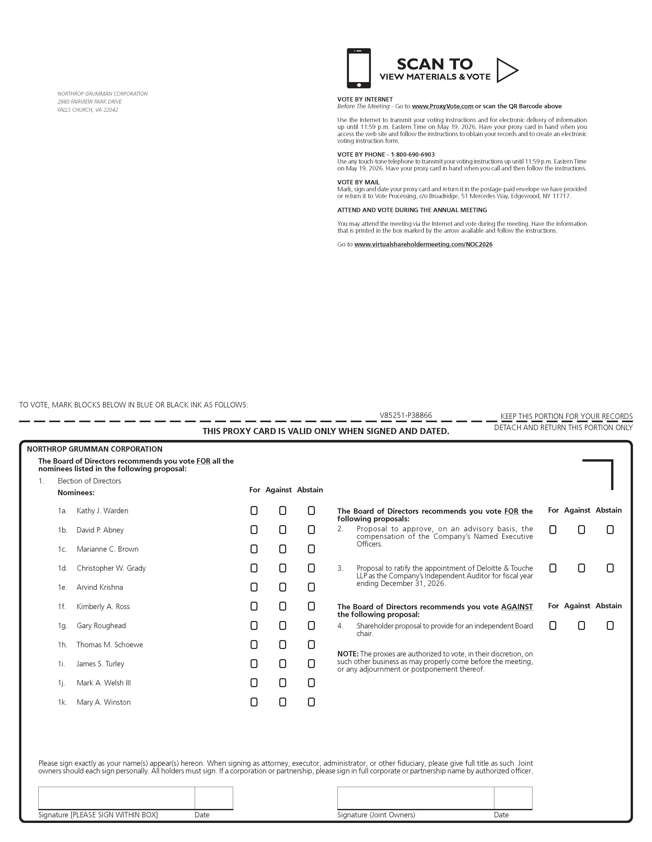

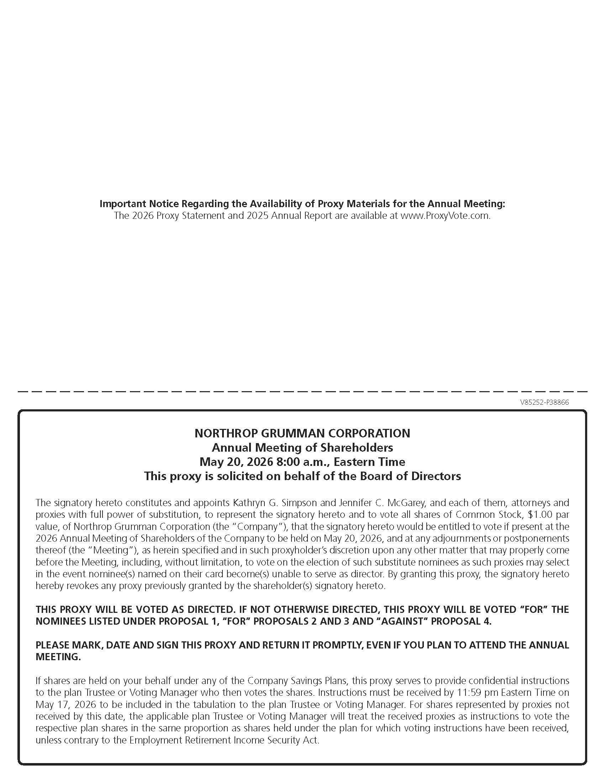



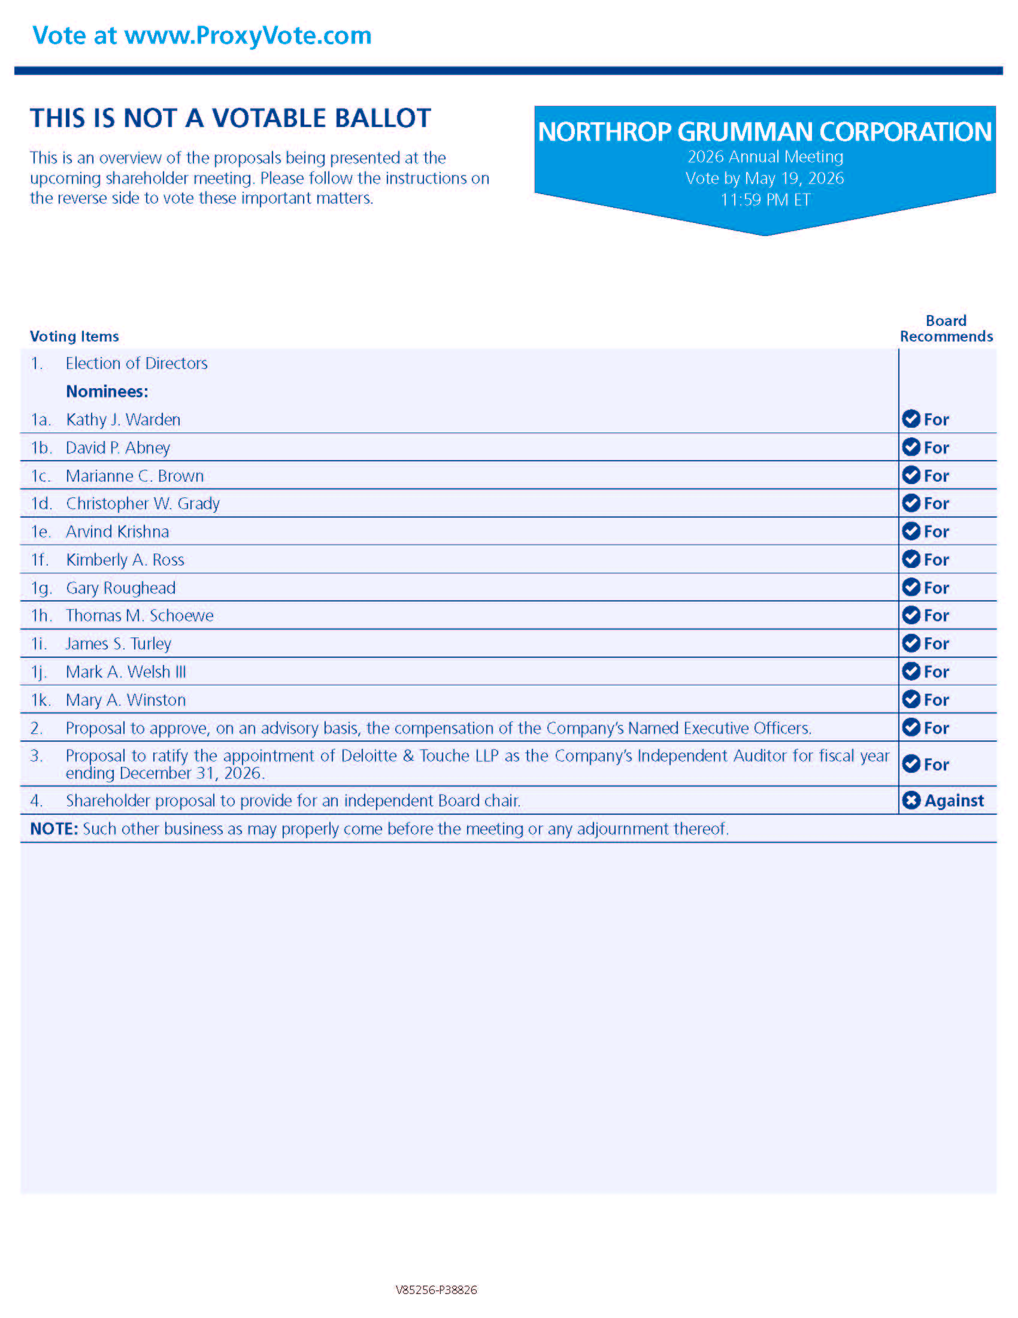



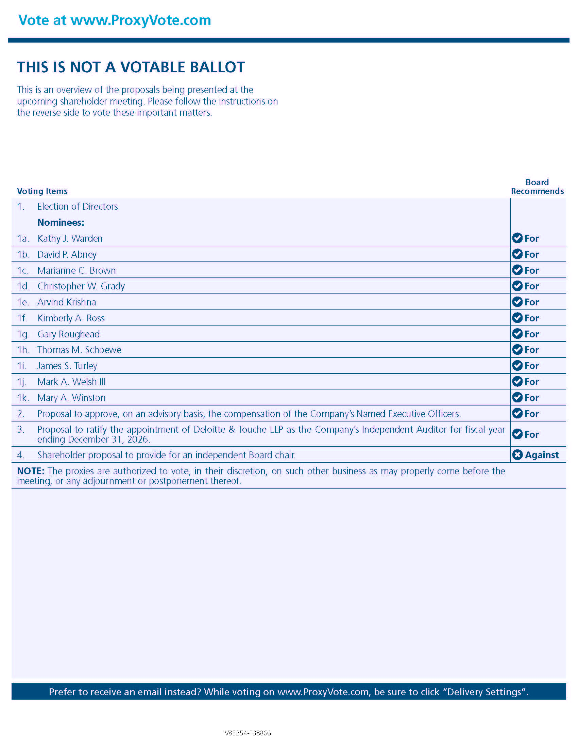



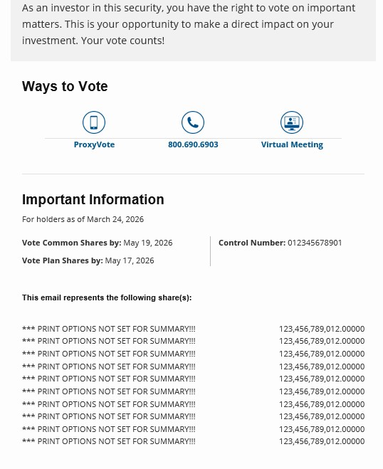

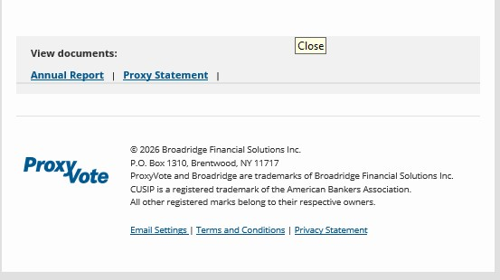


April 3, 2026

Information Regarding Your Northrop Grumman Shares — Your Vote Is Important

To Northrop Grumman Employees:

Northrop Grumman filed its proxy statement today for the 2026 Annual Meeting of Shareholders. The meeting will be held virtually on May 20, 2026. The 2026 Proxy Statement and 2025 Annual Report are now available online.

Many of you hold Northrop Grumman shares through one of the company’s savings plans. As shareholders, you have the right to vote on matters that impact the company. Your vote on these matters is important and you are encouraged to vote your shares.

Northrop Grumman employees who hold these shares as participants in the Northrop Grumman Savings Plan or the Northrop Grumman Financial Security and Savings Program should receive an email regarding the availability of proxy materials for the Annual Meeting and containing instructions for voting your shares. This email will be sent to your email address on record (either personal or company email) and contains important instructions for viewing the proxy statement and annual report and for voting your shares.

This email is an important communication approved by Northrop Grumman. The subject line of the email will read, “Vote Now! NORTHROP GRUMMAN CORPORATION Annual Meeting.” Note that the “EXT” warning tag, which appears in the subject line of emails originating outside of Northrop Grumman, will be removed for this message.

Northrop Grumman values your input as shareholders. Please ensure that your shares are represented at the 2026 Annual Meeting.
CORPORATE COMMUNICATIONS

